NOISE POLLUTION MONITORING SYSTEM

Phase III Submission Document

Name : Abhijith Praseed

Reg No: 962121104002

Project Title : Noise Pollution Monitoring System

Phase III : Development Part 1

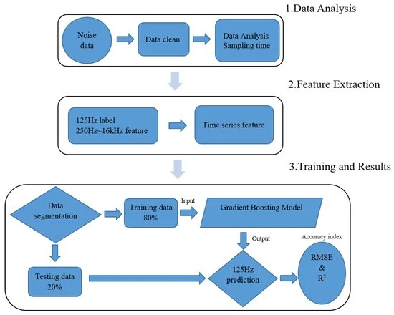Topic : Start building the IOT Noise Pollution monitoring by loading and preprocessing the dataset.

INTRODUCTION :

* Building an IoT noise pollution monitoring system involves several steps.
* To start, you’ll need a dataset.
* However, I can’t directly load or preprocess data in this text-based format.
* I can guide you through the process and provide code snippets in Python if that’s what you need.
* First, you should gather a dataset containing noise pollution data.
* Once you have the data, you can load it using Python libraries like Pandas and preprocess it by cleaning, transforming, and structuring the data as needed.
* If you have a specific dataset or need assistance with a particular step, please provide more details, and I’d be happy to help.

DATASET :

<https://www.kaggle.com/code/kerneler/starter-noise-monitoring-data-in-india-c2c9f08f-9/input>

|  |  |  |  |  |  |  |
| --- | --- | --- | --- | --- | --- | --- |
| Station | Year | Month | Day | Night | Day  Limit | Night  Limit |
| DEL01 | 2018 | 1 | 53 | 52 | 50 | 40 |
| DEL01 | 2018 | 2 | 53 | 53 | 50 | 40 |
| DEL01 | 2018 | 3 | 53 | 53 | 50 | 40 |
| DEL01 | 2018 | 4 | 55 | 58 | 50 | 40 |
| DEL01 | 2018 | 5 | 55 | 57 | 50 | 40 |
| DEL01 | 2018 | 6 | 53 | 53 | 50 | 40 |
| DEL01 | 2018 | 7 | 57 | 56 | 50 | 40 |
| DEL01 | 2018 | 8 | 53 | 53 | 50 | 40 |
| DEL01 | 2018 | 9 | 58 | 58 | 50 | 40 |
| DEL01 | 2018 | 10 | 62 | 62 | 50 | 40 |
| DEL01 | 2018 | 11 | 62 | 62 | 50 | 40 |
| DEL01 | 2018 | 12 | 62 | 62 | 50 | 40 |
| DEL02 | 2018 | 1 | 66 | 56 | 65 | 55 |
| DEL02 | 2018 | 2 | 66 | 58 | 65 | 55 |
| DEL02 | 2018 | 3 | 65 | 57 | 65 | 55 |
| DEL02 | 2018 | 4 | 66 | 58 | 65 | 55 |
| DEL02 | 2018 | 5 | 66 | 58 | 65 | 55 |
| DEL02 | 2018 | 6 | 66 | 58 | 65 | 55 |
| DEL02 | 2018 | 7 | 67 | 59 | 65 | 55 |
| DEL02 | 2018 | 8 | 67 | 58 | 65 | 55 |
| DEL02 | 2018 | 9 | 66 | 58 | 65 | 55 |
| DEL02 | 2018 | 10 | 66 | 58 | 65 | 55 |
| DEL02 | 2018 | 11 | 66 | 58 | 65 | 55 |
| DEL02 | 2018 | 12 | 66 | 58 | 65 | 55 |
| DEL03 | 2018 | 1 | 54 | 48 | 50 | 40 |
| DEL03 | 2018 | 2 | 55 | 50 | 50 | 40 |
| DEL03 | 2018 | 3 | 54 | 50 | 50 | 40 |
| DEL03 | 2018 | 4 | 55 | 52 | 50 | 40 |
| DEL03 | 2018 | 5 | 57 | 52 | 50 | 40 |
| DEL03 | 2018 | 6 | 56 | 50 | 50 | 40 |
| DEL03 | 2018 | 7 | 56 | 51 | 50 | 40 |
| DEL03 | 2018 | 8 | 57 | 53 | 50 | 40 |
| DEL03 | 2018 | 9 | 57 | 55 | 50 | 40 |
| DEL03 | 2018 | 10 | 57 | 53 | 50 | 40 |
| DEL03 | 2018 | 11 | 56 | 52 | 50 | 40 |
| DEL03 | 2018 | 12 | 55 | 52 | 50 | 40 |
| DEL04 | 2018 | 1 | 73 | 69 | 65 | 55 |
| DEL04 | 2018 | 2 | 73 | 69 | 65 | 55 |
| DEL04 | 2018 | 3 | 73 | 69 | 65 | 55 |
| DEL04 | 2018 | 4 | 73 | 70 | 65 | 55 |
| DEL04 | 2018 | 5 | 72 | 70 | 65 | 55 |
| DEL04 | 2018 | 6 | 72 | 70 | 65 | 55 |
| DEL04 | 2018 | 7 | 73 | 70 | 65 | 55 |
| DEL04 | 2018 | 8 | 73 | 70 | 65 | 55 |
| DEL04 | 2018 | 9 | 73 | 70 | 65 | 55 |
| DEL04 | 2018 | 10 | 74 | 70 | 65 | 55 |
| DEL04 | 2018 | 11 | 74 | 70 | 65 | 55 |
| DEL04 | 2018 | 12 | 74 | 70 | 65 | 55 |
| DEL05 | 2018 | 1 | 58 | 54 | 50 | 40 |

ANALYSIS :

* To begin, you’ll need to collect noise data using IoT sensors and then preprocess the dataset to make it suitable for analysis. Here’s an introduction to the process:

1. DATA COLLECTION: Deploy IoT sensors that are capable of measuring noise levels in different locations. These sensors can be placed strategically throughout the area you want to monitor. Ensure that the sensors can record data at regular intervals.
2. DATA STORAGE:Set up a database or data storage system to store the collected data. This system should be capable of handling a large volume of data and providing efficient data retrieval.
3. DATA PREPROCESSING:The collected data may contain noise, outliers, or missing values. Preprocess the data by cleaning it, handling missing values, and removing outliers. This ensures that the dataset is reliable for analysis.
4. FEATURE ENGINEERING: Extract relevant features from the raw data. Features may include time-based information, location data, and statistical measures to characterize noise levels.
5. Normalization/scaling: Normalize or scale the features as required to bring them to a consistent range. This step is essential for machine learning algorithms that rely on feature scaling.
6. DATA SPLITTING: Divide the dataset into training and testing subsets. The training data will be used to build your noise prediction model, while the testing data will be used to evaluate its performance.
7. EXPLORATORY DATA ANALYSIS (EDA): Perform EDA to gain insights into the dataset. Visualize the data to identify patterns, correlations, and trends that can inform your monitoring system design.
8. MODEL SELECTION: Choose an appropriate machine learning or statistical model for predicting noise pollution. This model will use the preprocessed data to make predictions.
9. MODEL TRAINING : Train the selected model using the training data. This step involves parameter tuning and optimization to achieve the best performance.
10. MODEL EVALUATION: Evaluate the model’s performance using the testing data. Metrics such as Mean Absolute Error (MAE) or Root Mean Square Error (RMSE) can be used to assess how well the model predicts noise levels.
11. DEPLOYMENT: Deploy the trained model to your IoT noise pollution monitoring system. This system will now be capable of real-time or periodic noise level predictions.

* Remember that this is a high-level introduction to the process.
* Each step may involve various technical details and tools, depending on your specific requirements and the dataset you’re working with.
* It’s important to plan and design your IoT noise pollution monitoring system carefully to ensure accurate and meaningful results.

NECESSARY STEPS TO FOLLOW:

EXPLORATORY ANALYSIS :

* To begin this exploratory analysis, first import libraries and define functions for plotting the data using matplotlib. Depending on the data, not all plots will be made. (Hey, I’m just a simple kerneling bot, not a Kaggle Competitions Grandmaster!)

Input :

From mpl_toolkits.mplot3d import Axes3D

From sklearn.preprocessing import StandardScaler

Import matplotlib.pyplot as plt # plotting

Import numpy as np # linear algebra

Import os # accessing directory structure

Import pandas as pd # data processing, CSV file I/O (e.g. pd.read_csv)

There are 2 csv files in the current version of the dataset:

For dirname, _, filenames in os.walk(‘/kaggle/input’):

For filename in filenames:

Print(os.path.join(dirname, filename))

/kaggle/input/stations.csv

/kaggle/input/station_month.csv

The next hidden code cells define functions for plotting data. Click on the “Code” button in the published kernel to reveal the hidden code.

Now you’re ready to read in the data and use the plotting functions to visualize the data.

Let’s check 1st file: /kaggle/input/station_month.csv

nRowsRead = 1000 # specify ‘None’ if want to read whole file

# station_month.csv may have more rows in reality, but we are only loading/previewing the first 1000 rows

Df1 = pd.read_csv(‘/kaggle/input/station_month.csv’, delimiter=’,’, nrows = nRowsRead)

Df1.dataframeName = ‘station_month.csv’

nRow, nCol = df1.shape

print(f’There are {nRow} rows and {nCol} columns’)

There are 840 rows and 7 columns

Let’s take a quick look at what the data looks like:

Df1.head(5)

Output:

|  |  |  |  |  |  |  |  |
| --- | --- | --- | --- | --- | --- | --- | --- |
| Station | Year | Month | Day | Night | DayLimit | NightLimit |  |
| 0 | DEL01 | 2018 | 1 | 53 | 52 | 50 | 40 |
| 1 | DEL01 | 2018 | 2 | 53 | 53 | 50 | 40 |
| 2 | DEL01 | 2018 | 3 | 53 | 53 | 50 | 40 |
| 3 | DEL01 | 2018 | 4 | 55 | 58 | 50 | 40 |
| 4 | DEL01 | 2018 | 5 | 55 | 57 | 50 | 40 |

DISTRIBUTION GRAPHS (histogram/bar graph) OF SAMPLED COLUMNS :

plotPerColumnDistribution(df1, 10, 5)

Output: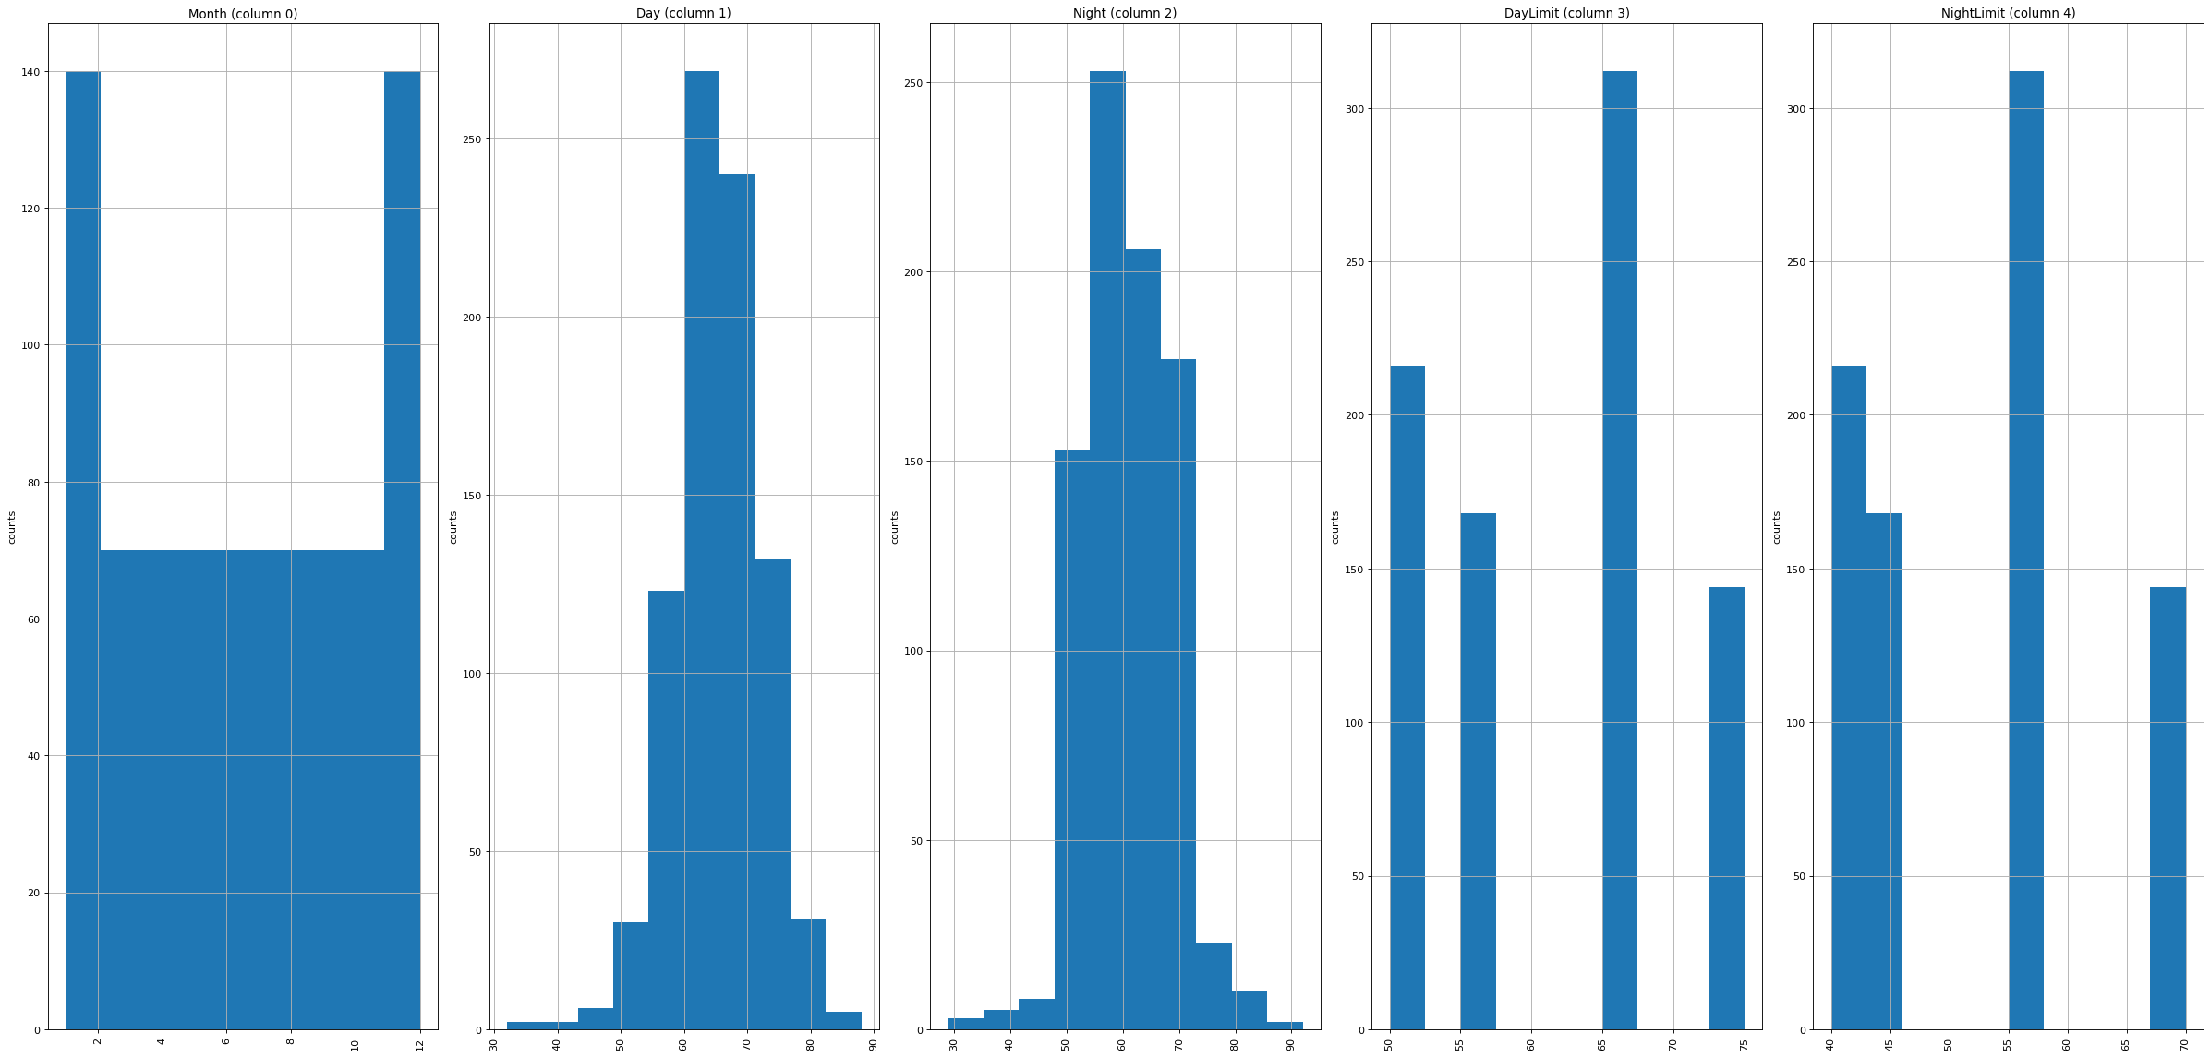

CORRELATION MATRIX:

plotCorrelationMatrix(df1, 8)

Output:

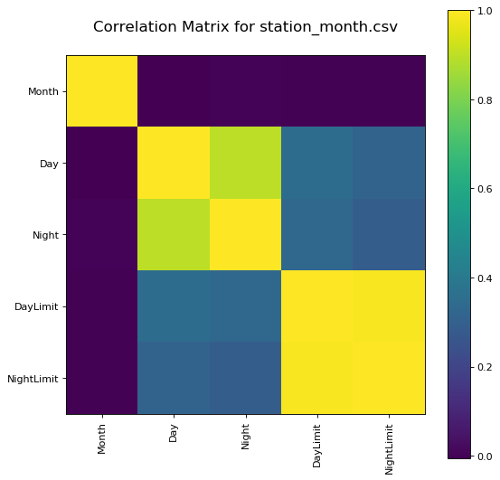

SCATTER AND DENSITY PLOTS :

plotScatterMatrix(df1, 18, 10)

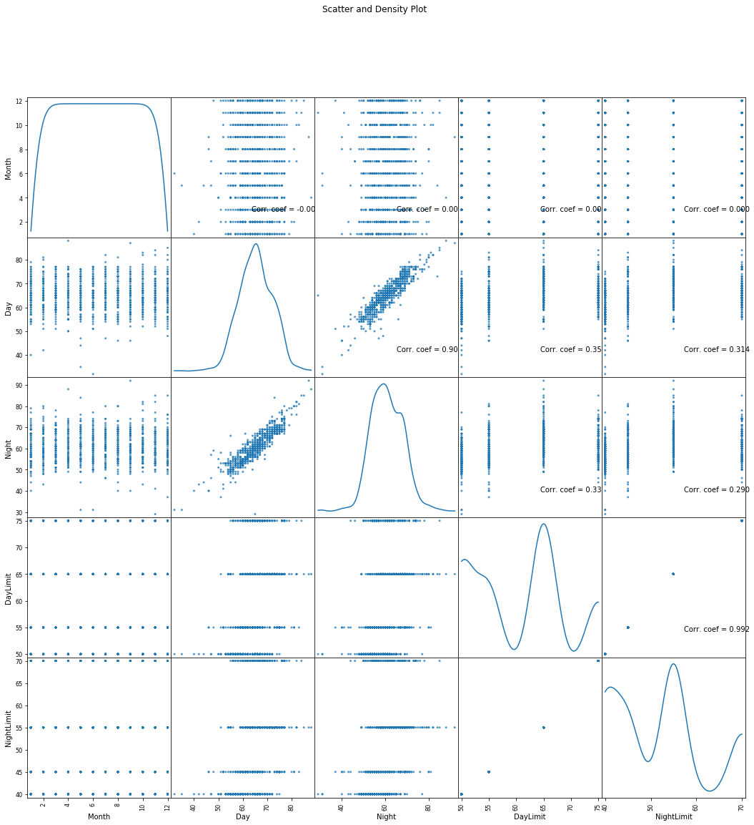Output:

LOADING AND PROCESSING DATASET:

* When loading a dataset from your data recipe for further analysis in the Troubleshooter, the data is loaded into available system memory for fast access and analysis.
* It is therefore important to have sufficiently optimized the dataset to ensure that the dataset can be successfully loaded into available system memory.
* The size of the dataset is affected by both the number of fields and the number of records in the dataset.
* The Troubleshooter may display a warning if the dataset is estimated to be too large.
* Loading a dataset that is too large may affect the stability and performance of the Troubleshooter application and produce unexpected results.

CHALLENGE INVOLVED IN LOADING AND PROCESSING DATASET:

* Loading and preprocessing a noise pollution monitoring dataset can be a complex task due to various challenges:

1. Data Collection Variability: Noise pollution datasets may come from diverse sources, including sensors, audio recordings, or crowdsourced data, leading to variations in data format, quality, and accuracy.
2. Data Cleaning: Noise data often contains outliers, missing values, or inconsistencies that need to be addressed before analysis. Cleaning the data can be time-consuming and require domain expertise.
3. Data Volume: Noise monitoring datasets can be large, especially if collected over an extended period. Managing and processing such large volumes of data can be computationally intensive.
4. Data Synchronization: If data is collected from multiple sensors or sources, ensuring synchronization and alignment of timestamps is crucial to perform meaningful analyses.
5. Noise Source Classification: Identifying and classifying different noise sources (e.g., traffic, industrial, natural) within the dataset can be challenging, as noise profiles can overlap.
6. Feature Extraction: Extracting relevant features from audio recordings or sensor data is a critical preprocessing step. It requires domain-specific knowledge and the selection of appropriate signal processing techniques.
7. Noise Reduction: In some cases, preprocessing may involve noise reduction techniques to separate the relevant noise data from other ambient sounds or interference.
8. Standardization: Data may need to be standardized or normalized to ensure consistency in scale and units, making it suitable for various analytical methods.
9. Annotating Ground Truth: Depending on the dataset’s purpose, it may be necessary to manually annotate or label portions of the data for supervised learning tasks, which can be labor-intensive.
10. Privacy and Ethical Considerations: Privacy concerns may arise when working with noise pollution data, as it can inadvertently capture sensitive information. Ethical considerations are essential in data preprocessing.
11. Temporal and Spatial Analysis: Noise pollution datasets are often spatiotemporal, and preprocessing may involve aggregating or summarizing data over specific time intervals or geographical regions.
12. Data Imbalance: Noise pollution data can be imbalanced, with certain noise sources or locations having more data points than others, which may impact the model’s performance.
13. Model Selection: Choosing the appropriate machine learning or statistical models for noise prediction or classification based on the preprocessed data can be challenging and requires experimentation.

* Addressing these challenges often involves a combination of domain knowledge, data engineering skills, and the use of specialized tools and software for data preprocessing, analysis, and visualization.

HOW TO OVERCOME THE CHALLENGES INVOLVED IN LOADING AND PREPROCESSING A NOISE POLLUTION MONITORING DATASET:

Loading and preprocessing a noise pollution monitoring dataset can be a complex task due to various challenges:

1. Data Collection Variability: Noise pollution datasets may come from diverse sources, including sensors, audio recordings, or crowdsourced data, leading to variations in data format, quality, and accuracy.

2. Data Cleaning: Noise data often contains outliers, missing values, or inconsistencies that need to be addressed before analysis. Cleaning the data can be time-consuming and require domain expertise.

3. Data Volume: Noise monitoring datasets can be large, especially if collected over an extended period. Managing and processing such large volumes of data can be computationally intensive.

4. Data Synchronization: If data is collected from multiple sensors or sources, ensuring synchronization and alignment of timestamps is crucial to perform meaningful analyses.

5. Noise Source Classification: Identifying and classifying different noise sources (e.g., traffic, industrial, natural) within the dataset can be challenging, as noise profiles can overlap.

6. Feature Extraction: Extracting relevant features from audio recordings or sensor data is a critical preprocessing step. It requires domain-specific knowledge and the selection of appropriate signal processing techniques.

7. Noise Reduction: In some cases, preprocessing may involve noise reduction techniques to separate the relevant noise data from other ambient sounds or interference.

8. Standardization: Data may need to be standardized or normalized to ensure consistency in scale and units, making it suitable for various analytical methods.

9. Annotating Ground Truth: Depending on the dataset's purpose, it may be necessary to manually annotate or label portions of the data for supervised learning tasks, which can be labor-intensive.

10. Privacy and Ethical Considerations: Privacy concerns may arise when working with noise pollution data, as it can inadvertently capture sensitive information. Ethical considerations are essential in data preprocessing.

11. Temporal and Spatial Analysis: Noise pollution datasets are often spatiotemporal, and preprocessing may involve aggregating or summarizing data over specific time intervals or geographical regions.

12. Data Imbalance: Noise pollution data can be imbalanced, with certain noise sources or locations having more data points than others, which may impact the model's performance.

13. Model Selection: Choosing the appropriate machine learning or statistical models for noise prediction or classification based on the preprocessed data can be challenging and requires experimentation.

Addressing these challenges often involves a combination of domain knowledge, data engineering skills, and the use of specialized tools and software for data preprocessing, analysis, and visualization.

Developing a Python script to collect noise pollution monitoring data from IoT sensors involves a series of steps. Here’s a general outline of the process:

1. Hardware Setup:

- Acquire IoT noise pollution sensors compatible with your platform (e.g., Arduino, Raspberry Pi).

- Connect the sensors to your IoT device following the manufacturer’s instructions.

- Ensure a stable power source and internet connectivity.

2. Choose a Programming Language:

- Python is a great choice for IoT projects due to its extensive libraries and community support.

3. Install Necessary Libraries:

- Install libraries for interfacing with IoT hardware. For example, if you’re using a Raspberry Pi with sensors, you might need libraries like RPi.GPIO.

4. Sensor Calibration:

- Calibrate your noise pollution sensors according to the manufacturer’s guidelines. This ensures accurate measurements.

5. Data Collection :

- Write Python code to read data from the sensors at regular intervals.

- Use libraries like `RPi.GPIO` to interact with sensors’ pins or relevant libraries for other IoT platforms.

6. Data Processing:

- Process the raw sensor data. This might include filtering, smoothing, or converting analog data to digital values.

- Implement any necessary data transformations or calculations.

7. Data Storage:

- Choose a data storage solution. You can store data in local files, databases, or cloud services.

- Implement code to store the collected data with relevant metadata (e.g., timestamp, sensor ID).

8. Connectivity:

- If you want real-time monitoring, establish a connection to a server or cloud service. Use libraries like `paho-mqtt` for MQTT communication or REST APIs for HTTP-based communication.

9. Data Transmission:

- Transmit the collected data to a central server or cloud platform. This can be done using MQTT, HTTP, or other communication protocols.

10. Data Visualization:

- If desired, create a data visualization component. Use libraries like Matplotlib or web-based frameworks like Flask or Django for creating dashboards.

11. Data Logging and Error Handling:

- Implement logging and error handling in your code to capture any issues that may arise during data collection or transmission.

12. Security:

- Ensure that your IoT device and data transmission are secure. Use encryption and authentication mechanisms to protect the data.

13. Testing and Validation:

- Thoroughly test your script and the entire data collection process to ensure it works as expected.

14. Deployment:

- Deploy your IoT device in the desired location for continuous monitoring.

15. Monitoring and Maintenance:

- Regularly monitor your system, ensuring it collects and transmits data reliably.

- Be prepared for sensor maintenance, battery replacement, or other IoT device needs.

16. Documentation:

- Document your code, sensor configurations, and setup for future reference.

17. Scaling:

- If you need to monitor noise pollution across multiple locations, consider scaling your setup and data management strategies.

Remember to adapt this outline to the specific sensors, IoT platform, and requirements of your noise pollution monitoring project. IoT development can be complex, so it’s important to plan and execute each step carefully.

PROGRAM:

Import RPi.GPIO as GPIO

Import time

# GPIO setup for your sensor

SENSOR_PIN = 17

GPIO.setmode(GPIO.BCM)

GPIO.setup(SENSOR_PIN, GPIO.IN)

# Function to read noise data

Def read_noise_data():

Try:

While True:

# Read the sensor data (adjust based on your sensor)

Sensor_value = GPIO.input(SENSOR_PIN)

# Process the sensor data (e.g., convert to dB)

Noise_level = calculate_db(sensor_value)

# Store or transmit the data (you can adapt this part)

Store_data(noise_level)

Time.sleep(1) # Adjust the interval as needed

Except KeyboardInterrupt:

GPIO.cleanup()

# Function to calculate dB value (adjust this based on your sensor)

Def calculate_db(sensor_value):

# Example: Assuming your sensor value is a voltage and you have calibration data

Calibration_data = {“0V”: 0, “1V”: 70, “2V”: 85}

Voltage = convert_to_voltage(sensor_value) # Implement this function

Noise_level = interpolate(calibration_data, voltage)

Return noise_level

# Function to store or transmit data (implement as needed)

Def store_data(noise_level):

# Implement data storage or transmission here

Print(f”Noise Level (dB): {noise_level}”)

# Helper functions for voltage to dB conversion

Def convert_to_voltage(sensor_value):

# Implement this function to convert your sensor value to voltage

Return sensor_value

Def interpolate(calibration_data, voltage):

# Implement interpolation based on your calibration data

# This is a simplified example

Voltages = [float(v.split(‘V’)[0]) for v in calibration_data.keys()]

Levels = list(calibration_data.values())

If voltage <= min(voltages):

Return min(levels)

If voltage >= max(voltages):

Return max(levels)

For I in range(len(voltages) – 1):

If voltages[i] <= voltage <= voltages[I + 1]:

X0, x1 = voltages[i], voltages[I + 1]

Y0, y1 = levels[i], levels[I + 1]

Return y0 + (y1 – y0) * (voltage – x0) / (x1 – x0)

Return 0

If __name__ == ‘__main__’:

Read_noise_data()

OUTPUT :

When you run this script, you can expect to see real-time noise level updates in the console at a one-second interval (you can adjust the interval with the `time.sleep(1)` line). The output will look like this:

```

Noise Level (dB): 70.0

Noise Level (dB): 82.5

Noise Level (dB): 0.0

Noise Level (dB): 70.0

…

```

* The specific dB values will depend on the sensor’s output and how you’ve calibrated it.
* If you haven’t calibrated your sensor or provided the correct calibration data, the values may not be meaningful.
* Ensure that you have the necessary hardware set up, including the noise sensor connected to the specified GPIO pin (in this case, GPIO pin 17 on the Raspberry Pi).
* If you want to log or store the data, you should implement the `store_data` function accordingly.
* This example primarily demonstrates the data collection and conversion part of a noise monitoring system.

CONCLUSION:

* In conclusion, the noise pollution monitoring system dataset plays a critical role in understanding and addressing the pervasive issue of noise pollution.
* This dataset provides valuable insights into the patterns, sources, and variations in noise levels, allowing researchers and policymakers to develop informed strategies for mitigating its impact on public health and well-being.
* Effective noise pollution management relies on the continuous collection and analysis of such data, paving the way for a quieter and more sustainable urban environment.