# Blender

## Keymap

Edit -> preference -> keymap -> Industry compactible

## Keys

G- grab

R- rotate

S- scale



## Torus creation

* Shift + a

## Rotate

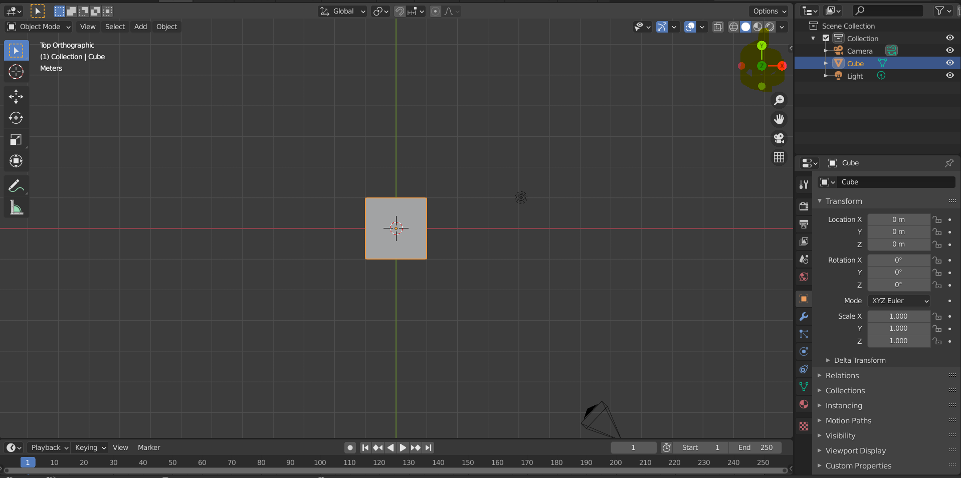

## Move

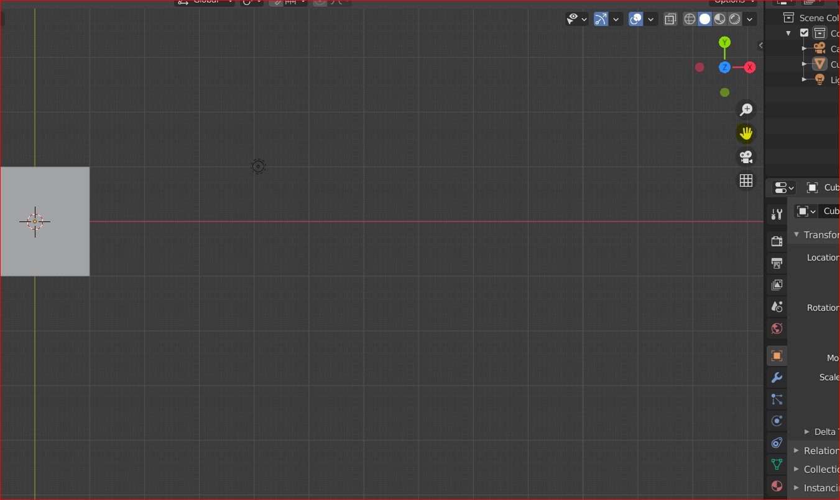

## Reframe selected object

View -> Frame selected

Select object + F

## Zoom or zoom out

Middle key in mouse

+ or – in number key pad

## Camera view

F4

## Split area

Right click the boundary of view -> horizontal or vertical split

## Magnifies an area

Cntrl + space

## Select all

Cntrl + a

## Scale up or down

R

Scale evenly – select object drag in viewport

## Move 3d object

Press c

Move (+) icon

Select object

Object -> snap -> selection to cursor

## Add object

Add -> mesh -> object

## delete

Select modelling tab on top

Select edge or face – right click outside object or press delete btn

## Edit object

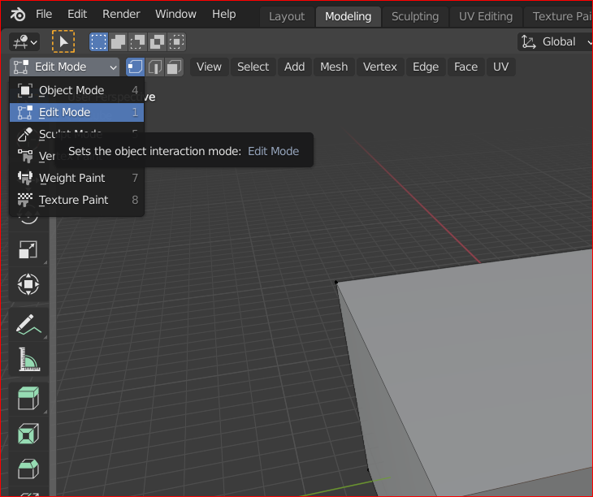

Keep this in edit mode

## Extrude

Select modelling in top nav

Cntrl + E (Extrude option)

Select face

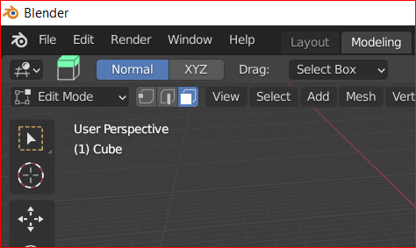

Select face

Drag (+) icon to up

Click anywhere outside the face (inside circle) and drag

## Make chair

Select scale tool

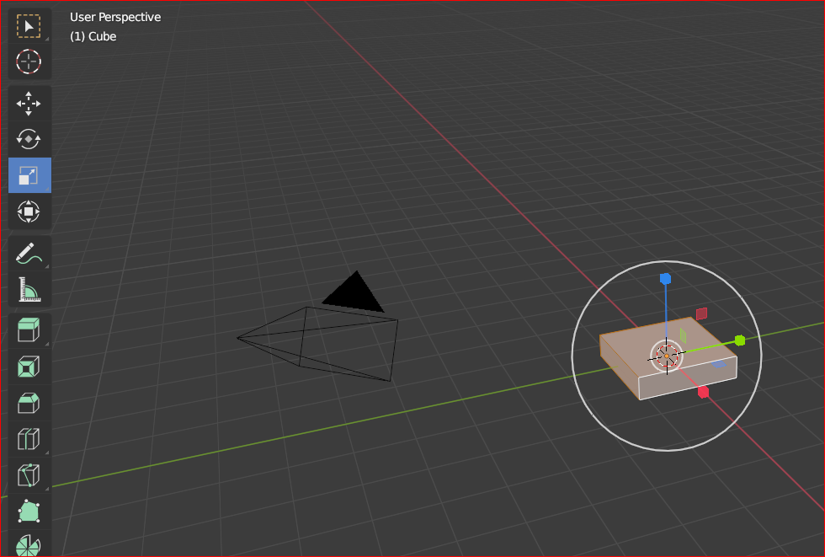

Resize box in z axis

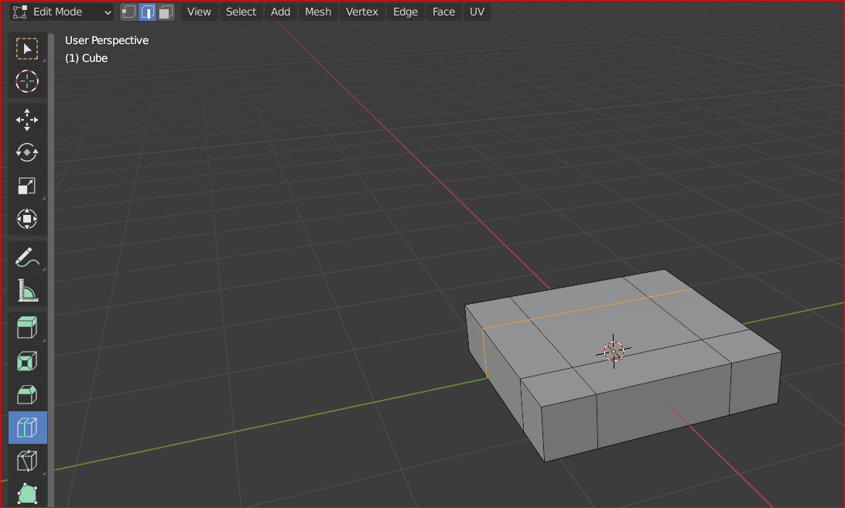

Select loop cut

Left click and drag the position

Select face select mode

Select faces

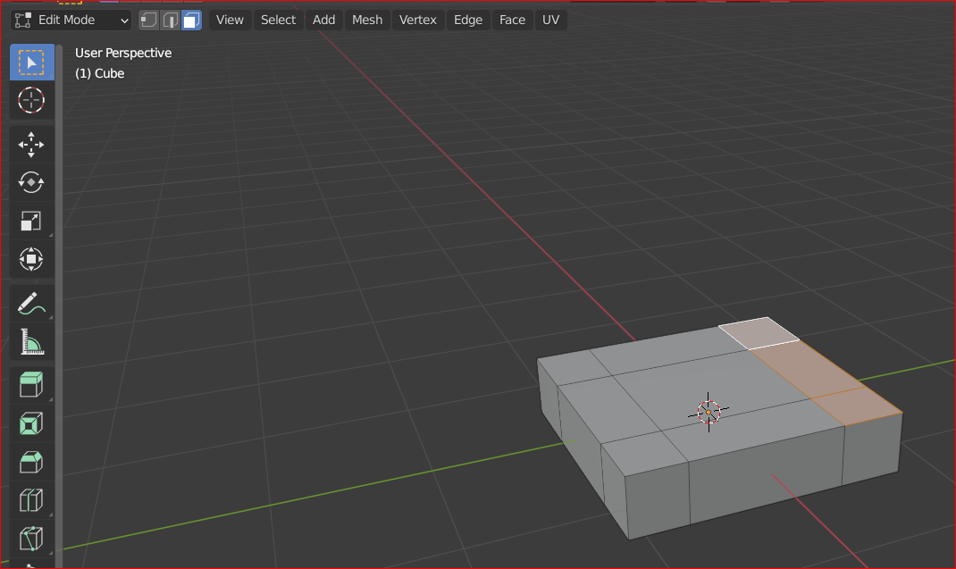

Select 4 corners in bottom

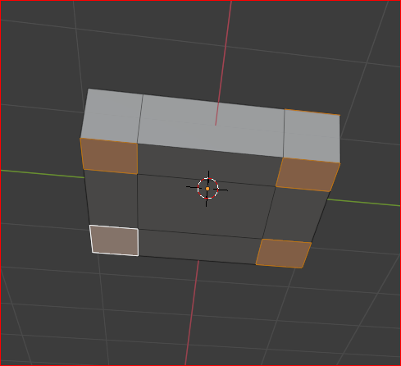

Extrude

## Bevel

For smoothing edge

* Select modelling in top
* Cntrl + b
* Click and drag + (+) icon