# Docker

# Installation

<https://docs.docker.com/docker-for-windows/install/>

## Install on ubntu

<https://docs.docker.com/engine/install/ubuntu/>

* curl -fsSL https://get.docker.com -o get-docker.sh
* sudo sh get-docker.sh
* run docker in user mod
* sudo usermod aG docker zeroneadmin
* zeroneadmin is username

# Create Django app

## Create a folder and create below 3 files in it

* docker-compose.yml

version: '3'

services:

    web:

        build: .

        command: python manage.py runserver 0.0.0.0:8000

        volumes:

            - .:/app

        ports:

            - "8000:8000"

* Dockerfile

FROM python:3

ENV PYTHONUNBUFFERED 1

RUN mkdir /app

WORKDIR /app

COPY requirements.txt /app/

RUN pip install -r requirements.txt

COPY . /app/

* requirements.txt

Django==2.2

## Create project

* run the following cmd on terminal
* docker-compose run web django-admin startproject mysite .
* this will create all layers for the project

1. Start server

* docker-compose up

1. open new cmd

* docker ps
* this will prompt like this

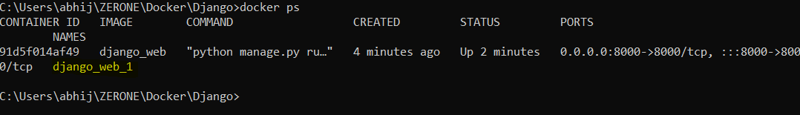

1. To create new app on running docker image

* docker exec django_web_1 python manage.py startapp greet

# Create component from existing django

1. Create Django project
2. Move all three files into project folder
3. Run the following cmd

* Docker-compose build

# Move container form one pc to another

<https://bobcares.com/blog/move-docker-container-to-another-host/>

do step 2, 3, 4