# Changathi - chatbot

# Pypy creation

1. Create account in <https://pypi.org/>
2. Go to pc
3. Create one folder named **src**
4. Move projects into src folder
5. Go to parent directory
6. Create new python file **setup.py**

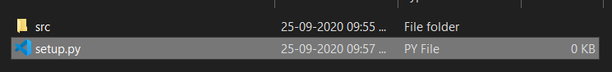

1. Create a new file **start.py** inside **src** folder

import sys

import subprocess

def start_server():

    try:

        theproc = subprocess.Popen([sys.executable, "manage.py", "runserver"])

        theproc.communicate()

    except :

        return "please call download_model()"

def download_model():

    return "Downloading ..."

1. Setup.py

from setuptools import setup

setup(name="changathi",

    version="0.0.0",

    description="changathi first version",

    py_modules = ["start"]

    author="Doodle.ai",

    packages={'':'src'})

1. Open cmd –
2. $ python setup.py bdist_wheel

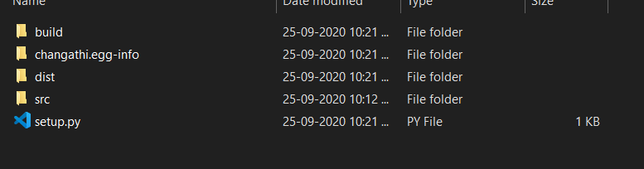

1. Install locally
2. Open cmd
3. $ pip install -e .
4. Copy this license file into setup.py folder



1. Install
2. $ pip install check-manifest