# PowerBi

# Powerbi with python

* Install pandas and matplotlib
* Select py in visual tab
* Import [financial dataset](https://go.microsoft.com/fwlink/?LinkID=521962)
* Drag and drop columns to values field

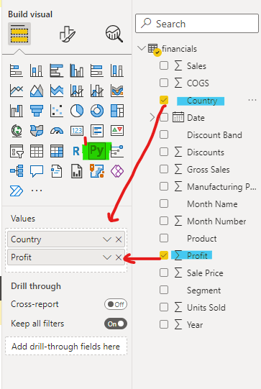

## Visualizing using matplotlib

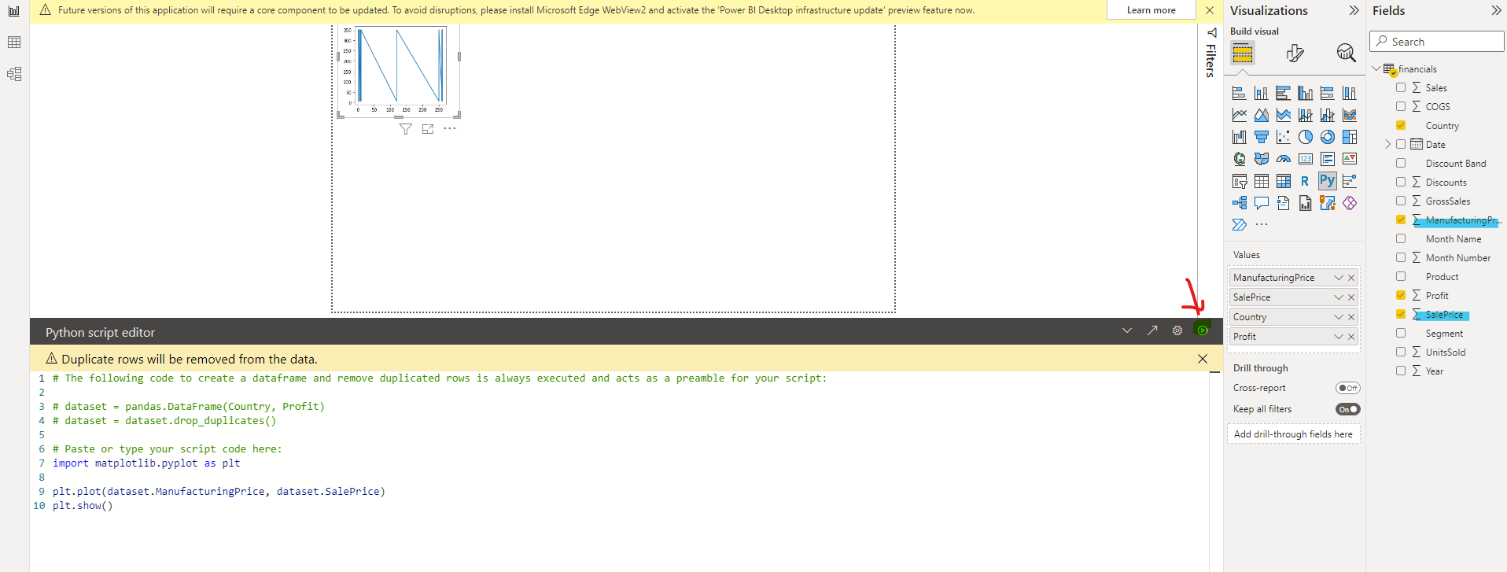

* Check “do not sum ”

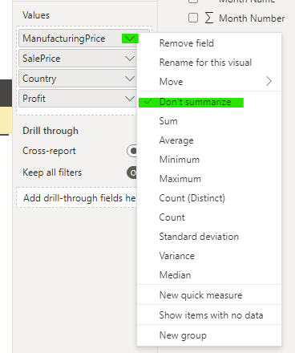

Styling

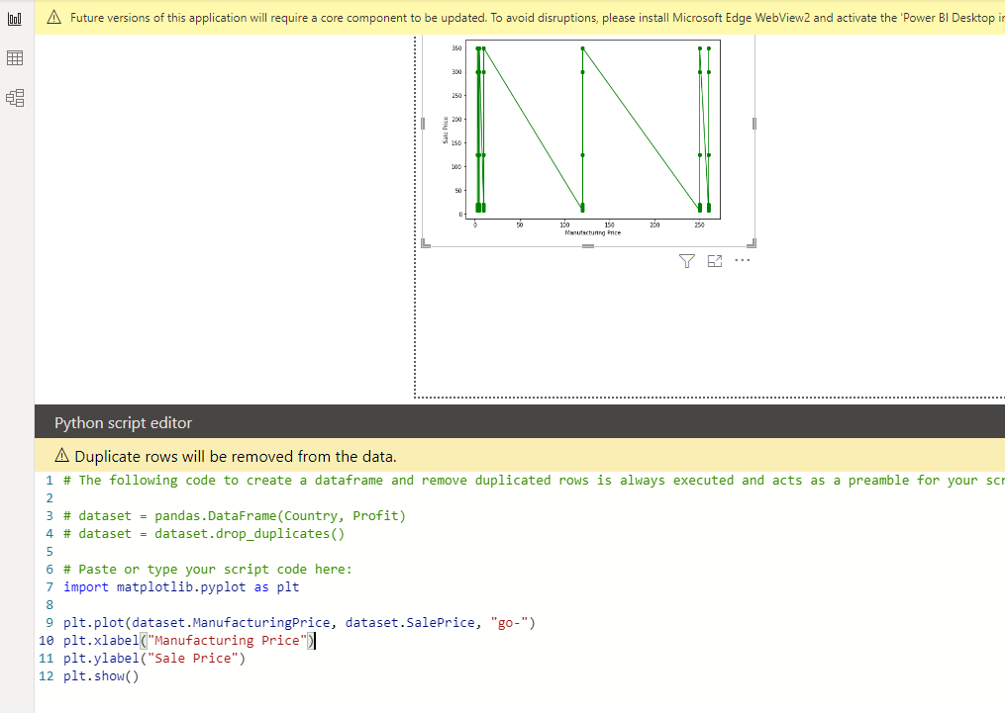

## Violin plot using seaborn

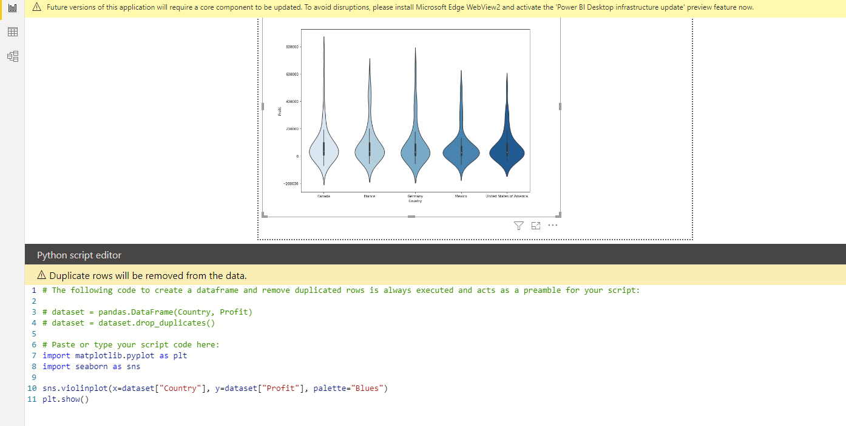

Rectangle in plot – data distribution >95%

Smaller line – 50% of data

White dot – mean/median of data

## pairplot

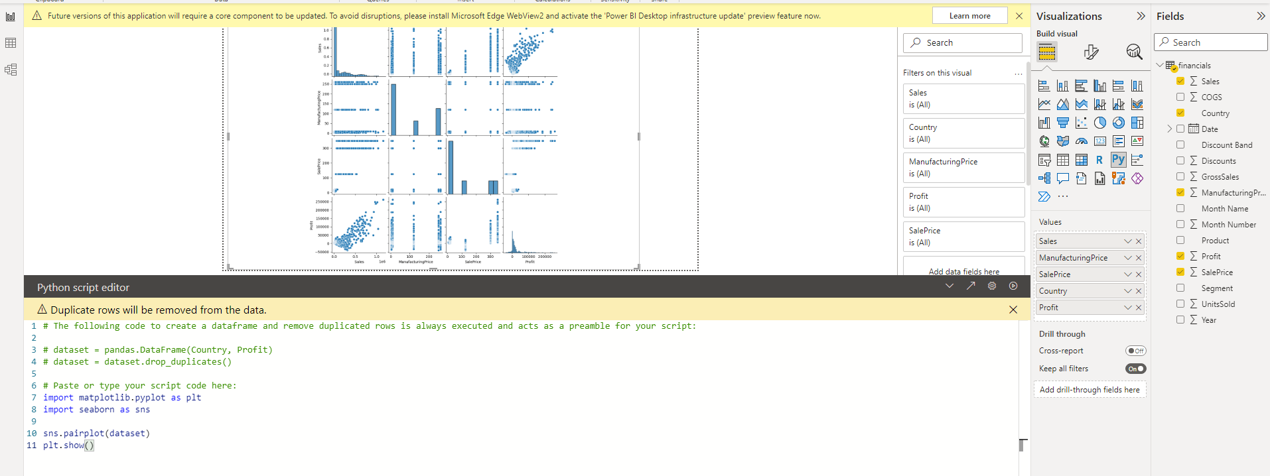

## Removing null with mean

* Table – right click -> edit query

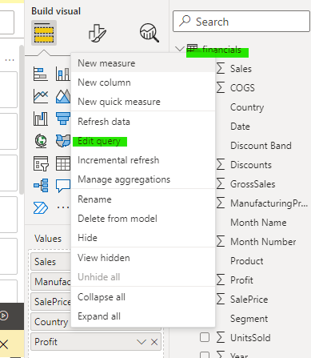

On transform tab

* Click “Run Python Script” -> add

Final = dataset.fillna(dataset.mean())

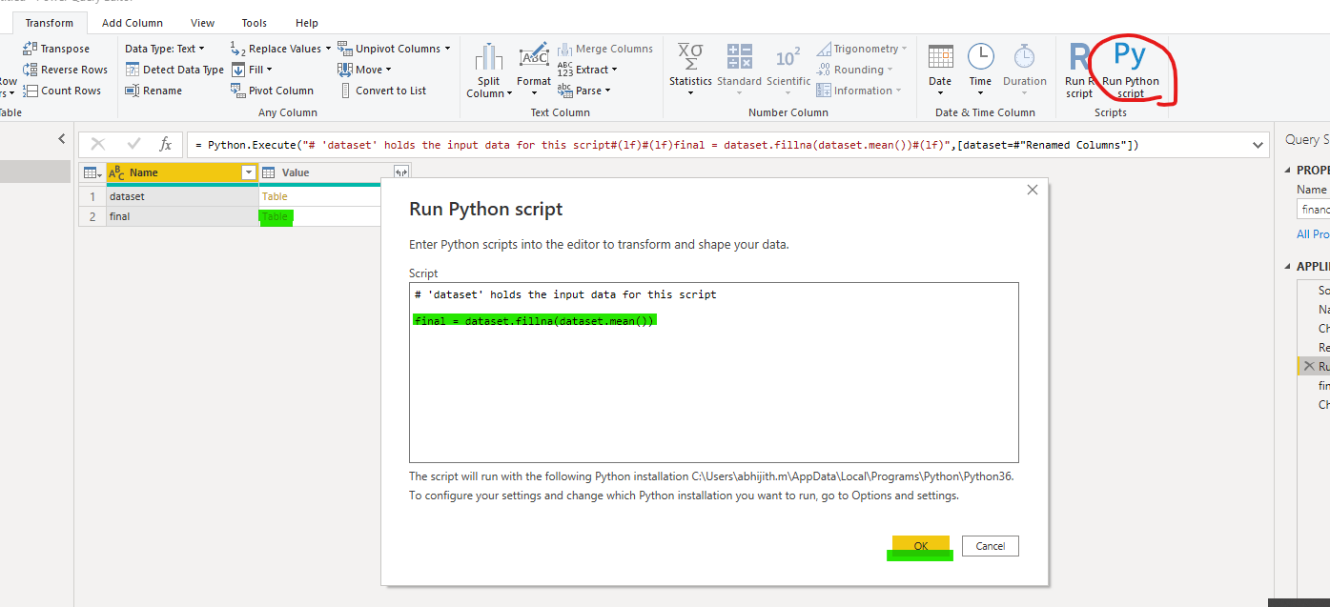

## Adding slicer for country

* Select profit and year
* Change view to pie chart
* Click on panel outside pie chart
* Select country and add slicer

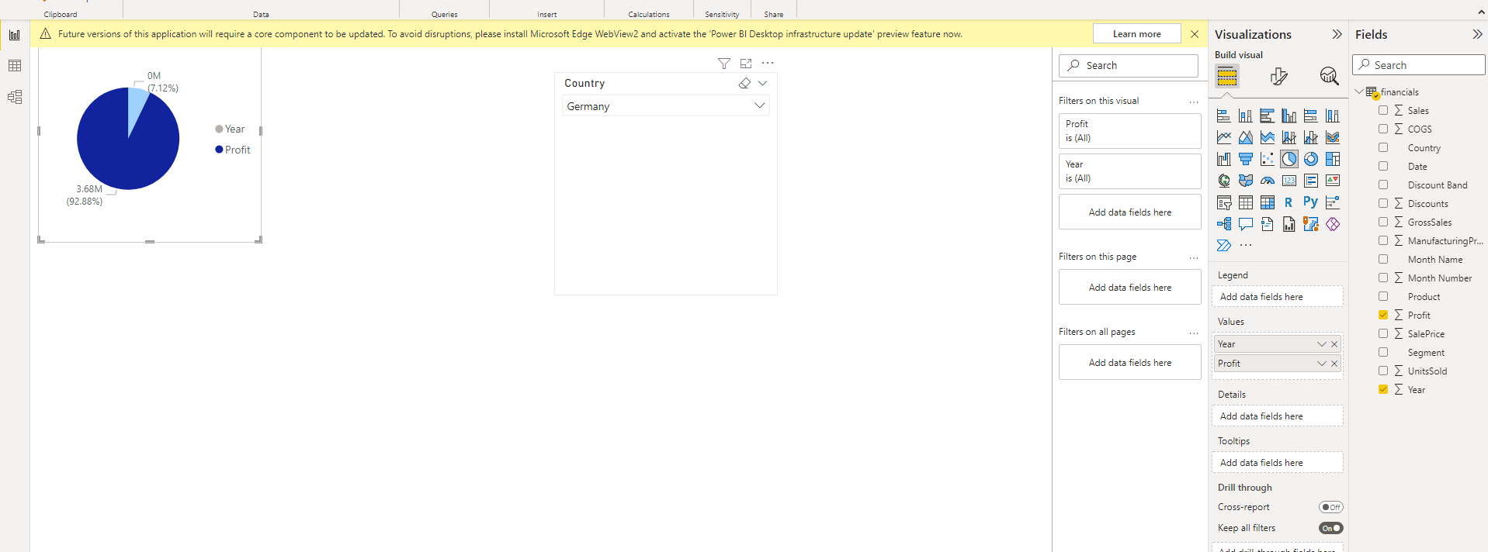

## Sales prediction model

[Reference](https://www.youtube.com/watch?v=0zveIwThlfE)

## Info graphic design

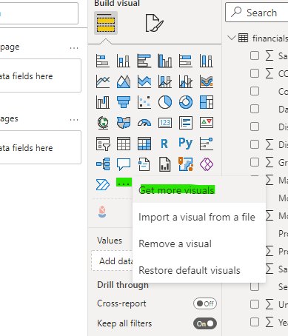

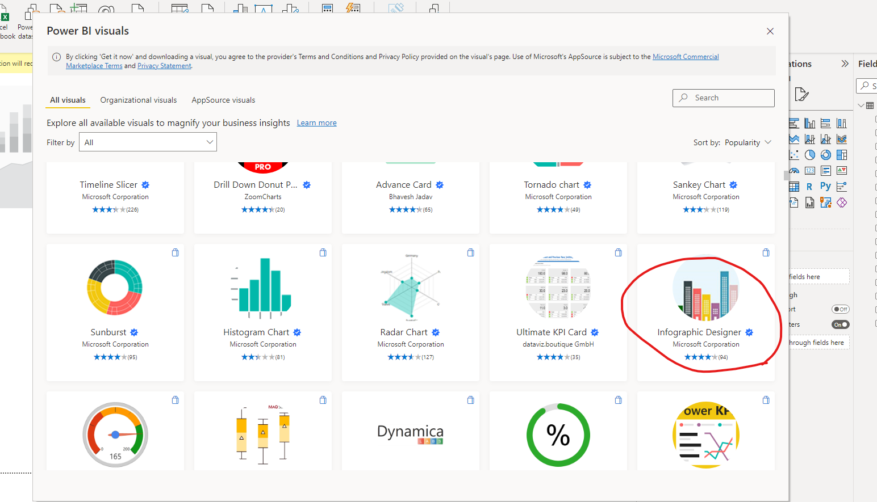

-add values

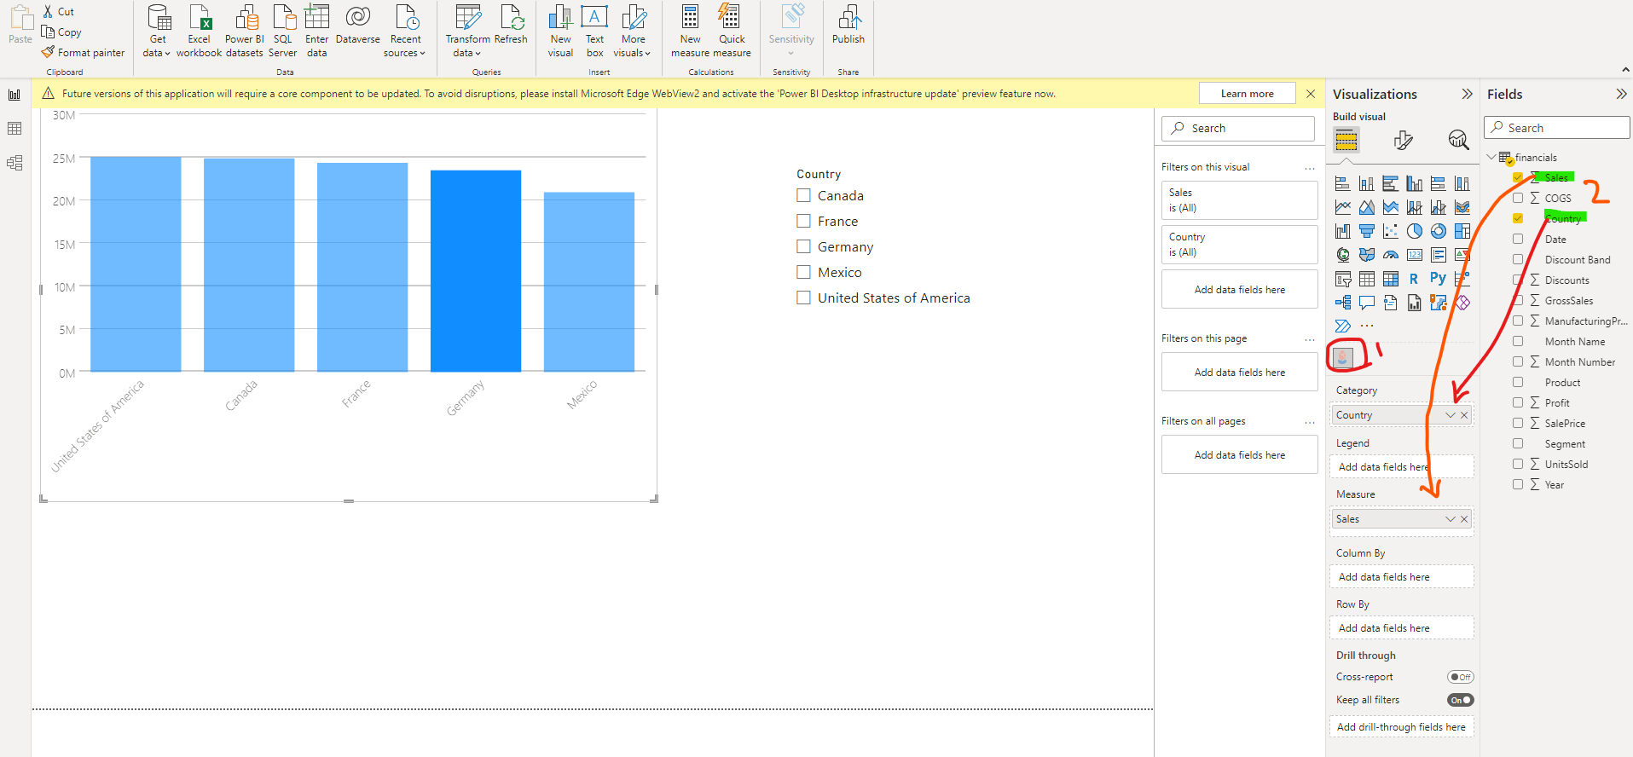

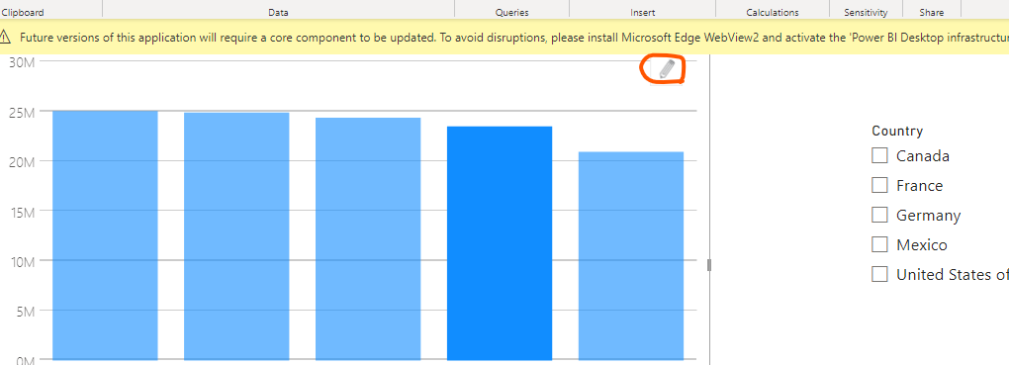

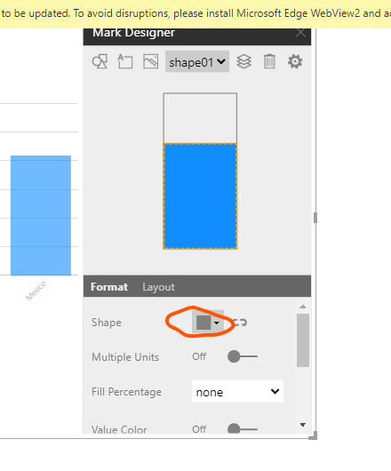

Edit style

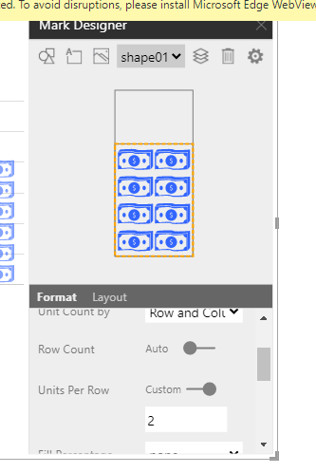

## Navigation panel

[Tutorial](https://www.youtube.com/watch?v=34pBbd92BQI&list=PLbmr31Ozd_E6VGQ8hJGLqxYaA-IJDoMPq&index=12)

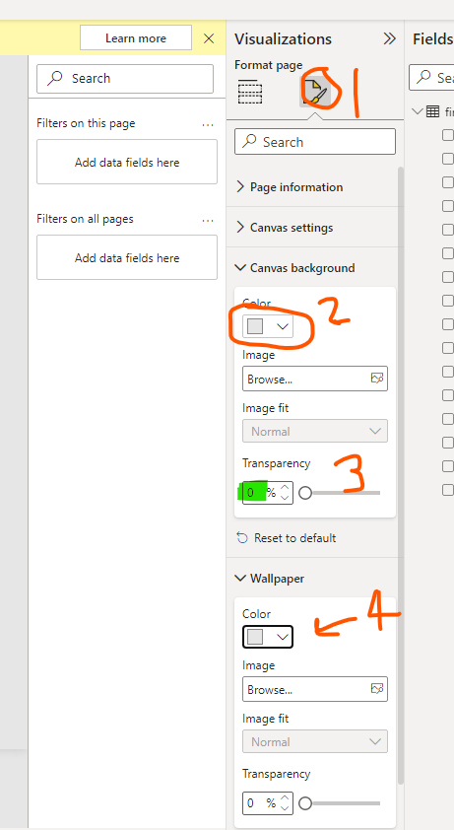

Insert a rectangle -> Insert(tab) -> shapes (choose rectangle)

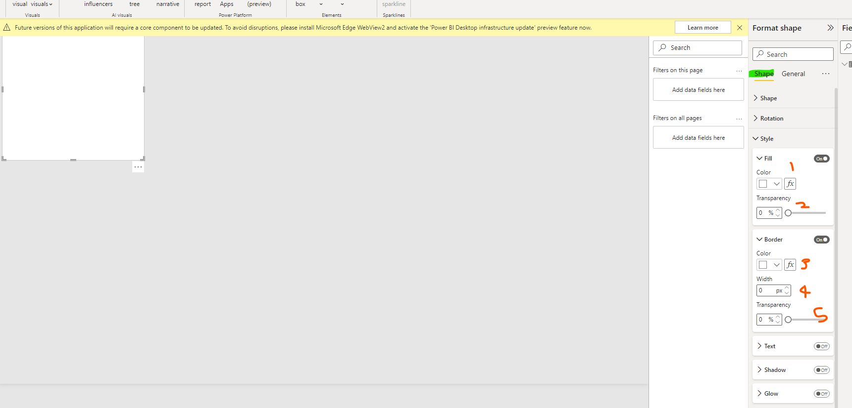

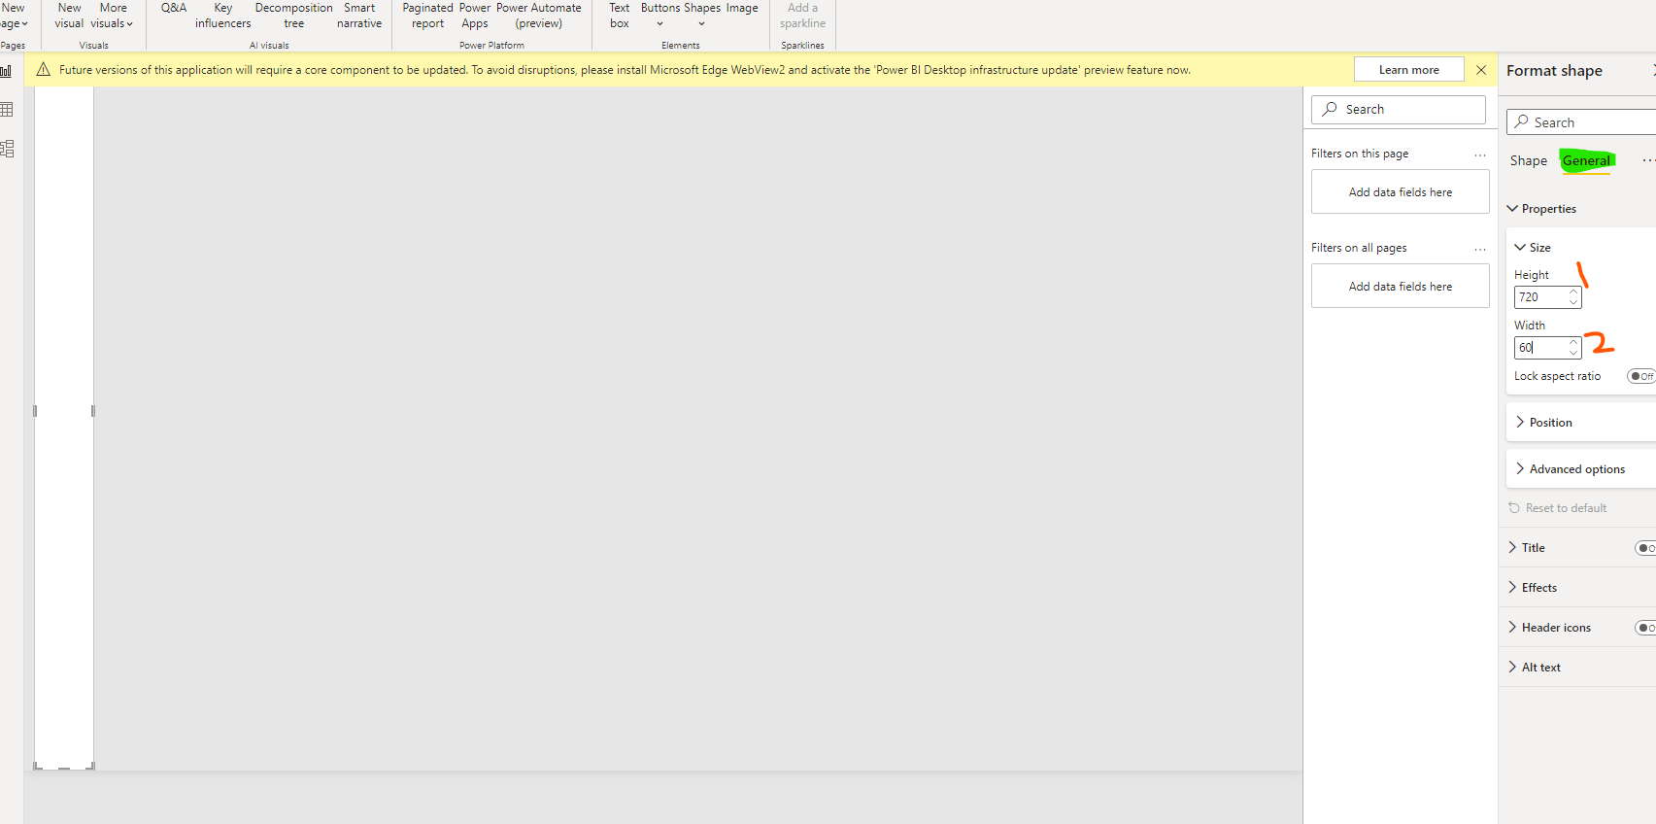

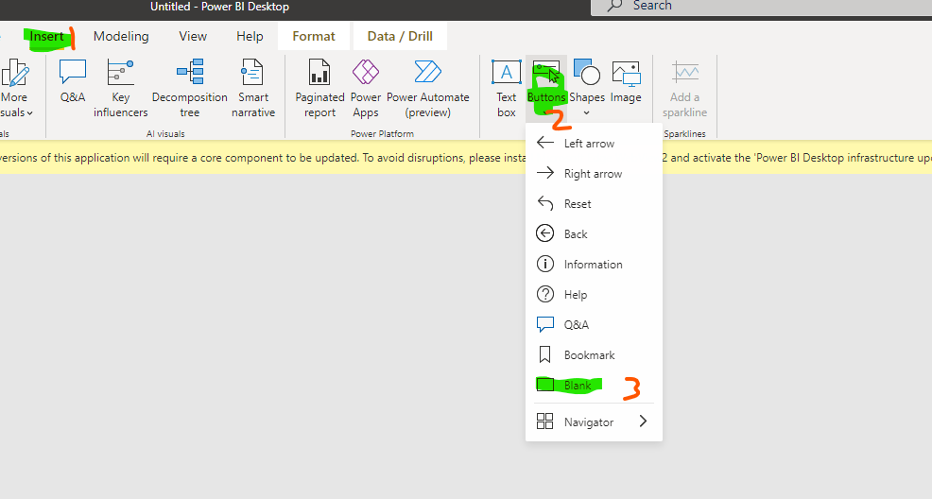

Copy and paste button 11 times

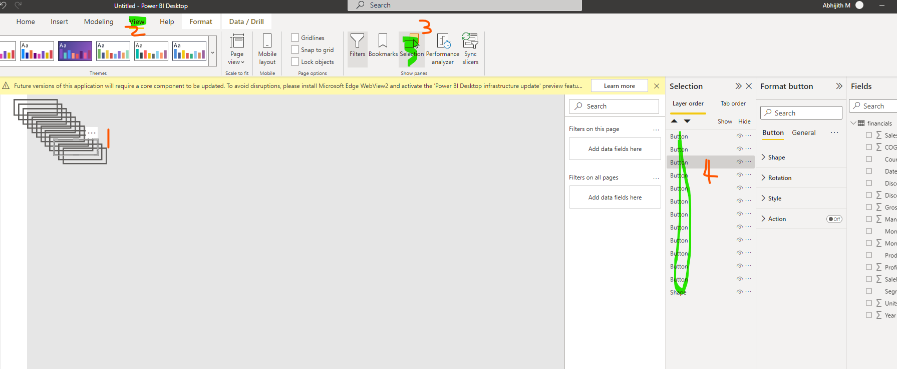

* Select all buttons

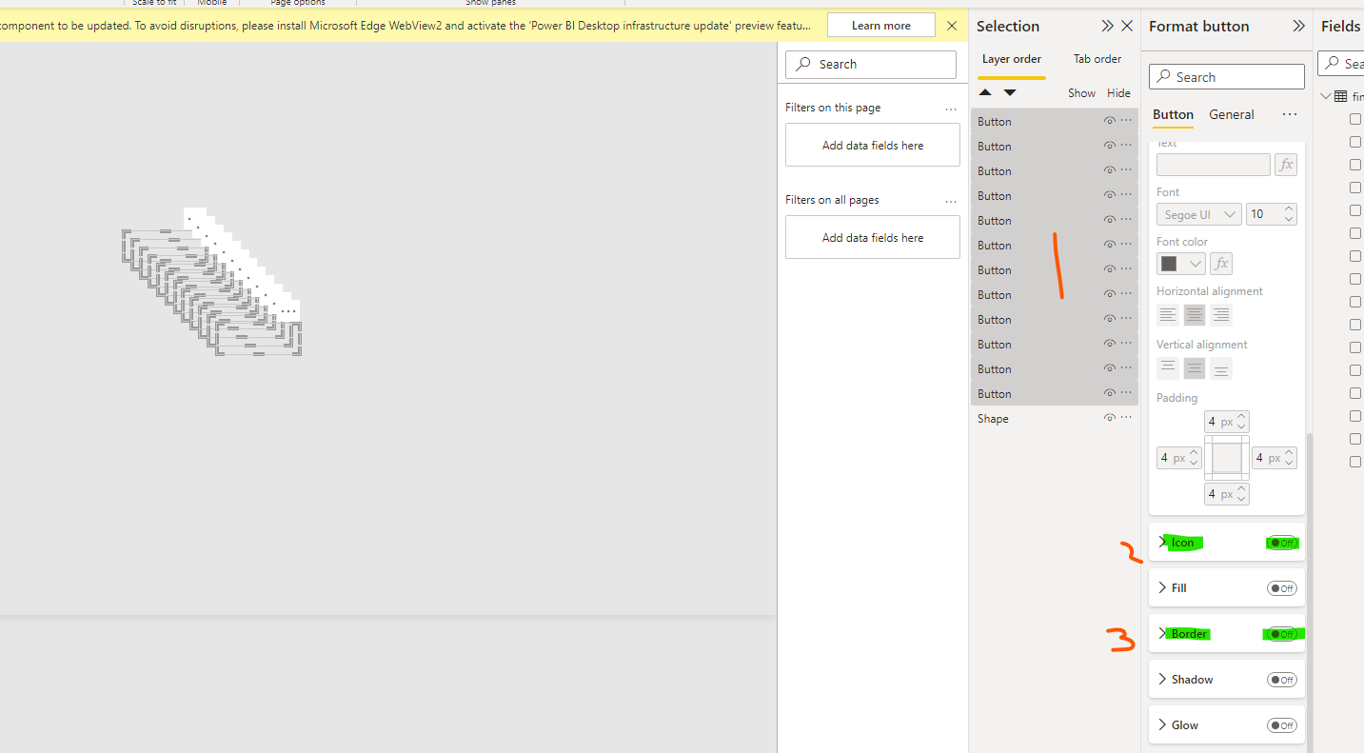

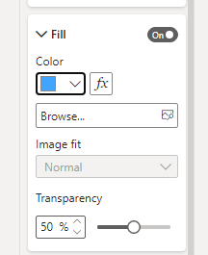

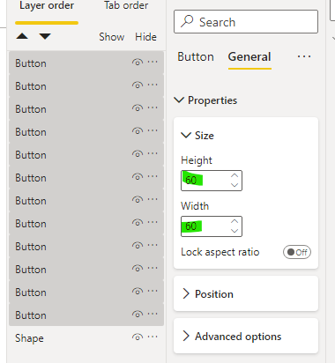

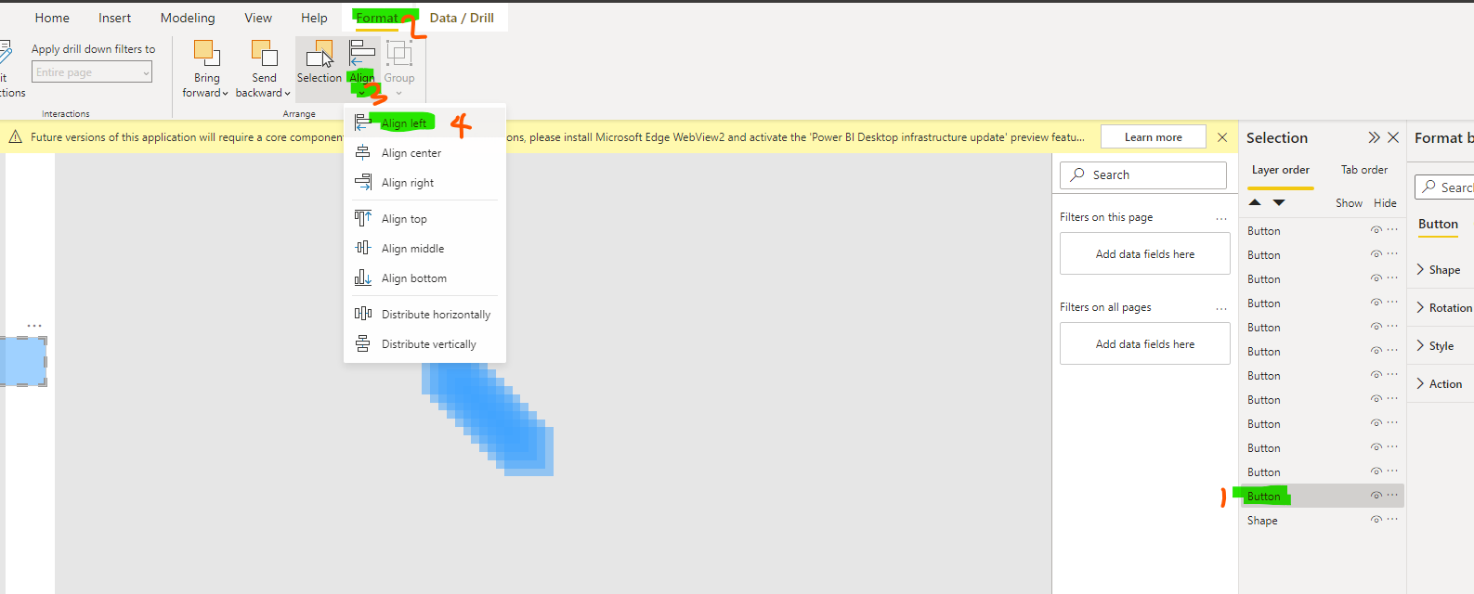

Similarly set align to top

* Select first button -> align (left) -> align (bottom)
* Select all buttons one by one by pressing control key
* Align (left)
* Align -> distribute vertically

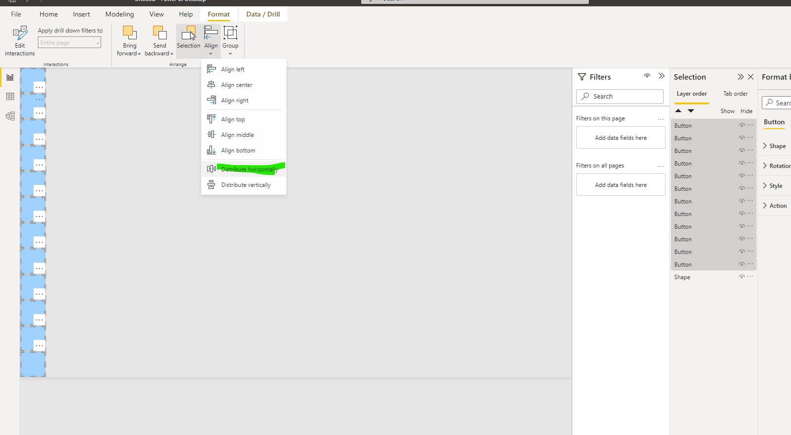

# PowerBi ML with python

## Price prediction

<https://www.youtube.com/watch?v=IP76UJ4nZ70>

# PowerBi – NLP

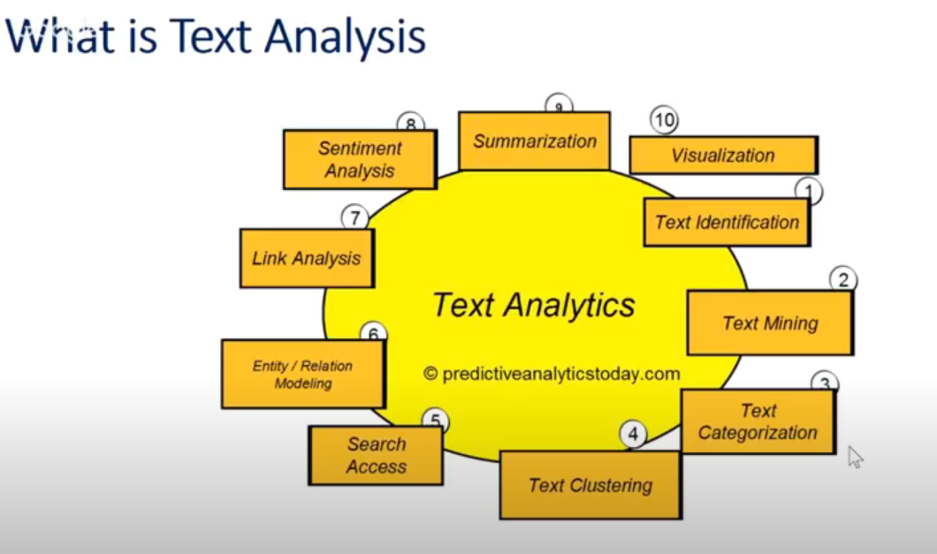

## Word Cloud

Add word cloud on visuals

Stopwords removal

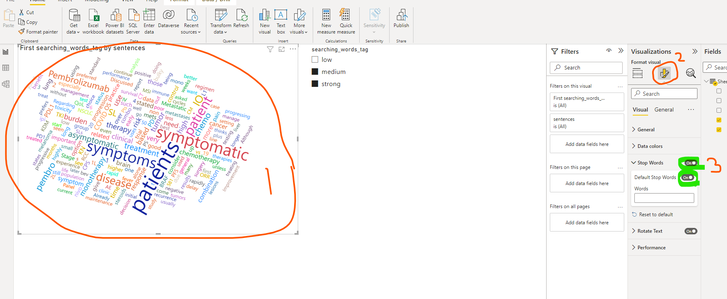

# Reference

## Useful ytb videos

Excel [here](https://docs.google.com/spreadsheets/d/10xQxfEnCQXX1-uZd8TLo78nydaa2IvKZo_9p58F2BxM/edit#gid=0)

All in all powerbi ytb channel 203 [videos](https://www.youtube.com/watch?v=dPrDJ4C3stY&list=PLH6mU1kedUy-kg9J1AtqWT6QpiYzbDs61)