# WXform Builder – python

Forms->Frame

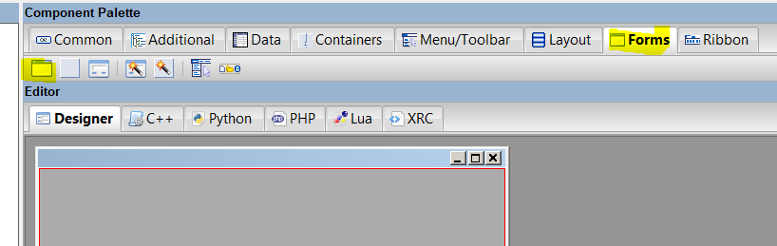

Layout->boxsizer

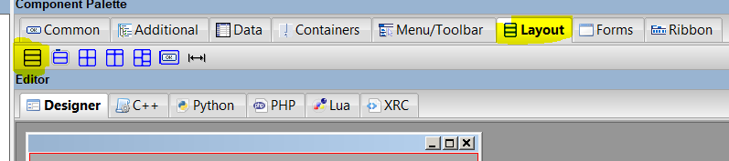

Common – wxStaticText

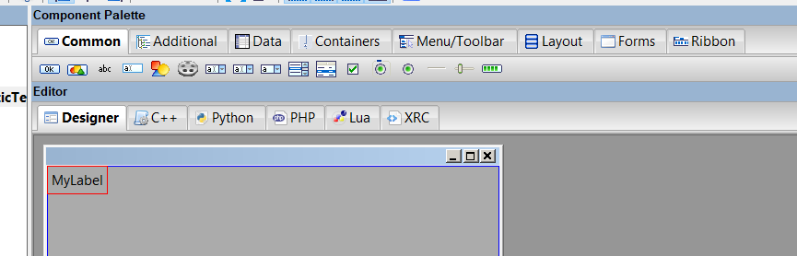

Center – fill

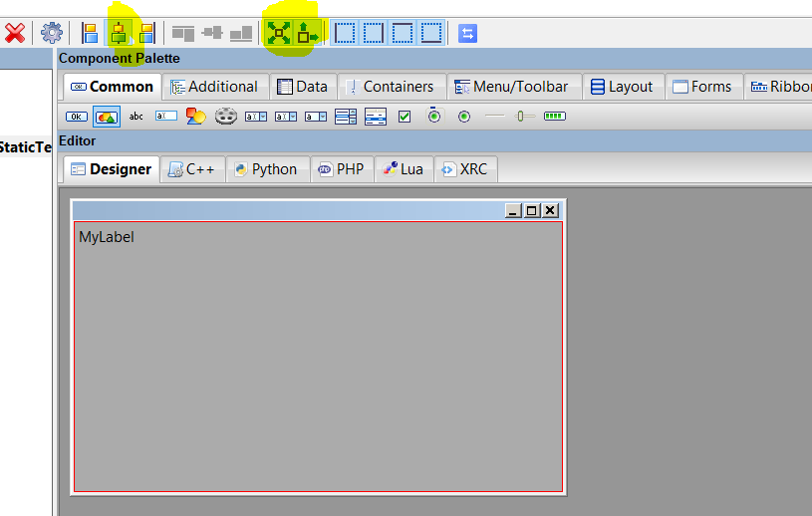

Properties -> label = my test project

Generate code

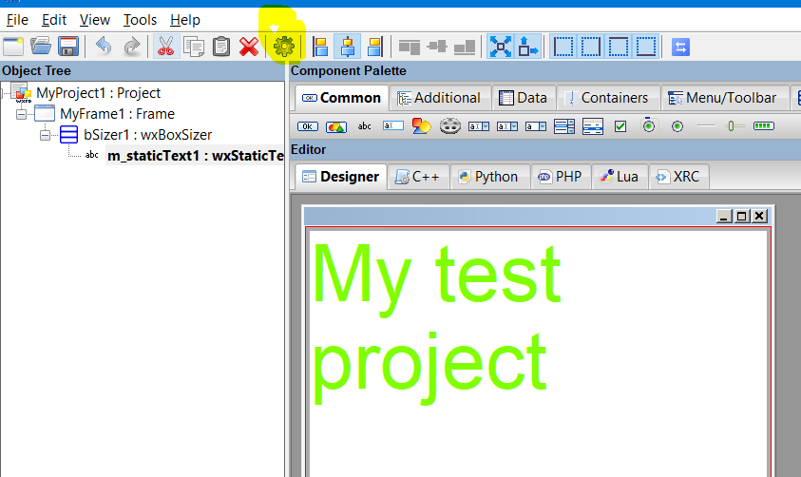

Install wxpython==4.0.7

python 3.6, that was <https://extras.wxpython.org/wxPython4/extras/linux/gtk3/ubuntu-16.04/wxPython-4.0.7.post2-cp36-cp36m-linux_x86_64.whl>

Add this line at the bottom

## Loop window

if __name__ == '__main__':

    app = wx.App(False)

    frame = MyFrame1(parent=None)

    frame.Show()

    app.MainLoop()

Run python