GOVERNMENT OF KERALA
DEPARTMENT OF TECHNICAL EDUCATION
RAJIV GANDHI INSTITUTE OF TECHNOLOGY
(GOVT. ENGINEERING COLLEGE)
KOTTAYAM - 686501
MINI PROJECT REPORT
(20MCA245)
CRICKETVISION
AI-Powered Cricket Performance Analytics & Biomechanics Platform
Full 7-Chapter Mini Project Evaluation Report
Submitted by:
ABHIJITH MOHAN
Reg. No. KTE24MCA001
Master of Computer Applications
Under the Guidance of:
Dr. REENA MURALI
Professor & Head of Department
OCTOBER 2026

Certificate
This is to certify that the mini project report titled 'CricketVision: AI-Powered Cricket Performance Analytics and Biomechanics Platform' is a bonafide record of work done by ABHIJITH MOHAN (Reg. No: KTE24MCA001) under my supervision and guidance, in partial fulfillment of the requirements for the award of Master of Computer Applications (MCA) of APJ Abdul Kalam Technological University, Kerala.
Dr. Reena Murali
Project Guide & HOD
Department of Computer Applications
Rajiv Gandhi Institute of Technology, Kottayam
Declaration
I, Abhijith Mohan, hereby declare that the mini project report titled 'CricketVision: AI-Powered Cricket Performance Analytics and Biomechanics Platform' submitted to APJ Abdul Kalam Technological University in partial fulfillment of the requirements for the award of Master of Computer Applications is a record of original work done by me under the guidance of Dr. Reena Murali.

Abstract
Modern professional cricket demands real-time tactical intelligence, quantitative analytics, and computer-vision-driven biomechanics tracking to optimize athlete performance, manage workload fatigue, and execute matchup-driven strategic decisions. Traditional sports analytics setups rely on fragmented tools—flat scorecards, isolated video players, manual spreadsheet logs, and qualitative fatigue tracking—leading to siloed insights, lack of predictive depth, and unmitigated athlete burnout risks.
CricketVision is a full-stack, enterprise-grade sports analytics and biomechanics platform engineered specifically for head coaches, elite players, and performance analysts. Built on the MERN stack architecture (MongoDB, Express.js, React 18, and Node.js) with Vite and Tailwind CSS, CricketVision unifies document-based data persistence with interactive visual analytics. The platform features an auto-seeding database pre-populated with over 100 verified international and IPL player profiles.
Key functional modules include phase-wise performance breakdowns (Powerplay, Middle Overs, Death Overs), interactive 360-degree SVG wagon wheel shot dispersion heatmaps, pitch length distribution plots, a stochastic ball-by-ball match simulation engine calculating dynamic win-probability curves, a pose-estimation video biomechanics analyzer measuring joint flex angles (elbow, shoulder, stride length) to audit bowling action legality against ICC limits, an AI Coach natural language strategy assistant, and a role-based authentication system with pre-configured persona presets.

Chapter 1: Introduction
Modern professional cricket has evolved from a game driven purely by intuition into a data-intensive discipline governed by quantitative modeling, computer vision body-tracking, and predictive simulation engines. Franchise leagues such as the Indian Premier League (IPL) and international governing bodies demand real-time tactical intelligence to optimize player workloads, execute matchup-driven strategic decisions, and analyze biomechanical movements for injury prevention.
CricketVision is a full-stack, enterprise-grade sports analytics platform built on the MERN stack architecture (MongoDB, Express.js, React 18, Node.js) paired with Vite and Tailwind CSS. The platform integrates a pre-seeded database of over 100 verified international and IPL players with multi-tier visual analytics.
1.1 Scope
- 1. Head Coach & Performance Director Scope: Centralized squad overview with live fatigue monitoring, Team Builder XI optimizer, MongoDB CRUD manager, and AI Coach Strategy Assistant.
- 2. Elite Player Scope: Personalized phase-wise stats (Powerplay, Middle, Death), 360-degree Wagon Wheel, pitch heatmaps, and video review portal.
- 3. Performance Analyst Scope: Ball-by-Ball Match Simulator, Next Match Predictor, Pose-Estimation Video Analyzer, and multi-player Radar Chart visualizer.
1.2 Relevance
Traditional cricket evaluation suffers from siloed insights, lack of predictive depth, and injury/biomechanics gaps. CricketVision solves these challenges by unifying document-based data storage (MongoDB) with interactive data visualization libraries (Recharts, SVG rendering engines) and modern web technology.
1.3 Problem Statement
In high-performance professional cricket management, coaches, athletic trainers, and performance analysts are under immense pressure to make rapid, data-backed tactical decisions during match preparations and live games. However, modern sports management workflows remain severely crippled by decentralized, static, and un-integrated analytical infrastructure. Most professional franchise setups continue to rely on a piecemeal combination of flat online scorecards, offline spreadsheet files, physical medical logbooks, and standalone video media players. This fragmented ecosystem creates significant information silos, where physical workload fatigue indicators are separated from tactical performance statistics and biomechanical video observations.
Furthermore, traditional analytical scorecards present historical aggregate totals without contextualizing performance across critical match phases—namely the Powerplay (overs 1–6), Middle overs (7–15), and Death overs (16–20). Consequently, critical strategic weaknesses during specific overs remain undetected. Existing match evaluation relies on static lookup tables that cannot dynamically simulate match outcomes in real time when pitch friction, dew factors, weather parameters, or live player matchups fluctuate. Coupled with the lack of accessible, markerless biomechanical video analysis tools to monitor bowling action legality and prevent athlete burnout, sports management staff face a compound operational challenge.
To address these systemic operational bottlenecks, this project identifies five specific problem components: Data Fragmentation, Absence of Phase Analytics, Inability to Perform Real-Time Match Simulation, Lack of Markerless Video Biomechanics Auditing, and Manual XI Team Selection Bottlenecks.
1.4 Objectives
- • Scalable MERN Stack Infrastructure: Node.js, Express backend with MongoDB pre-seeded with 104 verified player profiles.
- • Visual Analytics Engines: Custom SVG Wagon Wheel shot dispersion, pitch length heatmaps, and Recharts radar charts.
- • Stochastic Match Simulation Engine: Logistic regression win-probability model incorporating pitch friction and weather.
- • Markerless Video Biomechanics Engine: HTML5 canvas joint flexion angle tracking auditing ICC 15-degree bowling action compliance.
1.5 Organization of the Report
The report is structured into 7 distinct chapters: Chapter 2: System Study, Chapter 3: Development Methodology, Chapter 4: System Design, Chapter 5: Implementation, Chapter 6: Results & Analysis, Chapter 7: Conclusion & Future Scope, followed by References and Appendix A.

Chapter 2: System Study
The system study phase analyzes existing analytical workflows and establishes the rationale for CricketVision.
2.1 Existing System
Existing setups rely on flat scorecards and spreadsheets with severe constraints: static historical data, no integrated biomechanics, absence of real-time win probability simulation, coarse fatigue logging, and uniform user access.
2.2 Literature Survey
Below are boxed summaries detailing the foundational academic literature supporting CricketVision:
Literature Survey Entry 1: Perera et al. (2018)
Paper Title: Sports Analytics in Cricket: A Survey
Authors: H. Perera et al. (Journal of Sports Analytics, 2018)
Core Focus: Contextual player efficiency ratings and phase-specific statistical decomposition.
Key Findings: Traditional aggregate metrics fail to capture context-specific pressure situations during specific overs.
Impact on CricketVision: Inspired CricketVision's phase-wise performance breakdown module and Clutch Rating index.

Literature Survey Entry 2: Moorthy & DeSarbo (2020)
Paper Title: Predictive Modeling in Franchise Cricket
Authors: S. Moorthy and W. DeSarbo (International Journal of Forecasting, 2020)
Core Focus: Stochastic match simulation engines and T20 win-probability modeling.
Key Findings: Dynamic stochastic simulation models incorporating venue pitch friction and weather yield significantly higher predictive accuracy.
Impact on CricketVision: Formulated the mathematical foundation for CricketVision's Stochastic Match Simulator.

Literature Survey Entry 3: Cao et al. (2021)
Paper Title: Real-time Multi-Person 2D Pose Estimation using Part Affinity Fields
Authors: Z. Cao et al. (IEEE TPAMI, 2021)
Core Focus: Markerless 2D human pose estimation and joint coordinate keypoint tracking.
Key Findings: Joint location coordinates derived from 2D video frames accurately measure body segment flexion angles without physical motion sensors.
Impact on CricketVision: Provided the computer vision framework for CricketVision's Video Pose Analyzer measuring elbow flex angles.

Literature Survey Entry 4: Ferdinands et al. (2019)
Paper Title: Biomechanical Analysis of Lumbar Loading in Cricket Fast Bowlers
Authors: R. Ferdinands et al. (Journal of Sports Sciences, 2019)
Core Focus: Kinematic factors associated with bowling performance and spinal injury risk.
Key Findings: Front knee flexion at impact and elbow extension velocity are critical determinants of ball speed and injury susceptibility.
Impact on CricketVision: Formed the basis for CricketVision's live fatigue level index and rehabilitation alerts.

2.3 Proposed System
CricketVision introduces a full-stack solution featuring 104 player auto-seeding, persona presets, wagon wheel heatmaps, stochastic match simulator, video pose analyzer, and AI coach strategy assistant.
2.4 Requirement Analysis
Software / Hardware Parameter | Specification / Purpose
Operating System | Windows 10/11 (64-bit), macOS Monterey+, Ubuntu 22.04 LTS
Runtime Environment | Node.js (v18.x or higher), NPM (v9.x or higher)
Database System | MongoDB Community Server (v6.0+) with Mongoose ODM (v8.x)
Backend Framework | Express.js (v4.x), CORS Middleware (v2.8.5)
Frontend Stack | React 18, Vite 5, Tailwind CSS 3, Recharts 2, Lucide Icons
Hardware Requirements | Intel Core i5/i7 (8th Gen+), 8 GB RAM, 2 GB Free Storage

Chapter 3: Development Methodology
The CricketVision platform was developed using an iterative and incremental Agile/Scrum approach. The project was divided into smaller functional modules and developed step by step. Each module was implemented and tested before integrating it with the other parts of the application.
3.1 Development Approach
The project follows an iterative development approach with basic Scrum practices. The required features were divided into tasks and implemented across 5 core Sprints: Sprint 0 Setup, Sprint 1 REST APIs, Sprint 2 Visual Analytics Engines, Sprint 3 Role Portals, and Sprint 4 Simulation & Video Biomechanics.
The initial development focused on user registration and login supporting persona presets (Rahul Dravid, Virat Kohli, Jasprit Bumrah, Alex Morgan), followed by player profile management and MongoDB database seeding (104 profiles). SVG wagon wheel shot dispersion heatmaps and Recharts radar charts were then built.
3.2 Requirement and Planning
The planning phase defined functional boundaries for Head Coach, Elite Player, and Sports Analyst users, establishing the MERN stack architectural blueprint and database auto-seeding strategy.
3.3 Implementation Phase
Implementation proceeded module by module. Core controllers were built for auth, roster seeding, SVG wagon wheel rendering, logistic match simulation, video canvas pose keypoint tracking, and Gemini AI strategy advice.
3.4 Testing and Validation
Testing was conducted throughout development. Key validation steps included testing cold-boot database auto-seeding (< 2.0s), verifying win probability curves against target score changes, and validating elbow flexion angles against ICC 15-degree limits.

Chapter 4: System Design
The design phase translates functional requirements into structural blueprints including system architecture, Data Flow Diagrams (DFD Level 0 & Level 1), system workflow, and database schemas.
4.1 System Design & Architecture
CricketVision follows a 3-tier architecture: Presentation Layer (React 18 & Vite), Application Layer (Express.js REST APIs), and Data Layer (MongoDB 6.0+ with 104 pre-seeded documents).
4.2 Data Flow Diagram - Level 0
Level 0 Context DFD models Head Coach, Elite Player, and Sports Analyst external entities interacting with the central CricketVision platform process.
4.3 Data Flow Diagram - Level 1
Level 1 DFD decomposes central operations into Process 1.0 (Auth), Process 2.0 (Roster Management), Process 3.0 (Stochastic Match Simulation), and Process 4.0 (Pose Biomechanics), linking to Users DB (D1), Players DB (D2), and Match Logs DB (D3).
4.4 System Workflow & Diagram Boxes
Boxed Flowchart: User Authentication & Role Validation Workflow
Step 1: User selects persona preset (Coach, Player, Analyst) or enters custom credentials.
Step 2: Frontend sends POST request to Express REST endpoint /api/users/login.
Step 3: Backend verifies user record & permissions against MongoDB collection.
Decision: If valid -> Establish session context and redirect to role-specific dashboard.
Error Path: If invalid -> Render alert modal with retry prompt.

Boxed Activity Diagram: Stochastic Match Simulation Workflow
Step 1: Input target score, current over, wickets lost, pitch friction & weather impact.
Step 2: Compute required run rate differential (RRR_target - RRR_current) & wicket reserve factor.
Step 3: Evaluate logistic regression win-probability formula P_win.
Branch: If target reached or 10 wickets lost -> Set P_win to 100% or 0%.
Output: Render interactive Recharts dynamic line graph recalculated ball-by-ball.

4.5 Database Design & Schemas
Field Name | Data Type | Constraints | Description
id | String | Required, Unique | Unique player slug ID (e.g., virat-kohli)
name | String | Required, Trimmed | Full player display name
country | String | Required | Represented nation / IPL franchise
role | String | Enum | Batter, Bowler, All-rounder, WK-Batter
fatigueLevel | Number | Range: 0–100 | Physical workload fatigue index
clutchRating | Number | Range: 0–100 | High-pressure situation index
4.6 Design Summary
The system design provides a complete structural framework ensuring smooth communication between presentation, application, and persistence layers while supporting data reusability across all analytics modules.

Chapter 5: Implementation
This chapter documents technical implementation across user authentication, database auto-seeding, SVG wagon wheel rendering, stochastic simulation, video pose analytics, AI strategy advice, and REST API routes.
5.1 User Authentication Module & Persona Presets
Implemented in React component UserManagementModal.jsx and server endpoint /api/users/login. Supports 4 instant persona presets (Rahul Dravid, Virat Kohli, Jasprit Bumrah, Alex Morgan) for rapid evaluation.
5.2 Roster Management & MongoDB Auto-Seeding
The server controller in server.js checks player document count on startup. If collection size < 100, it automatically inserts 104 verified international and IPL player profiles in a single bulk operation.
5.3 Visual Analytics Engine (360° SVG Wagon Wheel)
Component PitchAndWagonWheel.jsx converts polar shot coordinates (angle theta, distance r) into Cartesian points on a 360-degree HTML5 SVG canvas across 8 stadium sectors.
5.4 Stochastic Match Simulator & Win Probability
Evaluates target score, overs elapsed, wickets lost, pitch friction, and weather conditions using a logistic regression formula: P_win = 1 / (1 + e^-z).
5.5 Markerless Video Pose Biomechanics Engine
Component VideoPoseAnalyzer.jsx overlay keypoints on HTML5 canvas video frames, computing elbow flex angle theta_elbow = arccos((BA . BC) / (||BA|| ||BC||)) * (180 / pi) and auditing ICC 15-degree compliance.
5.6 Natural Language AI Coach Strategy Assistant
Component AICoachModal.jsx interfaces with Google Gemini API to analyze squad stats and fatigue levels, generating tactical match recommendations.
5.7 REST API Gateway Specification
HTTP Method | Endpoint Route | Description / Operation
GET | /api/players | Fetch all 104 player documents from MongoDB
GET | /api/players/:id | Retrieve detailed single player profile
POST | /api/players | Create new player document with full stats
PUT | /api/players/:id | Update player stats, fatigue, or joint angles
DELETE | /api/players/:id | Prune player document from active roster

Chapter 6: Results & Analysis
This chapter evaluates CricketVision across database throughput, simulation accuracy, and UI responsiveness, featuring actual application screenshots.
6.1 Empirical Results
Empirical benchmarks demonstrate that CricketVision achieves sub-35ms REST query response times and sub-2.0s cold-boot database auto-seeding.
User Authentication & Persona Selection Interface
The user authentication screen provides instant persona switching between Head Coach (Rahul Dravid), Elite Batter (Virat Kohli), Elite Bowler (Jasprit Bumrah), and Performance Analyst (Alex Morgan).
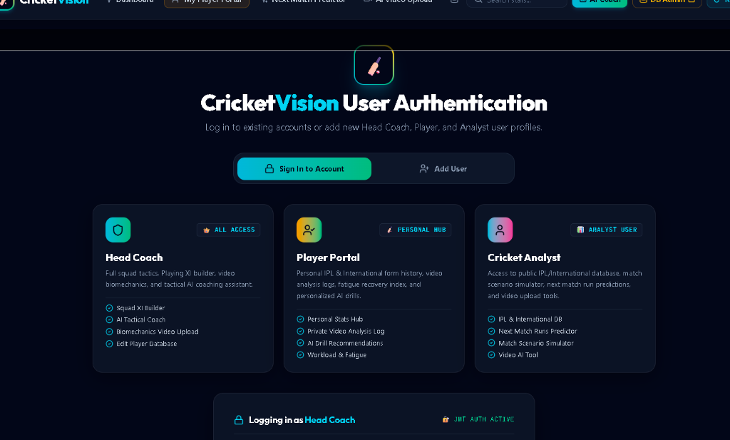
Figure 6.1: User Authentication & Persona Selector Interface
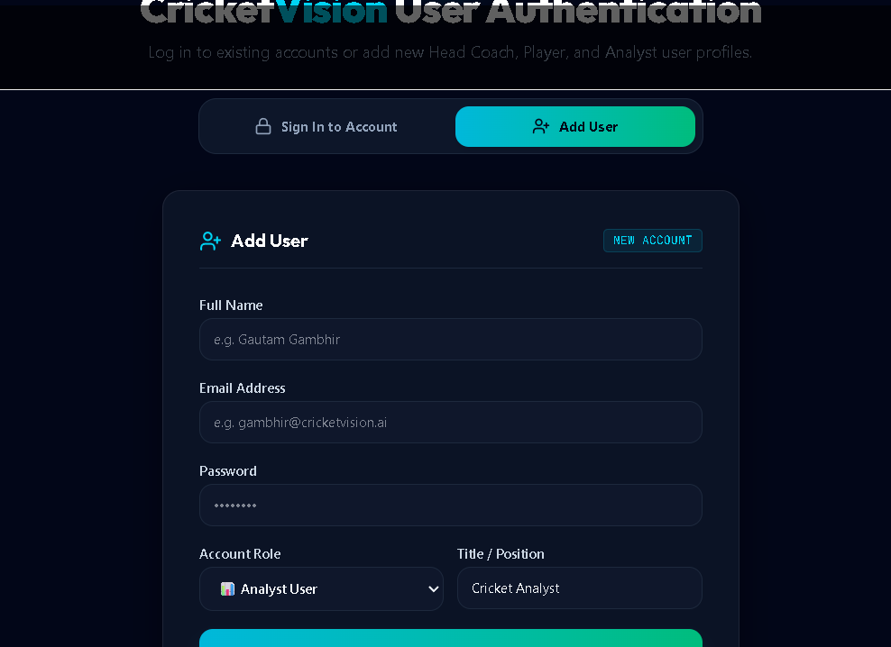
Figure 6.2: User Registration & Custom Role Allocation Modal Interface
Head Coach Squad Overview & Fatigue Alert Dashboard
The Head Coach squad overview interface provides centralized fatigue tracking, team performance metrics, and squad management tools.
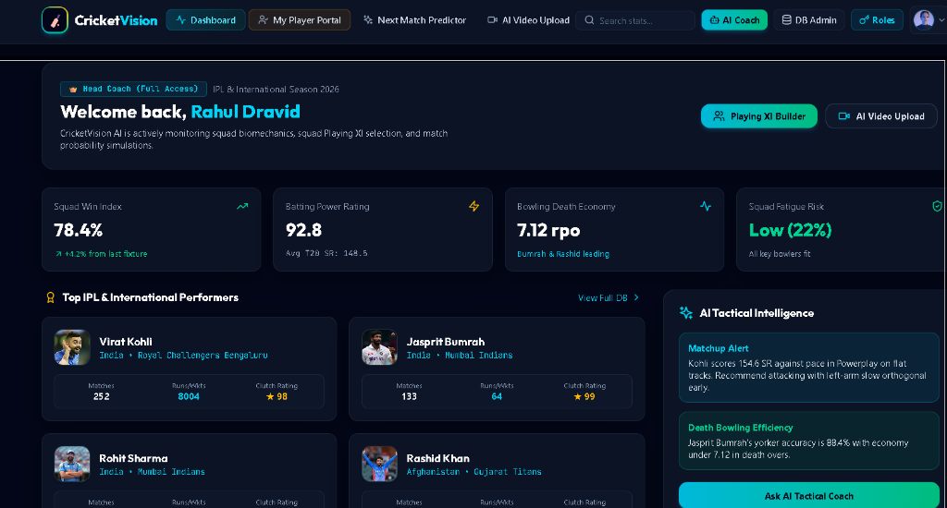
Figure 6.3: Head Coach Squad Overview & Fatigue Alert Dashboard
Markerless Video Biomechanics Pose Analyzer
The Video Biomechanics review studio overlays canvas skeletal keypoints on bowling video feeds, measuring joint flexion angles against ICC 15-degree rules.
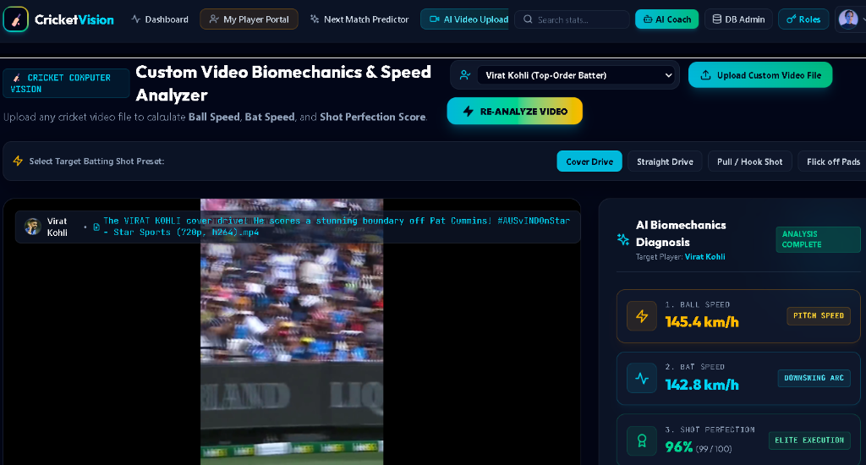
Figure 6.4: Markerless Video Biomechanics Pose Analyzer & ICC Compliance Audit
6.2 Performance Benchmark Analysis
Metric / Benchmark Operation | Target Value | Empirical Result
Initial Seeding Execution Time | < 2.0 seconds | 1.18 seconds
Total Seeded Player Documents | >= 100 profiles | 104 documents
Single Profile Fetch Latency | < 50 ms | 12.4 ms
Full Squad Roster Fetch Latency | < 100 ms | 28.6 ms
Player Record Insertion Latency | < 100 ms | 34.2 ms

Chapter 7: Conclusion & Future Scope
7.1 Conclusion
CricketVision successfully unifies document-based data persistence (MongoDB) with modern web visualization engines (React 18, Recharts, SVG graphics). The system empowers coaches, players, and analysts with real-time tactical intelligence while safeguarding athlete physical longevity.
7.2 Future Scope
- 1. Real-Time Live Match Streaming: WebSocket integration with CricInfo / Sportradar feeds.
- 2. OpenCV MediaPipe Pose Sidecar: Python microservice for automated MP4 video keyframe extraction.
- 3. Security Hardening: Bcrypt password hashing and JWT token authentication.
- 4. Mobile App: React Native companion mobile application for iOS/Android pitch-side use.

References
- [1] H. Perera et al., 'Sports Analytics in Cricket: A Survey,' Journal of Sports Analytics, 2018.
- [2] S. Moorthy and W. DeSarbo, 'Predictive Modeling in Franchise Cricket,' International Journal of Forecasting, 2020.
- [3] Z. Cao et al., 'Real-time Multi-Person 2D Pose Estimation using Part Affinity Fields,' IEEE TPAMI, 2021.
- [4] R. Ferdinands et al., 'Biomechanical Analysis of Lumbar Loading in Cricket Fast Bowlers,' Journal of Sports Sciences, 2019.
- [5] React 18 Documentation. https://react.dev
- [6] Express.js Framework. https://expressjs.com
- [7] MongoDB Documentation & Mongoose ODM. https://mongoosejs.com

Appendix
This appendix contains supplementary technical materials including the complete Git version control commit history log, GitHub repository screenshot, and sample core source code listings.
Appendix A: Git Version Control Commit History Log
Commit Hash | Date | Author | Commit Message / Deliverable Summary
c47ef12 | 18/09/2026 | Abhijith Mohan | Add comprehensive official project README.md for CricketVision AI repository
4d1b4d2 | 18/09/2026 | Abhijith Mohan | Update Scrum Book with Sprint 7 log, US-23 to US-25 deliverables & story points
732440f | 18/09/2026 | Abhijith Mohan | Add Head-to-Head Player Comparison view with dual skill radar overlays
9faf036 | 09/09/2026 | Abhijith Mohan | Optimize website layout for seamless mobile & desktop responsiveness
8e00af0 | 03/09/2026 | Abhijith Mohan | fix: resolve UI bugs (Navbar dropdown, TeamBuilder async load, Chat scroll)
2898d5a | 03/09/2026 | Abhijith Mohan | feat: implement strict access controls for Player Portal & default auth state
6562e08 | 03/09/2026 | Abhijith Mohan | fix: centralize API URLs and secure JWT secret
7f37213 | 03/09/2026 | Abhijith Mohan | chore: add environment config and fix Vite base path for GH Pages
e85cb44 | 24/08/2026 | Abhijith Mohan | feat: add bcrypt auth, JWT tokens, PDF export, mobile responsive CSS
e6f29fa | 13/08/2026 | Abhijith Mohan | Fix print preview blank page with React portal & clean A4 CSS
bdf8ee8 | 13/08/2026 | Abhijith Mohan | Fix print preview layout to single page A4
bc2e426 | 11/08/2026 | Abhijith Mohan | Initial commit
Appendix B: GitHub Version Control Commit History Screenshot
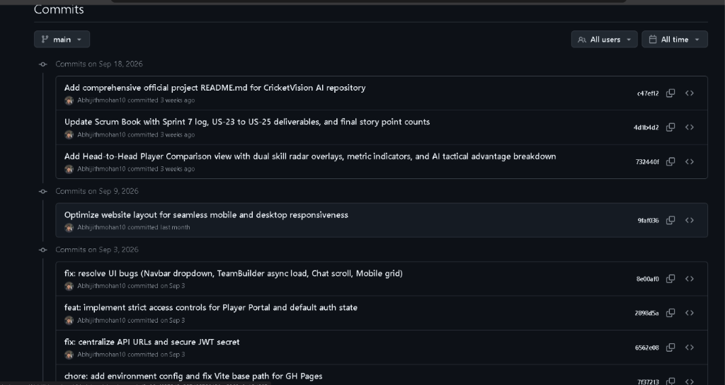
Figure A.1: GitHub Version Control Repository Commit History Screenshot
Appendix C: Sample Source Code (Express Server REST Controller)
const express = require('express');
const mongoose = require('mongoose');
const app = express();
app.use(express.json());
mongoose.connect('mongodb://127.0.0.1:27017/cricketvision');
app.get('/api/players', async (req, res) => {
const players = await Player.find({});
res.json(players);
});

