Agent Anatomy

Lets first start with the Agent runtime and we define each module/agent to explain what it is actually performing.

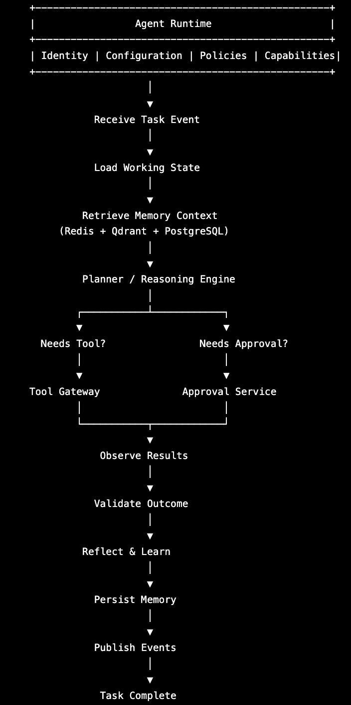

As we have already defined what agents we are implementing, here we will be mainly focusing on what the agents actually do individually. Lets first start by defining what an Agent is
Agent: An Agent is a long-lived, stateful software component capable of reasoning, planning, communication, executing tools, learning from outcomes, and collaborating with other agents to accomplish a bounded business responsibility.

Interface:
Now we define what states every agent basically implements.
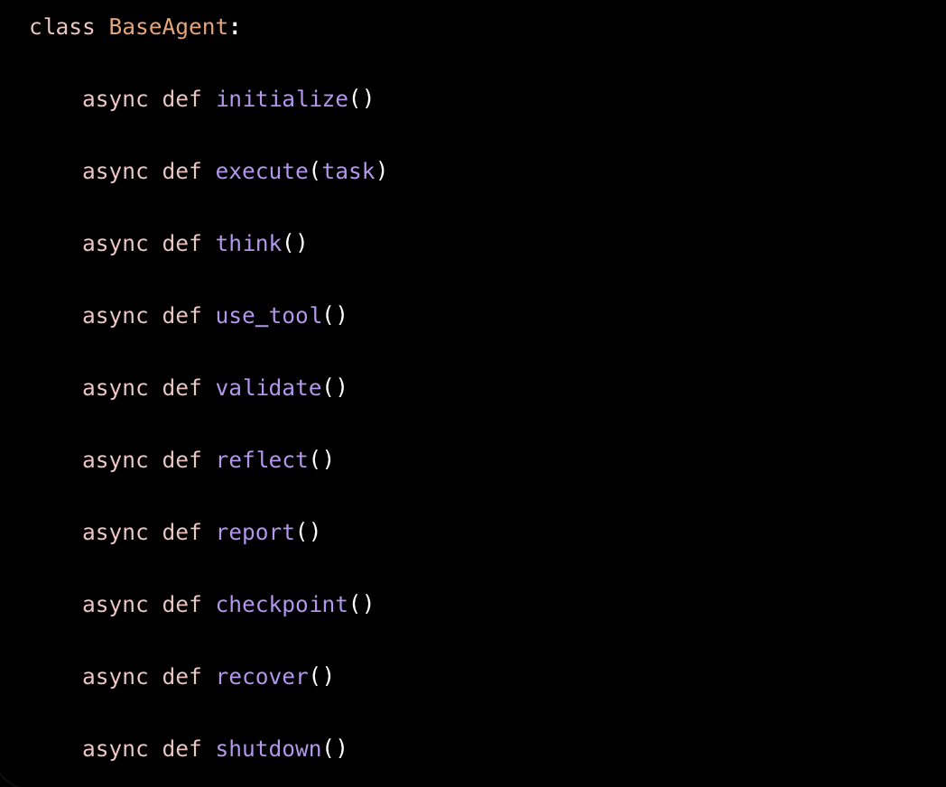
General Agent Lifecycle:
This is the basic agent lifecycle.
Receive Task
↓
Load Context
↓
Retrieve Memory
↓
Understand Objective
↓
Create Plan
↓
Need a Tool?
↓
Execute Tool
↓
Observe Results
↓
Validate
↓
Need More Work?
↓
Repeat
↓
Reflect
↓
Save Memory
↓
Report
↓
Complete
Agent Memory:
Agent’s memory is very short lived and basically is saved in Redis database.

