KLE Society's

KLE Technological University



**Open Ended (OE) Assessment Report**

**On**

**Zomato Application**

**Object Oriented Programming (20ECSC204)  
Object Oriented Programming Lab (20ECSP203)**

Submitted by

| **Name** | **Roll no** | **SRN** |
| --- | --- | --- |
| Sinchan A Karogal | 112 | 01fe21bcs078 |
| Abhijna R Kalbhag | 119 | 01fe21bcs107 |
| **Team Number: 03** | | |

Faculty In-charge:

Prof. Manjunath Gonal

SCHOOL OF COMPUTER SCIENCE & ENGINEERING

Academic year 2022-23

| **1.** | **Introduction** | |
| --- | --- | --- |
|  | 1.1 | Overview of the problem statement |
|  | 1.2 | Features of Application |
| **2.** | **Design** | |
|  | 2.1 | Class Diagrams |
| **3.** | **Implementation** | |
|  | 4.1 | Results |

| **1.** | **Introduction** |
| --- | --- |

* 1. **Overview**

The Problem statement showcases a simplified implementation of a food ordering and delivery application, drawing inspiration from well-known food delivery platforms like Zomato. This application aims to offer users a seamless and user-friendly experience for ordering their favorite dishes from different restaurants and having them delivered to their doorstep. By employing a structured design and utilizing various classes and data structures, the application efficiently manages user interactions, restaurant details, orders, and reviews.

* 1. **Features Of Application**

1. User Authentication and Details:

* The application starts by prompting users to log in, requiring them to input their username, password, and email ID.
* Once logged in, users can access the application's features.
* User details, such as name, age, phone number, and address, can be entered and displayed, providing a personalized experience.

1. Restaurant Selection and Menu Display:

* After logging in, the application presents users with a list of available restaurants to choose from.
* Each restaurant's name and location are displayed, making it easy for users to identify their preferred option.
* Upon selecting a restaurant, the application shows the menu with various food items and their corresponding prices.

1. Ordering Food:

* Users can interact with the menu and select their desired food items.
* For each selected item, users can specify the quantity they wish to order, accommodating their preferences.

1. Viewing Order Details:

* The application provides a comprehensive view of the current order before confirmation.
* Users can review the selected restaurant, the list of ordered items, and the total cost of their order.

1. Confirming Orders:

* After reviewing the order details, users have the option to confirm the order and proceed with the placement.
* This step ensures that users have a final chance to validate their choices before completing the order.

1. Payment Processing:

* The application facilitates payments for the placed orders, offering various modes of payment (e.g., cash or card).
* Upon payment confirmation, a detailed bill is generated, showing the total amount, applicable tax, and individual item-wise costs.

1. Assigning Delivery Person:

* To ensure timely delivery, the application maintains a pool of predefined delivery persons.
* Once an order is confirmed, the application automatically assigns a delivery person to fulfill the delivery.
* Users are informed about the delivery person's details for transparency and tracking purposes.

1. Providing Restaurant Reviews:

* Users can express their satisfaction by rating and adding comments/reviews for the restaurant they ordered from.
* These reviews contribute to the overall feedback and reputation of the respective restaurants, helping other users make informed decisions.

**3. Design**

**3.1 Output**

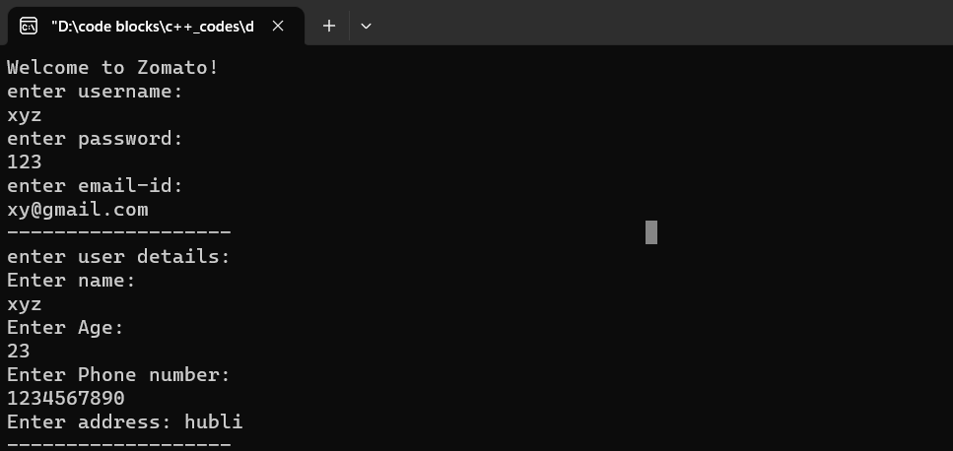

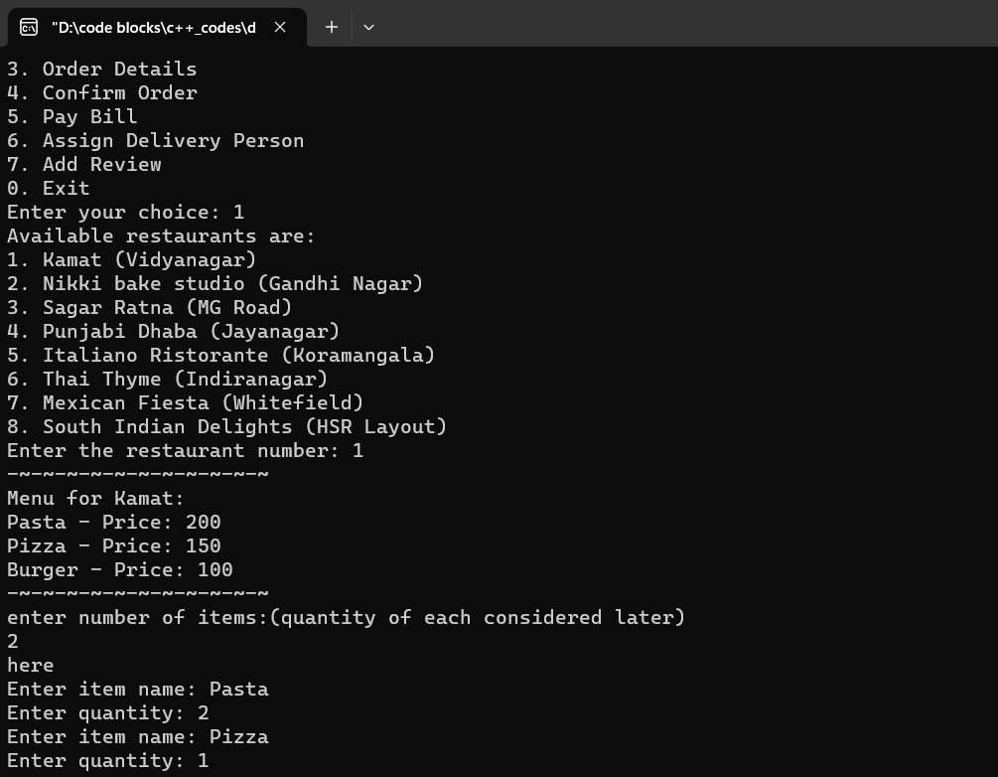

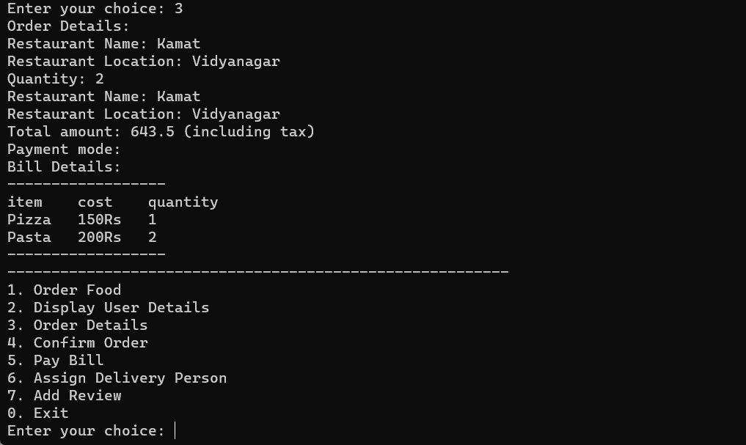

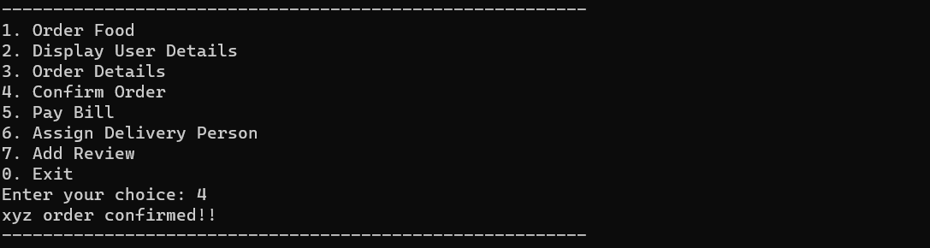

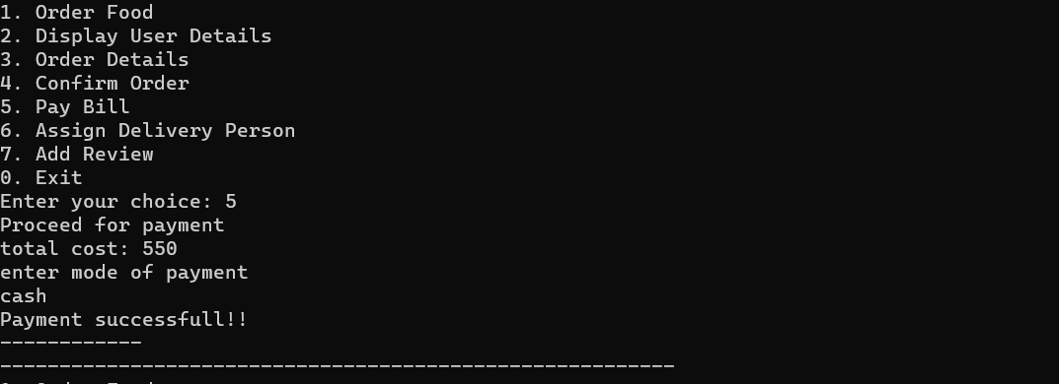

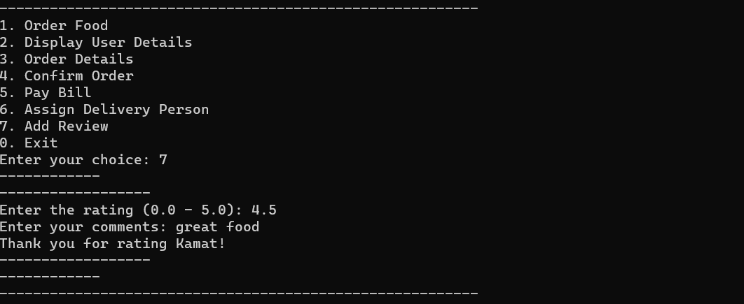

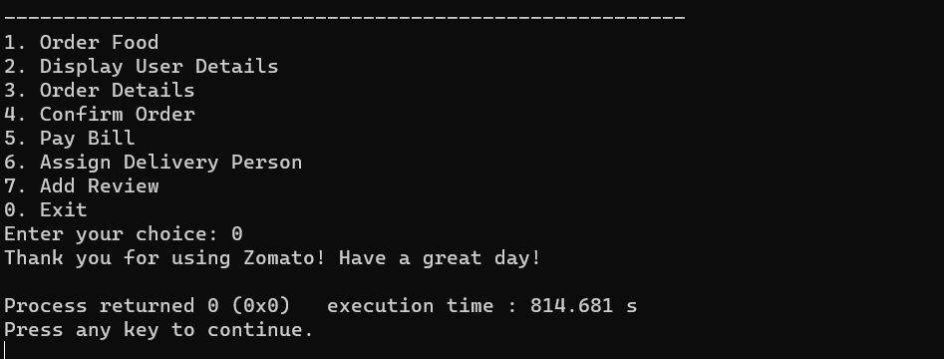

**3. Implementation**

**2.1 Class Diagrams**

