Graphs

Bubble Sort:
Size vs Number of Comparisons:
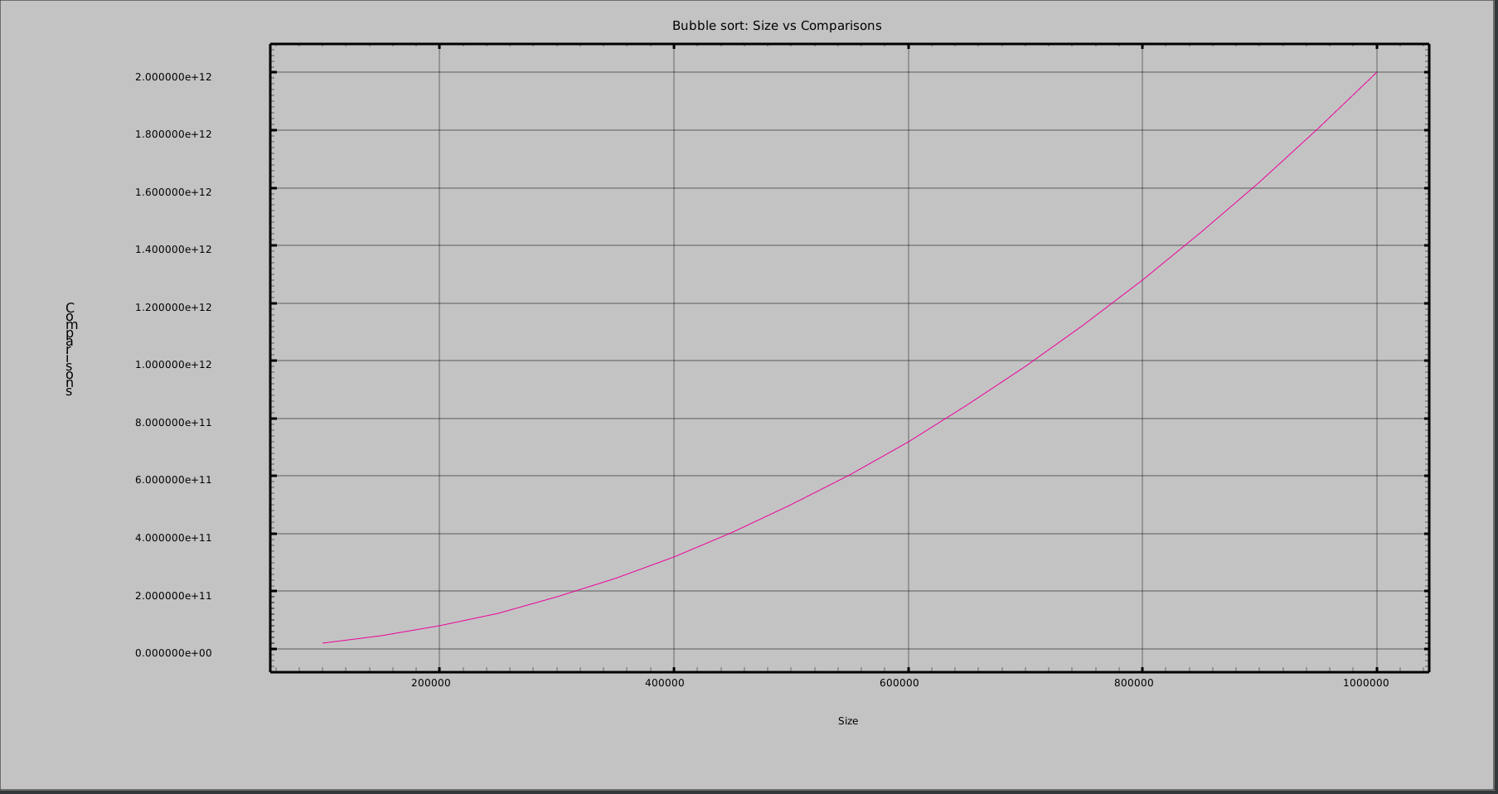
Size vs Time in minutes:

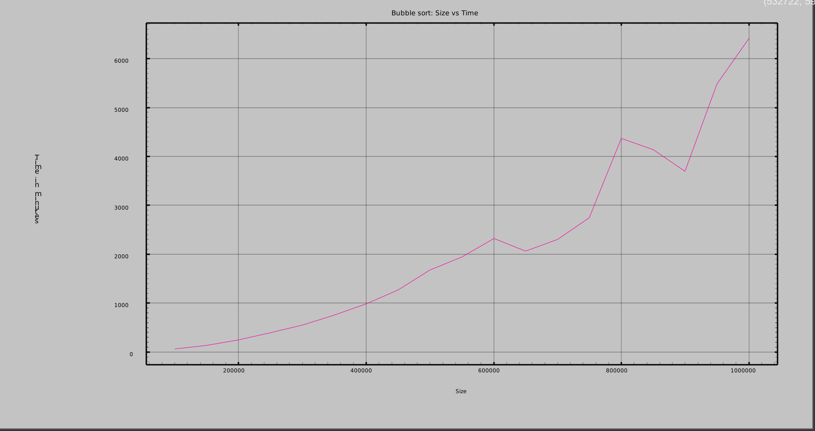

Selection Sort:
Size vs Number of Comparisons:
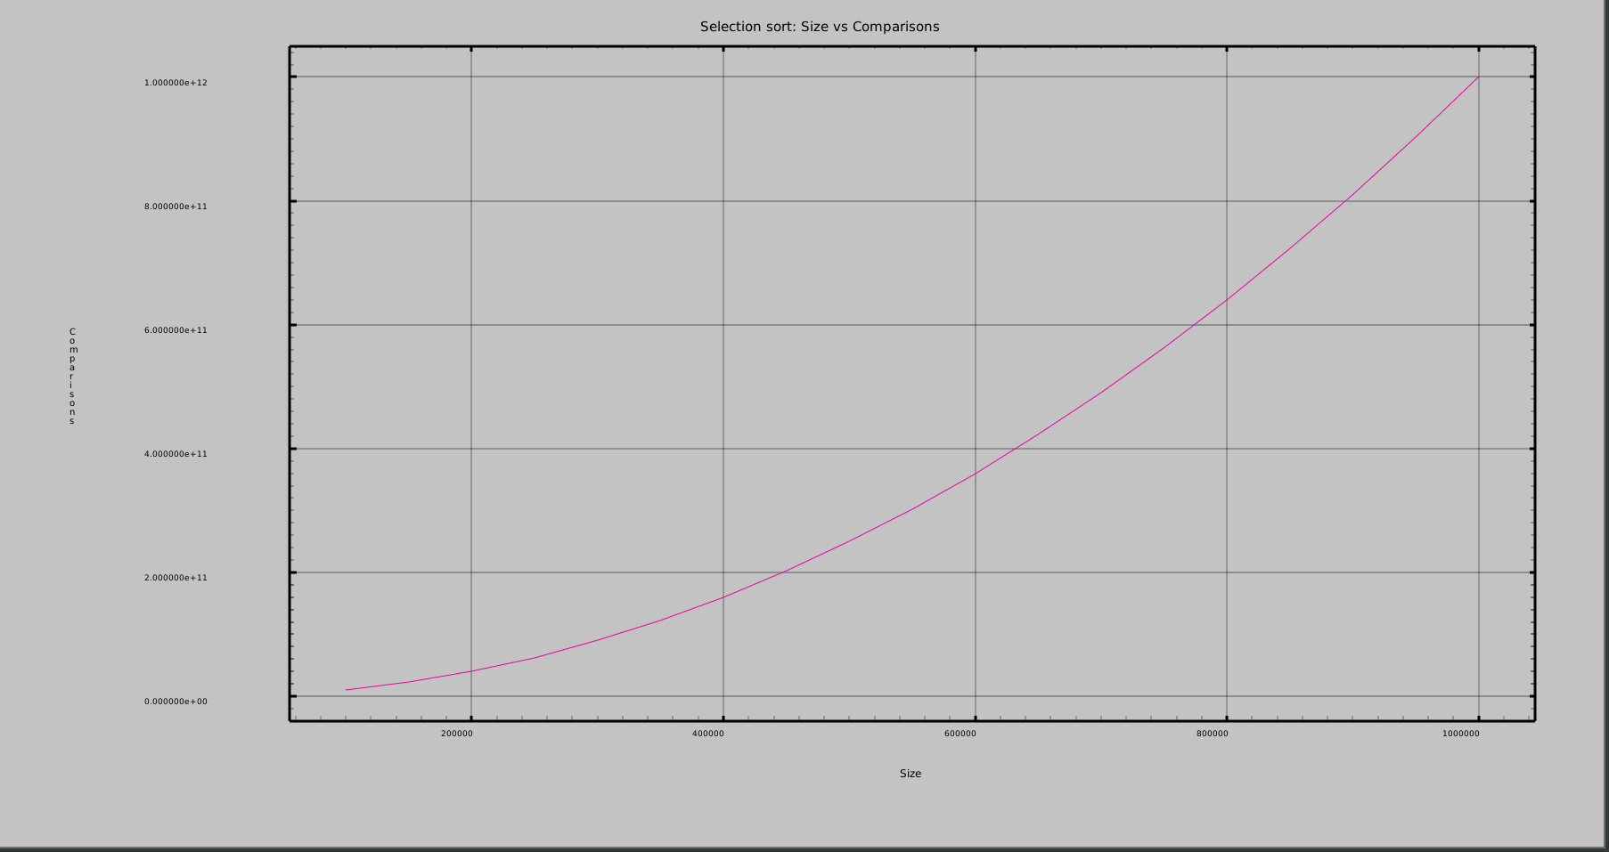
Size vs Time in minutes:

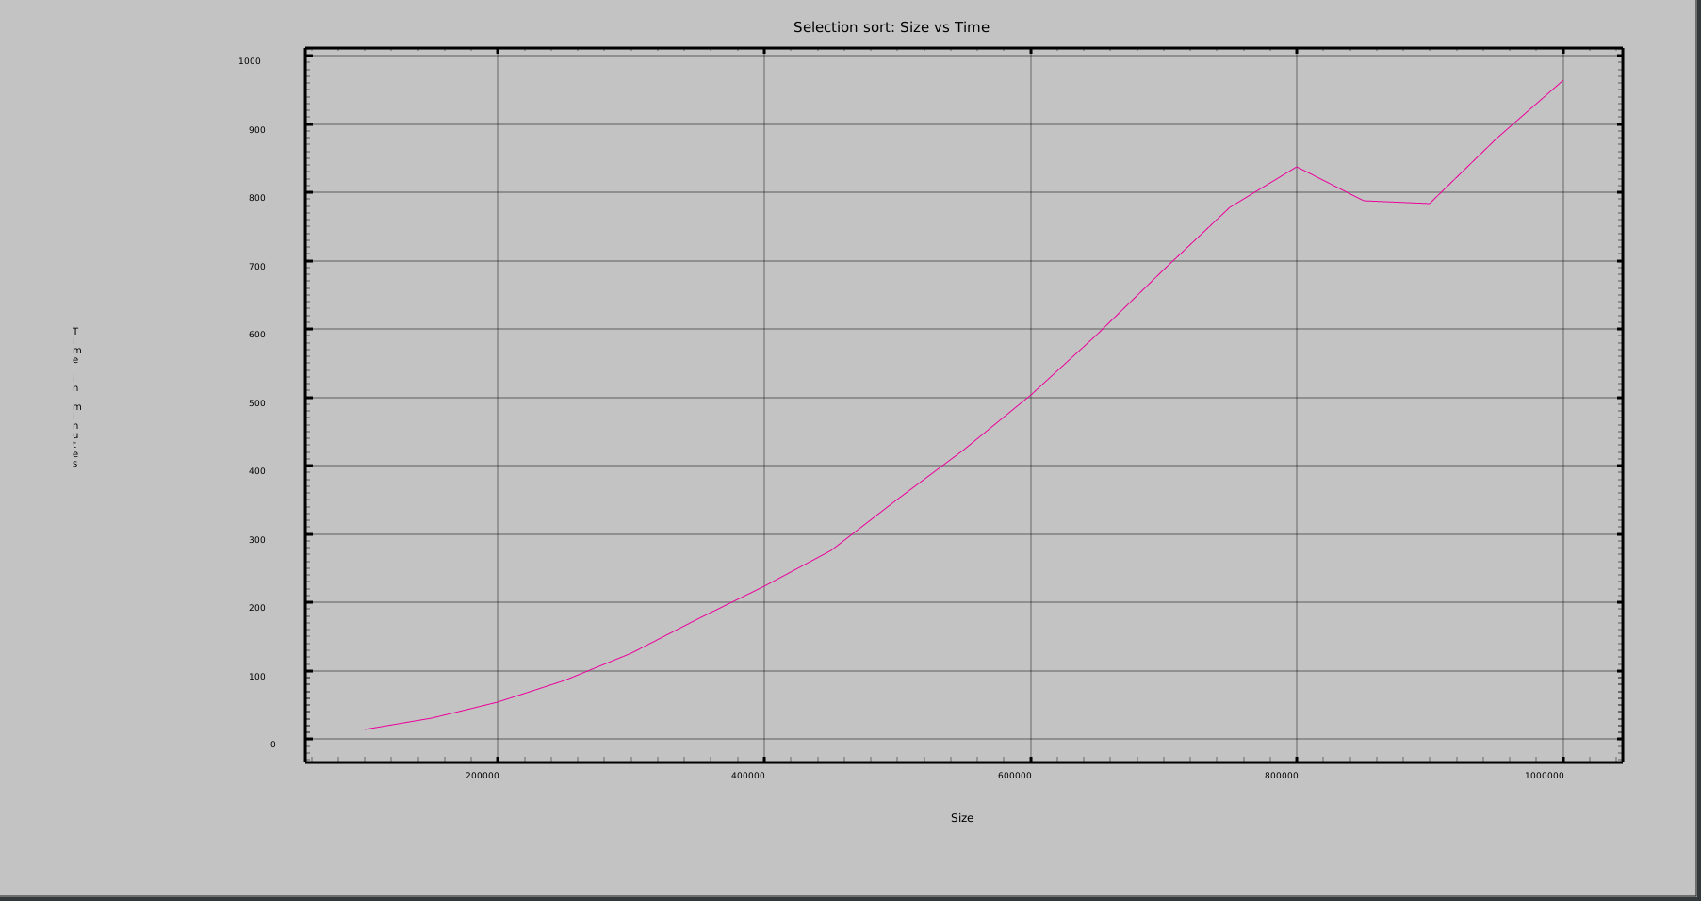

Merge Sort:
Size vs Number of Comparisons:
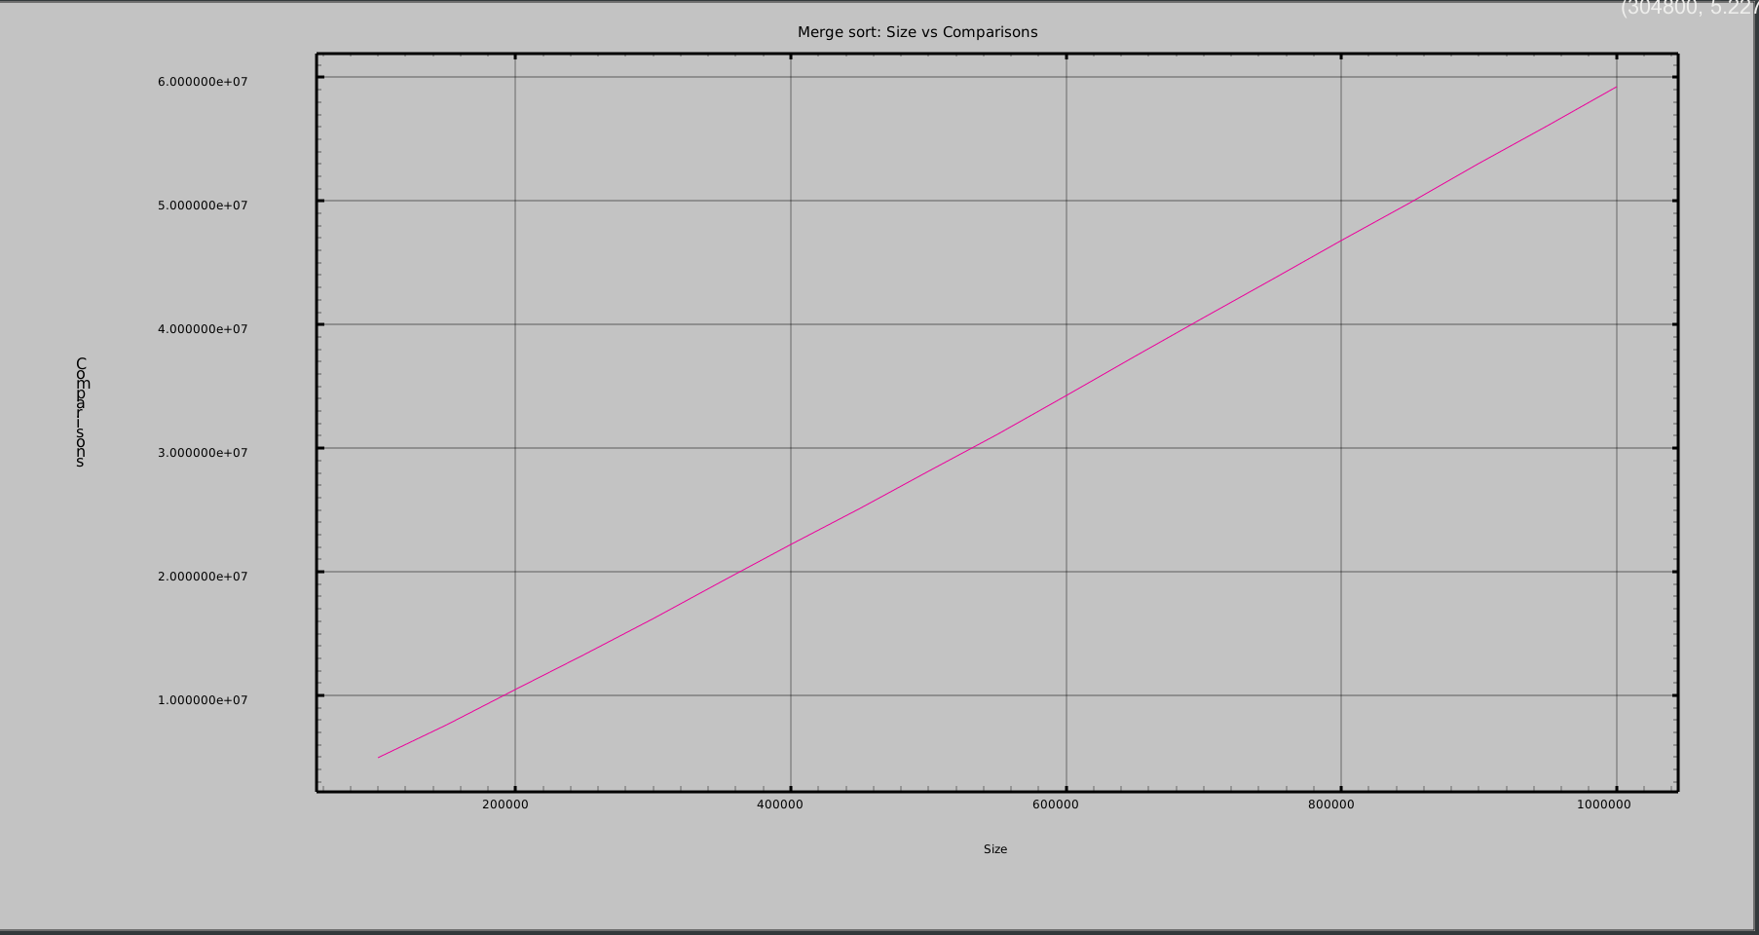

Size vs Time in minutes:
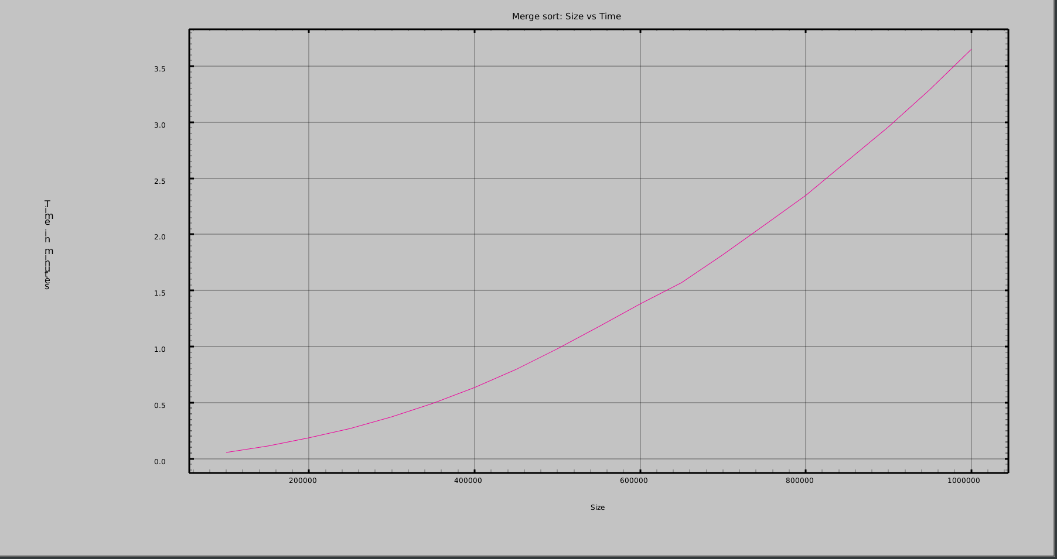

Quick Sort:
Size vs Number of Comparisons:
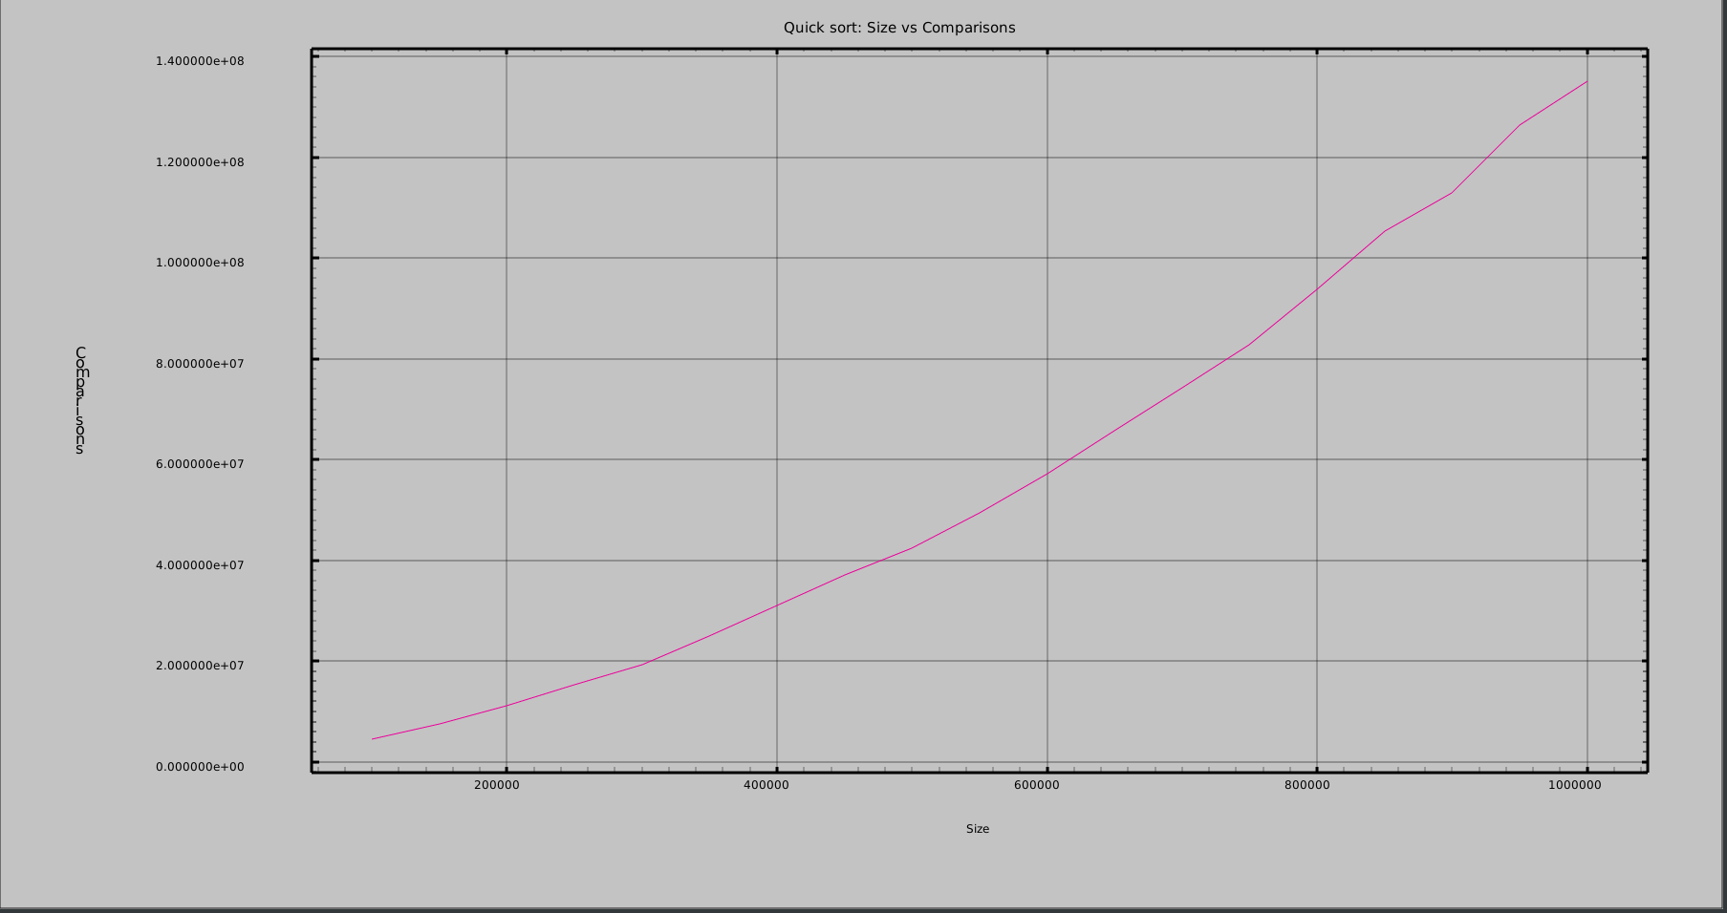

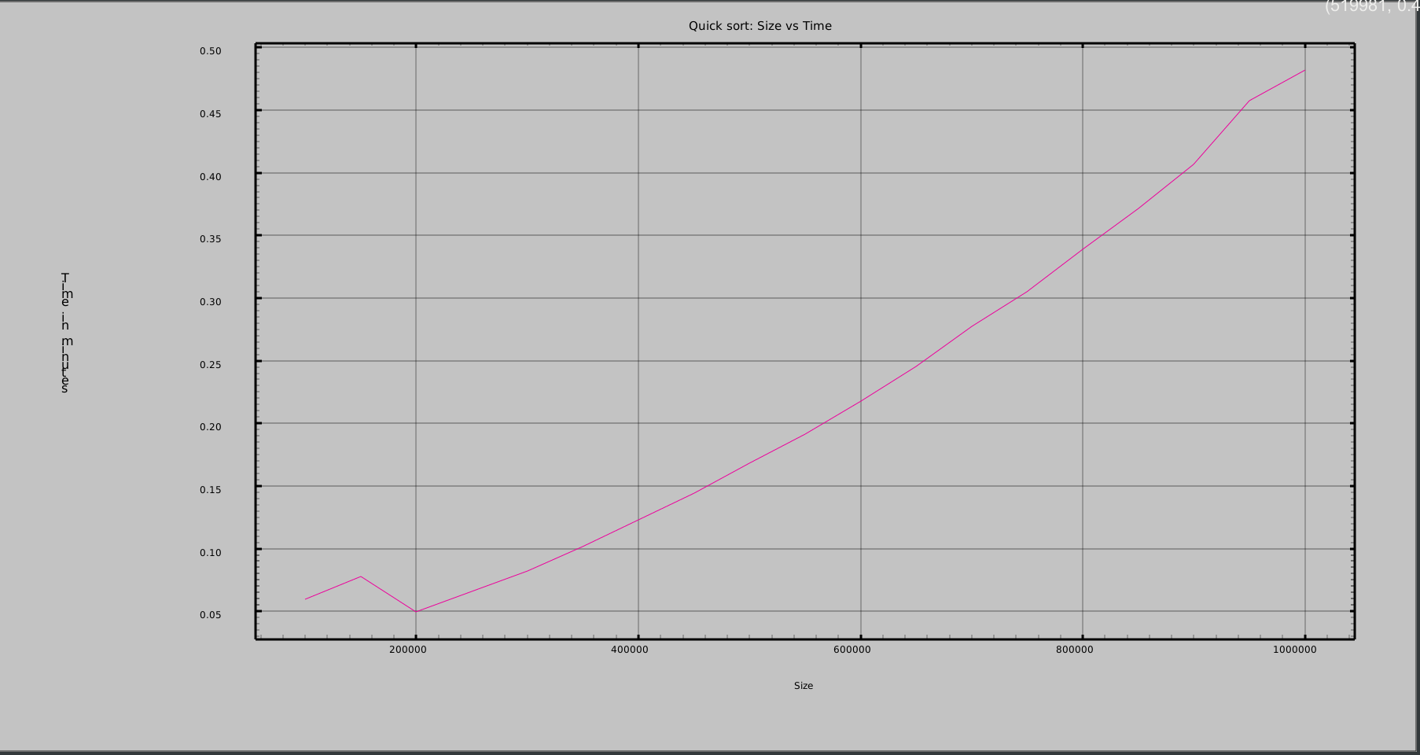
Size vs Time in minutes:

