Dataset — FER2013 (Facial Expression Recognition 2013)
- Source: Kaggle (kaggle.com/datasets/msambare/fer2013)
- Contains 35,887 grayscale facial images, each 48×48 pixels
- Labeled into 7 emotion classes: Angry, Disgust, Fear, Happy, Sad, Surprise, Neutral
- Dataset is split into train and test sets
- Pre-trained model built on this dataset achieves ~73% accuracy
- Known limitation: dataset is imbalanced — "Happy" has 8,989 images while "Disgust" has only 547
- Human-level accuracy on this dataset is ~65%, making it a challenging but standard benchmark

Tools & Libraries Used
Python 3.10 — Core programming language used for the entire implementation.
FER (v22.4.0) — Facial Emotion Recognition library that provides a pretrained deep learning model trained on FER2013. Handles both face detection and emotion classification internally.
TensorFlow / Keras — Deep learning backend that powers the CNN model. Used for loading and running the pretrained emotion classification network.
OpenCV (cv2) — Used for image loading, face detection via Haar Cascade classifier, image resizing, drawing bounding boxes, and saving annotated output images.
NumPy — Used for all numerical operations including probability vector normalization, Shannon entropy calculation, and array manipulation in the scoring pipeline.
Anaconda / Conda — Environment manager used to create an isolated Python 3.10 environment (multibio-env) ensuring clean dependency management.
VS Code — Primary code editor used for development, with integrated PowerShell terminal for running scripts.

Custom Modules Built
deception_scorer.py — The core logic of the project. Takes raw emotion probabilities as input and computes a suspicion score (0 to 1) using three signals: a weighted stress score, a masking penalty, and a Shannon entropy factor.
predict.py — End-to-end pipeline script. Loads an input image, detects faces, runs emotion classification, computes the suspicion score, and saves an annotated output image with verdict labels.
batch_predict.py — Processes an entire folder of images at once. Saves annotated images and exports a summary CSV with scores for every detected face.
face_utils.py — Utility functions for preprocessing: face cropping, grayscale conversion, resizing to 48×48, and pixel normalization to [0, 1].

Suspicion Scoring — Three Signals
- Weighted stress score — Each emotion is assigned a weight based on its association with deceptive behavior. Fear (0.9), Disgust (0.8), and Anger (0.75) contribute positively to suspicion. Happy reduces it (−0.3).
- Masking penalty — If a person appears very neutral or happy (>60% confidence) but stress emotions are still leaking through underneath, a penalty is added. This captures the classic impersonator behavior of suppressing stress with a calm expression.
- Entropy factor — Shannon entropy measures how mixed or conflicted the emotion probabilities are. A genuine emotion is clear and low-entropy. A person suppressing stress shows moderate entropy with stress bleeding through — flagged as suspicious.
Final verdict thresholds:
- Score ≥ 0.65 → SUSPICIOUS
- Score 0.40–0.64 → CAUTION
- Score < 0.40 → NORMAL
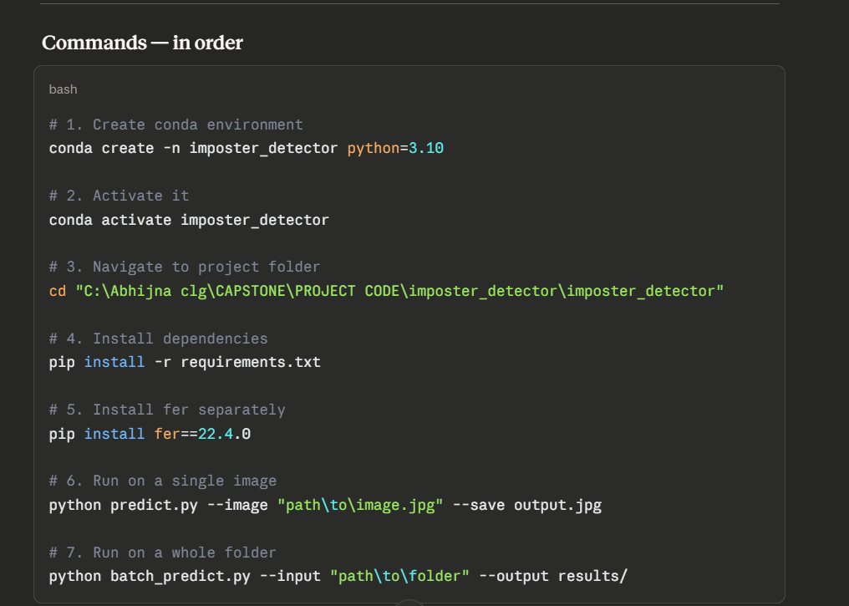
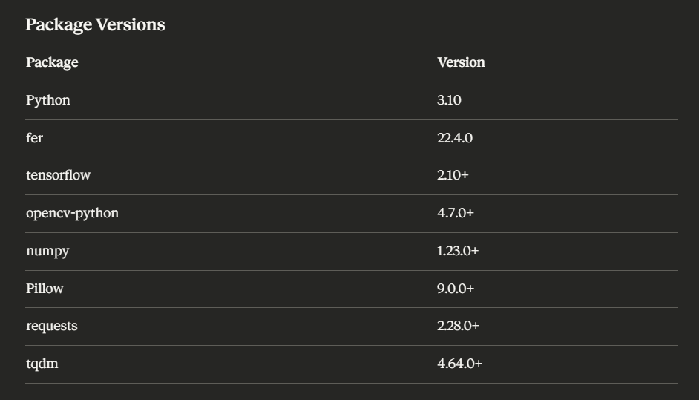

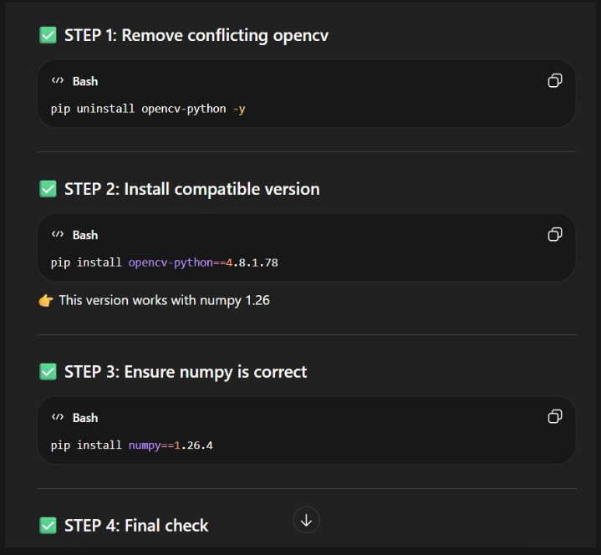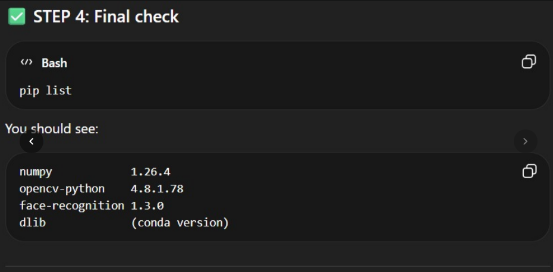

Perfect — here’s your FULL command flow from scratch → working face module (clean, in order, no confusion) 👍

🚀 STEP 1: Create Environment (Anaconda Prompt)
conda create -n multibio-env python=3.10
conda activate multibio-env

🚀 STEP 2: Install Core Dependencies
conda install -c conda-forge dlib
pip install numpy==1.26.4
pip install face_recognition==1.3.0
pip install opencv-python==4.8.1.78
pip install pandas scikit-learn

🚀 STEP 3: Open Project in VS Code
- Open your project folder
- Press Ctrl + Shift + P
- Select Python: Select Interpreter
- Choose:
multibio-env

🚀 STEP 4: Verify Installation
python -c "import face_recognition; import cv2; import numpy; print('Setup OK')"

🚀 STEP 5: Create Project Structure
face/
├── data/
├── face_capture.py
├── face_encode.py
├── face_auth.py
├── utils.py

🚀 STEP 6: Capture Face Images
python face/face_capture.py
👉 Enter username (e.g., abhijna)
👉 Press:
- s → capture images
- q → quit

🚀 STEP 7: Encode Faces
python face/face_encode.py
👉 Creates:
face/encodings.pkl

🚀 STEP 8: Run Face Authentication
python face/face_auth.py
👉 Enter username
👉 Camera opens → authentication starts

🔥 OPTIONAL (Multiple Users)
python face/face_capture.py # for friend
python face/face_encode.py

🎯 EXPECTED OUTPUT
- Camera opens ✅
- Face detected ✅
- Output:
abhijna | ACCESS GRANTED | 0.92
or
IMPERSONATION DETECTED

🚨 IMPORTANT NOTES
- Always activate env before running:
conda activate multibio-env
- Do NOT upgrade numpy beyond 1.26
- Do NOT reinstall dlib via pip

In your project (VERY relevant)
You’re using:
- facial expression
- behavioral signals
- trust scoring
👉 If you rely only on visualization:
You might say:
“Model uses facial expression”
But actually it could be using:
- lighting conditions
- camera angle
- background
⚠️ That’s risky for a security system

💡 How to reduce this gap (advanced insight)
To move toward causation, you need:
- Ablation studies (remove features and test)
- Counterfactuals (“what if this feature is removed?”)
- Controlled experiments

