**JAVA WEEKEND ASSIGNMENT**

**31st May 2025 – 1st June 2025**

**Abhik Chakraborty (Abhik.Chakraborty@bounteous.com)**

TASK 1: Car Customization and Option Display

Create a program that allows users to customize a car build and prints all the selected options. The user will provide input via standard input, and the output will be displayed on standard output.

1. Car Manufacturer:
   * Mahindra
   * Tata
   * Maruti
2. Model (for Mahindra):
   * Scorpio
   * Thar
   * Scorpio N
   * XUV 700
3. Transmission Variant:
   * Manual
   * Automatic
4. Fuel Type:
   * Diesel
   * Petrol
   * CNG
5. Accessories:
6. Color
   * Silver
   * Blue
   * Yellow
7. Location:
   * Delhi
   * Bangalore
   * Hyderabad
   * Chennai

Solution:

**Parent Class**: Car

**Child Classes**:

* Mahindra → models: Scorpio, Thar, etc.
* Tata
* Maruti

Each brand may have model info and options for transmission, fuel, color, location.

PARENT CLASS: CAR

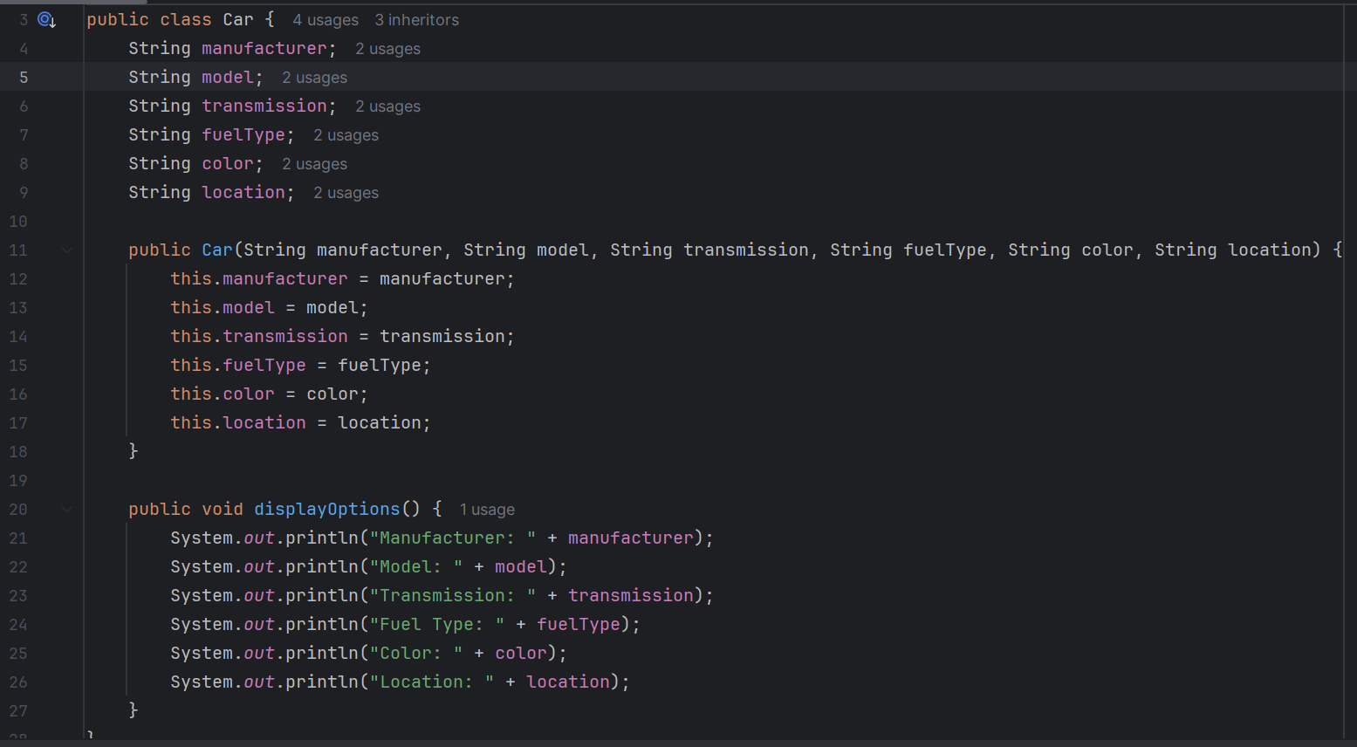

CHILD CLASSES: CHILD CLASS 1: MAHINDRA

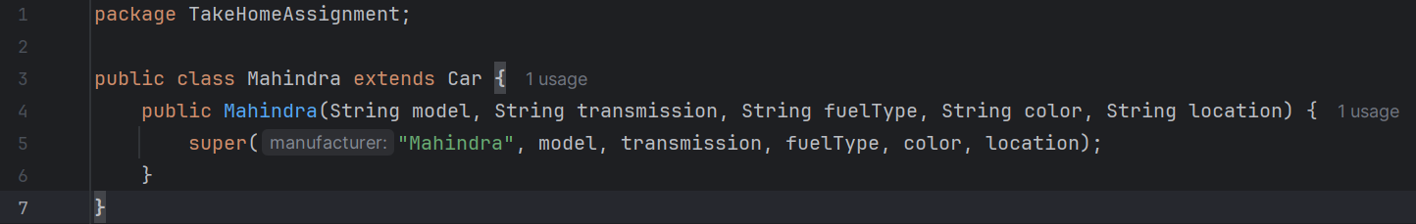

CHILD CLASS 2: MARUTI

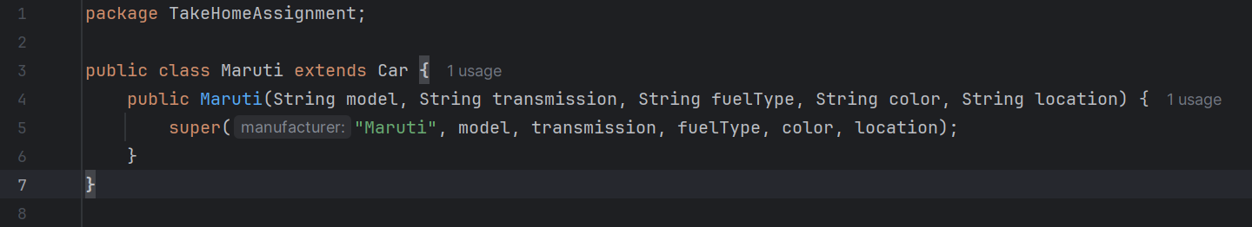

CHILD CLASS 3: TATA

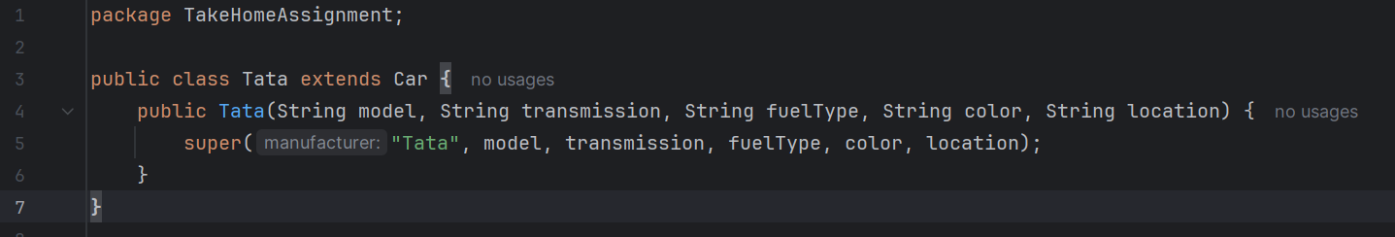

THE MAIN FUNCTION:

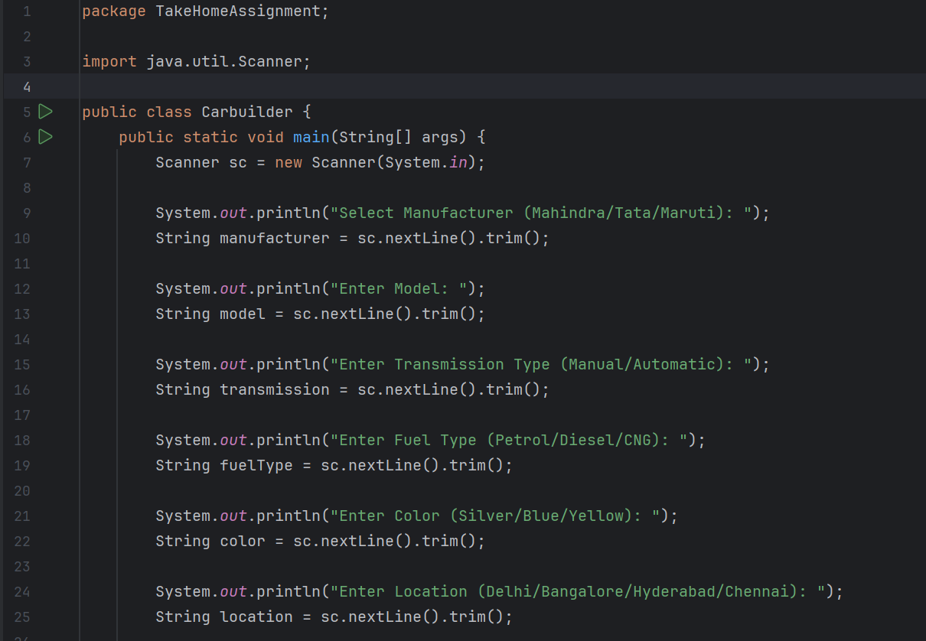

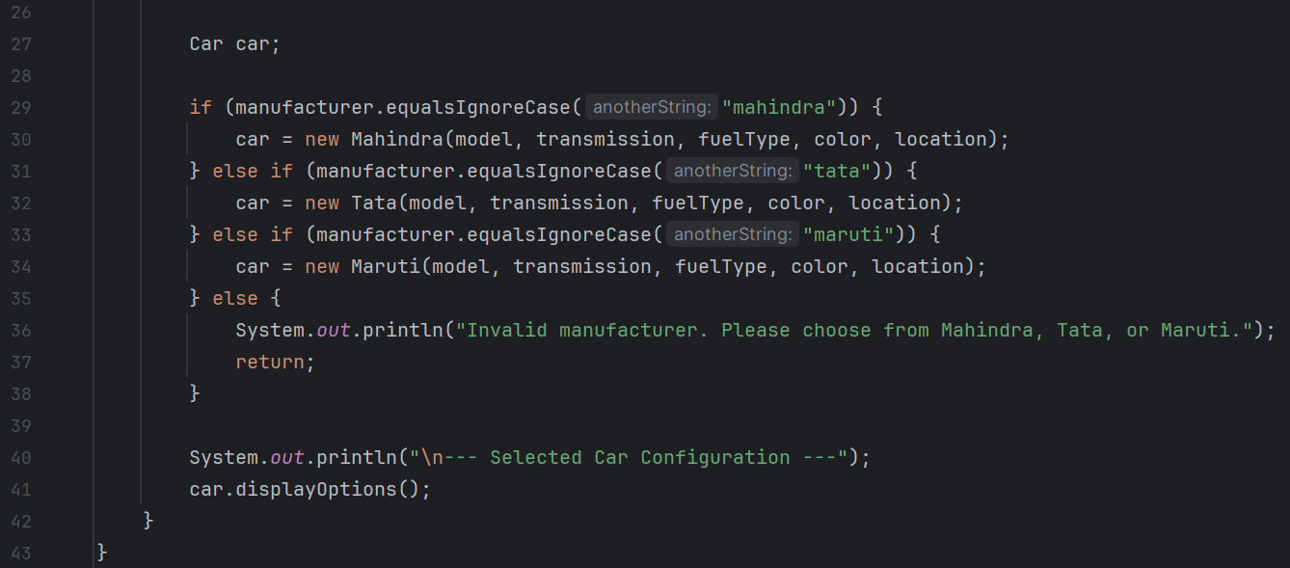

THE INPUT:  
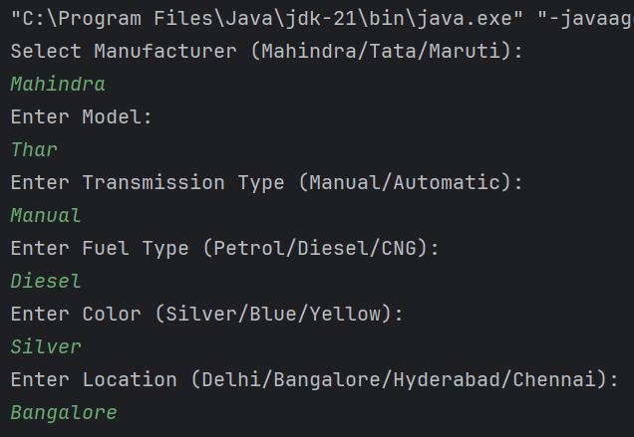

THE OUTPUT:

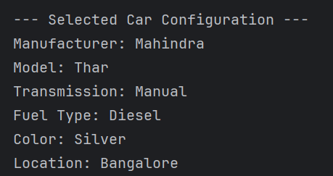

TASK 2: Tax Calculation

Write a program to calculate the annual tax owed by an individual based on their salary, age, and other parameters. The user will input their details, and the program will output the total tax amount.

**Parameters**:

* 1. **Salary (in INR):**
* Annual salary of the individual.
  1. **Age (in years):**
* Age of the individual.
  1. **Investment in Tax-saving Instruments (in INR):**
* Amount invested in tax-saving instruments like PPF, ELSS, etc.
  1. **Health Insurance Premium (in INR):**
* Annual health insurance premium paid by the individual.
  1. **Home Loan Interest (in INR):**
* Annual interest paid on a home loan.

**Tax Slabs:**

1. **For individuals below 60 years:**

* Up to ₹2,50,000: No tax
* ₹2,50,001 to ₹5,00,000: 5%
* ₹5,00,001 to ₹10,00,000: 20%
* Above ₹10,00,000: 30%

1. **For individuals between 60 and 80 years:**

* Up to ₹3,00,000: No tax
* ₹3,00,001 to ₹5,00,000: 5%
* ₹5,00,001 to ₹10,00,000: 20%
* Above ₹10,00,000: 30%

1. **For individuals above 80 years:**

* Up to ₹5,00,000: No tax
* ₹5,00,001 to ₹10,00,000: 20%
* Above ₹10,00,000: 30%

**Deductions:**

1. **Section 80C:**

* Maximum deduction of ₹1,50,000 for investments in tax-saving instruments.

1. **Section 80D:**

* Maximum deduction of ₹25,000 for health insurance premium (₹50,000 for senior citizens).

1. **Section 24:**

* Maximum deduction of ₹2,00,000 for home loan interest.

**Output:**

The program should output the total tax amount owed by the individual after considering the applicable deductions.

SOLUTION:

**Class** TaxPayer to store individual's details.

**Methods** to:

* Calculate total deductions
* Calculate taxable income
* Compute tax based on slabs and age

TaxPayer.java

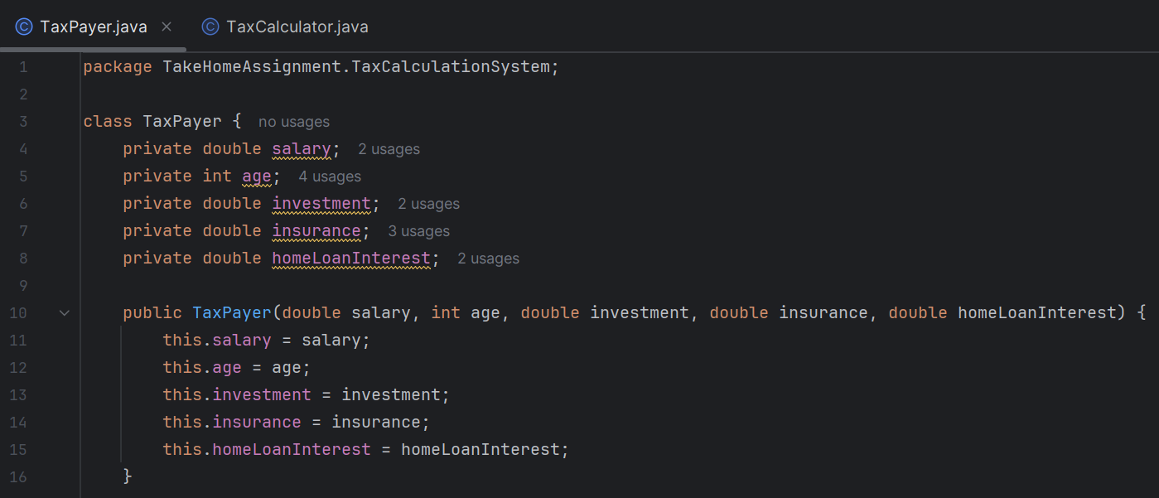

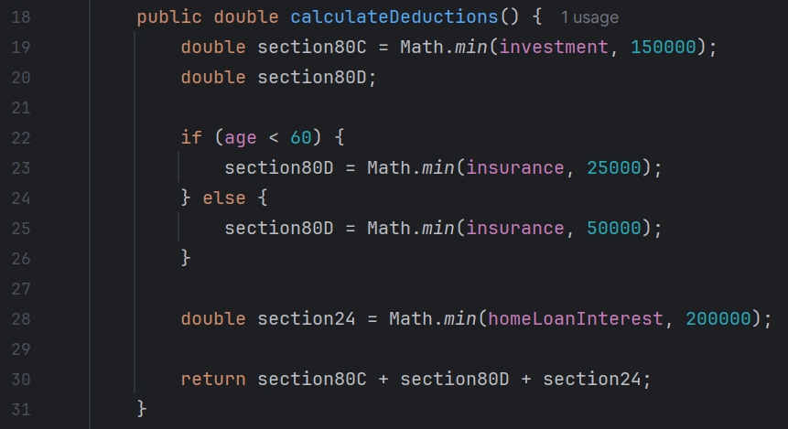

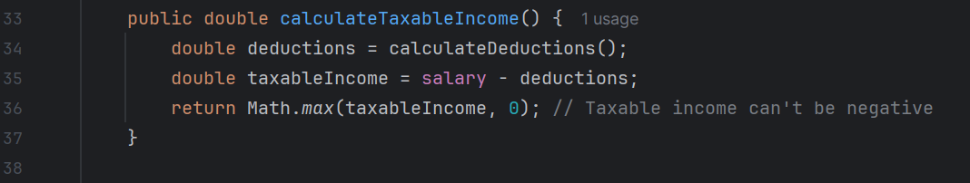

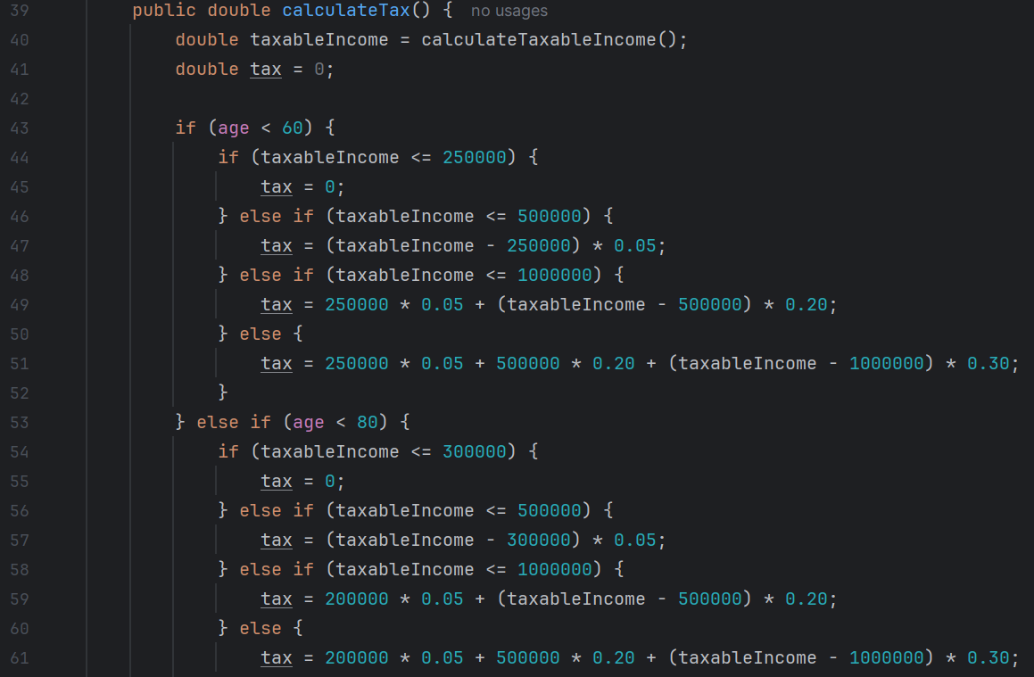

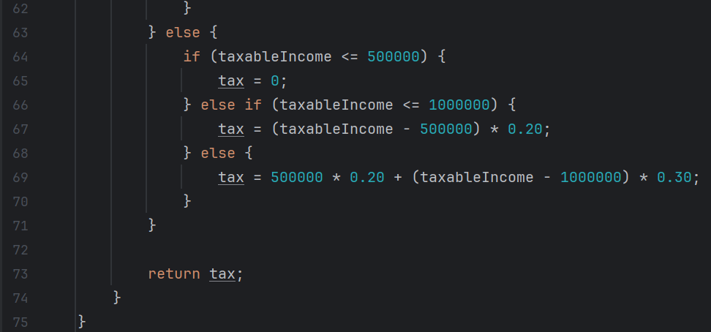

TaxCalculator.java

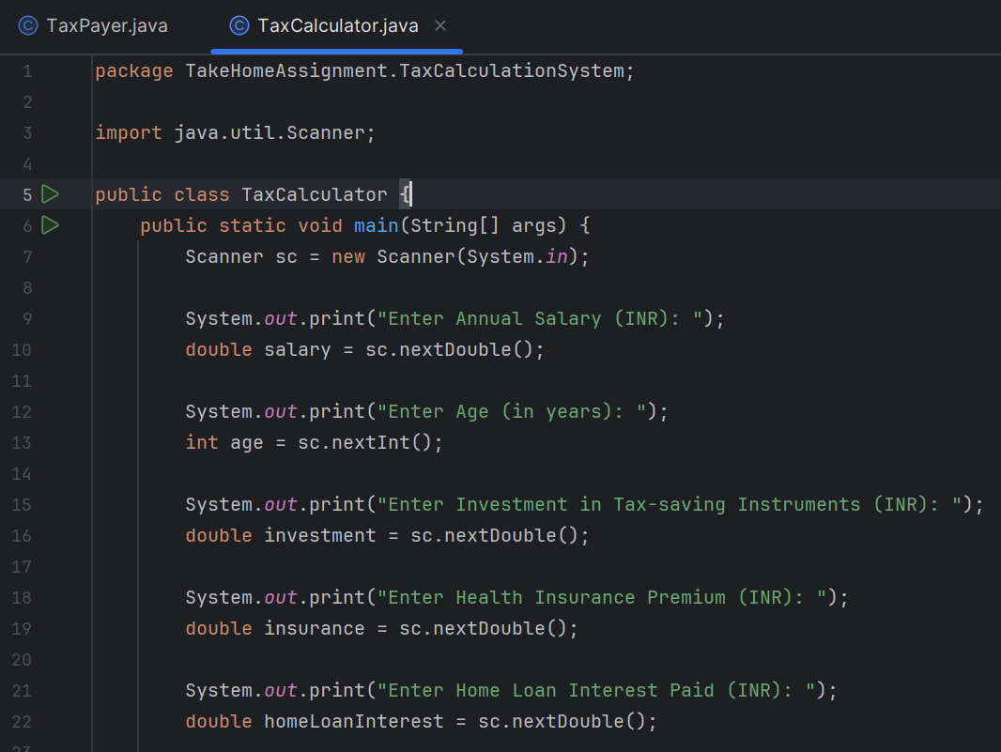

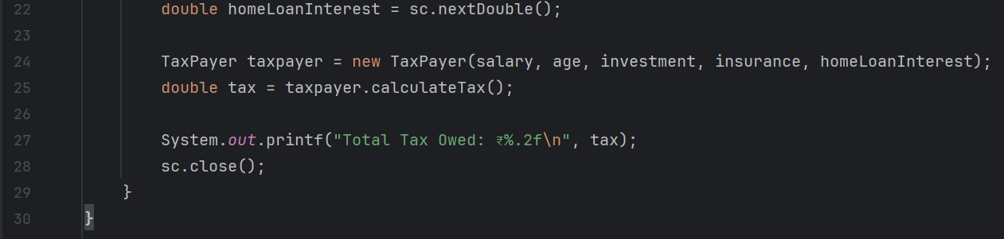

INPUT and OUTPUT  
