**JAVA COLLECTION ASSIGNMENT**

**2nd June 2025**

**Abhik Chakraborty (**[**Abhik.Chakraborty@bounteous.com**](mailto:Abhik.Chakraborty@bounteous.com)**)**

1) We are looking for a Java-based application that will help us efficiently manage product records using the Collections framework. The system should allow us to:

* Store and manage product data in a structured format.
* Perform key operations such as adding, retrieving, updating, and deleting product records.
* Sort products dynamically based on criteria like product id, product name.
* Prevent duplicate entries to maintain data integrity.

Product entity should contain the following:

Product ID

Product Name

Category

Price

2) Create a product catalogue key as a product and value as quantity:

* Store and manage product data in a structured format.
* Perform key operations such as adding, retrieving, updating, and deleting product records.
* Sort products dynamically based on criteria like product id, product name.
* Prevent duplicate entries to maintain data integrity.

Product entity should contain the following:

Product ID

Product Name

Category

Price

Solution:  
1. Stores product info (ID, name, category, price)

2. Add, update, delete, and view products

3. Prevents duplicate products

4. Can **sort products by ID or name**

5. Maintains a **product catalogue** where each product has a quantity

* 1. Product.java -> A **POJO** is a simple class.

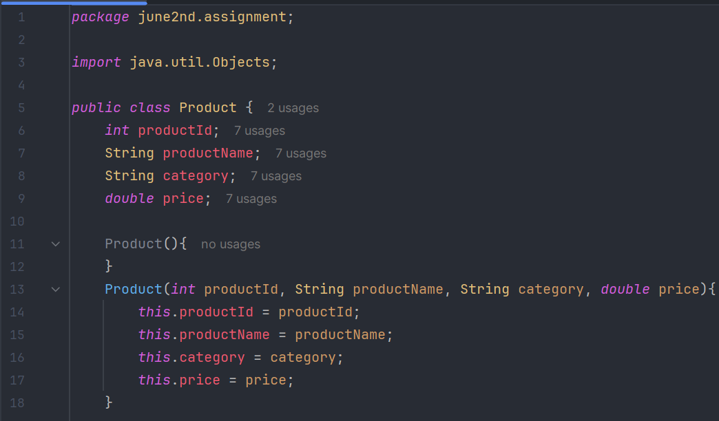

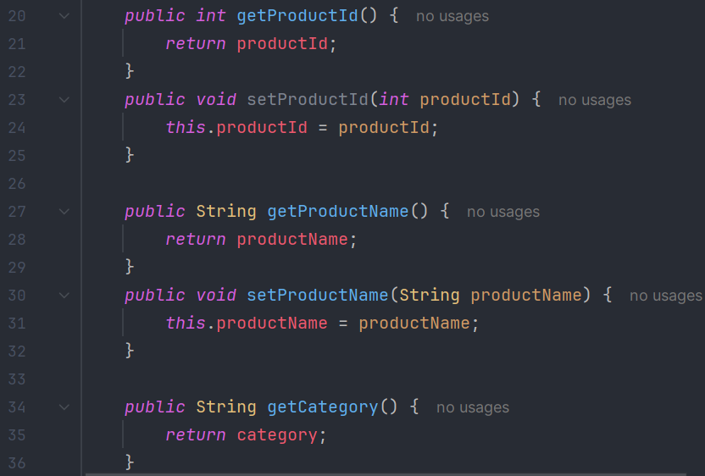

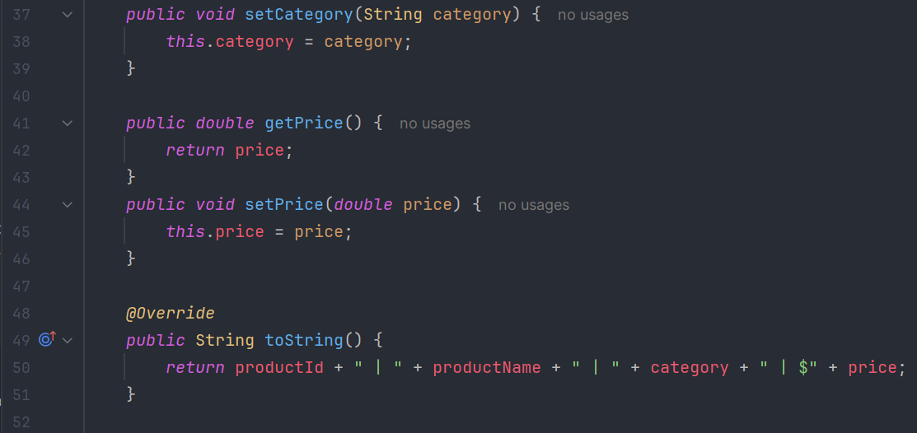

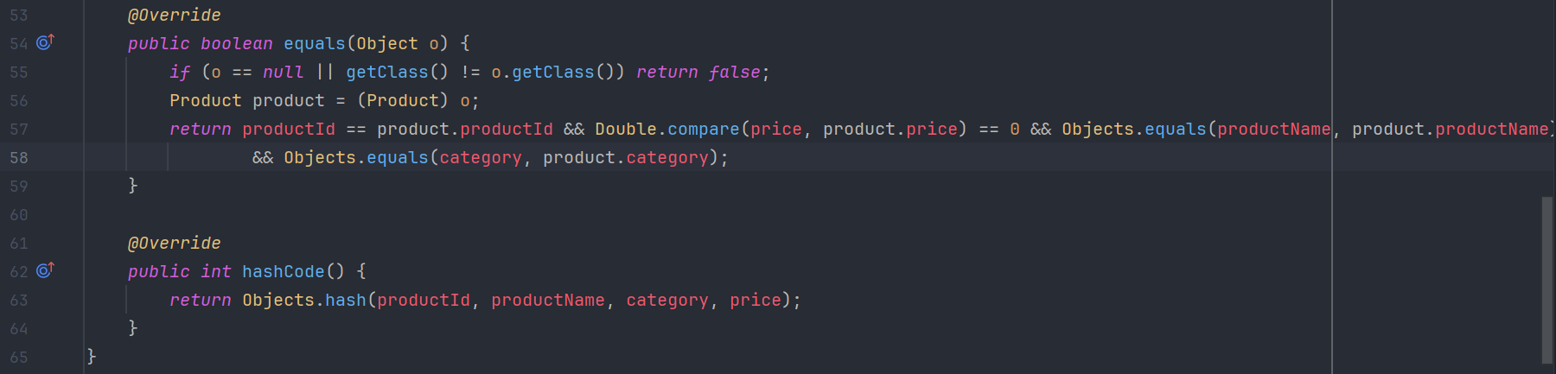

* 1. Manage Products (ProductManagerService)

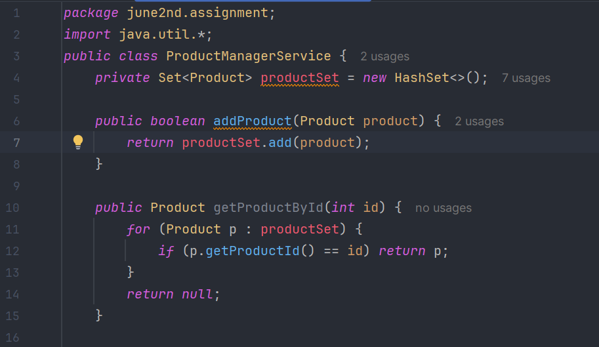

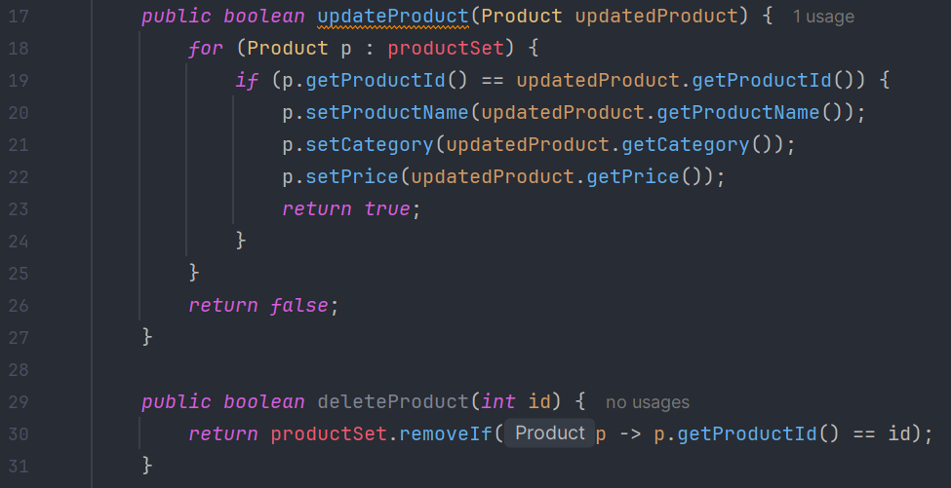

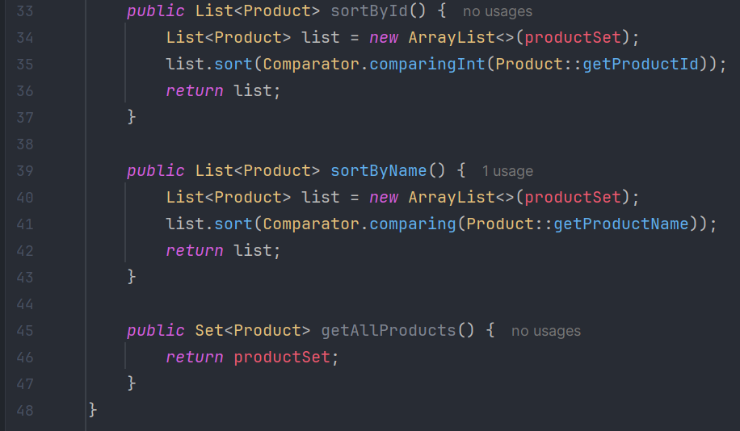

* 1. Create Product Catalogue (ProductCatalogueService)

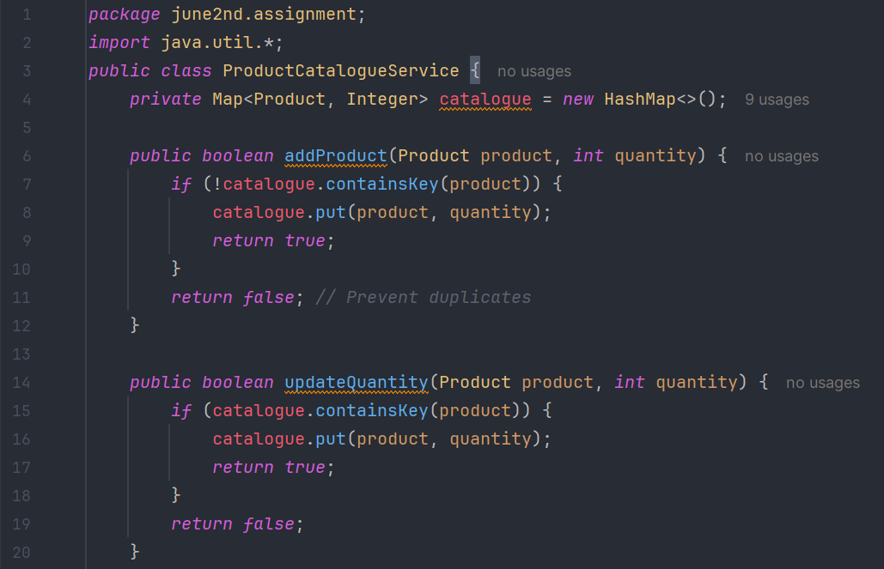

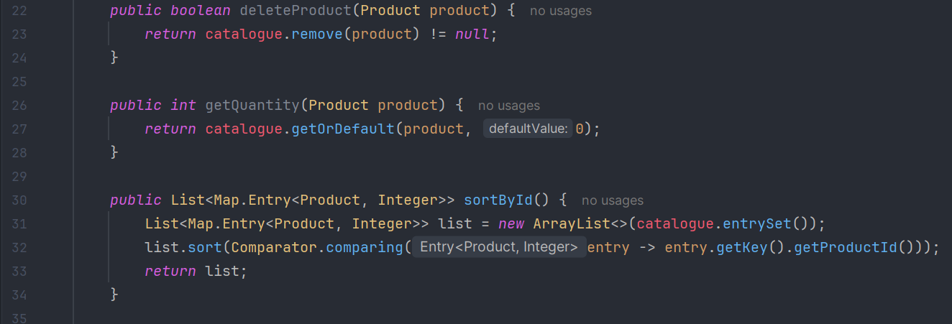

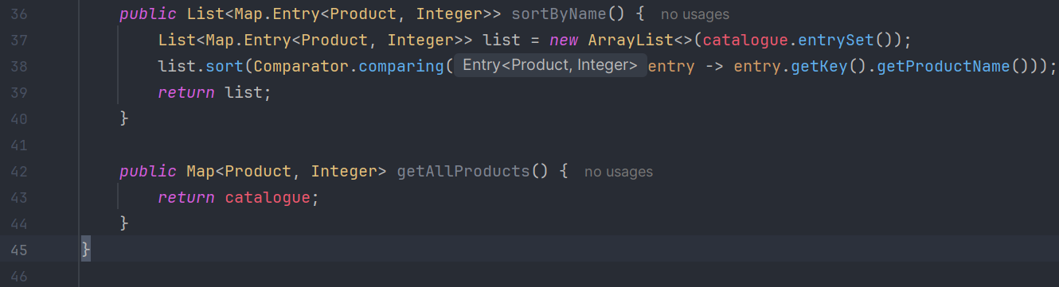

The Main Function:

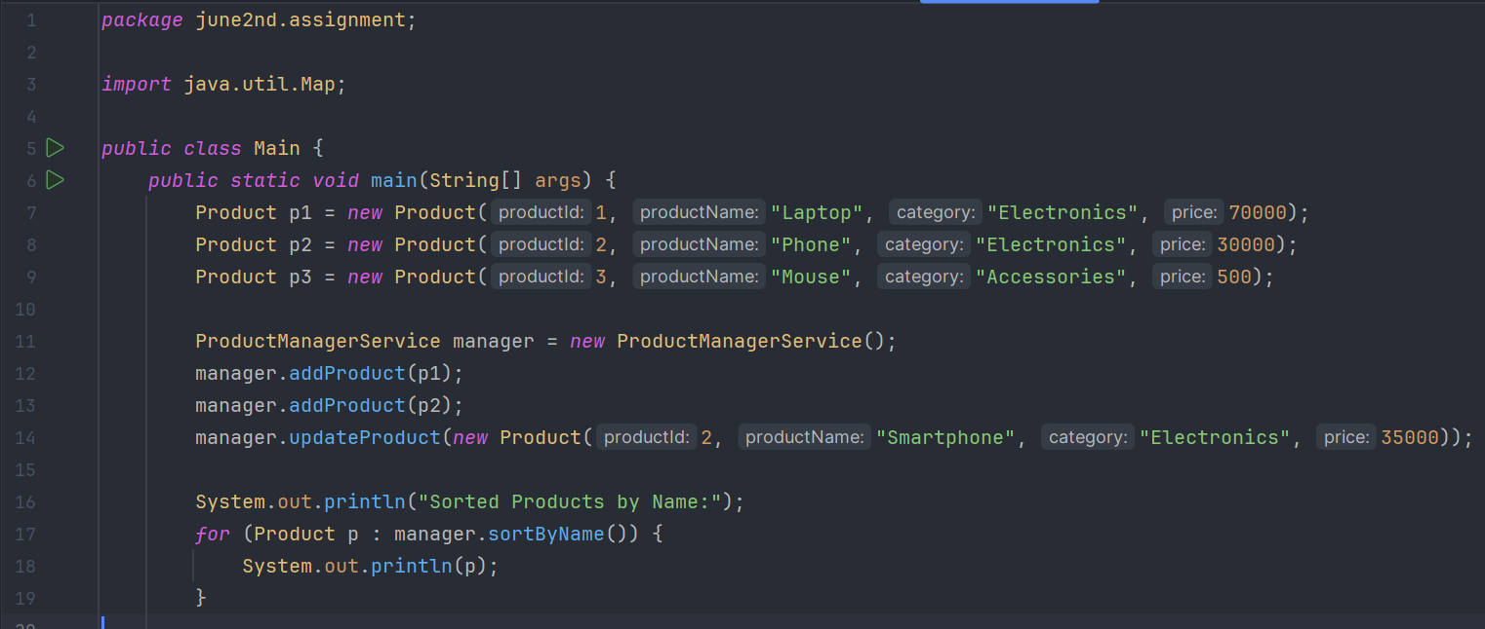

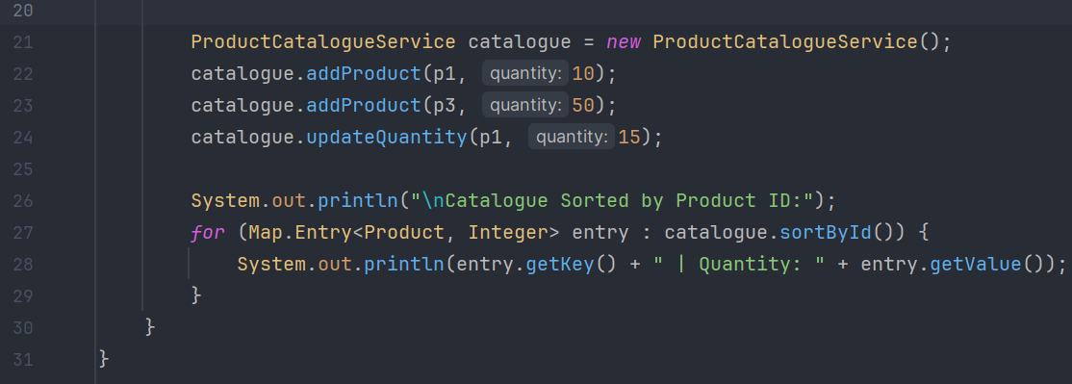

THE OUTPUT:

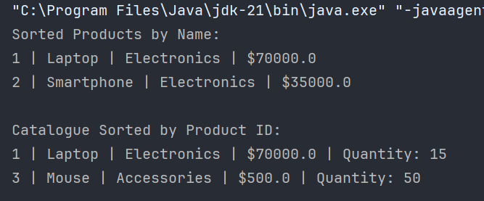

|  |  |
| --- | --- |
| **POJO** | To store product info cleanly |
| **HashSet** | To avoid duplicate products |
| **HashMap** | To link products with their quantities |
| **equals/hashCode** | To treat products with same ID as same |
| **Comparator** | To sort products by ID or name |