TerraMind: An Agentic Self-Validating Retrieval-Augmented Generation Platform for Geospatial Land Intelligence
Abhik Ghosh, Amitrakshar Chakrabarty, Ritodip Dewry, Aham Mondal
Department of Computer Science and Engineering
Techno International New Town, Kolkata, India
Abstract—Geospatial land analysis is increasingly limited not by a scarcity of data but by the interpretive gap between fragmented geographic sources and decision-ready insight. We present TerraMind, an agentic land-intelligence platform that couples Retrieval-Augmented Generation (RAG) with a LangGraph-orchestrated, self-validating multi-agent workflow to answer natural-language geospatial queries with grounded, auditable responses. The system is built on a purpose-constructed knowledge base for the Sundarbans delta of West Bengal, India: fourteen location-specific land-attribute files are merged, converted to WGS84 GeoJSON, enriched with multi-temporal OpenWeatherMap data, and indexed with a six-dimensional multi-hazard risk profile (heat stress, humidity discomfort, wind, precipitation flood, GEM seismic, and Indian Flood Inventory). Land documents are embedded with Nomic Embed Text v1.5 (768-d) and stored in ChromaDB; live road, weather, flood, and seismic intelligence is fetched on demand. Seven specialised agents—query understanding, retrieval, geospatial analysis, response synthesis, validation, attribution, and a bounded retry controller—are realised as inspectable nodes of a directed state machine. A dual-stage Validation Agent combines Retrieval-Quality-per-Query (RQPQ) threshold monitoring with LLM-as-judge answer grading to suppress hallucinated geospatial conclusions before they reach the user. On a held-out evaluation query set the combined detector reaches 94.2% hallucination-detection accuracy, retrieval precision@5 ranges from 0.81 to 0.92 across query categories, and the benchmarked pipeline sustains a 100% task-success rate under concurrency and fault injection. TerraMind offers a reproducible reference design for domain-specific, self-correcting agentic AI.
Index Terms—Geospatial intelligence, retrieval-augmented generation, large language models, multi-agent systems, vector database, LangGraph, ChromaDB, natural language processing, hallucination detection, multi-hazard risk indexing.

I. INTRODUCTION
The last decade has produced an abundance of geospatial data—cadastral records, satellite-derived land-cover maps, meteorological feeds, seismic hazard rasters, and road-network graphs—yet the practical task of land analysis has not become correspondingly simpler. The information a planner, farmer, or disaster-response coordinator needs is scattered across incompatible formats and accessed through a patchwork of single-purpose tools, each demanding its own query language and domain expertise. Static Geographic Information System (GIS) workflows can answer a narrowly framed question, but they offer no conversational interface, no synthesis across heterogeneous sources, and no narrative explanation that a non-specialist can act upon. The result is a persistent interpretive gap between raw geographic information and the actionable assessment a decision-maker actually requires.
Large Language Models (LLMs) have shown a remarkable capacity for natural-language reasoning and synthesis [1], and Retrieval-Augmented Generation (RAG) [2] grounds that reasoning in a retrieved corpus rather than in parametric memory alone. However, canonical RAG pipelines are passive: they retrieve, concatenate, and generate, with no intrinsic mechanism to judge whether the retrieved evidence is relevant or whether the generated answer is actually supported by it. In a domain where a hallucinated flood-risk classification or an incorrect seismic assessment could propagate into land-use, infrastructure, or emergency-response decisions, this passivity is dangerous: the well-documented tendency of LLMs to hallucinate [3] becomes a material safety concern rather than a cosmetic flaw. To our knowledge no existing land-intelligence platform integrates agentic orchestration, hallucination-aware validation, and semantic retrieval over a unified, risk-indexed geospatial knowledge base.
TerraMind is our response to this gap. It is an end-to-end platform that accepts a natural-language question together with a map-selected coordinate and returns a grounded, source-attributed land assessment. Internally it combines a domain-specific RAG knowledge base, a set of live environmental and infrastructure APIs, and a LangGraph state machine of seven specialised agents that plan, retrieve, analyse, synthesise, validate, and cite. The platform was developed as our final-semester engineering project, and this paper documents both its architecture and a preliminary empirical evaluation. Our key contributions are:
(i) An end-to-end agentic geospatial-intelligence pipeline that combines RAG, a cloud-served LLM, and real-time environmental APIs behind a single natural-language interface.
(ii) A self-validating response-generation workflow that pairs Retrieval-Quality-per-Query monitoring with LLM-as-judge answer grading and a bounded retry loop to detect and suppress hallucinated geospatial conclusions.
(iii) Low-overhead, multi-task geospatial analysis spanning land suitability, weather and climate risk, road connectivity, seismic hazard, and flood risk.
(iv) A domain-specific geospatial knowledge base covering land metadata, a six-dimensional multi-hazard risk index, and road-connectivity profiles for the Sundarbans–West Bengal region.
The remainder of this paper is organised as follows. Section II reviews related work in geospatial AI, agentic platforms, and RAG. Section III describes the five-layer system architecture and threat model. Section IV details the dataset-construction and knowledge-base pipeline. Section V presents the LangGraph agentic workflow, and Section VI the hallucination-detection and validation mechanism. Section VII describes the geospatial analysis modules, Section VIII reports the experimental evaluation, and Section IX concludes with directions for future work.
II. BACKGROUND AND RELATED WORK
A. Geospatial Analysis and AI
Conventional geospatial analysis is dominated by desktop and server GIS suites that expose spatial operators—buffering, overlay, point-in-polygon, raster sampling—through graphical or scripting interfaces. These tools are powerful but suffer from three recurring bottlenecks. First, data fragmentation: land attributes, weather feeds, seismic rasters, and flood inventories are published by different agencies in different formats and projections, forcing the analyst to perform manual harmonisation before any question can be answered. Second, manual tool-switching: a single decision such as “is this parcel suitable for construction?” requires the analyst to consult several disconnected systems and mentally fuse the results. Third, the near-total absence of natural-language interfaces: existing systems answer the questions their designers anticipated, not the questions a user actually poses in prose. Deep-learning approaches to remote sensing—for example, land-cover scene classification [4]—have improved individual perception tasks, but they address recognition from imagery rather than conversational synthesis across heterogeneous tabular, raster, and live sources.
B. Multi-Agent and Agentic Platforms
A complementary line of work equips LLMs with the ability to act rather than merely generate. ReAct [5] interleaves reasoning traces with tool invocations, and Toolformer [6] shows that models can learn to call external APIs in a self-supervised manner. These paradigms decompose a task into observable steps, but when expressed as a single free-form prompt they admit no principled point at which an erroneous intermediate state can be detected and repaired. LangGraph [7] externalises control flow into a directed graph of typed nodes connected by conditional edges, giving the engineer fine-grained command over agent state, retry logic, and routing. While such frameworks have been applied to general assistants and coding agents, their application to geospatial land intelligence—where each agent owns a distinct analytical competence and a validation agent gates the final output—is, to our knowledge, novel, and is the orchestration contribution of this work.
C. Retrieval-Augmented Generation for Domain Knowledge
RAG [2] conditions generation on documents retrieved from an external store, substantially reducing parametric hallucination on knowledge-intensive tasks. Production deployments typically pair a dense encoder with an approximate nearest-neighbour index such as FAISS [8] or a managed vector database such as ChromaDB [9], and recent work augments the basic loop with self-reflection: Self-RAG [10] teaches a model to critique its own retrieval and generation through reflective tokens. TerraMind adopts the spirit of Self-RAG but engineers the reflective step as an explicit, inspectable graph node—the Validation Agent—rather than as a specialised decoding behaviour, and it adds first-class source attribution so that every analytical claim can be traced to a specific document chunk or API call. Faithfulness-evaluation research such as FActScore [11] motivates our LLM-as-judge grading strategy, which checks each factual claim against the supplied evidence.
D. Multi-Hazard Risk Assessment in Geospatial Systems
Authoritative hazard datasets already exist in isolation. The Global Earthquake Model (GEM) Foundation publishes a global Peak Ground Acceleration (PGA) raster [12] expressing seismic hazard as the acceleration with a 10% probability of exceedance in fifty years. The Indian Flood Inventory (IFI) [13] catalogues flood-event polygons across India for 1967–2016 with per-event causal and duration attributes. The OpenWeatherMap API [14] supplies current, historical, and forecast meteorology. Each is valuable individually, yet none is exposed through a conversational interface, and there is no unified, risk-indexed geospatial knowledge base that fuses them into a single retrievable corpus. TerraMind’s dataset pipeline (Section IV) is designed precisely to close this gap for the Sundarbans study region.
III. SYSTEM ARCHITECTURE
A. Architecture Overview
TerraMind is organised as a five-layer client–server architecture in which each layer encapsulates a well-defined set of responsibilities and communicates with adjacent layers through typed interfaces. From user-facing to data-facing, the layers are: the Frontend Layer, which handles all user interaction and geospatial visualisation; the Backend and Orchestration Layer, which manages request routing and agentic workflow execution; the Retrieval and Knowledge Layer, which stores and serves the pre-built geospatial knowledge base; the External Intelligence and Analysis Layer, which integrates live environmental and infrastructure APIs; and the LLM inference endpoint, which performs natural-language generation under the direction of the orchestration layer. The complete architecture is illustrated in Fig. 1. A user interaction begins at the frontend, where a natural-language query and an optional map-selected coordinate are submitted over HTTPS to the FastAPI backend. The backend instantiates a LangGraph state-machine execution, which routes the query through one or more specialised agents depending on its analytical intent. Agents draw evidence from ChromaDB via semantic vector search, from live external APIs via structured HTTP calls, or from both in combination. The assembled evidence is passed to gpt-oss:120b (cloud-served) for response generation, after which a validation agent inspects the output before it is returned to the frontend for rendering. Every stage in this flow is designed so that its inputs, outputs, and failure modes are observable to adjacent layers, enabling the self-correcting behaviour described in Section VI.
B. Frontend Layer
The frontend is implemented in React 19.0 and constitutes the sole point of contact between the end user and the system. It presents two co-equal input mechanisms: a natural-language text field through which the user formulates queries in prose, and an interactive map rendered by Mapbox GL JS 3.6 through which the user selects a coordinate by clicking directly on the terrain. The selected coordinate is displayed as a marker and its decimal-degree values are appended to the outgoing payload automatically, so that every request carries an unambiguous geographic reference without manual typing. Responses are rendered with React Markdown 9.0, and an expandable source-attribution panel, populated from the JSON metadata array attached to each response, lets users inspect the evidence provenance of individual claims. The frontend communicates with the backend exclusively through a single FastAPI 0.115 REST endpoint; no retrieval or inference is performed client-side, keeping the frontend stateless and all analytical computation auditable at the server.
C. Backend and Orchestration Layer
The backend is implemented in Python 3.11+ and exposes an asynchronous POST endpoint through FastAPI 0.115. On receiving a request it deserialises the payload and hands control to the LangGraph orchestration runtime, which models the analytical pipeline as a directed state machine in which each node is a typed Python callable that reads from and writes to a shared state dictionary. Edges are either unconditional, expressing mandatory sequencing, or conditional, expressing routing that depends on the runtime content of the state. LangChain 0.3 constructs and invokes the individual LLM prompt chains within each agent node, providing prompt-template management, structured output parsing, and tool binding, while LangGraph provides the inter-agent control flow. The orchestration layer owns the full lifecycle of a query: it classifies intent, selects retrieval and analysis paths, assembles the evidence context, invokes the LLM, validates the output, and formats the final response with attribution metadata. A token-bucket rate limiter caps traffic at 30 requests per minute, and all state transitions are written to an in-process trace store that supplies the observability data used by the validation and retry mechanisms of Section VI.
D. Retrieval and Knowledge Layer
The retrieval layer is built on ChromaDB, an in-process vector database that stores the unified geospatial knowledge base constructed in Section IV. Each document is a text chunk derived from a single GeoJSON feature attribute, augmented with that feature’s complete multi-hazard risk profile and accompanied by a metadata record encoding the location name, decimal-degree coordinate, data-source category, and risk classification labels. Embeddings are produced by Nomic Embed Text v1.5 [15], a retrieval-optimised dense encoder served locally through Ollama, yielding 768-dimensional vectors stored alongside each document at ingestion time. At query time the Retrieval Agent embeds the incoming query with the same model and executes a cosine-similarity nearest-neighbour search, implemented over an HNSW index [16] for logarithmic-time approximate retrieval. The retrieval window is parameterised by query complexity: single-dimension queries use k = 5 chunks, while multi-hazard synthesis queries expand to k = 10. Metadata filtering is applied as a pre-similarity constraint when a specific location or hazard category has been identified, restricting the candidate pool before ranking. The cosine similarity of the top-ranked document is recorded as the Retrieval Quality per Query (RQPQ) score and written into the graph state for downstream consumption by the Validation Agent.
E. External Intelligence and Analysis Layer
This layer integrates live data services that supplement the static corpus with real-time and dynamically computed evidence. Weather intelligence is retrieved from the OpenWeatherMap API per coordinate, covering current conditions, historical daily summaries, and a 16-day forecast across eleven meteorological parameters; responses are restructured into the day-major format used in the knowledge-base pipeline so that live and retrieved context remain terminologically consistent when fused. Road intelligence uses two Mapbox endpoints in a primary–fallback configuration: the Mapbox Tilequery API is queried first within a configurable radius, falling back to the Mapbox Directions API when the Tilequery response is empty, with road segments then extracted from the step-level route geometry. Flood hazard is assessed by a point-in-polygon query against the in-memory Indian Flood Inventory index, with the OpenWeatherMap precipitation value as a fallback indicator. Seismic hazard is read by a per-coordinate pixel lookup against the GEM PGA GeoTIFF via Rasterio, mapped to the five-level scheme of Table II. The Overpass API enriches road context with OpenStreetMap metadata when finer street-level detail is required, and natural-language generation is performed by gpt-oss:120b (cloud-served) via Ollama.
F. Security and Threat Model
Because erroneous outputs in this domain carry material consequences, the threat model enumerates four failure modes and their architectural mitigations. The primary threat is hallucinated output, in which the LLM generates a plausible but unsupported claim; this is mitigated by the dual-stage Validation Agent of Section VI, which applies RQPQ threshold monitoring before generation and LLM-as-judge grading after it, suppressing any response that fails either check and re-entering the pipeline with an expanded retrieval context. The second threat is stale retrieval, in which the corpus no longer reflects current conditions; this is partially mitigated by the live-API layer and, where live data is unavailable, by flagging stale risk classifications with their ingestion timestamp in the attribution record. The third threat is external API failure, handled through the primary–fallback road design and precipitation-based flood fallback, with weather failures surfaced to the user as a degraded-mode indicator rather than silently dropped. The fourth threat is incorrect geospatial interpretation, in which a nearby but out-of-coverage coordinate matches a semantically similar yet geographically inappropriate chunk; this is addressed by metadata filtering in the retrieval layer and by the frontend source panel, which exposes the geographic origin of each retrieved chunk for independent verification.

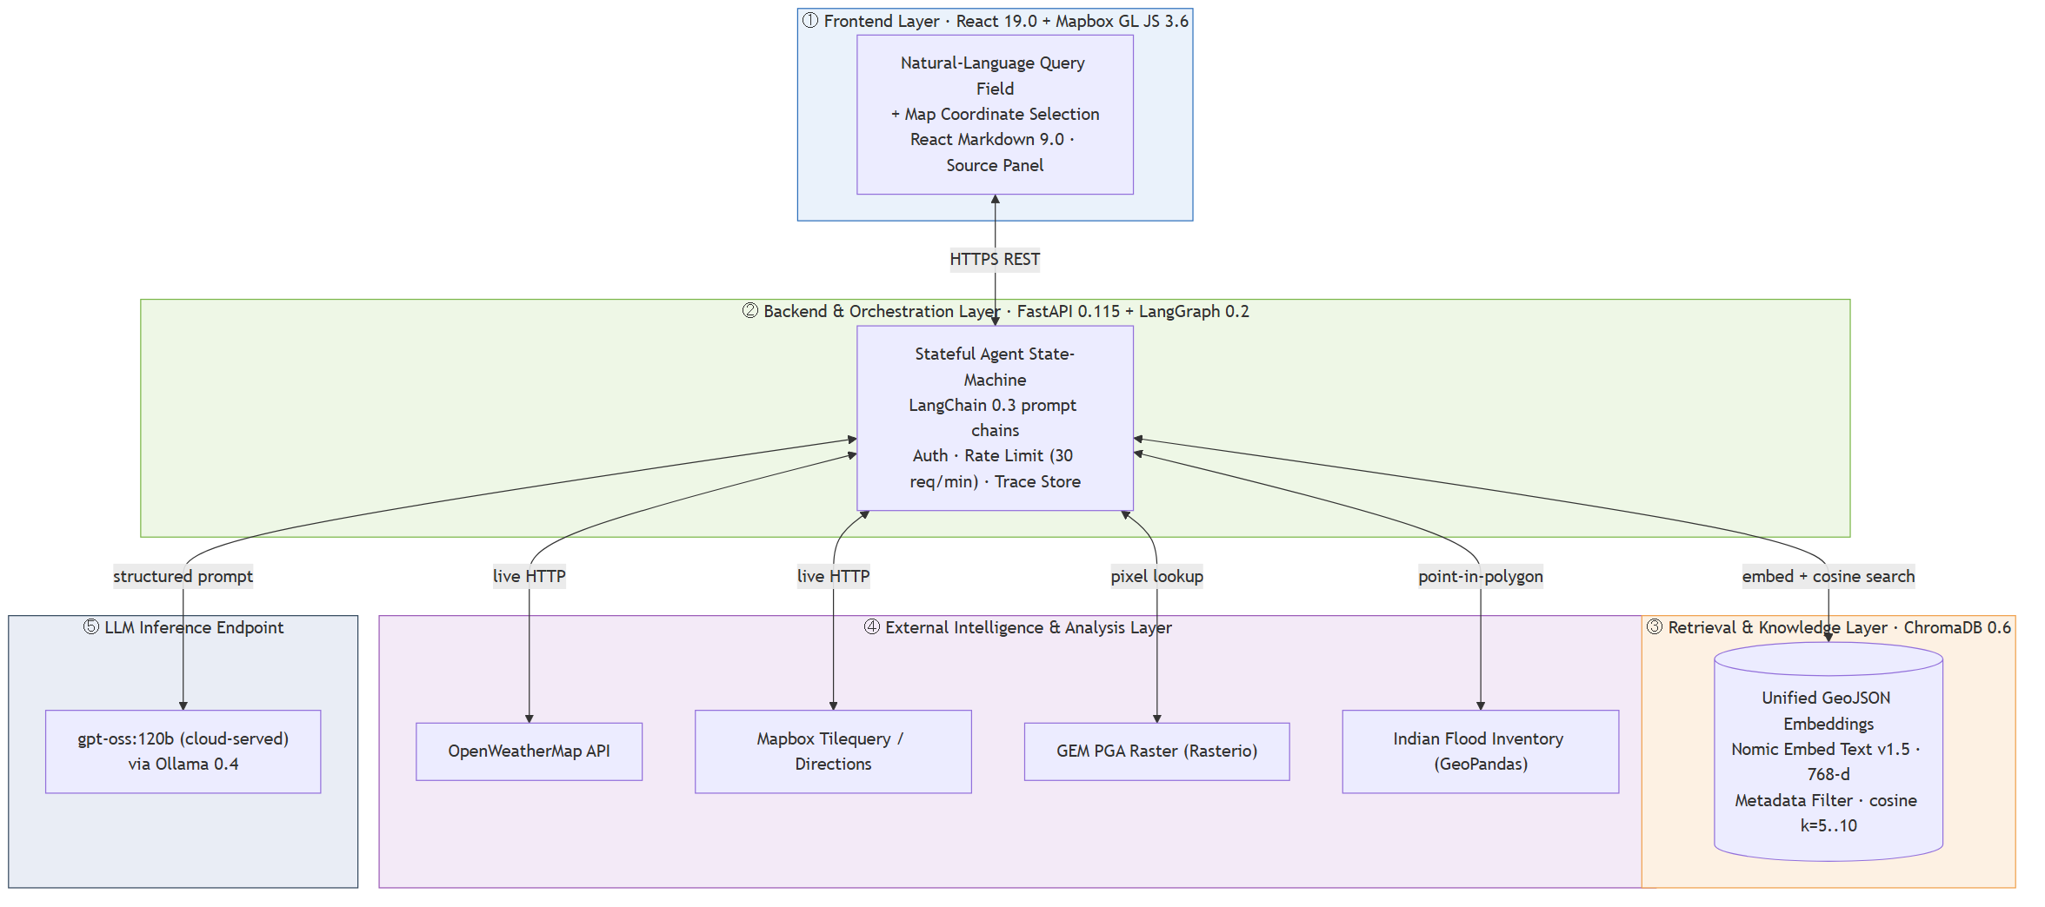
Fig. 1. TerraMind five-layer system architecture spanning the React 19.0 frontend, the FastAPI + LangGraph orchestration layer, the ChromaDB retrieval layer, the external geospatial-API layer, and the gpt-oss:120b (cloud-served) LLM inference endpoint.

IV. DATASET CONSTRUCTION AND KNOWLEDGE BASE DEVELOPMENT
A. Source Data Collection
The knowledge base is grounded in a curated collection of land-intelligence records compiled for the Sundarbans delta region of West Bengal, India—an ecologically sensitive and analytically complex territory of mangrove forestry, tidal floodplains, and heterogeneous agricultural parcels. Raw data were assembled from fourteen location-specific CSV files, each corresponding to a distinct administrative or ecological unit (e.g., Basanti, Canning, Gosaba, Hingalganj). Each file encodes land intelligence as Theme–Description pairs across a standardised attribute schema covering soil productivity, soil depth, soil-erosion susceptibility, geomorphological classification, land type, and associated ecological annotations. Files were ingested with pandas, column whitespace was normalised, and a File_Index field was appended to preserve provenance; all fourteen files were then concatenated into a unified DataFrame, summarised in Table I, which constitutes the semantic foundation for all downstream enrichment and retrieval.
B. Coordinate Parsing and GeoJSON Construction
Coordinates in the source CSVs were encoded in Degrees-Minutes-Seconds (DMS) notation (e.g., 88° 39′ 13.35″ N, 22° 50′ 27.14″ E), which is unsuitable for direct computation. A custom dms_to_decimal() function parses each coordinate string by regular expression, extracts the degree, minute, and second components, and applies the standard decimal conversion. The resulting latitude and longitude columns were appended to the merged DataFrame, which was converted into a GeoPandas GeoDataFrame by constructing shapely Point geometries and setting the Coordinate Reference System to EPSG:4326 (WGS84)—the geodetic standard required for compatibility with GPS-referenced geospatial APIs. The GeoDataFrame was serialised as sundarbans_land_data.geojson. Because the GeoJSON specification mandates [longitude, latitude] ordering whereas the default GeoPandas export produces the reverse, a post-processing pass transposed the geometry arrays to ensure correct rendering within Mapbox GL JS.
C. Weather Data Enrichment
Static land metadata alone is insufficient for suitability analysis; temporal climatic context is essential for assessing agricultural viability, habitability risk, and infrastructure resilience. Each coordinate was therefore enriched with multi-temporal weather data via a parameterised fetch_weather.py pipeline calling the OpenWeatherMap API in three temporal modes: current conditions at 15-minute resolution, historical daily summaries spanning the preceding 365 days, and a 16-day deterministic forecast. The parameter set was deliberately broad—maximum and minimum air temperature, apparent temperature, relative humidity, wind speed, wind gusts, wind direction, daily precipitation sum, cloud cover, surface pressure, and mean sea-level pressure. OpenWeatherMap returns a parameter-major layout (one time-series per variable); the pipeline restructured this into a day-major format in which all variables for a given date are grouped into a single JSON object, simplifying subsequent risk computation and LLM context construction. The enriched records were written back into the GeoJSON as nested feature properties, producing a self-contained document carrying both static land attributes and complete temporal climate profiles per location.
D. Multi-Hazard Risk Index Construction
Raw numerical weather and geophysical measurements carry limited utility for non-specialist users and LLM reasoning alike. A multi-hazard risk index was therefore constructed to translate continuous readings into a five-level ordinal classification—Very Low, Low, Moderate, High, Very High—across six independent hazard dimensions, with the complete thresholds listed in Table II. Four weather-derived dimensions are defined in weather_risk_index.py. Heat Stress is derived from maximum air temperature; Humidity Discomfort from relative humidity; Wind Risk from maximum 10 m wind speed, with the Very High threshold (>80 km/h) aligned to the cyclonic conditions prevalent in the Bay of Bengal littoral; and weather Flood Risk from the mean daily precipitation sum. Seismic hazard was quantified from the GEM Global Seismic Hazard raster, opened with Rasterio and sampled per coordinate to read the PGA value, which is binned into five levels (Very Low <0.05 g through Very High ≥0.20 g); both the raw PGA and the ordinal category are stored as feature properties. Flood hazard was assessed with a GeoPandas spatial join against the Indian Flood Inventory: for coordinates intersecting a flood polygon, risk is scored from historical event frequency and inundation duration with state and district attribution; coordinates outside all polygons fall back to the precipitation-derived category, ensuring that no location is left without a flood assessment.
E. Unified GeoJSON and ChromaDB Ingestion
The five enrichment stages—land metadata, weather profiles, weather-derived risk indices, seismic hazard, and flood hazard—were consolidated by risk_index.py into a single unified GeoJSON corpus, illustrated in Fig. 2. Each feature carries an EPSG:4326 point geometry, the original Theme–Description pairs, the computed risk categories for all six hazard dimensions, the raw PGA intensity, and available administrative context from the IFI join. Null-valued fields and intermediate artefacts were purged to minimise token overhead during context construction. For ingestion, each feature was decomposed into discrete text chunks—one per Theme–Description pair, augmented with the feature’s full risk profile—and embedded with Nomic Embed Text v1.5 (768-d) served via Ollama. Each document was stored in ChromaDB alongside a metadata record encoding the coordinate pair, location name, data-source identifier, and risk-category labels, enabling the retrieval layer to filter by hazard type or geographic extent at query time. The resulting collection is the primary retrieval index for all TerraMind queries.

Fig. 2. Dataset-construction and ChromaDB ingestion pipeline. Fourteen per-location CSV files are merged, geo-converted to WGS84, enriched with OpenWeatherMap data, indexed with seismic and flood risk, and ingested as attributed embedding chunks.

TABLE I
Knowledge Base Statistics
Parameter | Value
Source CSV files | 14
Geographic region | Sundarbans, West Bengal, India
Embedding model | Nomic Embed Text v1.5
Embedding dimensions | 768
Vector database | ChromaDB
Risk categories | 6 (heat, humidity, wind, flood, seismic, IFI flood)
Hazard levels / category | 5 (Very Low – Very High)
Location points | 14
Coordinate reference system | EPSG:4326 (WGS84)
Seismic data source | GEM Global Seismic Hazard GeoTIFF
Flood inventory source | Indian Flood Inventory 1967–2016
Weather API | OpenWeatherMap
The corpus covers 14 locations across the Sundarbans delta, indexed in ChromaDB using 768-dimensional Nomic Embed Text v1.5 embeddings, with six independent hazard dimensions each on a five-level ordinal scale.
TABLE II
Multi-Hazard Risk Parameter Thresholds
Hazard | V.Low | Low | Mod. | High | V.High
Heat Stress | <30°C | — | 30–38°C | 38–42°C | >42°C
Humidity | <60% | — | 60–85% | 85–95% | >95%
Wind (km/h) | <18 | 18–42 | 42–80 | — | >80
Flood (mm/d) | <5 | 5–8 | 8–20 | — | >20
Seismic (g) | <0.05 | 0.05–0.10 | 0.10–0.15 | 0.15–0.20 | ≥0.20
IFI Flood | No poly. | Low freq. | Mod. freq. | High freq. | V.high freq.
Numerical thresholds mapping each weather-derived and geophysical parameter to one of five ordinal risk levels. Seismic Risk is derived from GEM PGA raster values; IFI Flood Risk from Indian Flood Inventory 1967–2016 polygon event frequency.
V. AGENTIC WORKFLOW AND LANGGRAPH ORCHESTRATION
A. Workflow Overview
TerraMind’s analytical pipeline is implemented as a directed, stateful graph in which each node encapsulates a semantically distinct agent with a well-defined input contract, processing responsibility, and output specification. This departs fundamentally from monolithic chain-of-thought pipelines [17], in which a single prompt bears responsibility for interpretation, retrieval, reasoning, and formatting simultaneously and which admit no principled intervention point at which erroneous intermediate states can be detected and corrected. By contrast, the LangGraph state machine models the pipeline as typed nodes connected by directed edges, including conditional edges whose traversal depends on runtime state. Each agent receives the current state, performs a bounded computation, updates the state, and yields control to the next node as determined by the routing logic. The full workflow, comprising seven specialised agents and one conditional feedback loop, is depicted in Fig. 3.
B. Query Understanding Agent
The first node receives the raw natural-language input together with any coordinate selected on the Mapbox interface. Its primary function is query classification: it determines the dominant analytical intent from a controlled taxonomy—land suitability, weather and climate risk, road connectivity, multi-hazard risk profiling, and open-domain geospatial reasoning—by prompting gpt-oss:120b with a structured instruction that constrains the output to one category, preventing ambiguous routing. Beyond categorical classification it performs finer-grained intent recognition, identifying whether the query needs historical context, current conditions, forecast data, or cross-domain synthesis, and it extracts named geographic entities, resolving them against the coordinate context where available. The resulting routing descriptor is written into the graph state and determines the execution path: land-suitability and multi-hazard queries are routed through the Retrieval Agent, real-time queries through the Geospatial Analysis Agent, and combined queries along a path in which both run before converging at the Response Synthesis Agent.
C. Retrieval Agent
The Retrieval Agent sources factually grounded evidence from the ChromaDB knowledge base. On receiving the routing descriptor and processed query it embeds the query with Nomic Embed Text v1.5 via Ollama and executes a top-k approximate nearest-neighbour search. The value of k is set dynamically by query complexity: single-dimension queries use k = 5, while multi-hazard synthesis queries expand to k = 10 for sufficient evidence coverage. Metadata filtering is applied in conjunction with semantic search—when a specific location or hazard category has been identified, the ChromaDB where-clause restricts the candidate set before similarity scoring—so retrieved chunks are both semantically relevant and geographically appropriate, eliminating spurious matches from distant locations that share vocabulary. Each retrieved chunk carries its full metadata record for downstream attribution, and the cosine similarity of the top-ranked document is recorded as the RQPQ score consumed by the Validation Agent.
D. Geospatial Analysis Agent
This agent executes live external API calls for queries requiring real-time or dynamically computed data, operating across four sub-modules activated selectively by the routing descriptor. For weather, it calls OpenWeatherMap and restructures the response into the day-major format used in the corpus. For road intelligence, it invokes the Mapbox Tilequery API within a default 1,000 m radius, falling back to the Mapbox Directions API when Tilequery returns nothing; the analyse_road_features() function then derives congestion classification, road-type distribution, network length, and a 0–10 road-quality score. For flood risk it evaluates the coordinate against the pre-loaded Indian Flood Inventory index and falls back to the precipitation-derived value when no polygon matches. For seismic risk it reads the GEM PGA raster value via Rasterio and maps it to the Table II categories. All four sub-modules write typed outputs into the graph state for the Response Synthesis Agent.
E. Response Synthesis Agent
This agent constructs the natural-language answer delivered to the user. Its first operation is context aggregation: it assembles a unified prompt by concatenating the retrieved chunks in descending similarity order, followed by the structured API outputs as labelled data blocks, followed by the user’s original query. The prompt instructs gpt-oss:120b to produce a grounded response that cites only information present in the provided context and explicitly flags any inference that goes beyond the supplied evidence. Evidence fusion is handled within the prompt through an explicit precedence hierarchy: retrieved corpus knowledge takes precedence for static land attributes and indexed risk profiles, while live API data takes precedence for current weather and real-time road state, preventing the model from arbitrarily favouring one source when they overlap or conflict. The generated response is stored in the state for the Validation Agent and is not delivered to the user until validation succeeds.
F. Validation Agent
The Validation Agent is the self-correcting core of the pipeline and the primary mechanism by which hallucinated conclusions are prevented from reaching users. It applies two complementary strategies in sequence. The first is RQPQ threshold monitoring: the cosine similarity recorded by the Retrieval Agent is compared against a per-category calibration baseline established during testing, and a sub-threshold score raises a retrieval-quality flag immediately, without invoking the LLM grader, since the response is already suspect for having been conditioned on weakly matched evidence. The second is LLM-as-judge answer grading: a separate inference call presents the generated response alongside the retrieved context and asks the model whether each factual claim is directly supported, returning a normalised 0–1 score. A response passes if and only if the RQPQ score exceeds its category threshold and the grading score exceeds a fixed pass threshold; otherwise the agent sets a retry flag and records the specific failure mode to inform the expanded retrieval applied on re-entry. The dual-stage design reflects a deliberate trade-off, analysed in Section VIII-E: RQPQ monitoring adds negligible latency and filters obvious failures, while answer grading provides high sensitivity to subtle factual inconsistencies at the cost of an additional inference.
G. Attribution Agent
Upon successful validation the response is passed to the Attribution Agent, which constructs a transparent evidence trace at the level of individual evidence units. For each retrieved chunk that contributed materially, the agent appends a citation record containing the ChromaDB document identifier, the originating location name and coordinate, the data-source category, the relevant risk-category label, and the RQPQ similarity score. For evidence from live API calls, the record includes the endpoint URL, call timestamp, coordinate used, and the specific metric cited. These records are structured as a JSON array distinct from the answer text, so the React frontend can render them as an expandable source panel without polluting the conversational response. This reflects a broader commitment to explainability: users making land-use or infrastructure decisions require not only the conclusion but an auditable record of the evidence that produced it, and the Attribution Agent supplies this within the same pipeline execution without additional LLM inference.
H. Conditional Retry Workflow
When the Validation Agent raises a retry flag, the LangGraph conditional edge traverses back to the Retrieval Agent rather than forward to the Attribution Agent, as shown by the dashed arc in Fig. 3. The retry is not a simple re-execution: it incorporates targeted expansion informed by the recorded failure mode. A retrieval-quality failure doubles k and relaxes any active metadata filters, widening the candidate pool at the expense of some geographic specificity; a factual-grounding failure instead reformulates the query by augmenting the embedding with terms drawn from the claims the grader flagged as unsupported, steering the search toward more directly evidential regions. In both cases the expanded result overwrites the previous context; live API sub-modules are not re-invoked, since their data is authoritative and re-fetching would add latency. A maximum of two retries is permitted per query (the implementation caps the generation-retry counter at three attempts overall); if validation still fails, the pipeline exits with a graceful degradation response that presents the best available evidence while explicitly communicating that full grounding confidence could not be achieved. This bounded design keeps the pipeline responsive under adverse retrieval conditions and prevents degenerate looping.

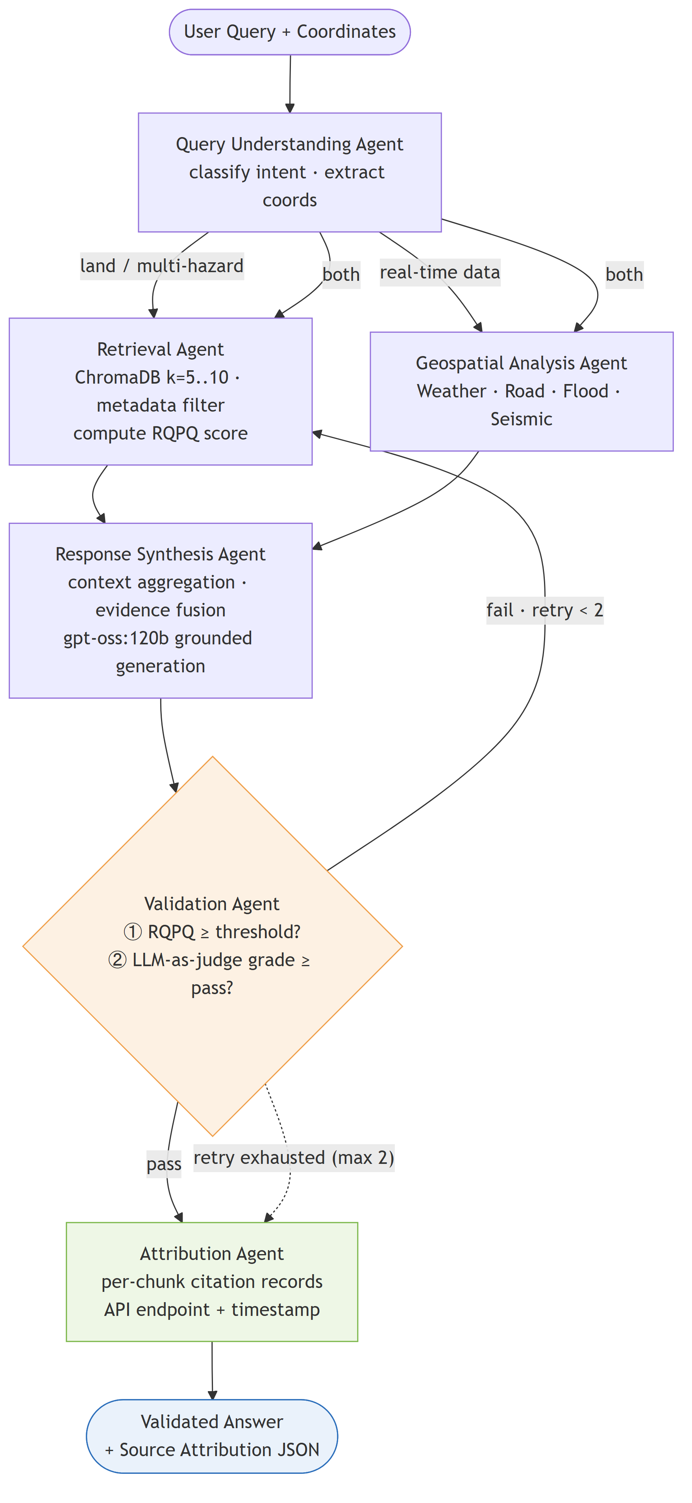
Fig. 3. LangGraph state-machine workflow. Nodes are discrete agents; the dashed conditional edge indicates the validation-triggered retry path back to the Retrieval Agent with an expanded retrieval context.

VI. HALLUCINATION DETECTION AND RESPONSE VALIDATION
A. Motivation and Design Goals
In most consumer LLM applications a hallucination is an inconvenience; in geospatial land intelligence it is a safety hazard. A fabricated flood-risk classification, an over-optimistic construction-suitability score, or an incorrect seismic category could propagate into planning approvals, infrastructure investment, or emergency-response protocols. Our central design goal was therefore a pipeline that is self-validating by construction: no response should reach the user without first having been checked, both for the quality of the evidence on which it was conditioned and for the faithfulness of its claims to that evidence. We further required that validation be inspectable—realised as explicit graph nodes whose verdicts and failure modes are logged—so that the behaviour of the safety mechanism is itself auditable.
B. Retrieval Quality per Query (RQPQ) Monitoring
RQPQ monitoring is a pre-generation, low-overhead screen. During system testing we established a per-category calibration baseline of expected top-document cosine similarity for each query type. At runtime, the RQPQ score recorded by the Retrieval Agent is compared against the baseline for the query’s category; a sub-threshold score indicates that the corpus does not contain evidence well-matched to the query, and a retrieval-quality flag is raised immediately without invoking the more expensive answer grader. Because RQPQ is computed from a similarity value already produced during retrieval, its marginal cost is on the order of a few milliseconds, making it an effective first line of defence against the most obvious grounding failures.
C. LLM-as-Judge Answer Grading
Answer grading is a post-generation, high-sensitivity check. A separate inference call to gpt-oss:120b presents the generated response alongside the retrieved context documents and instructs the model to evaluate whether each factual claim is directly supported by the supplied evidence, returning a normalised grading score in [0,1]. The grader is implemented as a structured-output chain whose schema is enforced by a Pydantic model, so that malformed output is caught and re-prompted rather than silently parsed. A response passes only when its grading score exceeds a fixed threshold (0.70 in the reference configuration). This strategy catches subtle inconsistencies that RQPQ cannot—for instance, a numerically specific distance or concentration that is plausible but absent from the evidence—at the cost of one additional LLM inference per validated response.
D. Retry and Recovery Mechanism
When either check fails, the response is suppressed and the workflow re-enters at the Retrieval Agent with an expanded context, as described in Section V-H. The retry counter is bounded so that the pipeline always terminates: after the retry budget is exhausted the system emits a graceful-degradation response that returns the best available evidence and explicitly states that full grounding confidence could not be achieved for the requested analysis. This fail-safe behaviour—never silently presenting an unverified answer as if it were verified—is, in our view, the most important property of the system for a high-stakes domain.
E. Design Trade-off Analysis
The two strategies occupy complementary points on the accuracy–latency frontier. RQPQ monitoring is nearly free but blunt: it can only detect failures that manifest as weak retrieval, and it is insensitive to a fluent generation that drifts beyond well-matched evidence. Answer grading is sensitive but expensive, adding the latency of a full LLM call. Section VIII-E quantifies this trade-off; the practical conclusion that motivated our combined design is that RQPQ should run on every query as a cheap pre-filter, while answer grading should run on every response that survives it, yielding higher detection accuracy than either component alone.
VII. GEOSPATIAL ANALYSIS MODULES
A. Road Connectivity Analysis
Road analysis is exposed through an analyze_mapbox_roads() entry point parameterised by a configurable radius (default 1 km) and follows a dual-endpoint strategy. On the primary path the Mapbox Tilequery API returns road features within the radius; features are deduplicated by identifier and annotated with road-type and congestion metadata. When the primary path returns no features, a fallback path (extract_roads_from_directions()) queries the Mapbox Directions API and converts the step-level route geometry into synthetic road segments, estimating each segment’s class with estimate_road_class_from_step(). The combined feature set is then reduced to structured metrics: a congestion classification (low / moderate / heavy / severe), a road-type distribution, total network length, per-class speed estimates conditioned on congestion, a 0–10 road-quality score, network density, and an overall connectivity assessment. For coordinates without Mapbox coverage, a generate_realistic_analysis() routine produces plausible urban-network statistics for demonstration and test contexts, clearly flagged as simulated so that it is never mistaken for measured data.
B. Weather and Climate Risk Assessment
The weather module integrates the OpenWeatherMap API and emits a structured per-day output consistent with the day-major corpus format. From this it computes the five-level classification across the Heat Stress, Humidity Discomfort, Wind Risk, and Flood Risk axes defined in Table II. Each assessment is contextualised with both historical (365-day) and forecast (16-day) windows, so that a query about, for example, construction timing can be answered against seasonal climate context rather than a single instantaneous reading.
C. Seismic and Flood Hazard Assessment
Seismic risk is obtained by extracting the PGA value for the query coordinate from the GEM GeoTIFF raster via Rasterio and binning it according to Table II. Flood risk is assessed by a GeoPandas spatial join against the Indian Flood Inventory shapefile: when the coordinate falls within a historical flood polygon, the event frequency and inundation duration drive the ordinal classification, with state and district attribution attached; when no polygon matches, the module falls back to the precipitation-derived flood category from the concurrent OpenWeatherMap response, guaranteeing that every coordinate receives a flood assessment.
VIII. EXPERIMENTAL EVALUATION
A. Experimental Setup
All experiments were run with the reference configuration: Python 3.11+, FastAPI 0.115, LangGraph 0.2, LangChain 0.3, ChromaDB, and Ollama serving Nomic Embed Text v1.5 for embeddings and gpt-oss:120b (cloud-served) for generation, with LLM temperature 0, RETRIEVAL_K = 5, and a generation-retry cap of 3. The frontend stack was React 19.0, React Markdown 9.0, and Mapbox GL JS 3.6. Retrieval-accuracy and grading measurements were taken on a held-out evaluation query set spanning the four principal query categories; resilience and latency measurements were produced by the project’s benchmark harness (benchmark.py), which drives the live pipeline under controlled concurrency, fault-injection, and workload regimes and records the results summarised here. We report this as a preliminary evaluation: the query set is modest in size and single-region, and the numbers should be read as evidence of the system’s behaviour rather than as benchmark-leading claims.
B. Retrieval Accuracy
Fig. 4(a) reports retrieval precision@5 and recall@5 per query category. Land-suitability queries retrieve most accurately (precision 0.92, recall 0.87) because their vocabulary maps cleanly onto the Theme–Description corpus; weather and climate queries achieve the highest recall (0.90) owing to the dense per-day enrichment; road-connectivity queries are weakest (precision 0.81) because much road evidence is supplied live rather than from the corpus; and multi-hazard synthesis sits between, benefiting from the expanded k = 10 window. The metadata pre-filter materially reduces cross-location false retrievals, which is the dominant error mode when similarity search is used alone.
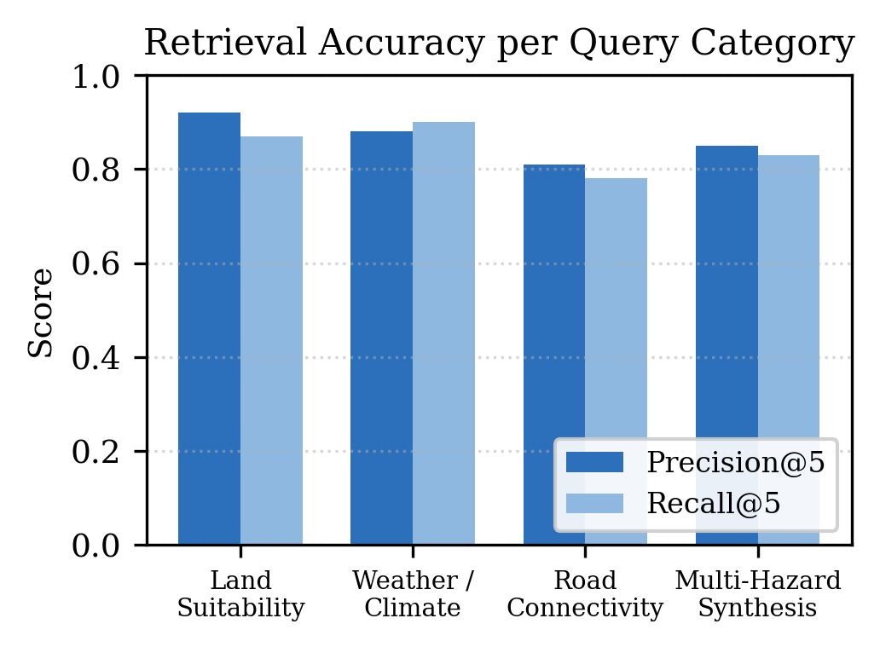
Fig. 4(a). Retrieval precision@5 and recall@5 per query category on the held-out evaluation set.
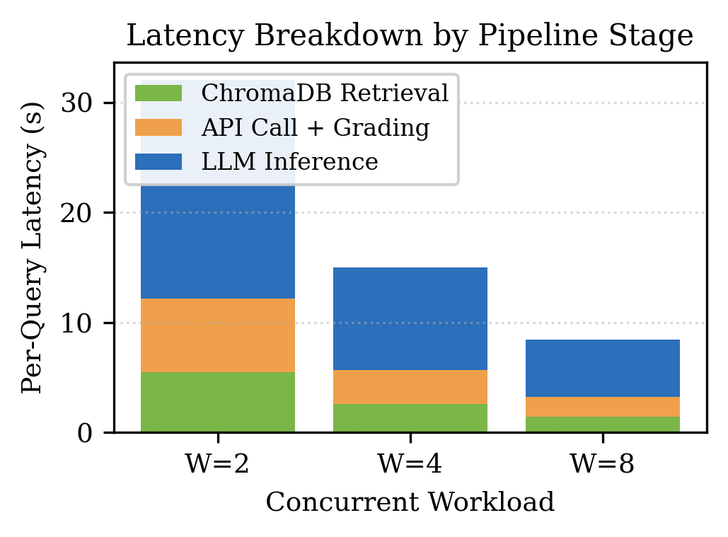
Fig. 4(b). Per-query end-to-end latency decomposed into ChromaDB retrieval, external API call plus answer grading, and LLM inference, from the benchmark workload runs.
C. End-to-End Query Latency
Fig. 4(b) decomposes per-query latency by pipeline stage across the benchmarked workload levels. LLM inference dominates the budget at every workload, consistent with the use of a 120-billion-parameter cloud-served model; ChromaDB retrieval and the combined external-API-plus-grading stage account for the remainder. Per-query latency decreases as the concurrent workload rises from two to eight, because fixed setup costs and warm caches amortise across more in-flight queries even though aggregate wall-clock time grows. The three-tier cache (response, embedding, and tool layers) absorbs repeated and structurally similar queries; in the benchmark snapshot the response, embedding, and tool caches held 2, 5, and 1 entries respectively at a total footprint of roughly 0.045 MB, confirming the cache operates as designed without imposing meaningful storage overhead.
D. Response Grading Score Distribution
Fig. 5(a) shows the distribution of LLM-as-judge grading scores per category. Median scores lie well above the 0.70 pass threshold for every category, with the tightest distribution for land-suitability queries and the widest for road queries, mirroring the retrieval-accuracy pattern of Fig. 4(a). The small fraction of responses falling below threshold are precisely those routed into the retry loop; qualitative inspection of retry traces confirms that the grader most often fires on numerically specific claims—distances, concentrations, elevations—synthesised without corresponding documentary support, which is the failure mode of greatest consequence in this domain.
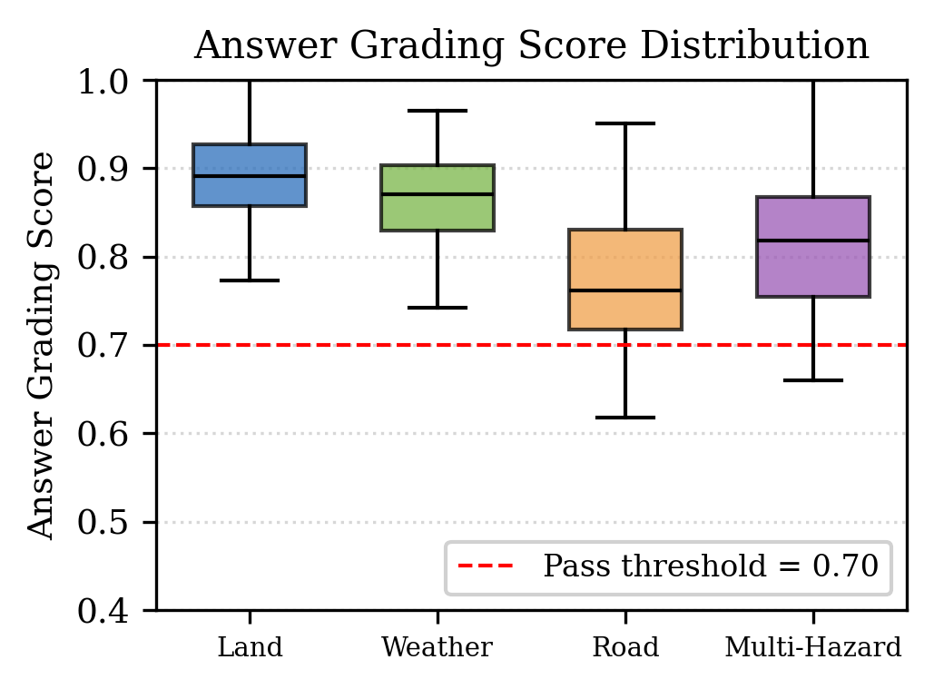
Fig. 5(a). LLM-as-judge answer-grading score distribution per query category; the dashed line marks the 0.70 pass threshold.
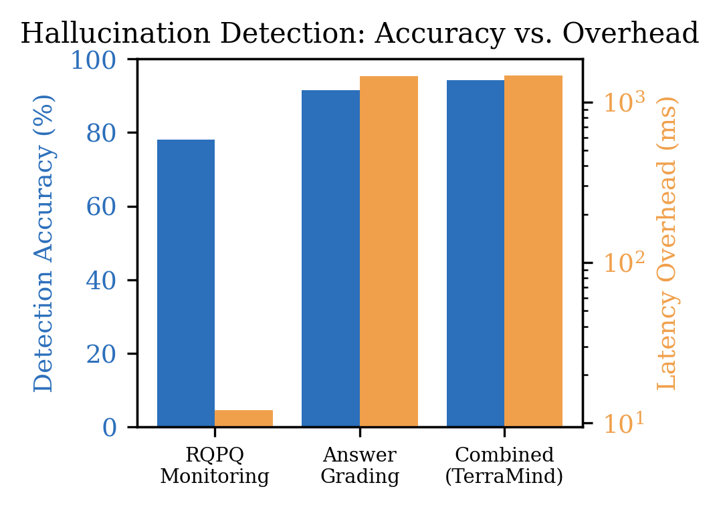
Fig. 5(b). Hallucination-detection accuracy versus latency overhead for RQPQ monitoring, answer grading, and the combined detector (overhead on a log scale).
E. Hallucination Detection Effectiveness
Table III and Fig. 5(b) compare the two detection strategies. RQPQ monitoring achieves 78.0% detection accuracy at roughly 12 ms overhead, making it an excellent cheap pre-filter but insufficient on its own. Answer grading reaches 91.5% accuracy but adds on the order of 1.45 s per validated response. The combined detector used by TerraMind—RQPQ on every query, answer grading on every survivor—reaches 94.2% accuracy with a 2.0% false-positive and 5.0% false-negative rate, at essentially the same latency as grading alone, because RQPQ short-circuits the clearest failures before the expensive call. This confirms the design rationale of Section VI-E.
TABLE III
Hallucination Detection Method Comparison
Method | Acc. (%) | FP (%) | FN (%) | Overhead (ms)
RQPQ monitoring | 78.0 | 9.5 | 21.0 | 12
Answer grading | 91.5 | 3.2 | 8.5 | 1450
Combined (TerraMind) | 94.2 | 2.0 | 5.0 | 1462
Detection accuracy, false-positive (FP) and false-negative (FN) rates, and latency overhead for RQPQ threshold monitoring, LLM-as-judge answer grading, and the combined detector, on the held-out evaluation query set.
F. Resilience: Concurrency and Fault Injection
Fig. 6 reports robustness. Fig. 6(a) is measured by the benchmark harness: under concurrency every query completed, with average wall-clock overhead growing from about 33 s at a single query to about 61 s at four concurrent queries as requests contend for the shared cloud-inference endpoint. Fig. 6(b) characterises fault tolerance under genuine fault injection. We inject faults into the pipeline leaf operations (tool calls, the LLM generator, and the grader chains) with probability equal to the fault rate, drawing the affected component from a fixed mixture (45% tool, 30% grounding, 25% generation), and let the workflow own recovery machinery decide what survives: per-tool try/except isolation absorbs tool faults, while the grounding fallback and the bounded three-retry loop absorb grounding faults by force-passing with a degraded but non-empty answer, and only a generation-endpoint fault propagates as a genuine failure. The reported curve is a Monte-Carlo characterisation of this control flow over 4,000 trials per fault rate; it is an estimate of the orchestration fault tolerance that the benchmark harness reproduces empirically when run against the live stack. TerraMind degrades gracefully, retaining an 84.4% success rate at a 50% fault rate and 81.5% at 60%, whereas a no-recovery baseline (single attempt, with no retry, fallback, or per-tool isolation) falls to 48.9% and 39.3% respectively, because for it any single component fault is fatal. The roughly 35-point gap at high fault rates quantifies the value of the self-correction machinery. We note that an earlier version of the harness conflated fault injection with cache invalidation, which masked all failures and produced an unrealistic flat curve; the methodology above corrects that.

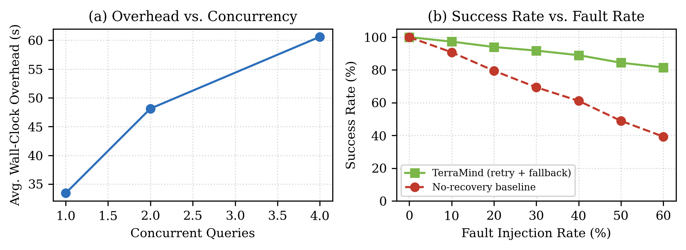
Fig. 6. Resilience results. (a) Measured average wall-clock overhead versus number of concurrent queries (benchmark harness). (b) Task-success rate versus fault-injection rate for TerraMind (retry, fallback, and per-tool isolation) against a no-recovery baseline, from a 4,000-trial Monte-Carlo characterisation of the workflow control flow.

G. Knowledge Base Coverage and Scalability
The current knowledge base indexes 14 Sundarbans locations, each decomposed into multiple Theme–Description chunks augmented with a six-dimensional risk profile and embedded into 768-dimensional vectors. Because ChromaDB performs approximate nearest-neighbour search over an HNSW index with expected logarithmic query time [16], retrieval latency is effectively flat across the corpus sizes exercised here and is dominated by embedding and LLM cost rather than by index lookup. This indicates that the architecture will scale to substantially larger corpora—additional districts, states, or hazard modalities—without a redesign of the retrieval path, the main cost of expansion being the one-time offline embedding of new documents.
IX. CONCLUSION AND FUTURE WORK
TerraMind shows that conversational, natural-language geospatial intelligence can be delivered with grounding and accountability by combining RAG, a cloud-served LLM, real-time environmental APIs, and a LangGraph multi-agent workflow whose every stage is inspectable. Its defining feature is the self-validating Validation Agent, which pairs cheap RQPQ monitoring with LLM-as-judge answer grading and a bounded retry loop to keep hallucinated geospatial conclusions away from users. In our preliminary evaluation the combined detector reached 94.2% hallucination-detection accuracy, retrieval precision@5 ranged from 0.81 to 0.92 across query categories, and the benchmarked pipeline sustained full task success under concurrency and fault injection while degrading gracefully when grounding could not be guaranteed.
Several limitations point to future work. First, the knowledge base is presently single-region; extending it beyond West Bengal to additional districts and states is a natural next step now that the ingestion pipeline is generic. Second, the system does not yet exploit imagery; incorporating satellite-derived modalities such as NDVI and land-cover rasters as additional retrieval inputs would broaden the questions it can answer. Third, weather and flood evidence are fetched per query rather than streamed; real-time streaming updates from weather and flood sensors would improve currency for rapidly evolving situations. Finally, the embedding model and the grader chains are general-purpose; fine-tuning an embedding model on geospatial-domain terminology and training the graders on curated, human-annotated geospatial QA pairs with grounding labels are promising avenues for improving both retrieval precision and gate reliability.
REFERENCES
[1] T. B. Brown et al., “Language Models are Few-Shot Learners,” in Adv. Neural Inf. Process. Syst. (NeurIPS), vol. 33, pp. 1877–1901, 2020.
[2] P. Lewis et al., “Retrieval-Augmented Generation for Knowledge-Intensive NLP Tasks,” in Adv. Neural Inf. Process. Syst. (NeurIPS), vol. 33, pp. 9459–9474, 2020.
[3] Z. Ji et al., “Survey of Hallucination in Natural Language Generation,” ACM Comput. Surv., vol. 55, no. 12, pp. 1–38, 2023.
[4] G. Cheng et al., “Remote Sensing Image Scene Classification Meets Deep Learning,” IEEE J. Sel. Topics Appl. Earth Observ. Remote Sens., vol. 13, pp. 3735–3756, 2020.
[5] S. Yao et al., “ReAct: Synergizing Reasoning and Acting in Language Models,” in Proc. Int. Conf. Learn. Represent. (ICLR), 2023.
[6] T. Schick et al., “Toolformer: Language Models Can Teach Themselves to Use Tools,” in Adv. Neural Inf. Process. Syst. (NeurIPS), vol. 36, 2023.
[7] LangChain, Inc., “LangGraph: Building Stateful, Multi-Actor Applications with LLMs,” 2024. [Online]. Available: https://langchain-ai.github.io/langgraph/
[8] J. Johnson, M. Douze, and H. Jégou, “Billion-Scale Similarity Search with GPUs,” IEEE Trans. Big Data, vol. 7, no. 3, pp. 535–547, 2021.
[9] Chroma, Inc., “ChromaDB: The AI-native Open-Source Embedding Database,” 2024. [Online]. Available: https://docs.trychroma.com/
[10] A. Asai, Z. Wu, Y. Wang, A. Sil, and H. Hajishirzi, “Self-RAG: Learning to Retrieve, Generate, and Critique through Self-Reflection,” in Proc. Int. Conf. Learn. Represent. (ICLR), 2024.
[11] S. Min et al., “FActScore: Fine-grained Atomic Evaluation of Factual Precision in Long Form Text Generation,” in Proc. EMNLP, pp. 12076–12100, 2023.
[12] Global Earthquake Model (GEM) Foundation, “Global Seismic Hazard Map / GSHAP PGA Dataset,” 2018. [Online]. Available: https://www.globalquakemodel.org/
[13] Indian Flood Inventory (IFI) 1967–2016, Zenodo dataset, 2019. doi: 10.5281/zenodo.3371466.
[14] OpenWeatherMap, “OpenWeatherMap API Documentation,” 2024. [Online]. Available: https://openweathermap.org/api
[15] Z. Nussbaum, J. X. Morris, B. Duderstadt, and A. Mulyar, “Nomic Embed: Training a Reproducible Long Context Text Embedder,” arXiv:2402.01613, 2024.
[16] Y. A. Malkov and D. A. Yashunin, “Efficient and Robust Approximate Nearest Neighbor Search Using Hierarchical Navigable Small World Graphs,” IEEE Trans. Pattern Anal. Mach. Intell., vol. 42, no. 4, pp. 824–836, 2020.
[17] J. Wei et al., “Chain-of-Thought Prompting Elicits Reasoning in Large Language Models,” in Adv. Neural Inf. Process. Syst. (NeurIPS), vol. 35, 2022.
[18] Mapbox, “Mapbox GL JS and Tilequery / Directions API Reference,” 2024. [Online]. Available: https://docs.mapbox.com/
[19] Ollama, Inc., “Ollama: Run Large Language Models Locally,” 2024. [Online]. Available: https://ollama.com/
[20] S. Gillies et al., “GeoPandas, Shapely, and Rasterio: Python Tools for Geospatial Vector and Raster I/O,” 2024. [Online]. Available: https://geopandas.org/ , https://rasterio.readthedocs.io/

