**SEMINAR REPORT**

**Entitled**

**“MONITORING SYSTEM FOR AIR POLLUTION USING IOT”**

***Submitted to the Department of Electronics Engineering***

***In Partial Fulfillment of the Requirement for the Degree of***

Bachelor of Technology

( ELECTRONICS & COMMUNICATION )

**Presented & Submitted By :**

Mr/Ms. ABHISHEKH KANOJIYA

(Roll No. U21EC070)

B. TECH. III (EC), 5th Semester

***Guided By :***

Prof./Dr. A.S MANDLOI

Professor or Associate Professor or Assistant Professor, ECED.



**(Year : 2023-24)**

**DEPARTMENT OF ELECTRONICS ENGINEERING**

Sardar Vallabhbhai National Institute of Technology

Surat-395007, Gujarat, INDIA.

**Sardar Vallabhbhai National Institute of Technology**

Surat-395 007, Gujarat, INDIA.

**DEPARTMENT OF ELECTRONICS ENGINEERING**



CERTIFICATE

This is to certify that the **SEMINAR REPORT** entitled **“MONITORING SYSTEM FOR AIR POLLUTION USING IOT”** ispresented & submitted by Candidate **Mr./Ms. ABHISHEKH KANOJIYA**, bearing **Roll No.U21EC070**, **of B.Tech. III, 5th Semester** in the partial fulfillment of the requirement for the award of **B. Tech.** degreein **Electronics & Communication Engineering** for academic year 2023-24.

He has successfully and satisfactorily completed his/her **Seminar Exam** in all respect. We, certify that the work is comprehensive, complete and fit for evaluation.

Prof. / Dr. A.S MANDLOI

Professor or Associate Professor or Assistant Professor &

**Seminar Guide**

**SEMINAR EXAMINERS :**

**Name of Examiner Signature with date**

1. Dr. Z.M PATEL __________________

2. Dr. P.J ENGINEER __________________

Dr. J. N. Sarvaiya **DEPARTMENT SEAL**

Professor & **Head, DECE, SVNIT (November - 2023)**

.

**ABSTRACT**

**Monitoring system for Air pollution using IOT**

This study introduces a smart way to tackle air pollution: the Monitoring System for Air Pollution using the Internet of Things (IoT). Imagine a network of smart sensors scattered across neighborhoods, always on the lookout for harmful things in the air, like smoke and dust. These sensors work together and send real-time data to a central system. This information helps us understand when the air is not safe to breathe. The best part? Anyone can access this information easily through simple apps, empowering people to make decisions to protect their health.

Beyond that, it's a reminder for all of us to be kinder to our environment. By using this system, we're not just monitoring air quality; we're also encouraging everyone to live in a way that keeps our air clean. This initiative is a step towards a future where everyone, armed with knowledge, works together for a healthier, safer world.

Signature of Student__________________

Name of Student: Abhishekh Kanojiya

Roll No. U21EC070

Guide Name: Dr.A.S Mandloi

Seminar Date & Time : 4/11/2023

Examiners’ Names :

1) Dr.Z.M patel

2) Dr.P.J Engineer

ACKNOWLEDGEMENT

This acknowledgement is a mark of gratitude for each and every one who helped and encouraged me with their efforts to work on this seminar topic. It is a great pleasure for me to present my seminar on this topic.

I wish to extend my sincere gratitude to my seminar guide, Dr. A.S Mandloi for his invaluable guidance, constant help, support, and constructive suggestions which have been very much helpful in the successful completion of this seminar.

I am also grateful to my parents and friends for their timely aid, without which I would not have finished my seminar successfully. I extend my thanks to all my well-wishers and all those who have contributed directly and indirectly to the completion of this work. I put my best efforts in making this seminar report mistakes free. Apologizes for any mistakes.

Student Signature:

Student Name:Abhishekh kanojiya

Roll No.: U20EC070

**Table of contents**

Acknowledgements .......................................................................................................03

Abstract..........................................................................................................................04

Table of Contents...........................................................................................................05

List of Figures................................................................................................................07

Chapters

1 INTRODUCTION ..................................................................................................07

* 1. significance of monitoring air quality ……………………………………07
  2. Objectives ………………………………………………………………...09
  3. Organization of the report………………………………………………...09

1. Literature Review…………………………………………………………. 11

2.1 surveys ……………………………………………………………………….11

3 IoT Technology in Air Pollution Monitoring………………………..13

3.1 What is IoT..................................................................................................13

3.2 Introduction to IoT-based air pollution monitoring systems……………...14

3.3 Iot Architecture…………………………………………………………....15

3.3.1 Realization of Perceptual Layer Architecture…………………...16

3.4 Realization of Network Layer………………………………………….....16

3.4.1 Data Transmission and Connectivity…………………………...17

3.4.2 ESP8266 Serial-to-Wi-Fi Module…………………………….17

3.4.3 TCP Packet Transmission………………………………………17

3.4.4 Gateway (Raspberry Pi 3)……………………………………...17

3.4.5 Service-Oriented Architecture………………………………….18

3.4.6 Data Security and Reliability…………………………………..18

3.5 Realization of Application Layer…………………………………………..18

3.5.1 Data Collection and Transmission……………………………..19

3.5.2 Data Storage and Management…………………………………19

3.5.3 Webserver and Data Visualization……………………………...19 3.5.4 Webserver Enhancements………………………………………………19

* + 1. Internet of Things (IoT) Integration…………………………….19

1. Components of an IoT-Based Air Pollution Monitoring System……..21

4.1 Gas sensors………………………………………………………………21

4.1.1 Sensor Arrays for Low-Cost Environmental Monitoring………………..22

4.1.2 Calibration Procedure…………………………………………………...22

4.1.3 Challenges in Gas Detection………………………………………..22

4.1.4 Semiconductor Gas Sensors in Proposed Work……………………22

4.2 Nucleo F401REtx…………………………………………………………23

1. Case studies and examples…………………………………………25

5.1 Introduction………………………………………………………………..25

5.2 Key Features and Implementation…………………………………………25

5.3 Impact on Public Health and Environment………………………………..26

5.4 Lessons Learned from BreatheEasy……………………………………….27

5.5 Conclusion………………………………………………………………....27

1. Challenges and Future Trends……………………………………..31

6.1 Challenges in IoT-Enabled Air Pollution Monitoring Systems……………31

6.2 Future trends……………………………………………………………….32

conclusions ................................................................................................................33

References..................................................................................................................34

**List of Figures**

Fig 1. 1: Air pollution monitoring system architecture................................................................ 8

Fig 3.1: IoT Architecture……………………………………………………………………….14

Fig 3.2 IoT-based System’s Integral Design Architecture...........................................................15

Fig 3.3 IOT Architecture design ……………………………………………………………….16

Fig 3.4 Serial to Wi-Fi module................................................................................................... 17

Fig 3.5 Raspberry Pi 3.................................................................................................................18

Fig 3.6 Application layer.............................................................................................................20

Fig 3.7 monitoring system block diagram…………….………………………………………20

Fig 4.1 Architecture of single node............................................................................................ 21

Fig 4.2 nucleo F401RE Board................................................................................................... 23

Fig 4.3 experimental setup.........................................................................................................24

Fig 4.4 Webpage using MEAN stack......................................................................................... 24

Fig 5.1 logo................................................................................................................................ 25

Fig 6.1 Pollution monitoring...................................................................................................... 27

**Chapter 1**

**Introduction**

India is grappling with a severe air pollution crisis that poses a significant threat to public health and the environment. The country's rapid industrial growth, increasing vehicular emissions, and massive construction activities have contributed to soaring levels of air pollutants. Large metropolitan areas like Delhi, Mumbai, and Kolkata frequently experience hazardous air quality, with PM2.5 and PM10 levels often far above the recommended limits.

One of the major contributors to India's air pollution is industrial emissions. The presence of numerous industries, especially in urban centers, releases a cocktail of pollutants into the air. Additionally, construction activities, both large-scale infrastructural projects and smaller building constructions, contribute significantly to particulate matter in the atmosphere. Dust from these sites gets suspended in the air, further deteriorating air quality.

Agricultural practices also play a pivotal role in the air pollution scenario. The burning of crop residues, a common practice among farmers, releases large amounts of pollutants into the atmosphere. Despite government efforts to discourage this practice, it remains a major contributor to air pollution, especially during the post-harvest seasons.

Furthermore, household pollution from the use of solid fuels for cooking and heating purposes contributes significantly to indoor air pollution. The reliance on traditional fuels like wood, dung, and crop residues releases harmful particulates and gases, adversely affecting the health of millions, particularly women and children.

In response to this crisis, the Indian government has introduced various measures, including the implementation of odd-even vehicle schemes in cities like Delhi, promoting the use of cleaner fuels, and encouraging the adoption of renewable energy sources. However, the enforcement of these measures and raising public awareness remain significant challenges.

The consequences of India's air pollution crisis are dire. The high levels of pollutants have led to a surge in respiratory diseases, heart ailments, and other health issues among the population. It also has far-reaching environmental implications, impacting ecosystems, wildlife, and climate patterns. Tackling this crisis requires a comprehensive approach, involving stringent regulations, technological advancements, public awareness campaigns, and active participation from industries and citizens alike.

* 1. **significance of monitoring air quality**

Air pollution monitoring using technology is crucial for several reasons. Firstly, real-time data obtained through advanced monitoring systems allows for accurate assessment of air quality, enabling authorities to make informed decisions and implement targeted interventions. This data helps in identifying pollution hotspots, understanding pollution sources, and formulating effective policies to mitigate its impact on public health.

Secondly, technological monitoring facilitates early warning systems. By detecting sudden spikes in pollutant levels, authorities can issue timely alerts and advisories to the public, enabling them to take necessary precautions, such as wearing masks or avoiding outdoor activities. This proactive approach is essential in minimizing health risks, especially for vulnerable groups like children and the elderly.

Thirdly, technology-driven air pollution monitoring promotes transparency and accountability. Accessible, real-time data fosters public awareness and participation. Citizens armed with information can advocate for cleaner air, hold industries accountable for their emissions, and pressurize policymakers to enforce stricter regulations.

Additionally, advanced monitoring technologies aid in research and policy development. Scientists and researchers can analyze the data to understand the long-term trends, study the impact of pollution on health, and assess the effectiveness of implemented policies. This knowledge is instrumental in shaping evidence-based policies and regulations, ensuring a targeted and efficient approach to curbing air pollution.

Lastly, in the face of climate change, monitoring air pollution becomes even more critical. Understanding the interplay between air quality and climate change helps in devising comprehensive strategies that address both environmental challenges simultaneously. This holistic approach is essential for sustainable development and ensuring a healthier future for generations to come.

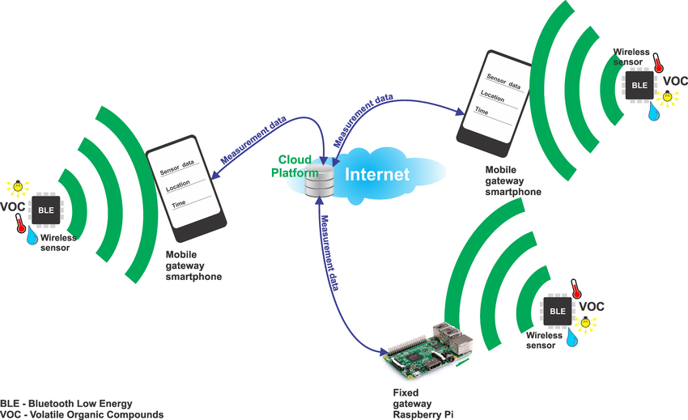

**Fig1.1:** Air pollution monitoring system architecture **[14]**

**1.2 Objectives**

The objective of this report is to explore the vital role of IoT technology in revolutionizing air pollution monitoring. It aims to introduce the significance of air quality monitoring, compare IoT-based systems with traditional methods, and delve into the components of an effective IoT-based monitoring system. The report will showcase real-world case studies, analyze the benefits and challenges of IoT implementation, and explore future trends. By providing valuable insights, the report aims to inform policymakers and researchers, contributing to the advancement of efficient and accurate air pollution monitoring systems.

**1.3 Organization of the report**

* In Chapter 1 we have discussed air pollution in India, the significance of air pollution monitoring, and the objective of this report.
* In Chapter 2 we will see a literature review in which various surveys done by researchers and the need for air pollution monitoring
* In Chapter 3, IOT architecture in detail, how to implement IoT projects in real life using sensors, microcontrollers, and database management system
* In Chapter 4, different components used in IoT architecture for instance Raspberry Pi 3, Wi-Fi module, sensors, and database(no SQL)
* In Chapter 5 case study
* In Chapter 6 challenges and future trends
* conclusion

**Chapter 2**

**Literature Review**

**2.1 Surveys**

Monika Singh Et al. in August 2019 proposed an Air Pollution Monitoring System. This system uses an Arduino microcontroller connected with MQ135 and MQ6 gas sensor which senses the different types of gases present in the environment. It is then connected to the Wi-Fi module which connects to the internet and LCD is used to display the output to the user and buzzer alerts when the ppm crosses a certain limit. Their applications were industrial perimeter monitoring, indoor air quality monitoring, site selection for reference monitoring stations, and making data available to users.

Yamunathangam Et al. in November 2018 used IoT by measuring the concentration of gas using various sensors which were observed through a serial monitor of Arduino. This data is collected in Thing speak channels by means of an Ethernet shield which is available in live for further processing. These analyzed results were viewed through Thing Speak in a graphical format. Then the average pollution level was calculated using Matlab analysis and the time-controlled results were viewed through an Android app. Further primarily based totally at the location, the air first-rate index price changed into acquired thru the Android app. Along with this, the fitness consequences had been additionally displayed on this app, in order that the customers can live aware about the pollutants levels

K. S. E. Phala Et al. in November 2014 presented an air quality monitoring system that consists of an air quality monitoring station, communication links, a sink node module, and a data server. They developed the GSM module-based sink node with a data server PC. The real-time facts had been stored in a micro SD card in textual content layout and additionally stored inside the facts server (PC). For the database, they chose MySQL as the DBMS. Electrochemical and infrared sensors were used to measure the concentrations of CO, CO2, SO2, and NO2. GSM modules have been used for wireless communication between the base station and the remote sensor node. The GSM modules communicate over cellular networks and an MCU was used to control all the processes on the sensor node. The MCU samples the sensor outputs the use of an inner ADC, it then calculates the fueloline concentrations and transmits the computed facts as packets for the use of the GSM. A test incubator was designed and constructed to evaluate the performance of the sensor node. The sensor node was tested by placing it inside the incubator; pumping gas into the incubator and observing the measurements taken by the sensor node. The base station comprises a sink node serially connected to a computer that runs the GUI software. The sink or receiving node captures the data transmitted by the remote sensor node and serially forwards it to the computer. The data was then plotted on the GUI and stored in text files.

Rajat Sankhe Et al. in 2017 used a carbon sensor for sensing the pollutants or the carbon particles in the air and it also detects the level of pollutants in the air and gives the output in the form of an analog signal. The microcontroller takes input in digital form so ADC was used to convert an analog output of the sensor into digital form and gives it as input to the microcontroller. These values are continuously displayed on the LCD. A switchpad was used for entering the critical value. If the value of pollutants in the air exceeds the critical value entered then the buzzer beeps and a notification will be sent to the webpage on the mobile phone by the microcontroller through the GPRS module. This information is continuously being updated on the webpage which can be accessed globally. A notification was also received on the webpage when the level of pollutants rose above the critical value. Mobile phone receives the signal frommodemwhichit forwarded to a server to the internet. Server analysis the data received from the smartphone. It concludes the output from the data received and sends the output over the internet.

**Chapter 3**

**IoT Technology in Air Pollution Monitoring**

**3.1 What is IoT**

The Internet of Things (IoT) has emerged as a transformative technology, creating a network of physical objects embedded with sensors and connectivity to exchange data efficiently. IoT facilitates seamless communication between devices and humans, enhancing convenience and efficiency in various sectors. At its core, IoT harnesses the power of data and connectivity to simplify and enrich our lives. Everyday objects, from household appliances to industrial machinery, are connected to the internet, allowing remote monitoring, data collection, and task automation. IoT devices are equipped with sensors that measure diverse parameters like temperature, humidity, motion, and light intensity.

Once collected, the data is transmitted to central hubs or cloud-based platforms for processing. Artificial intelligence and machine learning algorithms analyze this data, extracting valuable insights. Connectivity, established through technologies like Wi-Fi, cellular networks, and Bluetooth, is essential for IoT devices to communicate effectively.

IoT technology finds applications across various sectors. In healthcare, IoT enables remote patient monitoring and personalized care. Agriculture benefits from IoT by optimizing irrigation, monitoring crop health, and increasing yield. In transportation, IoT enhances fleet management, reduces congestion, and improves safety.

The scalability of IoT is remarkable, with the number of connected devices expected to reach billions. This growth fuels innovation and offers vast opportunities for advancement. The advent of 5G technology promises faster and more reliable connectivity, unlocking further potential for IoT applications. However, IoT also presents challenges, notably concerning security and privacy. As vast amounts of data are transmitted and stored, safeguarding sensitive information becomes paramount to prevent unauthorized access and breaches.

In summary, the Internet of Things revolutionizes industries by connecting physical devices, enabling data exchange, and enhancing efficiency. Despite challenges, IoT's potential to create a more connected world is vast, promising innovation and improved convenience in diverse areas of our lives.

**3.2 Introduction to IoT-based air pollution monitoring systems**

Air pollution is a significant problem caused by the release of toxic gases from industries, vehicle emissions, and an increase in harmful gases and particulate matter in the atmosphere. Factors such as industrial activities, urbanization, population growth, and vehicle use contribute to the rapid escalation of pollution levels, posing a serious threat to human health. Particulate matter, a key contributor to air pollution, necessitates real-time measurement and analysis for timely decision-making [2].

To address this issue, a real-time standalone air quality monitoring system is proposed in this paper. The Internet of Things (IoT) technology is utilized to create an efficient air quality monitoring setup. The system displays air quality in parts per million (PPM) on a webpage, enabling easy monitoring from computers or mobile devices [1].

The worsening air quality is attributed to various sources, including car emissions, industrial chemicals, smoke, and dust. The impact of air pollution on human health is severe, especially in areas where the air we breathe directly affects our lungs. Exposure to polluted air can lead to respiratory diseases such as asthma, coughing, and lung disorders [1]. Notably, air pollution is often imperceptible to human senses, containing hazardous substances such as LPG gas, carbon monoxide, and methane [2]. High concentrations of carbon monoxide, for instance, can cause dizziness, nausea, and even death within minutes.

In response to these challenges, the IoT Air Pollution Monitoring System is introduced as a solution. This project involves monitoring air quality over a web server through the internet. An alarm is triggered when the air quality deteriorates beyond a certain level, indicating the presence of harmful gases like CO2, smoke, alcohol, benzene, and NH3. The system displays air quality in PPM on an LCD and a webpage, enabling convenient monitoring from anywhere using computers or mobile devices. This innovative IoT project aims to enhance awareness and facilitate timely responses to mitigate the adverse effects of air pollution.

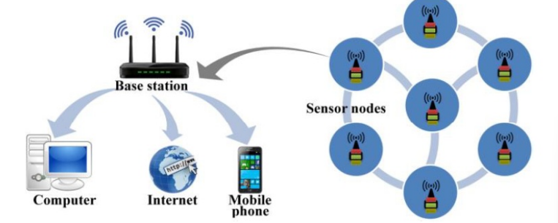

**Fig 3.1** Iot Architecture [2]

**3.3 Iot Architecture**

According to IoT architecture, the system is mainly composed of the perception layer (sensing layer), network layer, and Presentation layer.

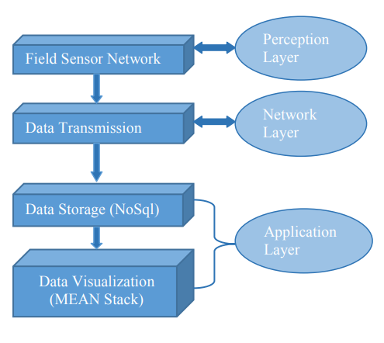

**Fig 3.2** IoT-based System’s Integral Design Architecture [2]

**3.3.1 Realization of Perceptual Layer Architecture**

The perception layer mainly includes the Field Sensor Network which is based on a front-end acquisition device. This sensor network hardware platform includes low low-power embedded microcontroller with onboard sensors [10]. In the proposed work we use Nucleo F401REtx (a 32-bit ARM Microcontroller) with a semiconductor gas sensor to make a simple node that collects and transmits a limited amount of data to a central controller or gateway (Raspberry Pi 3) which provides connectivity to the Internet.

In the present work, we are using only two sensor nodes, one node with MQ7 and the other with MQ135 (MQ7 is a carbon monoxide sensor and MQ135 detects NH3, CO2, etc.). The Air quality sensor MQ 135 will monitor the proportion of NH3, CO2, Benzene smoke etc. However, the sensor MQ 7 will monitor the CO emission in the environment. The output will be the array of numbers that will indicate the proportion of the gases in the environment in terms of Parts per Million (PPM). We program the Nucleo (Sensor Node) to read the analog value of a Sensor plugged into a simple circuit

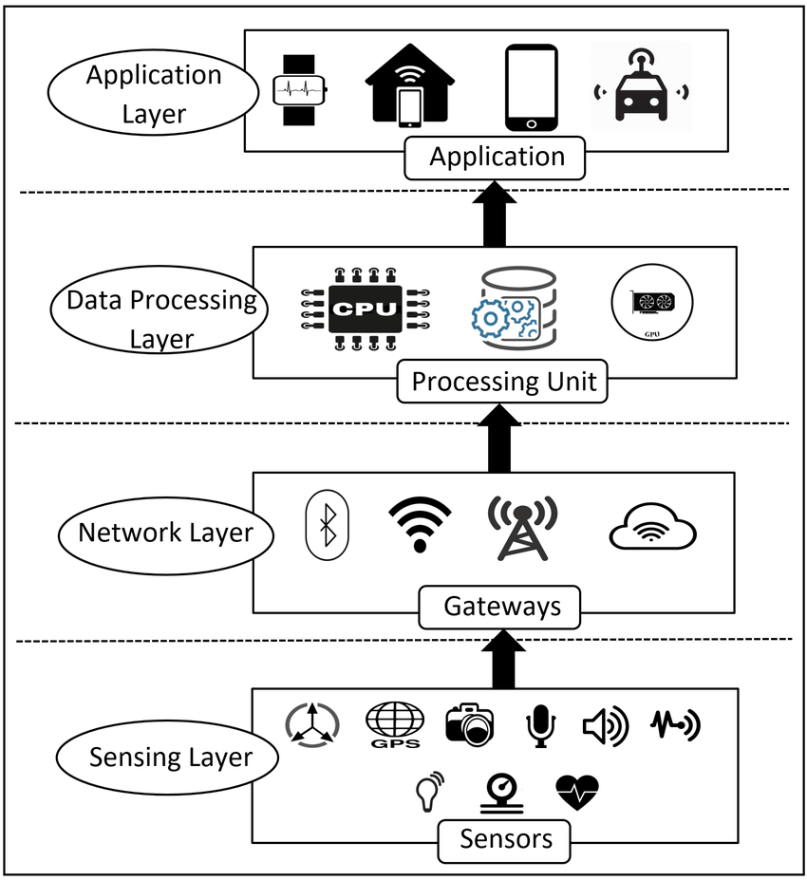

**Fig 3.3** IOT Architecture [5]

**3.4 Realization of Network Layer**

The network layer serves as the backbone of the air pollution monitoring system, facilitating the seamless transmission of sensed data from various deployed air sensors to a central server in real-time. This layer is critical in ensuring that the monitoring system functions efficiently and delivers accurate, up-to-date information to the data center. Here's an expanded explanation of its primary functions and the technology employed:

**3.4.1 Data Transmission and Connectivity:**

The network layer establishes a robust communication network between multiple air sensors scattered across the monitoring area. These sensors collect real-time air quality data, including parameters like PM2.5, NO2, and CO. The network layer ensures that this data is efficiently transmitted to a central server. This connectivity is crucial for continuous data collection and analysis.

**3.4.2 ESP8266 Serial-to-Wi-Fi Module**

In the proposed monitoring system, a cost-effective solution is employed using the ESP8266 Serial-to-Wi-Fi module. This module acts as a bridge between the sensors and the central server, enabling wireless data transmission. The ESP8266 module is chosen for its low cost, low power consumption, and full support for TCP/UDP stack. It ensures reliable data transfer from individual nodes (sensors) to a central collection point.

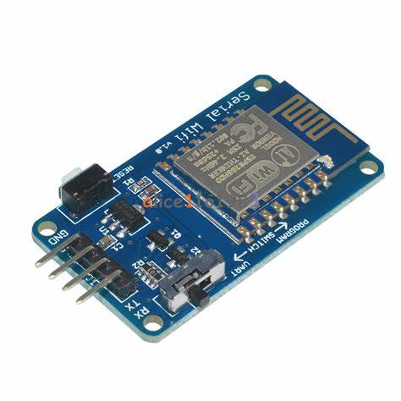

**Fig 3.4** Serial to wifi module [1]

**3.4.3 TCP Packet Transmission**

Data is transferred wirelessly in the form of TCP (Transmission Control Protocol) packets. TCP offers a reliable, connection-oriented method for transmitting data over the network. Each air sensor acts as a simple node, sending TCP packets containing the sensed data. These packets are transmitted over Wi-Fi and received by a central gateway, in this case, a Raspberry Pi 3.

**3.4.4 Gateway (Raspberry Pi 3)**

At the heart of the monitoring system, a Raspberry Pi 3 serves as the central data collection point or gateway. It receives the TCP packets containing air quality data from the sensors. The Raspberry Pi 3 processes, aggregates, and stores this data in a structured format for further analysis. Additionally, it can perform real-time data validation and handle error recovery, ensuring the integrity of the collected data.

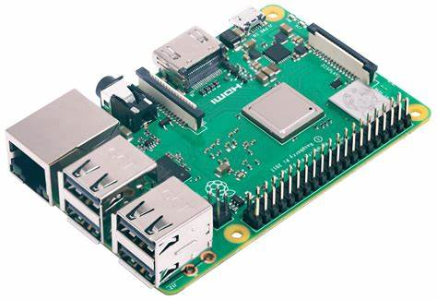

**Fig 3.5** raspberry pi 3 [2]

**3.4.5 Service-Oriented Architecture:**

The transmission system is designed following a service-oriented architecture (SOA) approach. SOA allows for modular and scalable development. It enables seamless integration of new sensors or components into the existing system without disrupting the entire infrastructure. This flexibility is vital for accommodating future expansion and incorporating advanced sensor technologies.

**3.4.6 Data Security and Reliability:**

The network layer also addresses concerns related to data security and reliability. Secure communication protocols and encryption techniques can be implemented to safeguard the transmitted data from unauthorized access. Additionally, error-checking mechanisms ensure that the data packets are received without corruption, maintaining the reliability and accuracy of the air quality information.

In summary, the network layer, facilitated by the ESP8266 module and supported by the Raspberry Pi 3 gateway, plays a pivotal role in establishing a reliable, real-time data transmission system. By employing TCP packet transmission and adhering to service-oriented architecture principles, the system ensures the secure, efficient, and scalable flow of air quality data from sensors to the central data center, forming the foundation for informed decision-making and effective pollution control measures.

**3.5 Realization of Application Layer**

The application layer of our system serves as the brain behind processing, analyzing, and predicting air pollutant data, as well as evaluating air quality and forecasting its future trends. This layer encompasses two primary functionalities: air quality evaluation and air pollution forecasting. In our innovative approach, the Application layer is centered around a Base Station, a Raspberry Pi micro-computer, which acts as the central hub for managing data transmitted from nodes deployed in the monitoring area.

**3.5.1 Data Collection and Transmission:**

The Base Station, powered by a Raspberry Pi micro-computer, is equipped to handle the data transmitted from the distributed nodes. Utilizing a TCP server implemented with Node.js, the Base Station efficiently collects real-time air quality data from the nodes. The Node.js runtime facilitates seamless handling of asynchronous data transmission, ensuring a smooth flow of information from multiple sources to the central processing unit.

**3.5.2 Data Storage and Management:**

To store the vast amount of collected data, a NoSQL database, MongoDB, is installed on the Raspberry Pi. MongoDB offers a flexible and scalable solution, allowing the Base Station to store the data in a structured format. This database management system efficiently organizes the data, making it readily accessible for analysis and evaluation.

**3.5.3 Webserver and Data Visualization:**

The Base Station also functions as a web server for data visualization purposes. A dynamic and user-friendly webpage is developed using the MEAN stack (MongoDB, Express, Angular.js, Node.js). Express, a minimal and flexible Node.js web application framework, facilitates the creation of robust APIs, while Angular.js enables the development of interactive and responsive user interfaces. The combination of these technologies ensures a seamless user experience.

**3.5.4 Webserver Enhancements:**

To enhance functionality and security, Nginx, a high-performance web server, is installed. Nginx offers additional features such as load balancing, reverse proxy, and SSL/TLS encryption, ensuring a robust and secure communication channel. Additionally, Port Forwarding is implemented, enabling the assignment of a DNS to the Raspberry Pi's IP address. This configuration allows users to access the web server and its visualized data from anywhere in the world via the assigned DNS.

**3.5.5 Internet of Things (IoT) Integration:**

The complete system exemplifies the concept of the "Internet of Things" (IoT). It leverages Nucleo board-based motes (nodes) for real-time pollution monitoring. These nodes form a wireless network, communicating with the Base Station to process data in a distributed information system. By employing wireless technology, the system achieves a decentralized yet interconnected architecture, a hallmark of IoT applications.

In summary, our innovative approach integrates sophisticated technologies to create a robust and scalable air pollution monitoring system. The Base Station, driven by a Raspberry Pi micro-computer, acts as the nerve center, managing data transmission, storage, analysis, and visualization. Through the seamless integration of IoT devices and web technologies, the system not only evaluates current air quality but also predicts future trends, making it a powerful tool for environmental monitoring and public health management.

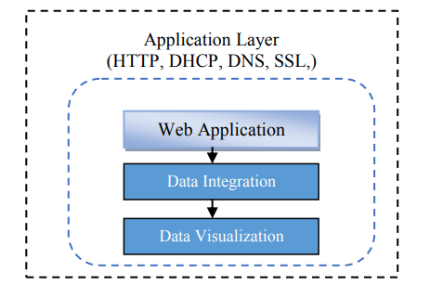

**Fig 3.6** Application layer [1]

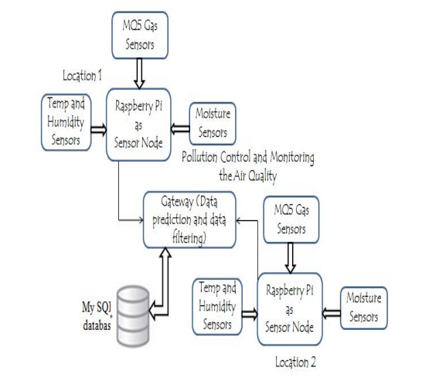

Fig 3.7 monitoring system block diagram [5]

**Chapter 4**

**Components of an IoT-Based Air Pollution Monitoring System**

In this section, we describe the different components of the pollution Monitoring system. The overall system architecture is depicted in Figure 3.6. It can be seen that integration of hardware and software platforms is obtained by combining web server, and database server gateway from the sensor nodes themselves. In contrast with the large-scale monitoring system at TEO, the system offered in this paper is designed for small-scale environment monitoring.

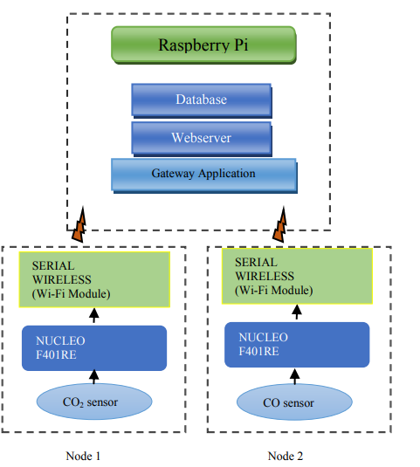

**Fig 4.1** Architecture of single node [2]

**4.1 Gas sensors**

In our laboratory IoT systems, the front end comprises the essential components, often referred to as the "Things" in the IoT ecosystem. These devices are designed with the primary purpose of either collecting environmental data from their surroundings (sensors) or providing data to the environment (actuators). Specifically, these devices play a crucial role in environmental monitoring by collecting data on various parameters.

**4.1.1 Sensor Arrays for Low-Cost Environmental Monitoring:**

Utilizing low-cost semiconductor sensors arranged in an array form is a practical approach for cost-effective environmental pollution monitoring systems. These sensors can measure pollutants and provide valuable data. To enhance their capabilities, additional sensors measuring parameters such as temperature, pressure, and relative humidity can be integrated into the array. This integration enables the measurement of pollutant concentrations alongside other physical parameters, offering the advantage of improved sensor calibration and accuracy.

**4.1.2 Calibration Procedure:**

Calibrating gas sensors is a critical process to ensure accurate and reliable measurements. The calibration procedure is typically conducted in two steps:

**- Zero Calibration**: Determining the initial position (zero) of the sensor, which involves using "zero air." However, defining a standard for "zero air" poses challenges. As a workaround, sensors are calibrated in clean air conditions in the morning to establish the zero point, considering the unavailability of controlled temperature and humidity conditions.

**- Span Calibration:** Determining the span of the sensor to establish accurate measurements for specific gases. This step ensures that the sensor can distinguish between different gas concentrations effectively.

**4.1.3 Challenges in Gas Detection:**

No single gas sensor is 100% specific to a particular gas. Therefore, analytical techniques are employed to identify gases accurately. Instruments, like Fourier transform infrared (FTIR) devices, gas chromatographs, and mass spectrometers, are utilized to precisely identify gases based on their unique spectral or chemical characteristics. These instruments offer a higher level of specificity compared to semiconductor gas sensors.

**4.1.4 Semiconductor Gas Sensors in Proposed Work:**

In our proposed work, two low-cost semiconductor gas sensors are utilized: MQ7 and MQ135.

**MQ7:** This sensor is designed to detect carbon monoxide (CO). It is a crucial component for monitoring CO levels in the environment, especially in confined spaces or areas prone to combustion.

**MQ135:** This sensor is capable of detecting a variety of gases, including ammonia (NH3) and carbon dioxide (CO2). Its versatility makes it valuable for monitoring indoor air quality and industrial environments.

By employing these sensors, our system can efficiently monitor multiple pollutants, providing valuable insights into environmental conditions. The integration of sensor arrays and the calibration process are fundamental steps in ensuring the accuracy and reliability of the collected data. These sensors, though not perfectly specific, form a cost-effective and practical solution for real-time environmental monitoring in our IoT systems.

**4.2 Nucleo F401REtx**

Figure 4.2 The diagram depicts a Nucleo F401RE microcontroller, which is equipped with a powerful ARM®32-bit Cortex®-M4 CPU running at a maximum frequency of 84 MHz. It comes with 512 KB Flash memory and a 12-bit ADC supporting 16 channels. The microcontroller features 14 digital input/output pins (6 of which can be used for PWM outputs), 6 analog inputs, USB connectivity, an ICSP header, and a reset button. It's easily accessible through a USB connection for computer interaction [16].

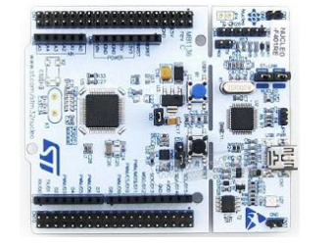

Fig 4.2 nucleo F401RE Board [1]

**Client Nodes (Fig. 4.3 ):** These client nodes are essentially individual units with Nucleo F401RE microcontrollers interfaced with Wi-Fi Modules (ESP8266). They send sensor data wirelessly to the Gateway (Raspberry Pi 3) in the form of data packets. These packets contain node IDs, data, and timestamps.

**Data Visualization**: For visualizing the data, a webpage is designed using the MEAN stack, which stands for MongoDB, Express.js, Angular, and Node.js. This technology stack allows for efficient development of dynamic and interactive web applications. The data from the MongoDB database is fetched and rendered on this webpage.

**Accessibility**:To make the system accessible globally, a DNS (Domain Name System) is assigned to the Raspberry Pi's static IP. Additionally, port forwarding is configured to enable access to the system from anywhere in the world.

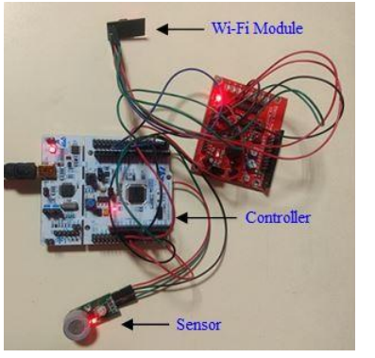

Fig 4.3 experimental setup [1]

This figure represents the webpage created using the MEAN stack. On this webpage, the data collected from the sensors is presented in an organized and user-friendly manner, allowing users to easily interpret and analyze the environmental data.

In essence, the system involves sensors collecting data, and client nodes transmitting this data to the Raspberry Pi gateway, which then stores and analyzes the data using MongoDB. The data is visualized on a webpage created using the MEAN stack and made accessible globally via DNS and port forwarding.

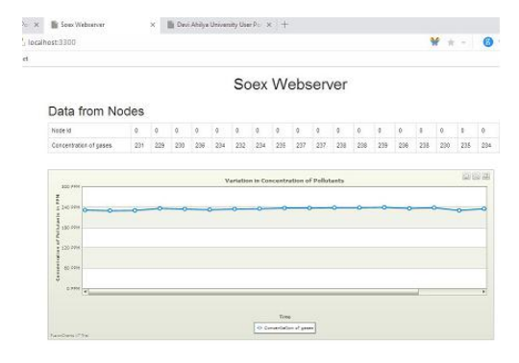

Fig 4.4 Webpage using MEAN stack [1]

**Chapter 5**

**Case studies and examples**

**BreatheEasy - IoT-Based Air Pollution Monitoring in London**

**5.1 Introduction:**

BreatheEasy represents a groundbreaking IoT-based air pollution monitoring initiative strategically implemented in London, UK. Launched as a collaborative effort between environmental agencies, tech innovators, and governmental bodies, this project addresses the critical issue of air pollution in urban environments. By deploying cutting-edge sensor technology and data analytics, BreatheEasy offers real-time, granular air quality insights to the public, fostering unprecedented levels of environmental awareness and citizen engagement.



Fig 5.1 logo

**5.2 Key Features and Implementation:**

**5.2.1 Sensor Network Deployment:**

BreatheEasy's foundation lies in its extensive network of advanced sensors meticulously positioned across London. These sensors are capable of measuring an array of crucial air quality parameters, including particulate matter (PM2.5 and PM10), nitrogen dioxide (NO2), sulfur dioxide (SO2), ozone (O3), and carbon monoxide (CO). The strategic placement of sensors encompasses various locations, such as parks, busy intersections, residential areas, and industrial zones, ensuring a comprehensive understanding of the city's air quality dynamics.

**5.2.2 Real-time Data Collection:**

The sensors operate continuously, collecting real-time data at frequent intervals. This ensures that the air quality information provided to the public is not only current but also highly accurate. The collected data is transmitted wirelessly to a central server, where it undergoes rigorous analysis and processing.

**5.2.3 User-Friendly Mobile App:**

BreatheEasy offers a user-friendly, intuitive mobile application available for both Android and iOS platforms. Through this app, users can access real-time air quality updates based on their geographical location. The application presents an easy-to-understand, color-coded air quality index, indicating the current pollution level. Additionally, the app provides personalized recommendations to users, suggesting activities and routes that minimize exposure to pollutants during high pollution periods.

**5.2.4 Public Awareness Campaigns:**

BreatheEasy places significant emphasis on public awareness campaigns. Through social media channels, local events, and educational programs, the initiative educates citizens about the importance of air quality and its direct impact on health and well-being. Community engagement initiatives such as tree planting drives and clean-up events are organized, encouraging active participation and a sense of shared responsibility.

**5.2.5 Partnerships and Civic Engagement:**

BreatheEasy actively collaborates with local educational institutions, community organizations, and environmental NGOs. Workshops, seminars, and awareness campaigns are conducted in schools and universities, aiming to educate students and residents about air pollution, its health implications, and the pivotal role technology plays in combating this issue. The project actively encourages citizen feedback, fostering a sense of civic engagement and collective ownership of the city’s air quality.

**5.3 Impact on Public Health and Environment:**

**5.3.1 Informed Decision-Making:**

BreatheEasy empowers citizens to make informed decisions regarding outdoor activities, exercise routines, and commuting routes. By accessing real-time air quality data, individuals can minimize their exposure to harmful pollutants, reducing the risk of respiratory diseases and related health issues.

**5.3.2 Data-Driven Policy Implementation:**

The data generated by BreatheEasy serves as a valuable resource for policymakers and urban planners. Evidence-based decision-making allows the implementation of targeted policies, including the promotion of electric vehicles, expansion of green spaces, and regulation of industrial emissions. These policies directly contribute to reducing pollution levels in the city.

**5.3.3 Community Engagement and Advocacy:**

BreatheEasy fosters a sense of community engagement and advocacy. Armed with accurate data, communities can engage in dialogues with local authorities, advocate for cleaner air, and actively participate in environmental initiatives. This collective effort contributes significantly to the city’s overall air quality improvement.

**5.4 Lessons Learned from BreatheEasy:**

1. Community Engagement: Involve the community in shared responsibility.

2. User-Centric Design: Ensure user-friendly interfaces for accessibility.

3. Data Accuracy: Regular calibration is essential for trustworthiness.

4. Data-Driven Policies: Real-time data informs effective policy decisions.

5. Partnerships Drive Innovation: Collaborate for technological advancements.

6. Scalability and Adaptability: Design systems to grow with the city's needs.

7. Transparency Builds Trust: Open communication fosters confidence.

8. Policy Feedback Loop: Update policies based on monitoring system insights.

9. Environmental Education: Invest in education for long-term awareness.

10. Continuous Improvement: Stay updated with evolving technologies and methodologies.

**5.5 Conclusion:**

BreatheEasy stands as a testament to the transformative potential of IoT technology in addressing complex urban challenges. By enhancing public awareness, fostering community engagement, and enabling data-driven policy-making, BreatheEasy serves as a beacon of success, demonstrating how innovative solutions can create healthier, more sustainable cities for current and future generations.

**Chapter 6**

**Challenges and future trends**

**6.1 Challenges in IoT-Enabled Air Pollution Monitoring Systems:**

**6.1.1 Sensor Selection and Accuracy:**

Selecting appropriate sensors that balance cost, accuracy, and sensitivity is a challenge. While IoT sensors offer reasonable accuracy, they often lack the precision of conventional systems. Ensuring that the selected sensors can provide reliable and consistent data is crucial for the system’s effectiveness.

**6.1.2 Continuous Power Supply and Node Deployment:**

Ensuring continuous power supply for sensor nodes is critical. Locations for sensor deployment must be carefully chosen to guarantee both accurate data collection and uninterrupted power. Identifying suitable sites that balance data accuracy and power accessibility is a significant challenge.

**6.1.3 Internet Connectivity and Data Transmission:**

Constant internet connectivity is essential for real-time data transmission. However, in many regions, uninterrupted internet access is not guaranteed. Limited connectivity disrupts data transmission, affecting the system's reliability. Moreover, transmitting vast amounts of heterogeneous data strains networks and increases costs, especially in areas with limited bandwidth.

**6.1.4 Energy Conservation vs. Data Processing:**

The IoT framework captures substantial data, leading to high energy consumption. Balancing the need for real-time data processing and energy conservation poses a challenge. Traditional cloud-based systems, while offering extensive processing power, often drain energy due to constant data transmission and analysis.

**6.1.5 Data Security and Privacy:**

IoT systems are vulnerable to security breaches and data theft. Ensuring the security and privacy of the collected data, especially sensitive environmental information, is a significant challenge. Implementing robust encryption, authentication, and access control mechanisms is essential.

**6.1.6 Standardization and Interoperability**

The diversity of IoT devices poses challenges in standardization and interoperability. Ensuring seamless communication and data exchange between heterogeneous devices, platforms, and protocols is crucial for the overall efficiency and scalability of the monitoring system.

**6.1.7 Scalability and Future-Proofing:**

IoT solutions must be scalable to accommodate the evolving needs of expanding urban areas. Designing systems that can adapt to emerging technologies and handle increasing data volumes without compromising accuracy is a significant challenge.

**Conclusion:**

Addressing these challenges requires continuous research, innovative technological solutions, and collaborative efforts between researchers, policymakers, and industry experts. Overcoming these hurdles is essential for the successful implementation of IoT-enabled air pollution monitoring systems, which play a pivotal role in creating healthier and sustainable urban environments.

**6.2 Future trends**

In the foreseeable future, IoT-based air pollution monitoring is poised to undergo substantial advancements, reflecting the rapid evolution of technology and the growing emphasis on environmental sustainability. One notable trend is the integration of air pollution monitoring systems within the broader framework of smart cities. This integration will allow for seamless coordination between various urban systems, enabling more informed decision-making processes in urban planning and policy implementation. By integrating air quality data with other urban data sets, cities can develop comprehensive strategies to address pollution in a holistic manner.

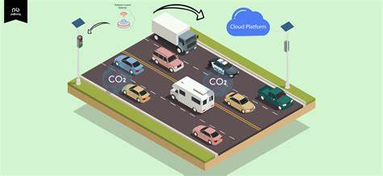

Fig 6.1 Pollution monitoring [12]

Technological advancements in sensor technologies are a key focal point. Ongoing research and development efforts are leading to the creation of sensors that are not only more accurate but also compact and multifunctional. These sensors will provide real-time data with higher precision, allowing for more nuanced analyses of pollution patterns and trends. Additionally, these advancements will enable the development of more cost-effective monitoring solutions, enhancing accessibility for various communities, including those in developing regions.

**The proliferation of 5G networks** is another significant trend shaping the future of IoT-based air pollution monitoring. The deployment of 5G technology will revolutionize data transmission capabilities, ensuring faster and more reliable communication between sensors and data processing units. This increased connectivity will enable real-time data analysis, facilitating prompt responses to pollution events and supporting more effective policy implementations.

The integration of **artificial intelligence (AI) and machine learning (ML)** algorithms is transforming the way air pollution data is analyzed and interpreted. These technologies can handle vast datasets, identifying intricate patterns and trends that might be challenging for traditional analytical methods. By utilizing AI and ML, air pollution monitoring systems can offer predictive insights, aiding policymakers in proactively addressing pollution hotspots and implementing targeted interventions.

Lastly, regulatory support from governments and international bodies will play a pivotal role in driving the adoption and standardization of IoT-based air pollution monitoring systems. Incentives, research funding, and the establishment of standardized frameworks will encourage businesses and researchers to invest in these technologies, further accelerating their development and deployment on a global scale. As these trends converge, the future of IoT-based air pollution monitoring appears promising, offering innovative solutions to address the complex challenges of environmental conservation and public health.

**conclusion**

In conclusion, the evolution of IoT-based air pollution monitoring systems represents a significant leap forward in our collective efforts to combat environmental degradation and protect public health. The amalgamation of advanced sensor technologies, 5G connectivity, edge computing, artificial intelligence, and blockchain security is reshaping the landscape of air quality monitoring. These systems not only provide real-time, accurate data but also empower communities, policymakers, and researchers to make informed decisions.

The future of air pollution monitoring lies in the seamless integration of these technologies into smart cities, fostering more sustainable urban environments. Predictive analytics and precise, localized interventions, made possible by AI and machine learning, promise to transform reactive policies into proactive strategies. Moreover, the robust security ensured by blockchain technology enhances public trust, encouraging active participation and engagement.

As governments, researchers, and industries collaborate, regulatory support becomes pivotal. Standardized frameworks, incentives, and research funding will accelerate the development and adoption of these systems globally. With continuous innovation and collective action, IoT-based air pollution monitoring systems are not just technological solutions; they are catalysts for a healthier, cleaner, and more sustainable future, where our cities breathe easier, and our communities thrive.

**References**

**[1]** G. Parmar, S. Lakhani and M. K. Chattopadhyay, "An IoT based low-cost air pollution monitoring system," 2017 International Conference on Recent Innovations in Signal processing and Embedded Systems (RISE), Bhopal, India, 2017, pp. 524-528, doi: 10.1109/RISE.2017.8378212.

**[2]** (online)Moursi, A.S., El-Fishawy, N., Djahel, S. *et al.* An IoT enabled system for enhanced air quality monitoring and prediction on the edge. *Complex Intell. Syst.* **7**, 2923–2947 (2021). <https://doi.org/10.1007/s40747-021-00476-w>

**[3]** S. Dhingra, R. B. Madda, A. H. Gandomi, R. Patan and M. Daneshmand, "Internet of Things Mobile–Air Pollution Monitoring System (IoT-Mobair)," in IEEE Internet of Things Journal, vol. 6, no. 3, pp. 5577-5584, June 2019, doi: 10.1109/JIOT.2019.2903821.

**[4]** (online) Arumugham, Anand Jayakumar & Yesyand, Praviss & Prashanth, Venkstesh. (2021). IoT-Based Air Pollution Monitoring System: <https://www.researchgate.net/publication/350679256>

**[5]** (online) Rawal, Ramik. (2019). Air Quality Monitoring System. 10.13140/RG.2.2.20471.37282. (research gate). <https://www.researchgate.net/publication/338557866>

**[6]** International Research Journal of Engineering and Technology (IRJET Volume: 04 Issue: 10) | Oct -2017 [www.irjet.net](http://www.irjet.net) p-ISSN: 2395-0072 )e-ISSN: 2395-0056

**[7]** T. W. Ayele and R. Mehta, "Air pollution monitoring and prediction using IoT," 2018 Second International Conference on Inventive Communication and Computational Technologies (ICICCT), Coimbatore, India, 2018, pp. 1741-1745, doi: 10.1109/ICICCT.2018.8473272.

**[8]** (online)Air quality monitoring using IOT. [Air Quality Monitoring using IoT - psiborg.in](https://psiborg.in/air-quality-monitoring-using-iot/).

**[9]** R. Kiruthika and A. Umamakeswari, "Low cost pollution control and air quality monitoring system using Raspberry Pi for Internet of Things," 2017 International Conference on Energy, Communication, Data Analytics and Soft Computing (ICECDS), Chennai, India, 2017, pp. 2319-2326, doi: 10.1109/ICECDS.2017.8389867**.**

**[10]** A Survey on Sensor-based Threats to Internet-of-Things (IoT) Devices and Applications <https://www.researchgate.net/publication/322975901>

**[11]** Toma, Cristian, Andrei Alexandru, Marius Popa, and Alin Zamfiroiu. 2019. "IoT Solution for Smart Cities’ Pollution Monitoring and the Security Challenges" *Sensors* 19, no. 15: 3401. <https://doi.org/10.3390/s19153401>

**[12]** (online)What Is the Internet of Things (IoT)? With Examples.

<https://www.coursera.org/articles/internet-of-things>

**[13]** S. Kumar and A. Jasuja, "Air quality monitoring system based on IoT using Raspberry Pi," *2017 International Conference on Computing, Communication and Automation (ICCCA)*, Greater Noida, India, 2017, pp. 1341-1346, doi: 10.1109/CCAA.2017.8230005.

**[14** [13 Best Internet of Things Projects (IoT Projects) To Start Right Now (techstorify.com)](https://techstorify.com/iot-projects/) (online)