**Python Lab**

**Date : 29-01-2025**

**Name: Abhijeet Prakash Karavate**

**Prn:1272240331**

**Q.10 .** **Demonstrate the following functions/methods which operates on lists in Python with suitable examples: len ( ) ,count( ) ,index ( ),append( ) ,insert( ) ,extend() ,remove( ), pop( ),reverse( ) ,copy( )**

A = [1,2,3,4,5,6,7,8,9,10,1,1]

B = [10,11,12,13,14,15,16,17,18,19,20]

print("Length:")

print(len(A))

print("Count :") A = [1,2,3,4,5,6,7,8,9,10,1,1]

B = [10,11,12,13,14,15,16,17,18,19,20]

print("Length:")

print(len(A))

print("Count :")

print(A.count(1))

print("value at index no: ")

print(A.index(5))

print("Append :")

A.append(10)

print(A)

print("Insert :")

B.insert(3,10)

print(B)

print("Remove:")

B.remove(10)

print(B)

print("Extend:")

B.extend([100,200])

print(B)

print("pop:")

B.pop(2)

print(B)

print("Copy:")

A.copy()

print(A)

print(A.count(1))

print("value at index no: ")

print(A.index(5))

print("Append :")

A.append(10)

print(A) A = [1,2,3,4,5,6,7,8,9,10,1,1]

B = [10,11,12,13,14,15,16,17,18,19,20]

print("Length:")

print(len(A))

print("Count :")

print(A.count(1))

print("value at index no: ")

print(A.index(5))

print("Append :")

A.append(10)

print(A)

print("Insert :")

B.insert(3,10)

print(B)

print("Remove:")

B.remove(10)

print(B)

print("Extend:")

B.extend([100,200])

print(B)

print("pop:")

B.pop(2)

print(B)

print("Copy:")

A.copy()

print(A)

print("Insert :")

B.insert(3,10)

print(B)

print("Remove:")

B.remove(10)

print(B)

print("Extend:")

B.extend([100,200])

print(B)

print("pop:")

B.pop(2)

print(B)

print("Copy:")

A.copy()

print(A)

Output:

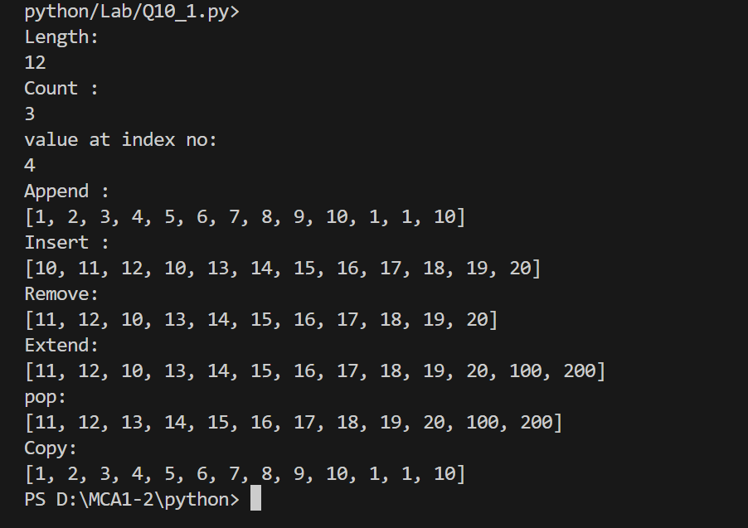

Q11. **Write a python program to read a list of ‘n’ integers (positive and negative) and create two new lists one having all positive numbers and the other having all negative numbers from the given list. Print all three lists.**

arr = input("Enter Elements of Array: ").split()

print("Your array:", arr)

arr = list(map(int, arr))

n = len(arr)

positive = []

negative = []

for i in range(n):

    if arr[i] > 0:

        positive.append(arr[i])

    else:

        negative.append(arr[i])

print("Positive numbers:", positive)

print("Negative numbers:", negative)

Output:

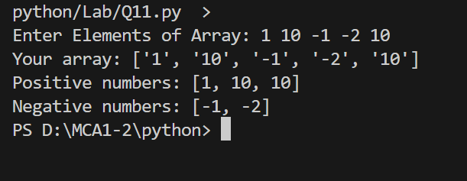

Q12**. Demonstrate the following functions/methods which operates on tuples in Python with suitable examples: len( ) ,count( ) ,index( ) ,sorted( ),min ( ), max( ) , cmp( ), reversed( )**

my_tuple = (10, 20, 10, 40, 50, 30)

print("Length of tuple:", len(my_tuple))

print("Count of 10:", my_tuple.count(10))

print("Index of 40:", my_tuple.index(40))

print("Sorted tuple:", sorted(my_tuple))

print("Minimum element:", min(my_tuple))

print("Maximum element:", max(my_tuple))

print("Reversed tuple:", tuple(reversed(my_tuple)))

**output:**

