Lab 5:

1. Write SQL code to display Employee records whose name begins with ‘p’.
2. Display records whose name ends with ‘e’.
3. Whose name start with ‘k’ and end with ‘l’.
4. Whose Address contain
5. Name start with ‘s’ end by ‘a’ and address is ‘Kantipur’.

SQL code:

* CREATE DATABASE db5;

USE db5;



* CREATE TABLE employee(

id INT(3),

fname VARCHAR(30),

address VARCHAR(30),

salary NUMERIC);



* INSERT INTO employee VALUES

(1,'Kapil','Kanchanpur',60000),

(2,'Rose','Myagdi',56000),

(3,'Kamal','Mustang',70000),

(4,'Salina','Jhapa',30000),

(5,'Prashna','Kantapur',87000),

(6,'Jose','Solukhumbu',67000),

(7,'Sahara','Kantipur',77000),

(8,'Pascle','Lalitpur',30000);

SELECT \* FROM employee;

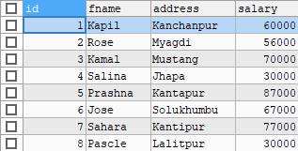

* SELECT \* FROM employee

WHERE fname LIKE 'p%';



* SELECT \* FROM employee

WHERE fname LIKE '%e';

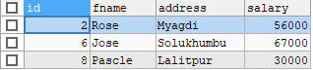

* SELECT \* FROM employee

WHERE fname LIKE 'k%l';



* SELECT \* FROM employee

WHERE address LIKE '%pur%';

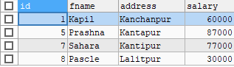

* SELECT \* FROM employee

WHERE fname LIKE 's%a' AND address='Kantipur';

