Lab 8:

Write SQL code to display records using CROSS, EQUI, AND SELF JOIN

SQL Query

* CREATE DATABASE db8;

USE db8;

* CREATE TABLE department (

department_id INT PRIMARY KEY,

department_name VARCHAR(50)

);

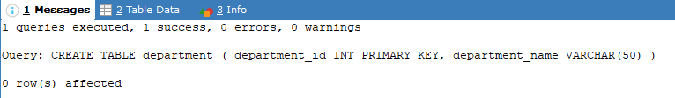

* INSERT INTO department VALUES

(10, 'Devloper'),

(20, 'Designer'),

(30, 'DevOps');

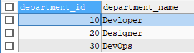

* CREATE TABLE employee (

emp_id INT PRIMARY KEY,

NAME VARCHAR(50),

department_id INT,

manager_id INT

);

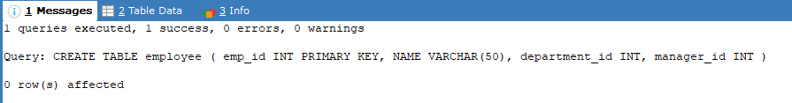

* INSERT INTO employee VALUES

(1, 'Abilekh', 10, NULL),

(2, 'Alisha', 20, 1),

(3, 'Anshu', 10, 1),

(4, 'Anush', 30, 2);

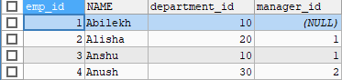

* SELECT e.name AS employee_name, d.department_name

FROM employee e

CROSS JOIN department d;

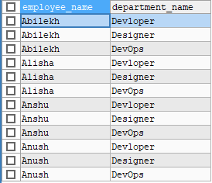

* SELECT e.name AS employee_name, d.department_name

FROM employee e

JOIN department d ON e.department_id = d.department_id;

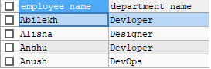

* SELECT e.name AS employee_name, m.name AS manager_name

FROM employee e

JOIN employee m ON e.manager_id = m.emp_id;

