1.Create Table name Student_list:-

->CREATE TABLE Student_list(

stu_id int,

stu_name varchar(34),

stu_department varchar(35),

stu_course varchar(13),

stu_gender varchar(34)

);

2.Add Student details using Insert commands

->INSERT INTO Student_list VALUES(1007,'Abhilaash','cse','DBMS','male');

INSERT INTO Student_list VALUES(1008,'Aadharsh','aids','DBMS','male');

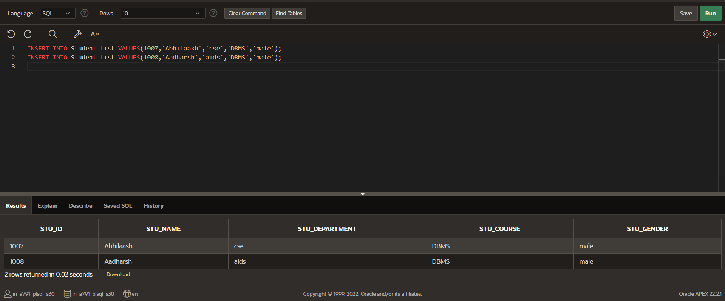

3. ALTER TABLE Student_list

DROP COLUMN stu_gender;

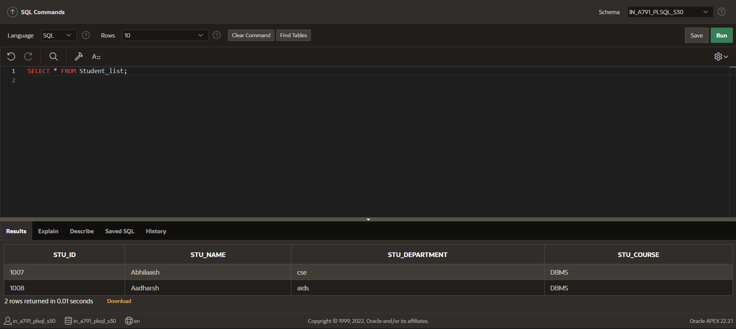

4. UPDATE Student_list

set STU_DEPARTMENT='BIO',STU_COURSE='Data analysis'

where STU_ID=1007

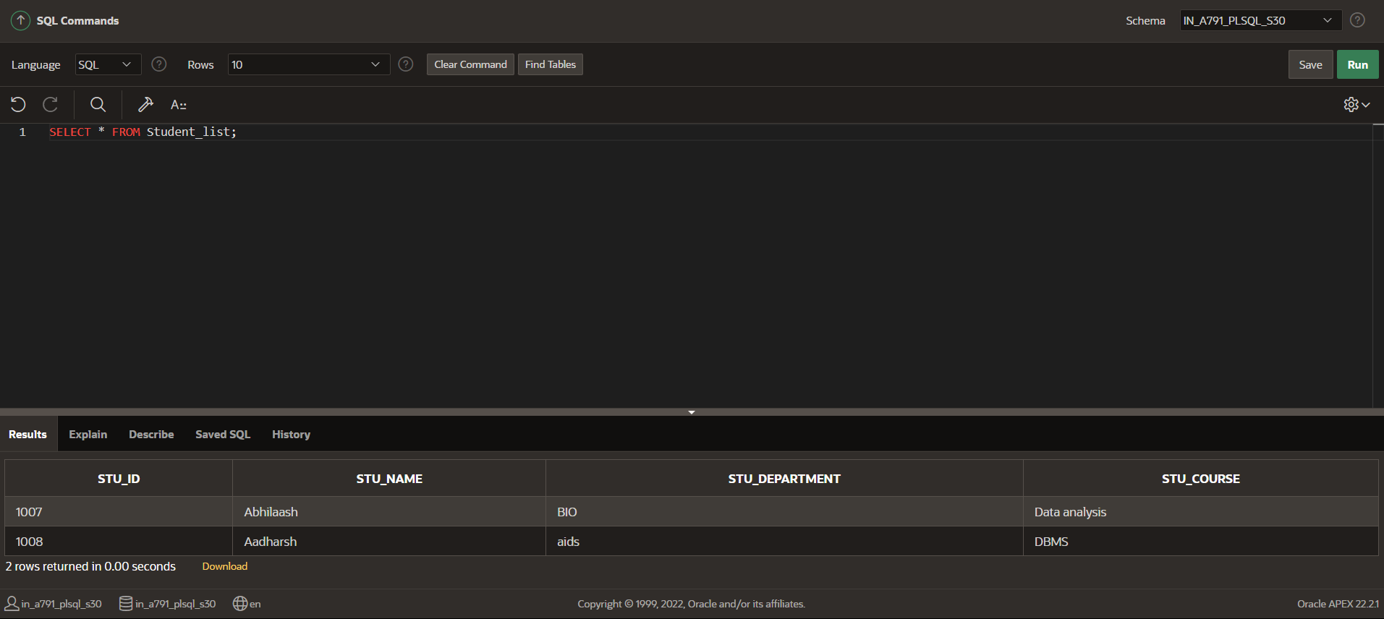

5. ALTER TABLE Student_list RENAME COLUMN Stu_id

TO STUDENT_ID;

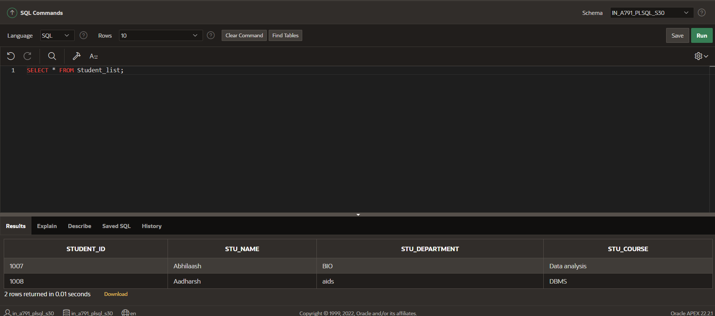

6.

**TRUNCATE TABLE STUDENT_DETAIL;**

**THE ENTIRE RECORD FROM THE TABLE ERASED.**