# JOIN

insert into studentscourse values(1,'CSE',30, 'Kseven');

insert into studentscourse values(2,'AIDS',30, 'Nelson');

insert into studentscourse values(3,'ML',33, 'Harish');

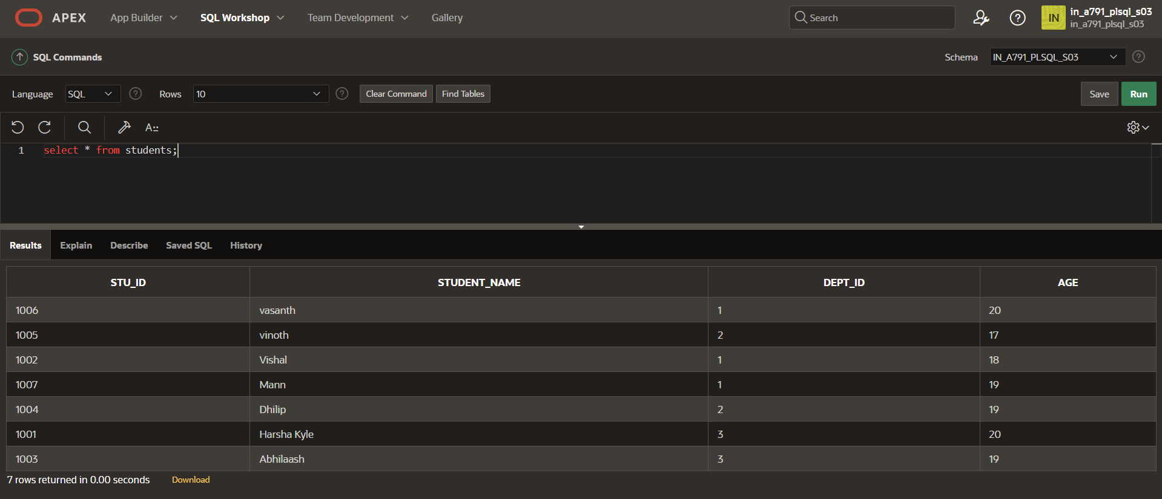

select * from studentscourse;

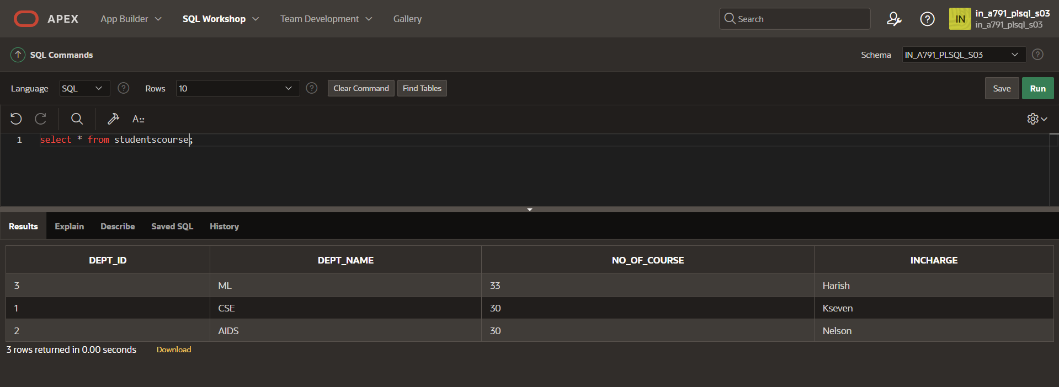

Ambiguous column names join

select s.STU_ID, s.STUDENT_NAME, d.DEPT_NAME,d.INCHARGE from STUDENTS s JOIN STUDENTSCOURSE d using (DEPT_ID);

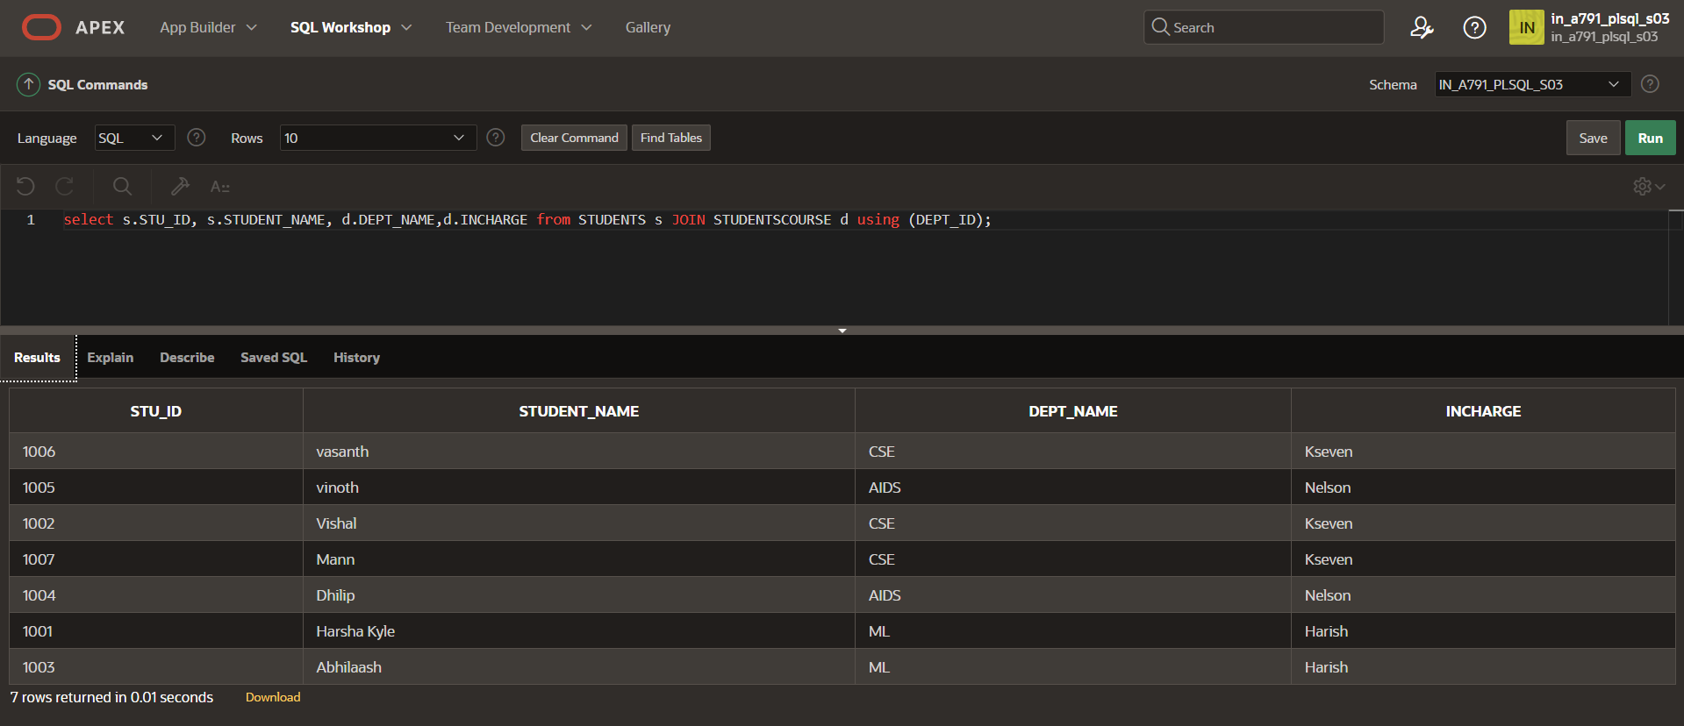

NATURAL JOIN

select STU_ID, STUDENT_NAME, DEPT_NAME,INCHARGE from STUDENTS NATURAL JOIN STUDENTSCOURSE ;

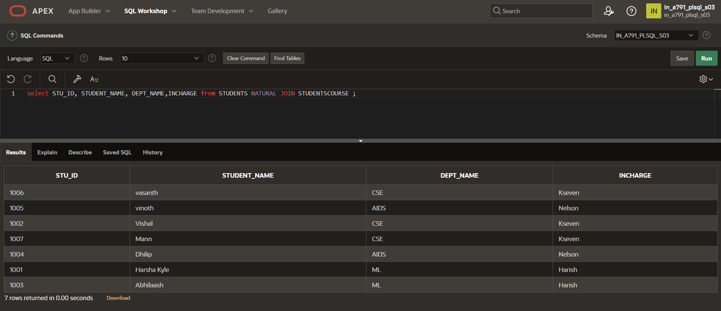

JOIN USING

select STU_ID, STUDENT_NAME, DEPT_NAME,INCHARGE from STUDENTS JOIN STUDENTSCOURSE using (DEPT_ID);

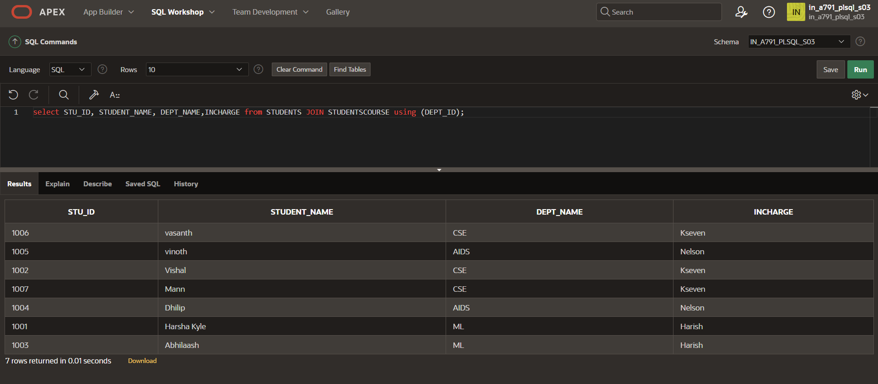

JOIN USING ON

select s.STU_ID, s.STUDENT_NAME, d.DEPT_NAME,d.INCHARGE from STUDENTS s JOIN STUDENTSCOURSE d on (s.DEPT_ID=d.DEPT_ID);

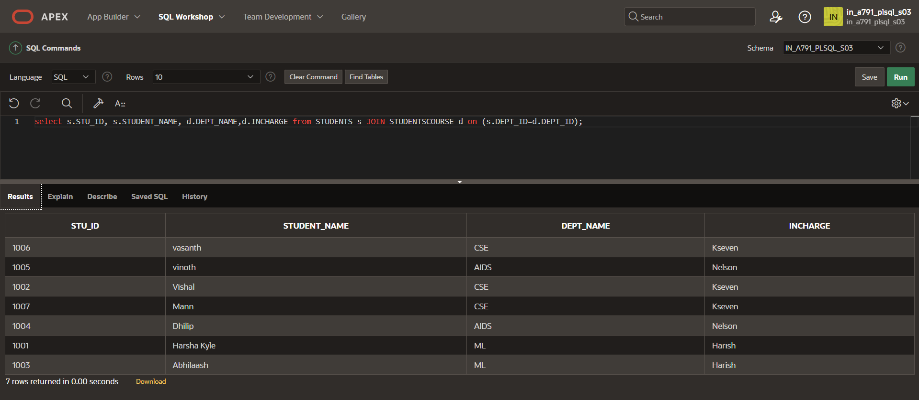

INNER JOIN

select STU_ID, STUDENT_NAME, DEPT_NAME,INCHARGE from STUDENTS INNER JOIN STUDENTSCOURSE on STUDENTS.DEPT_ID = STUDENTSCOURSE.DEPT_ID;

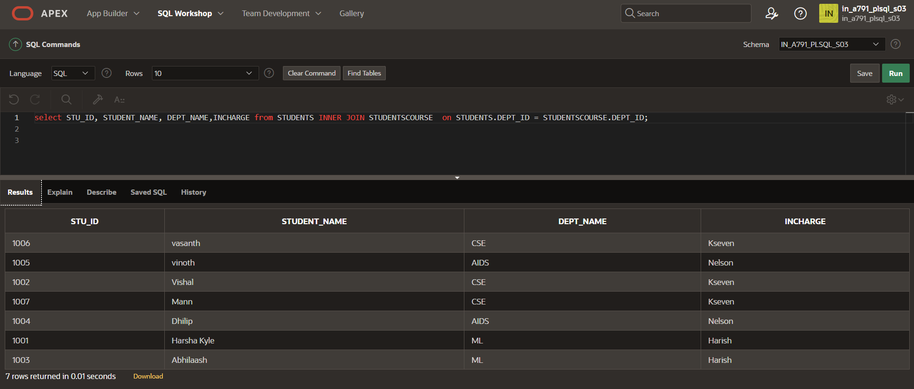

LEFT JOIN

select STU_ID, STUDENT_NAME, DEPT_NAME,INCHARGE from STUDENTS LEFT JOIN STUDENTSCOURSE on STUDENTS.DEPT_ID = STUDENTSCOURSE.DEPT_ID;

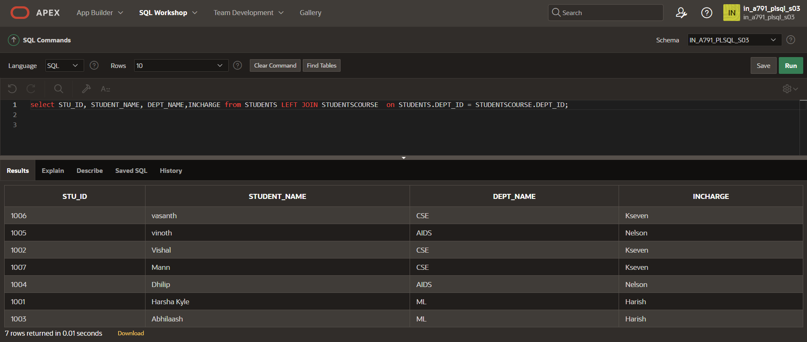

RIGHT JOIN

select STU_ID, STUDENT_NAME, DEPT_NAME,INCHARGE from STUDENTS RIGHT JOIN STUDENTSCOURSE on STUDENTS.DEPT_ID = STUDENTSCOURSE.DEPT_ID;

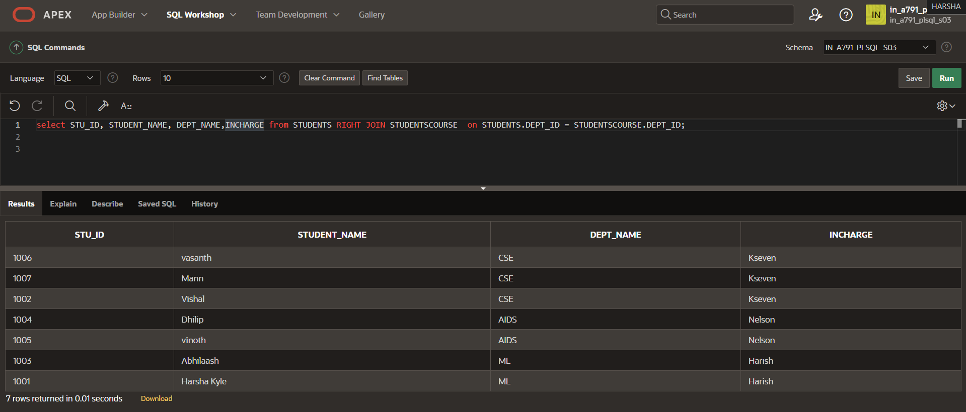

FULL OUTER JOIN

select STU_ID, STUDENT_NAME, STUDENTS.DEPT_ID,INCHARGE from STUDENTS FULL OUTER JOIN STUDENTSCOURSE on STUDENTS.DEPT_ID = STUDENTSCOURSE.DEPT_ID;

