MERN STACK
WEB APPLICATION

PROJECT TECHNICAL REPORT

Technology Stack | MongoDB · Express.js · React · Node.js
Document Type | Technical Project Report
Prepared By | J. Abhilash (AP24110012142) · G. Bhanu Prakash Reddy (AP24110012137) · P. Avinash (AP24110012139) · K. Manohar (AP24110012102)
Academic Year | 2025 – 2026

Team Members
# | Name | Roll Number
01 | J. Abhilash | AP24110012142
02 | G. Bhanu Prakash Reddy | AP24110012137
03 | P. Avinash | AP24110012139
04 | K. Manohar | AP24110012102

1. INTRODUCTION

This report presents a comprehensive overview of a modern full-stack web application built upon the MERN technology stack, comprising MongoDB, Express.js, React, and Node.js. The platform is engineered to offer users a seamless environment in which they may create, organise, and engage with digital content in a secure and scalable manner.
The system incorporates a suite of advanced capabilities, including token-based user authentication supplemented by OTP verification, comprehensive blog creation and management tools, a real-time messaging interface, and AI-powered utilities designed to enrich the overall user experience. Every architectural decision has been guided by the dual imperatives of security and performance, ensuring the application is well-suited for production deployment.
2. SCENARIO & CASE STUDY

Consider a knowledge-sharing practitioner who wishes to engage with a broader online community. Upon registering on the platform and completing the email-based identity verification process, the user gains access to a personalised dashboard from which all core features are readily accessible.
The user may compose and publish blog posts, revise existing entries, or remove content that is no longer relevant. Content created by other members of the community is equally accessible, enabling cross-pollination of ideas and perspectives. Beyond content management, the platform provides a real-time communication channel and an AI-assisted writing tool that helps users refine their prose, thereby improving both individual productivity and collective knowledge quality.
3. SYSTEM REQUIREMENTS

3.1 Software Requirements
Component | Specification
Operating System | Windows / macOS / Linux
Runtime Environment | Node.js v16 or above
Database | MongoDB (local instance or Atlas cloud)
Frontend Framework | React.js (bootstrapped via Vite)
Backend Framework | Express.js
Development IDE | Visual Studio Code
API Testing | Postman
Web Browser | Google Chrome / Mozilla Firefox

3.2 Hardware Requirements
Component | Specification
Processor | Intel Core i5 or equivalent / higher
Memory | Minimum 8 GB RAM (16 GB recommended)
Storage | At least 1 GB of available disk space
Display | Resolution of 1366 × 768 or higher
4. PROJECT ARCHITECTURE

The application is structured around a layered client-server architecture that cleanly separates presentation, business logic, and data persistence. This separation promotes modularity and independent scalability of each layer.
Data Flow Overview
- The end-user interacts exclusively with the React-based frontend interface.
- User actions trigger HTTP requests that are dispatched to the Node.js and Express.js backend via Axios.
- The backend processes each request through its controller and middleware pipeline, enforcing authentication and validation rules.
- Validated queries are executed against the MongoDB database via Mongoose ODM.
- The database returns the requested data, which the backend serialises as a JSON response.
- The frontend receives the response and updates the UI state accordingly.
This architecture ensures that the system remains horizontally scalable: the frontend may be deployed to a CDN, whilst the backend can be containerised and replicated behind a load balancer without altering the overall design.
5. DATABASE DESIGN & ENTITY RELATIONSHIPS

MongoDB serves as the persistence layer, with collections defined via Mongoose schemas that enforce structure, type coercion, and referential integrity through document references. The principal entities and their relationships are described below.
5.1 Core Entities
Entity | Key Attributes | Description
User | name, email, password (hashed), OTP token, profile metadata | Registered account holder
Post | title, body, author (ref), category (ref), timestamps, likes | Blog content entry
Category | name, slug, description | Taxonomy for posts
Message | sender (ref), recipient (ref), content, timestamp, read flag | Chat communication record

5.2 Relationships
- One User may author many Posts (one-to-many); each Post holds a reference to its author's User document.
- Each Post belongs to exactly one Category; a Category may contain multiple Posts.
- Users exchange Messages in a many-to-many fashion, with each Message document holding sender and recipient references.
6. KEY FEATURES

Feature | Description
Authentication System | Stateless, token-based login and registration using JSON Web Tokens (JWT), supplemented by one-time password (OTP) verification delivered over email.
Blog Management | Full CRUD operations on blog posts: authors may compose, update, and delete entries, whilst all authenticated users may browse and read published content.
User Interaction | Readers may express appreciation for posts via a like mechanism and bookmark entries for later reference using the save feature.
Real-Time Chat | A persistent WebSocket-based messaging interface that enables synchronous, low-latency communication between registered users.
AI Content Tools | Integrated AI utilities that assist users in generating initial drafts and refining existing prose for clarity, tone, and grammatical correctness.
Profile Management | Users may update personal information, change display preferences, and manage account security settings from a centralised profile dashboard.
7. ROLES & RESPONSIBILITIES

7.1 Registered User
- Register an account and complete email-based identity verification.
- Authenticate securely and access the personalised dashboard.
- Author, edit, and delete personal blog posts.
- Browse, like, and save posts created by other members of the community.
- Participate in real-time chat conversations with other registered users.
- Utilise AI-powered tools to enhance content quality.
7.2 Administrator
- Monitor platform activity and audit user-generated content for policy compliance.
- Review and remove content that violates community guidelines.
- Manage user accounts, including the ability to suspend or deactivate profiles.
- Oversee system performance metrics and co-ordinate maintenance operations.
8. USER FLOW

The following sequence outlines the typical end-to-end journey of a user interacting with the platform from initial registration through to session termination.
Step | Action | Detail
01 | Registration | The user submits their details; an OTP is dispatched to the registered email address for account verification.
02 | Authentication | Upon successful OTP confirmation, the user logs in with their credentials and receives a signed JWT.
03 | Dashboard Access | The authenticated user lands on the main dashboard, which surfaces personalised content and navigation options.
04 | Content Creation | The user may compose a new blog post, selecting an appropriate category and optionally invoking the AI writing assistant.
05 | Content Browsing | The user explores posts authored by others, interacting via likes and saves to curate a personalised reading list.
06 | Real-Time Chat | The user initiates or joins a conversation through the integrated messaging interface.
07 | Profile Management | The user reviews and updates their account information and notification preferences as required.
08 | Session Termination | The user logs out, invalidating the active JWT and clearing the local session state.
9. MVC ARCHITECTURAL PATTERN

The backend adheres to the Model-View-Controller (MVC) design pattern, a widely adopted convention that enforces a clean separation of concerns across three distinct layers of application logic.
Layer | Technology | Responsibility
Model | Mongoose / MongoDB | Defines the data schemas, enforces validation rules, and manages all database interactions.
View | React.js | Presents data to the user through a dynamic, component-driven interface that responds to state changes in real time.
Controller | Node.js / Express.js | Receives HTTP requests, invokes the appropriate service or model methods, and returns structured responses to the client.

Advantages of the MVC Pattern
- Clear separation of concerns simplifies debugging and unit testing.
- Independent modification of any layer without disturbing the others.
- Improved team collaboration: frontend and backend developers may work concurrently.
- Facilitates scalability, as individual layers may be optimised or replaced in isolation.
10. PROJECT SETUP & CONFIGURATION

10.1 Backend Initialisation
- Initialise a new Node.js project and establish the package manifest via npm init.
- Install core dependencies: Express.js, Mongoose, jsonwebtoken, nodemailer, and dotenv.
- Configure environment variables for database connection strings, JWT secrets, and SMTP credentials.
- Define Mongoose schemas and establish the MongoDB connection via a dedicated configuration module.
- Scaffold the route and controller directory structure, then register all API endpoint handlers.
10.2 Frontend Initialisation
- Bootstrap the React application using Vite for optimised development and build performance.
- Install supporting libraries: Axios for HTTP requests, React Router for client-side navigation, and a UI component library of choice.
- Configure the Axios base URL and authentication interceptors to attach JWT headers automatically.
- Establish the global context providers for authentication state and theme management.
- Structure the component and page directory hierarchy in alignment with the defined routes.
11. BACKEND DEVELOPMENT

The server-side application is implemented in Node.js with Express.js serving as the HTTP framework. The codebase is organised into the following principal modules:
Module | Purpose
Routes | Define the URL endpoint structure and map each route to its corresponding controller function.
Controllers | Contain the core business logic: validate input, invoke model methods, handle exceptions, and construct HTTP responses.
Models | Declare Mongoose schemas with field types, default values, validators, and virtual properties for each collection.
Middleware | Intercept requests to enforce JWT authentication, validate request payloads, and standardise error responses.
Services | Encapsulate reusable utilities such as email dispatch, token generation, and third-party API calls.

12. DATABASE DESIGN

MongoDB's document-oriented model aligns naturally with the application's data structures, offering flexible schema evolution without costly migrations. Mongoose provides an abstraction layer that introduces type safety, default values, and declarative validators.
Collections
- Users — stores account credentials, profile metadata, and verification tokens.
- Posts — houses all blog content alongside author and category references, engagement counters, and audit timestamps.
- Categories — maintains the taxonomy used to classify and filter posts.
- Messages — persists the full conversation history between users, including read receipts.
Index strategies are applied on frequently queried fields such as email (unique), post author, and message sender/recipient pairs to ensure sub-millisecond query performance at scale.
13. FRONTEND DEVELOPMENT

The client-side application is built with React, leveraging a component-driven architecture that maximises reusability and maintainability. The application is bootstrapped via Vite, which provides near-instantaneous hot-module replacement during development and optimised production bundles.

Layer | Implementation Detail
Pages | Login, Registration, Dashboard, Post Editor, Post Viewer, Chat, and User Profile.
Components | Reusable units including Navbar, PostCard, CommentThread, ChatBubble, and Modal.
State Management | React Hooks (useState, useEffect, useContext) with a global AuthContext and ThemeContext.
Routing | React Router v6 with protected route wrappers that redirect unauthenticated users.
API Integration | Axios instance pre-configured with the API base URL and JWT Authorization header injection.
Styling | Utility-first CSS framework supplemented by custom variables for consistent design tokens.

14. BACKEND DEVELOPMENT
The server-side application is built using Node.js and Express.js, following a modular and scalable architecture. The backend exposes RESTful APIs to handle authentication, content management, real-time communication, and user interactions. It is designed for performance, security, and maintainability.
Layer | Implementation Detail
Server Architecture
Modular MVC-based structure separating routes, controllers, services, and models for clean code organisation and scalability.
API Design
RESTful endpoints for authentication, posts, comments, users, and chat. Follows standard HTTP methods (GET, POST, PUT, DELETE).
Authentication & Authorization
Secure login and registration using JSON Web Token for stateless authentication. Middleware validates tokens and protects private routes.
Database
NoSQL database using MongoDB with Mongoose for schema modelling and validation.
Data Models
Schemas for User, Post, Comment, and Chat with relationships handled via references and population.
Real-Time Communication
Implemented using Socket.IO for instant messaging and live updates in chat and notifications.
Middleware
Custom and third-party middleware for request validation, authentication, error handling, and logging.
File Handling
Image uploads handled via cloud storage integration (e.g., Cloudinary or local storage with multer).
Security
Password hashing using bcrypt, input sanitisation, CORS configuration, and rate limiting.
API Testing
Endpoints tested using tools like Postman to ensure reliability and correctness.
Deployment
Backend deployed on cloud platforms (e.g., Render / Railway / Vercel serverless functions) with environment variable configuration for secrets.
15. OUTPUT SCREENSHOTS

The following interface screens are produced by the application and represent the primary interaction surfaces available to users. Actual screenshots should be inserted at the indicated positions upon completion of the implementation.
- Login Page — credential entry form with OTP resend and password-reset options.
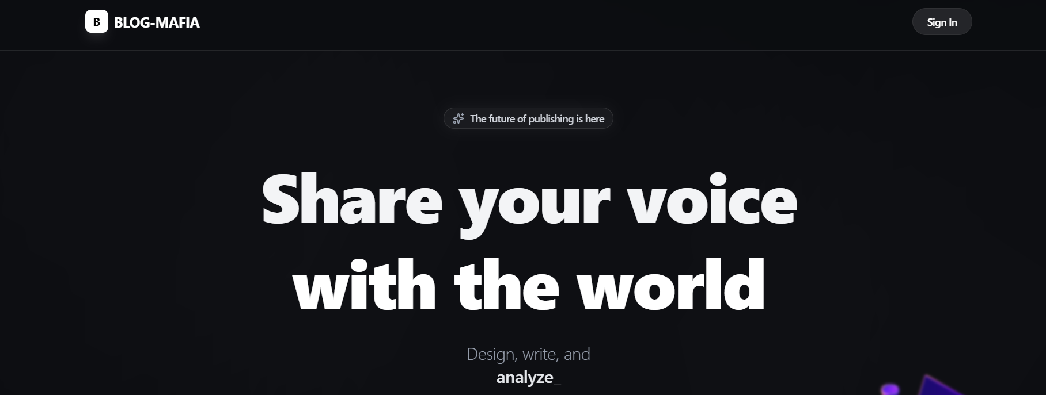

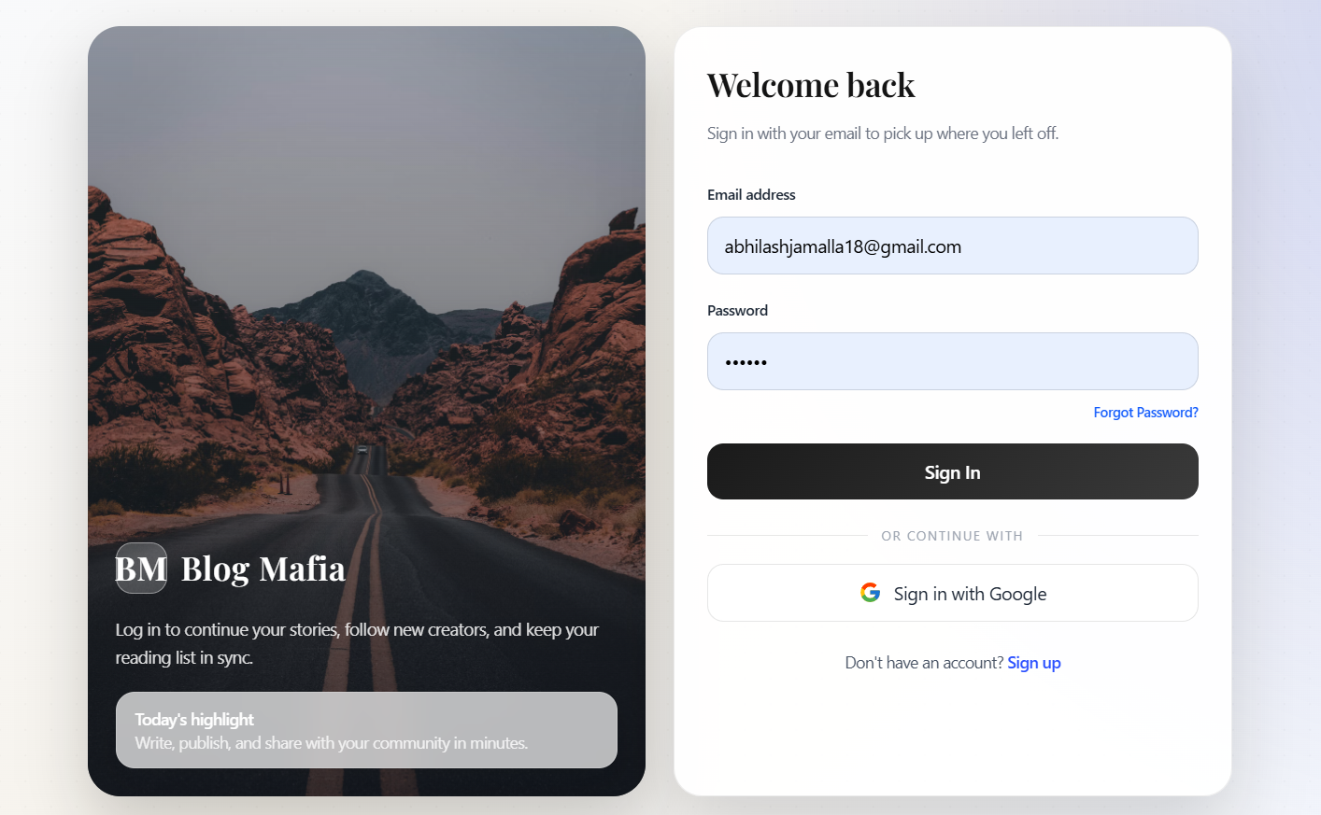

- Registration Page — multi-field sign-up form with real-time validation feedback.
- 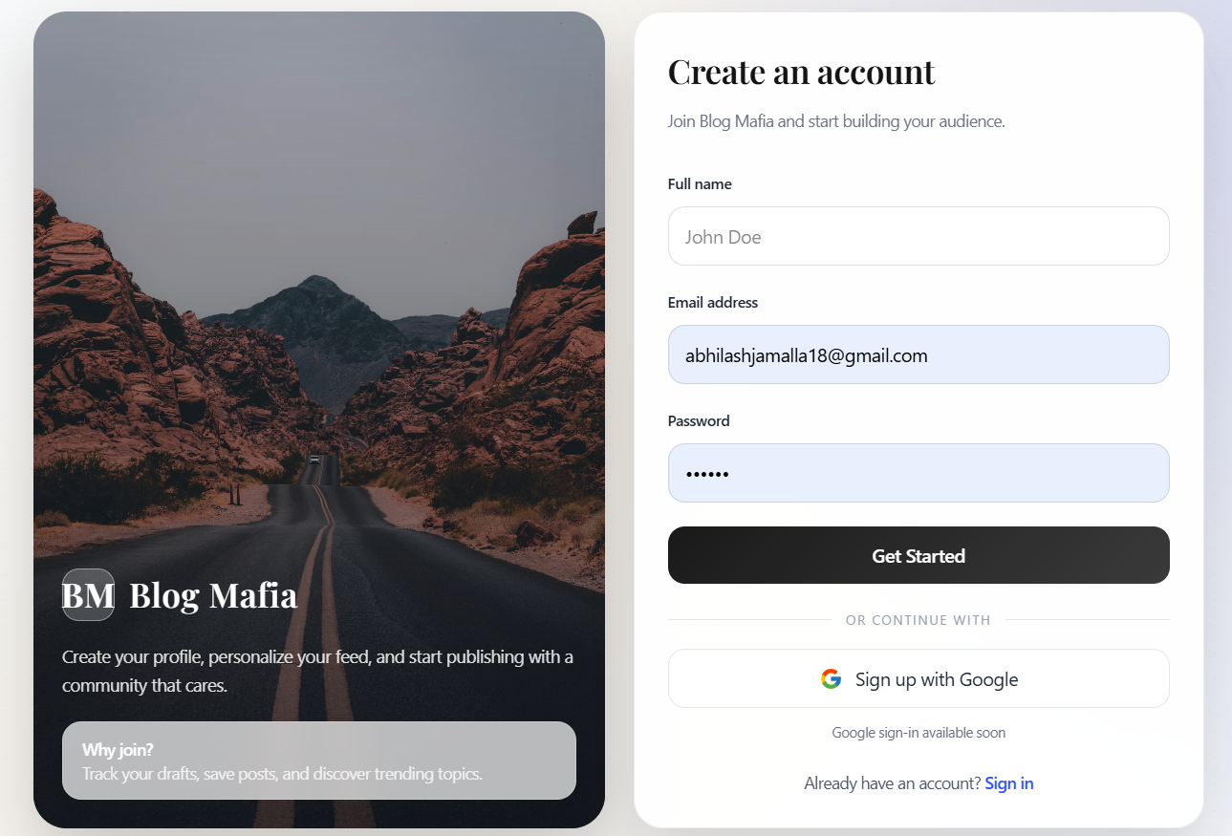

- Dashboard — personalised content feed with navigation rail and quick-action shortcuts.
- 

- Blog Post Page — full post view with like, save, comment, and share controls.
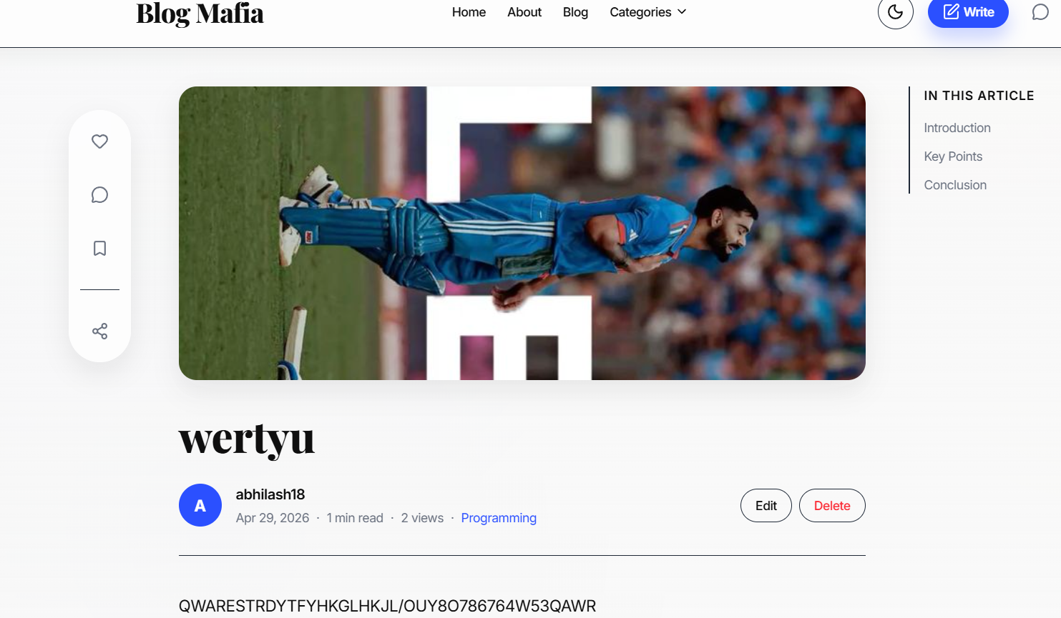

- Post Editor — rich-text editor with AI enhancement toolbar and category selector.

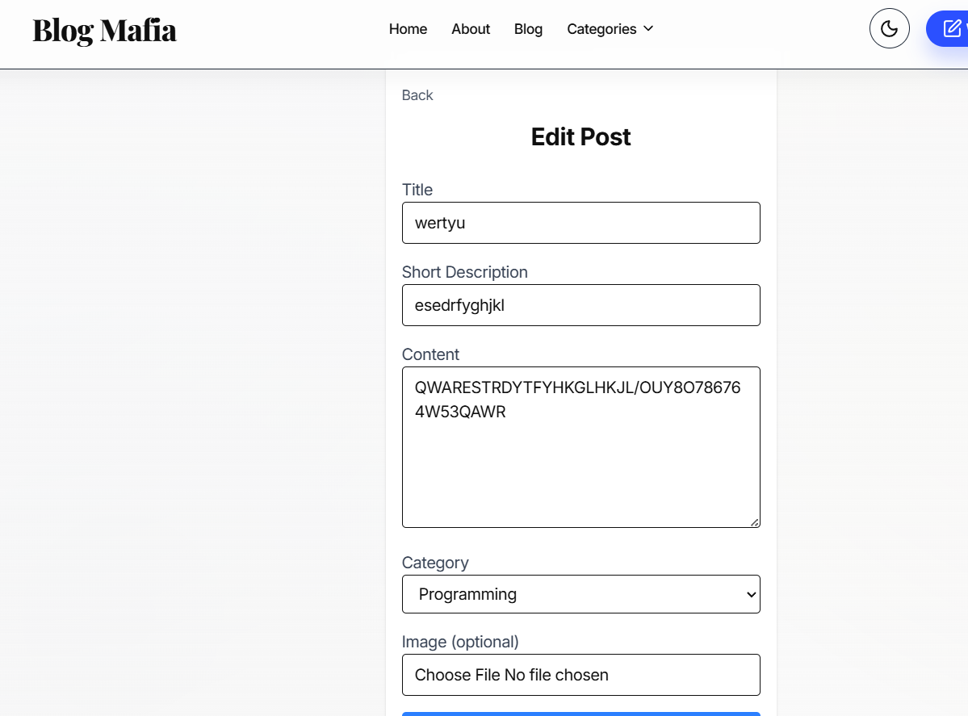Chat

Interface — real-time conversation view with online status indicators.
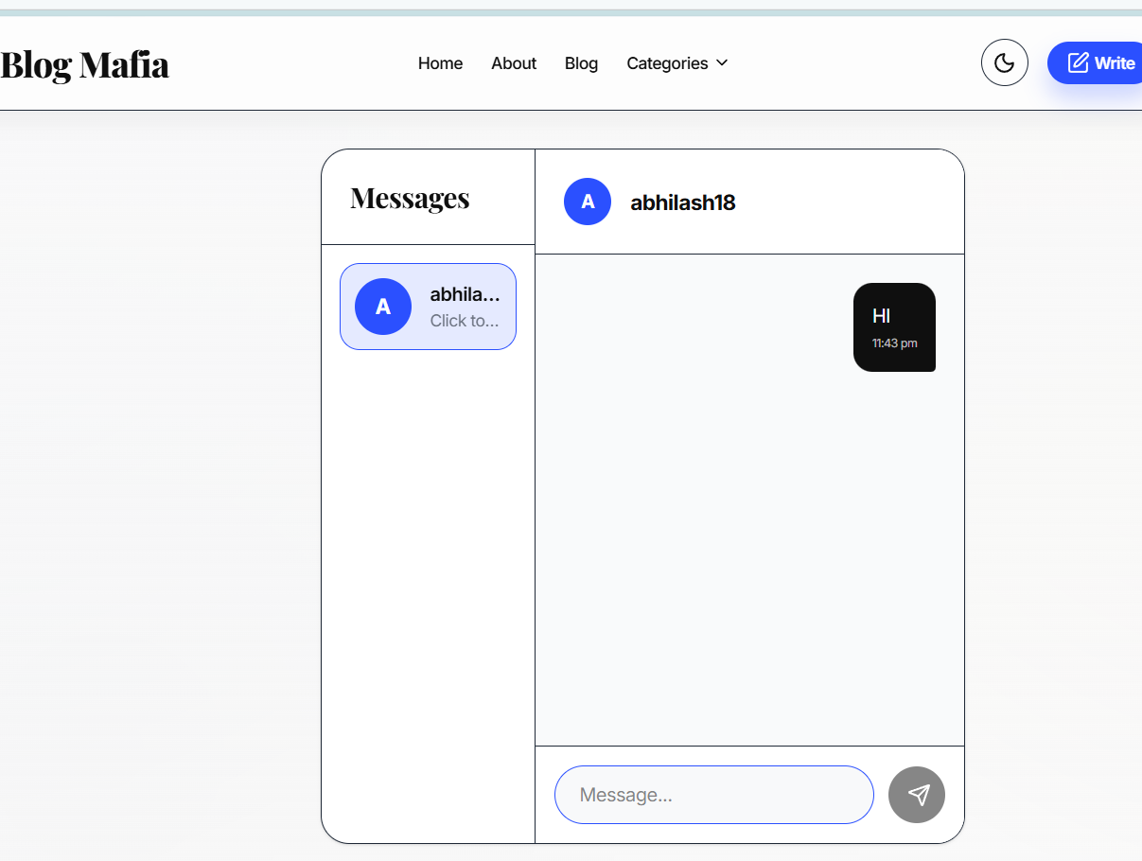
16. DEMO & REPOSITORY LINKS

Resource | URL / Reference
GitHub Repository | [ Insert repository URL ]
Live Demo | [ Insert deployment URL ]
Demo Video | [ Insert video link ]

All source code is version-controlled using Git and hosted on GitHub. Contributions, issues, and pull requests should be managed through the repository's standard workflow. The live deployment is hosted on a cloud platform and reflects the latest stable release of the application.

