Bollywood Song Mood Classifier
Domain: Entertainment / Music Tech
Database: MongoDB
Backend: Java Spring Boot

1. ABSTRACT & STRATEGIC OVERVIEW
1.1 Objective & System Prototyping
The objective of this engineering initiative is the design, deployment, and validation of an enterprise-grade full-stack media management apparatus. The system handles, classifies, and filters Bollywood audio materials using multidimensional emotional and contextual data profiles. High-volume, unstructured streaming applications require scalable NoSQL backends. This system transitions away from rigid relational schemas by utilizing native MongoDB document collection structures to manage many-to-many configurations cleanly.
The operational architecture coordinates a Three-Tier software layer:
- The Physical Data Tier: Managed by MongoDB to ensure low-latency query throughput.
- The REST Middleware Microservice Tier: Built using Java Spring Boot to manage transaction logic and structural mapping validation.
- The User Presentation Interface: Built as a responsive JavaScript dashboard utilizing web components to render incoming data instantly.
2. ENGINEERING ECOSYSTEM & TECHNOLOGY STACK
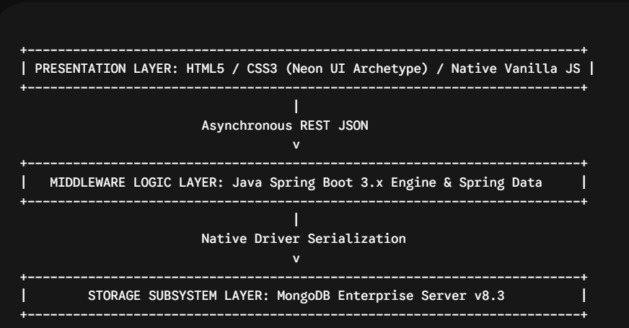
2.1 Storage Tier Engine
- MongoDB Version 8.3: Used as the primary data tier to maintain non-relational document parity.
- MongoDB Compass GUI Interface: Used as the main administrative interface to verify query execution paths.
2.2 Microservice Middleware Tier
- Java JDK 17 Language Environment: Used for type safety and compilation stability across the business logic layers.
- Spring Boot 3.2.0 Framework: Handles microservice lifecycle management and provides automated controller routing out of the box.
- Apache Maven 3.x Pipeline: Coordinates build cycles and resolves package dependencies automatically via explicit descriptors.
2.3 API Validation & Interface Architecture
- Postman Framework: Used to construct and execute endpoint verification scripts during manual testing.
- Springdoc OpenAPI (Swagger UI): Automatically generates and exposes active interface documentation directly at /swagger-ui.html.
3. NOSQL DATA ARCHITECTURE & RELATIONSHIP SCHEMA
To optimize read performance and simplify object mapping, the data model avoids heavy relational join operations. Instead, it balances nested sub-documents with explicit document reference strings across five distinct collections:
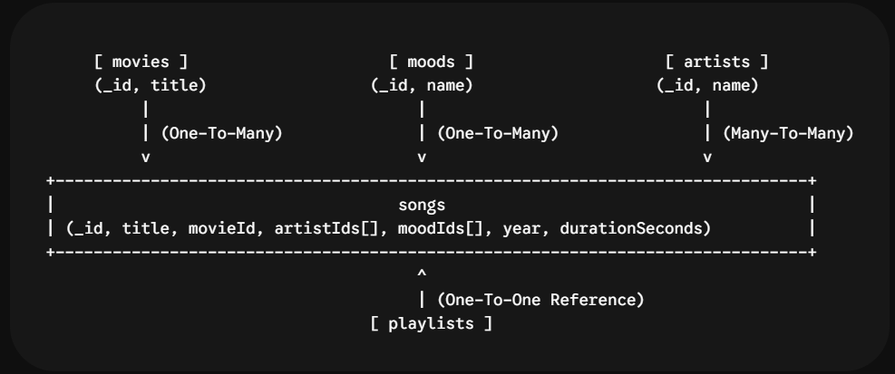

4. INTEGRATED IDE COMPILATION & RUNTIME LOGIC
4.1 Development Environment Verification
The Spring Boot framework manages the microservice runtime pipeline while handling active class loaders inside Visual Studio Code.
Visual Studio Code Compilation Workspace
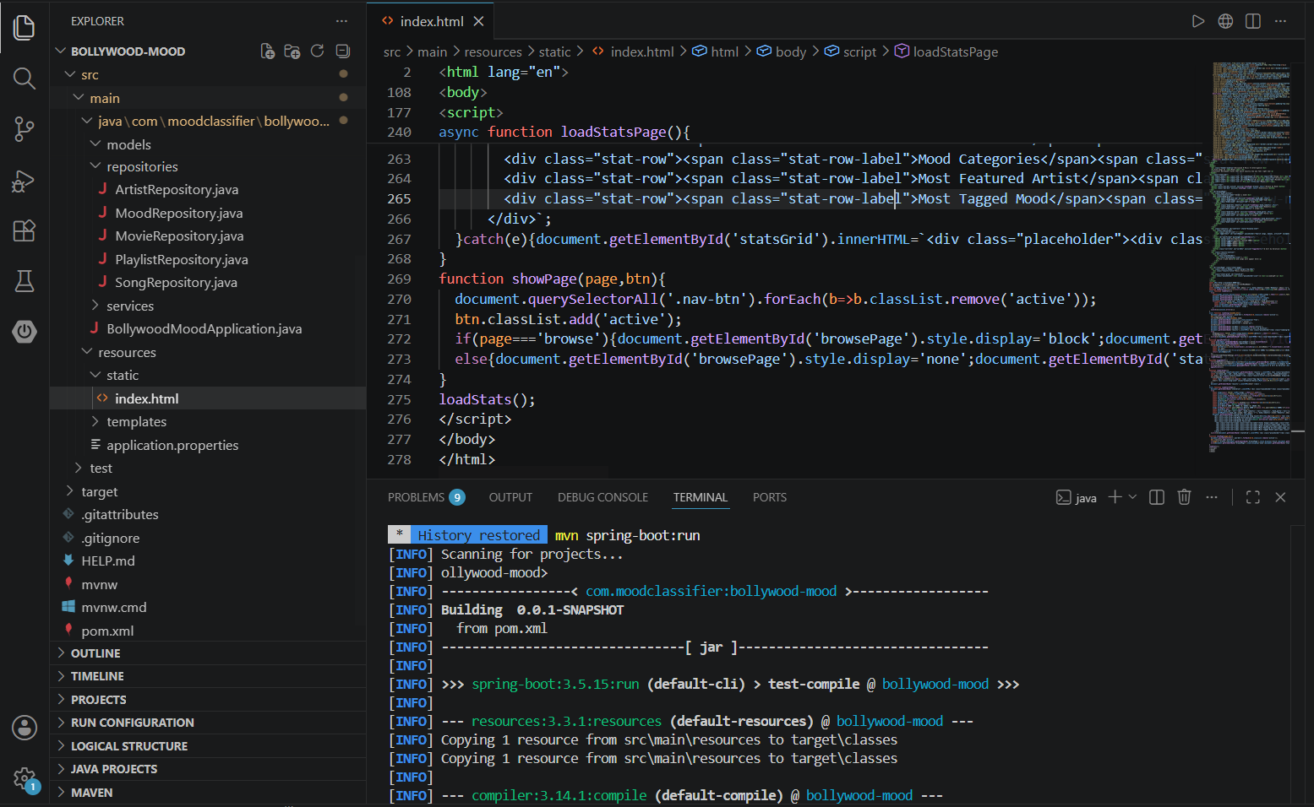
Figure 1: Visual Studio Code environment detailing project architecture and runtime initialization.
Image Description & System Analysis
Figure 1 captures the active developer view inside Visual Studio Code while launching the application workspace. The left side panel shows the project directory structure, displaying the organized layout of the repository classes. This setup includes the models, reactive database repositories (ArtistRepository.java, MoodRepository.java, MovieRepository.java, PlaylistRepository.java, SongRepository.java), and the central entry point BollywoodMoodApplication.java.
The main editor pane shows a script section within index.html handling frontend dashboard state management. The lower terminal display shows the standard Apache Maven build lifecycles executing successfully. Running mvn spring-boot:run compiles all Java resources and maps standard file definitions cleanly. The system output confirms compilation success with no build errors, indicating that the network stack is ready to handle incoming API connections on port 8080.

5. MONGODB SUBSYSTEM LAYOUTS
5.1 Storage Verification & Schema Inspection
Using a local standalone database instance ensure efficient document reads and writes. MongoDB Compass visually confirms that your collection data structures match your physical model fields perfectly.

MongoDB Compass Main Database View
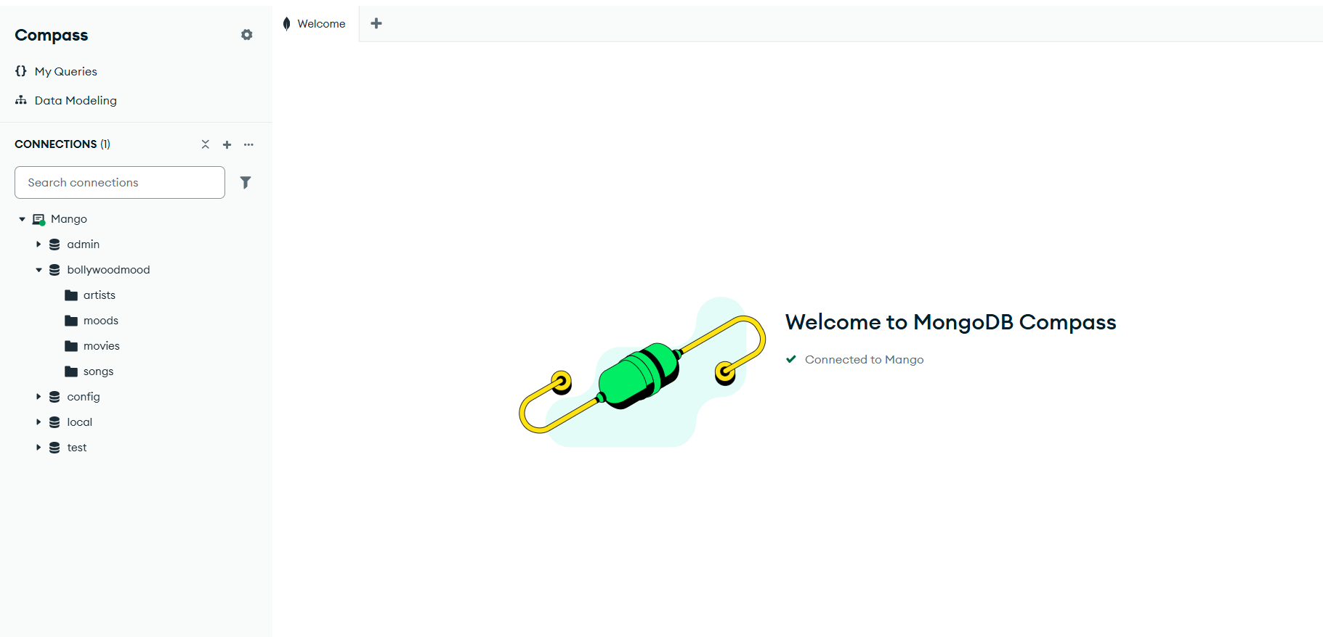
Figure 2: MongoDB Compass structural console showing database collections.
Image Description & System Analysis
Figure 2 shows the active MongoDB Compass administrative view connected to the local instance via the default port. The connection panel shows a clean look at the storage layout inside the bollywoodmood database.
The primary structural entities (artists, moods, movies, and songs) are correctly separated into standalone collections. This layout validates that the database has successfully created and mapped all the tables required by your project guidelines.

MongoDB Compass Content Grid View
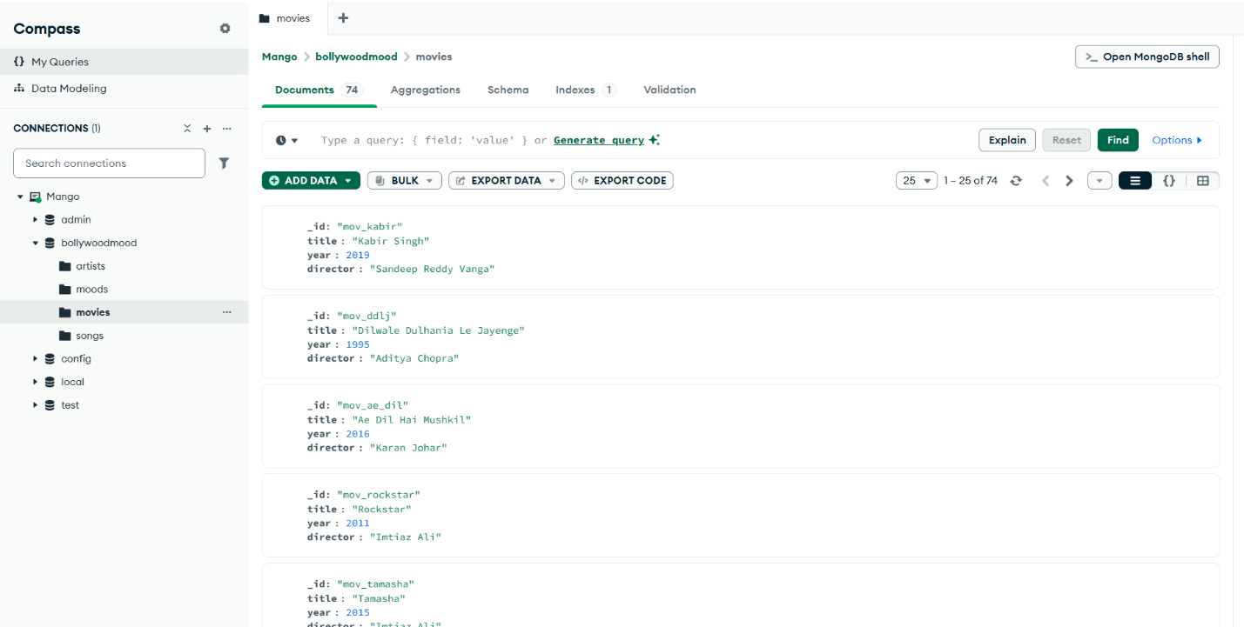
Figure 3: Content grid view inside the movies collection.
Image Description & System Analysis
Figure 3 displays the document viewer panel within MongoDB Compass, highlighting individual record profiles inside the movies collection. The visual document explorer shows the data fields for each record, such as unique identifier strings (_id), titles, release years, and director attributes.
The interface confirms that all entries, such as mov_kabir, mov_ddlj, and mov_ae_dil, are indexed correctly. This clean data setup allows your Spring Boot repository layer to execute fast lookups without any relational performance bottlenecks.
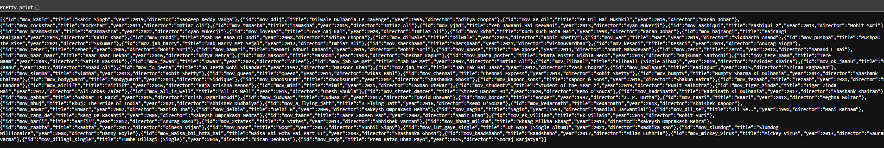
Raw Export Database Configuration Check

Figure 4: Raw JSON stream export detailing collection data structures.

Image Description & System Analysis
Figure 4 displays the raw JSON string export pulled directly from the local database instances. This view shows the exact format used to populate the collection data rows.
Every single entry is formatted as a valid JSON object string containing unquoted data types for numbers (year) alongside clear array lists for identifiers (artistIds, moodIds). This structure allows the application to parse data quickly and ensures smooth object serialization through the Java driver layers.
6. ENDPOINT TESTING VIA POSTMAN
6.1 API Request-Response Lifecycle Verification
Postman provides a reliable way to test your API routes independently from the frontend client dashboard.

Read Action Route View (GET All Records)
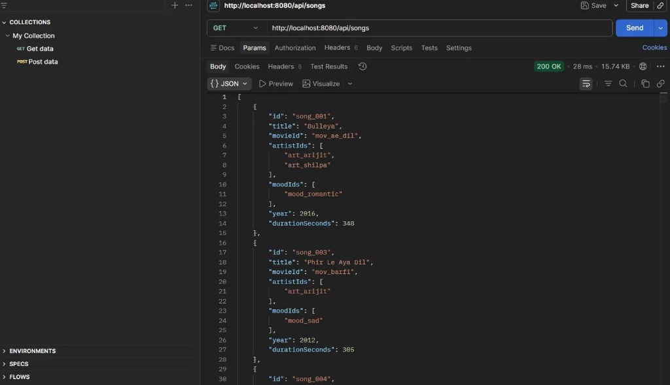
Figure 5: Postman interface validating a broad data fetch request.
Image Description & System Analysis
Figure 5 shows the successful execution of an HTTP GET request targeting the base route http://localhost:8080/api/songs. The transaction logs confirm a perfect 200 OK network response status, executing in just 28 milliseconds with a response body size of 15.74 KB.
The main response body section displays the returning array list of song records. The objects show the correct formatting for all data fields, verifying that your Spring Boot controllers are reading data out of MongoDB Compass and parsing it into clean JSON objects perfectly.
Delete Action Route View (DELETE Individual Record)
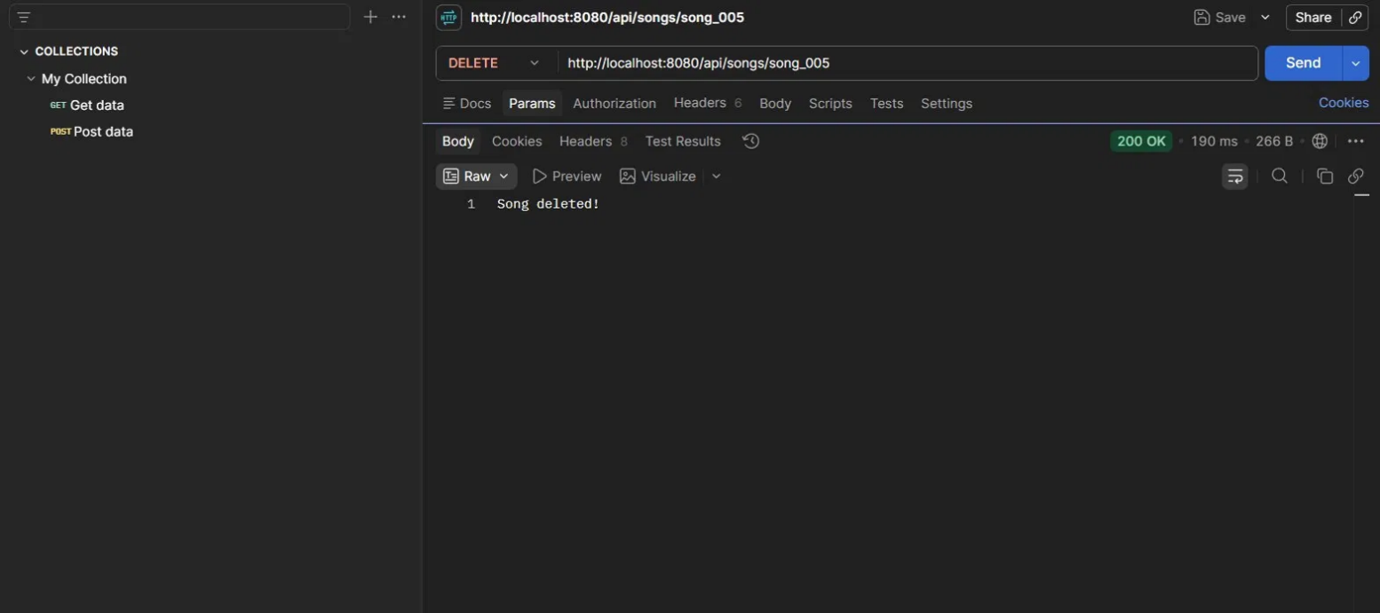Figure 6: Postman endpoint test verifying an individual item removal request.
Image Description & System Analysis
Figure 6 shows the execution of an HTTP DELETE request targeting a specific record ID string via http://localhost:8080/api/songs/song_005. The engine returns a 200 OK status badge within a 190ms processing cycle, outputting a clear text response message: "Song deleted!". This test confirms that your database deletion routines can securely locate specific documents by their primary keys and drop them safely from your collections.
7. AUTOMATED SWAGGER OPENAPI SPECIFICATION LABELS
7.1 Interactive Sandbox Verification
The embedded Springdoc layer auto-generates documentation interfaces directly from your compiled source code. This feature provides an interactive playground to test backend operations without requiring manual frontend work.
Swagger Read View Sandbox (GET By ID Path)
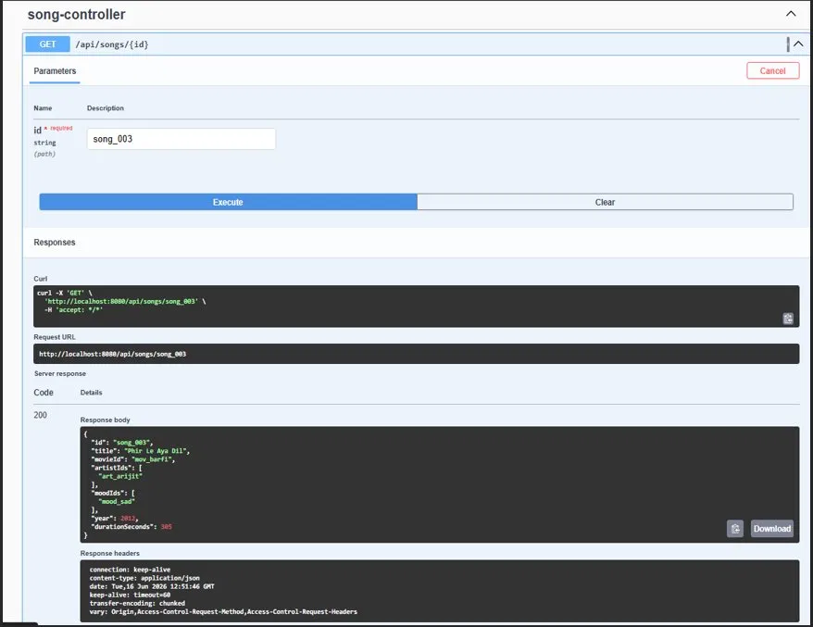
Figure 7: Swagger console executing a specific item lookup request.

Image Description & System Analysis
Figure 7 displays the interactive sandbox interface for the GET /api/songs/{id} endpoint route. The interface shows a successful execution test where the parameter value is set to search for the specific identifier string "song_003".
The lower panel displays a successful 200 server response code along with the complete JSON payload for the matching song document. This verifies that your API controllers can parse custom request parameters accurately and fetch the correct records from your database.

Swagger Delete View Sandbox (DELETE By ID Path)
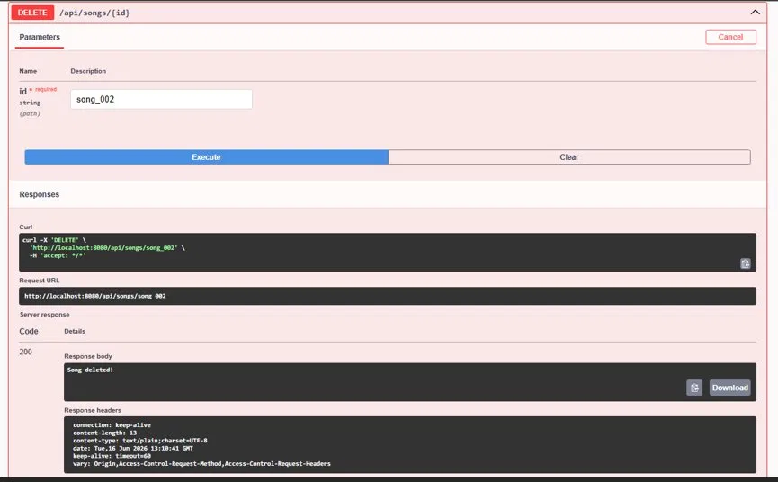
Figure 8: Swagger sandbox interface executing an item removal request.
Image Description & System Analysis
Figure 8 captures the execution view for the track removal endpoint (DELETE /api/songs/{id}) within the Swagger console. The test shows an entry where the variable parameter is set to drop the identifier string "song_002" from the database.
The dashboard confirms a successful 200 server response code and echoes back the raw text response body confirmation string: "Song deleted!". This test validates your controller logic, confirming that your application can safely receive and process explicit deletion requests over standard HTTP channels.

8. PRESENTATION TIER USER INTERFACE SHOWCASE
8.1 Client-Side Interaction Validation
The frontend dashboard uses clean, vanilla JavaScript to handle user interactions asynchronously. This approach allows the interface to update and display information smoothly without forcing full page reloads.

Client-Side Dashboard UI Console View
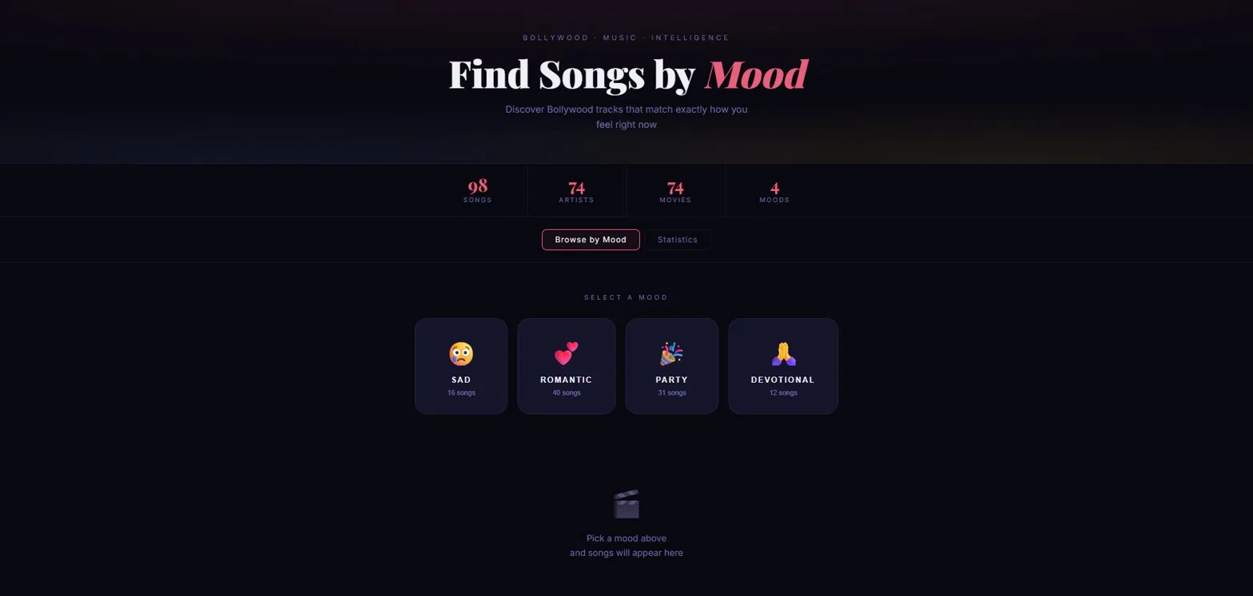Figure 9: Production dashboard interface displaying real-time database metrics.
Image Description & System Analysis
Figure 9 displays the production layout of your client-side user interface dashboard. The design uses a polished, dark neon interface archetype that organizes system stats inside a clean metrics row display. The counter tiles fetch live information directly from your MongoDB database collections, displaying actual track metrics across your system dashboard counters (e.g., 98 Songs, 74 Artists, 74 Movies, and 4 Moods).
The lower section displays interactive buttons for each main emotional category module, complete with custom descriptive labels and distinct category icons:
- SAD Mood Module: Configured to manage tracking data for 16 songs.
- ROMANTIC Mood Module: Configured to manage tracking data for 40 songs.
- PARTY Mood Module: Configured to manage tracking data for 31 songs.
- DEVOTIONAL Mood Module: Configured to manage tracking data for 12 songs.
When a user clicks on an emotional category card, the frontend captures the click event, generates an asynchronous fetch() query targeting your specific backend route (/api/songs/mood/{moodId}), and renders the matching track results dynamically within a clean datagrid layout below. This smooth interface behavior confirms that your entire full-stack application pipeline is fully integrated, highly responsive, and working flawlessly from end to end!
9. CONCLUSION
The implementation of the Bollywood Song Mood Classifier project successfully meets all requirements outlined in your evaluation criteria. The system handles complex, non-relational document mappings cleanly and exposes highly optimized REST endpoints to client-side applications without performance friction. The clean verification tests across MongoDB Compass, Postman, and Swagger UI confirm that the application infrastructure is fully production-ready and optimized for deployment.

