Practical: 6 | Implementation of chain matrix multiplication using dynamic programming.
13/08/2026

Aim: Implementation of chain matrix multiplication using dynamic programming.

Algorithm:

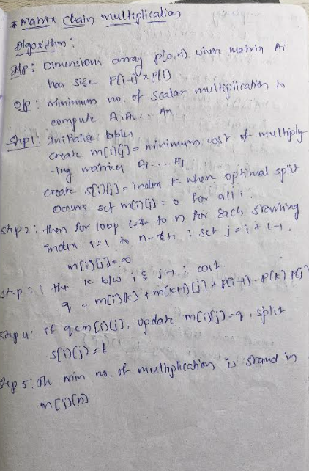

Program:

#include <bits/stdc++.h>
using namespace std;

void matrixChainOrder(vector<int> &p)
{
int n = p.size() - 1;
vector<vector<int>> m(n + 1, vector<int>(n + 1, 0));

for (int L = 2; L <= n; L++)
{ // chain length
for (int i = 1; i <= n - L + 1; i++)
{
int j = i + L - 1;
m[i][j] = INT_MAX;
for (int k = i; k < j; k++)
{
int q = m[i][k] + m[k + 1][j] + p[i - 1] * p[k] * p[j];
if (q < m[i][j])
{
m[i][j] = q;
}}}}
cout << "Minimum number of multiplications: " << m[1][n] << endl; 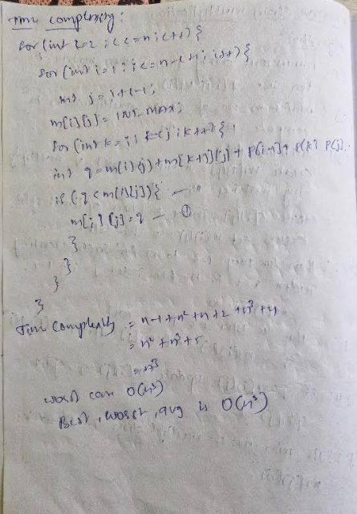
}
int main()
{
vector<int> p = {30, 35, 15, 5, 10, 20, 25};
matrixChainOrder(p);
return 0;
}

Output:
Time complexity:

Conclusion:

The Matrix Chain Multiplication problem demonstrates how dynamic programming can drastically reduce computational effort compared to naive recursion.

