**SQL - Capstone Project:**

## Purposes of The Capstone Project

The major aim of this project is to gain insight into the sales data of Amazon to understand the different factors that affect sales of the different branches.

**About Data:**

This dataset contains sales transactions from three different branches of Amazon, respectively located in Mandalay, Yangon and Naypyitaw. The data contains 17 columns and 1000 rows:

**Analysis List:**

1. **Product Analysis**

Conduct analysis on the data to understand the different product lines, the products lines performing best and the product lines that need to be improved.

1. **Sales Analysis**

This analysis aims to answer the question of the sales trends of product. The result of this can help us measure the effectiveness of each sales strategy the business applies and what modifications are needed to gain more sales.

1. **Customer Analysis**

This analysis aims to uncover the different customer segments, purchase trends and the profitability of each customer segment.

**Approach Used**

1. **Data Wrangling:** This is the first step where inspection of data is done to make sure NULL values and missing values are detected and data replacement methods are used to replace missing or NULL values.

1.1          Build a database

1.2          Create a table and insert the data.

1.3          Select columns with null values in them. There are no null values in our database as in creating the tables, we set NOT  NULL for each field, hence null values are filtered out.

1. **Feature Engineering:** This will help us generate some new columns from existing ones.

2.1           Add a new column named timeofday to give insight of sales in the Morning, Afternoon and Evening. This will help answer the question on which part of the day most sales are made.

2.2          Add a new column named dayname that contains the extracted days of the week on which the given transaction took place (Mon, Tue, Wed, Thur, Fri). This will help answer the question on which week of the day each branch is busiest.

2.3        Add a new column named monthname that contains the extracted months of the year on which the given transaction took place (Jan, Feb, Mar). Help determine which month of the year has the most sales and profit.

             3. **Exploratory Data Analysis (EDA):** Exploratory data analysis is done to answer the listed questions and aims of this project.

### Business Questions and Answers:

-- 1. What is the count of distinct cities in the dataset ?

Query :

Select Count(Distinct city)

AS distinct_city_count

From amazon_salesdb;

Output:

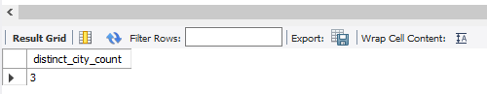

-- 2. For each branch, what is the corresponding city ?

Query :

Select Branch, City

From amazon_salesdb

Group By Branch, City;

Output :

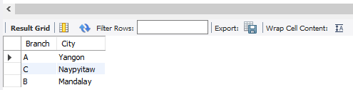

-- 3. What is the count of distinct product lines in the dataset ?

Query :

Select Count(Distinct product_line)

AS distinct_product_line_count

From amazon_salesdb;

Output :

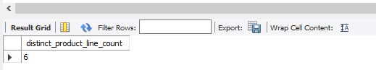

-- 4. Which payment method occurs most frequently ?

Query :

SELECT payment, Count(*)

AS frequency_payments_count

From amazon_salesdb

Group by payment

Order by frequency_payments_count DESC Limit 1;

Output :

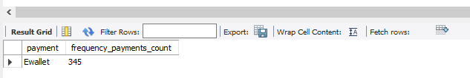

-- 5. Which product line has the highest sales ?

Query :

SELECT product_line, SUM(Quantity * Unit_price) AS Sales

FROM amazon_salesdb

Group By Product_line

Order By Sales DESC Limit 1;

Output :

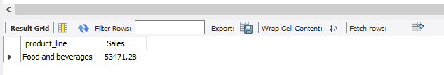

-- 6. How much revenue is generated each month ?

Query :

SELECT monthname, SUM(Total) AS Total_revenue

FROM amazon_salesdb

GROUP BY monthname;

Output :

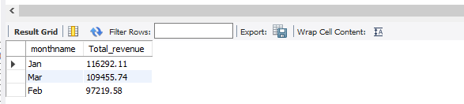

-- 7. In which month did the cost of goods sold reach its peak ?

Query :

SELECT monthname, SUM(COGS) AS cost_of_goods_sold

FROM amazon_salesdb

GROUP BY monthname

ORDER BY cost_of_goods_sold DESC Limit 1;

Output :

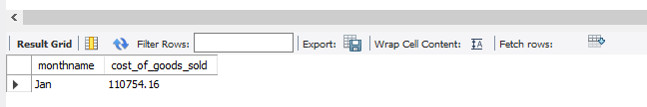

-- 8. Which product line generated the highest revenue ?

Query :

SELECT product_line, SUM(total) AS Total_revenue

FROM amazon_salesdb

GROUP BY product_line

ORDER BY Total_revenue DESC Limit 1;

Output :

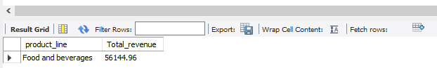

-- 9. In which city was the highest revenue recorded ?

Query :

SELECT City, SUM(Total) AS Total_revenue

FROM amazon_salesdb

GROUP BY City

ORDER BY Total_revenue DESC Limit 1;

Output :

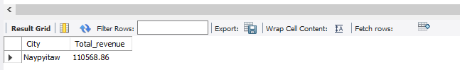

-- 10. Which product line incurred the highest Value Added Tax ?

Query :

SELECT Product_line, SUM(Tax_5_Percent) AS Value_Added_Tax

FROM amazon_salesdb

GROUP BY Product_line

ORDER BY Value_Added_Tax DESC Limit 1;

Output :

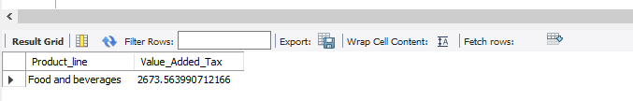

-- 11. For each product line, add a column indicating "Good" if its sales are above

average, otherwise "Bad." ?

Query :

WITH ProductSales AS

(SELECT Product_line, SUM(Quantity * Unit_price) AS Sales

FROM amazon_salesdb

Group By Product_line),

AverageSales AS (Select AVG(Sales)

AS Avg_Sales FROM ProductSales)

SELECT P.Product_line, P.Sales,

CASE WHEN P.Sales > (SELECT Avg_Sales FROM AverageSales)

THEN 'GOOD'

ELSE 'BAD'

END AS SalesPerformance

FROM ProductSales P;

Output :

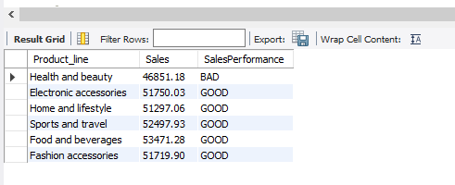

-- 12. Identify the branch that exceeded the average number of products sold ?

Query :

WITH BranchTotalSales AS

(SELECT Branch, SUM(Quantity) AS Total_Sales

FROM amazon_salesdb

GROUP BY Branch),

AverageProductsSold AS

(Select AVG(Total_Sales) AS Avg_Sales

FROM BranchTotalSales)

Select B.Branch, B.Total_Sales

FROM BranchTotalSales B

WHERE B.Total_Sales > (Select Avg_Sales

FROM AverageProductsSold);

Output :

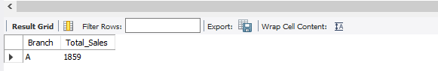

-- 13. Which product line is most frequently associated with each gender ?

Query :

WITH ProductLineGender

AS (SELECT Gender, Product_line, COUNT(Gender) AS count

FROM amazon_salesdb

GROUP BY Gender, Product_line),

MaxCountGender

AS (SELECT Gender,MAX(count) AS MaxCount

FROM ProductLineGender

GROUP BY Gender)

SELECT ProductLineGender.Gender,

ProductLineGender.Product_line, ProductLineGender.count

FROM ProductLineGender

JOIN MaxCountGender ON ProductLineGender.Gender =

MaxCountGender. Gender

AND ProductLineGender.count =

MaxCountGender.MaxCount;

Output :

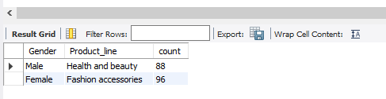

-- 14. Calculate the average rating for each product line ?

Query :

SELECT Product_line, ROUND(AVG(Rating), 2)

AS Average_Rating

FROM amazon_salesdb

GROUP BY Product_line;

Output :

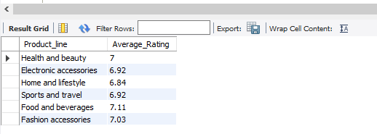

-- 15. Count the sales occurrences for each time of day on every weekday ?

Query :

SELECT Dayname(date) AS weekday,

CASE

WHEN TIME(time) BETWEEN '06:00:00' AND '11:59:59' THEN 'Morning'

WHEN TIME(time) BETWEEN '12:00:00' AND '17:59:59' THEN 'AFTERNOON'

WHEN TIME(time) BETWEEN '18:00:00' AND '23:59:59' THEN 'Evening'

ELSE 'Night'

END AS time_of_day,

COUNT(*) AS Sales_Occurrences

FROM amazon_salesdb

Group By weekday, time_of_day

Order By Field (Weekday, 'Monday', 'Tuesday', 'Wednesday', 'Thursday', 'Friday'),

Field (time_of_day, 'Morning', 'Afternoon', 'Evening');

Output :

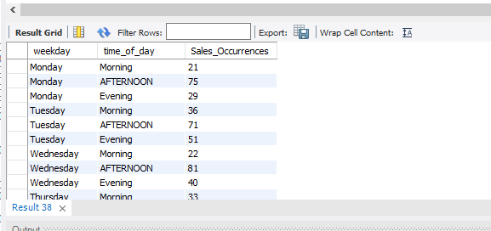

-- 16. Identify the customer type contributing the highest revenue ?

Query :

SELECT Customer_type, SUM(Total) AS total_revenue

FROM amazon_salesdb

GROUP BY Customer_type;

Output :

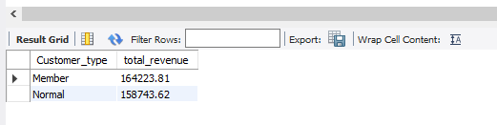

-- 17. Determine the city with the highest VAT percentage ?

Query :

SELECT City, SUM(Tax_5_Percent) AS VAT_percentage

FROM amazon_salesdb

GROUP BY City

ORDER BY VAT_percentage DESC Limit 1;

Output :

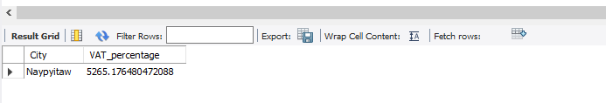

-- 18. Identify the customer type with the highest VAT payments ?

Query :

SELECT Customer_type, SUM(Tax_5_percent) AS VAT_payments

FROM amazon_salesdb

GROUP BY Customer_type

Order By VAT_payments DESC Limit 1;

Output :

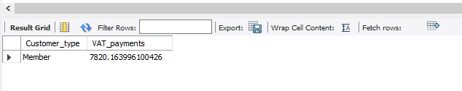

-- 19. What is the count of distinct customer types in the dataset ?

Query :

SELECT COUNT(Distinct Customer_type)

AS Count_of_Customer_types

FROM amazon_salesdb;

Output :

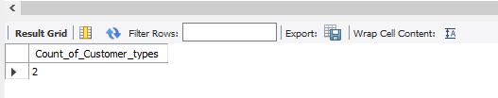

-- 20. What is the count of distinct payment methods in the dataset ?

Query :

SELECT COUNT(DISTINCT Payment)

AS count_of_payment_methods

FROM amazon_salesdb;

Output :

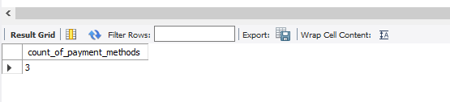

-- 21. Which customer type occurs most frequently ?

Query :

SELECT Customer_type, COUNT('Invoice_id') AS Transactions

FROM amazon_salesdb

GROUP BY Customer_type

ORDER BY Transactions DESC LIMIT 1;

Output :

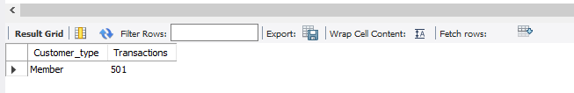

-- 22. Identify the customer type with the highest purchase frequency ?

Query :

SELECT Customer_type, COUNT(Quantity) AS purchase

FROM amazon_salesdb

GROUP BY Customer_type

ORDER BY purchase DESC LIMIT 1;

Output :

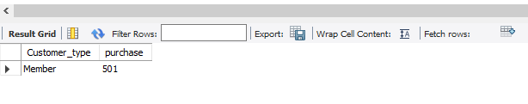

-- 23. Determine the predominant gender among customers ?

Query :

SELECT Gender, COUNT(*) AS count

FROM amazon_salesdb

GROUP BY Gender

ORDER BY count DESC LIMIT 1;

Output :

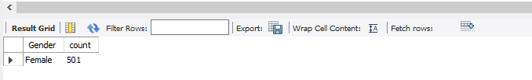

-- 24. Examine the distribution of genders within each branch ?

Query :

SELECT Branch, Gender, COUNT(*) AS Gender_Count

FROM amazon_salesdb

GROUP BY Branch, Gender

ORDER BY Branch, Gender_Count DESC;

Output :

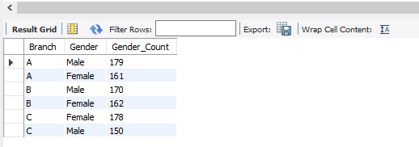

-- 25. Identify the time of day when customers provide the most ratings ?

Query :

SELECT TIME(time) AS Rating_time,

COUNT(*) AS Rating_count

FROM amazon_salesdb

WHERE Rating IS NOT NULL

Group By Rating_time

Order By Rating_Count DESC

Limit 1;

Output :

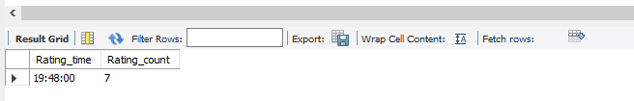

-- 26. Determine the time of day with the highest customer ratings for each branch ?

Query :

WITH Rating AS(

SELECT Branch, timeofday, Avg(Rating)

AS Avg_Rating

FROM amazon_salesdb

Group By Branch, timeofday)

SELECT Branch, timeofday, Avg_Rating

FROM Rating

WHERE (Branch, Avg_Rating) IN

(SELECT Branch, MAX(Avg_Rating)

FROM Rating

Group By Branch)

Order By Branch;

Output :

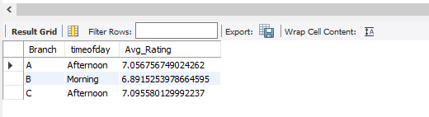

-- 27. Identify the day of the week with the highest average ratings ?

Query :

SELECT dayname,AVG(Rating) AS Avg_Rating

FROM amazon_salesdb

GROUP BY dayname

ORDER BY Avg_Rating DESC LIMIT 1;

Output :

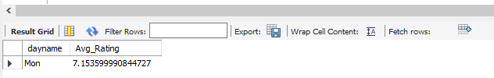

-- 28. Determine the day of the week with the highest average ratings for each branch ?

Query :

WITH Rating AS

(SELECT Branch, Dayname, AVG(Rating) AS Avg_Rating

FROM amazon_salesdb

GROUP BY Branch, Dayname)

SELECT Branch, Dayname, AVG_Rating

FROM Rating

WHERE (Branch, Avg_Rating) IN

(SELECT Branch, MAX(Avg_Rating)

FROM Rating

GROUP BY Branch)

ORDER BY Branch;

Output :

