# Can It Be Economically Rational to Restrict Big Box Retailers?

## Introduction

Conventional wisdom from committed "free market" economists would have it that moves to ban "big box" retailers such as Walmart from certain localities are rebellions against consumer sovereignty and must hurt consumer welfare. After all, if consumers did not want to shop at the big box retailer, they would simply not do so, correct? The fact that they switch their shopping to the big box and away from "mom-and-pop" stores shows they prefer the big box.

This paper attempts to show that the above analysis is simplistic. We present a model in which all consumers have the following preference ordering in some retail sector:

1. Have both local shops and a big box store.
2. Have only local shops.
3. Have only a big box store.

(We can further assume they know the costs of achieving 1, 2, or 3: they want 1 even if they sometimes pay higher prices to achieve it compared to 3, i.e., we could add a monthly shopping bill to each of the above.) We then show that, under not outrageous assumptions, it is easy for consumers, in trying to achieve their first preference, to instead wind up with their third.

We then show that, under not outrageous assumptions, it is easy for consumers, in trying to achieve their first preference, to instead wind up with their third. This is due to consumers facing a collective action problem, as well as a knowledge problem: Consumers might, if they had perfect knowledge of the exit points of the local shops and the ability to finely coordinate their own shopping with that of others, be able to achieve their first preference (a mix of big box and mom-and-pop shopping available). But, in general, consumers have little knowledge of what percentage reduction in sales will cause a small shop to exit the industry, nor do they have very much ability to coordinate their shopping with other consumers. (The latter means that even if consumers forego a certain amount of shopping at the big box stores, which they would otherwise do, simply to keep the small stores solvent, they cannot ensure their neighbors will do the same. So their rational choice is to "defect" and shop at the big box store as often as they wish, regardless of the impact on the small shops.)

Therefore, since they cannot fine tune their shopping to achieve 1), they shop at the big box store whenever it suits them for a particular purchase, without regards to the "macro" effects of their choices. (See Schelling, 2006, for extensive analysis of the potential gap between micromotives and macrobeahvior.) They shift "too" much of their shopping to the big box, with the end result is that all of the mom-and-pops are driven out of business, despite no consumer wanting that result. Thus, it might make sense, faced with such knowledge and game theoretic difficulties, for consumers to bind themselves in advance to 2), by banning a, or some, or all, big box stores, or to trying to achieve 1) by, say, forcing big box retailers to locate well outside the center of town, making trips to them less convenient. (All legislation has unintended consequences, which is why we make the weak claim that these types of actions might make sense: such legislation might also, for instance, serve the interest of an inefficient local monopolist seeking to protect its privileged position in a market.)

We further suggest that our model may actually capture the mechanism underlying the intuition of the existence of "predatory pricing." As has often been noted, the idea that big box stores engage in predatory pricing to drive out small competitors and then jack up the prices to achieve high profits has an obvious problem: once the prices charged by the big box stores have been raised, why don't the small competitors simply reenter the market? (See, for instance, DiLorenzo, 1992.)

Our model avoids this pitfall: the big box stores do not need to set prices artificially low for a time: they can rely on their greater financial resources to ride out the period during which all stores will be losing money, and once their smaller competitors have exited, they can keep their prices right where they were, and now be profitable. And new smaller competitors will not enter the market, since that would merely reestablish the situation in which all stores are losing money. Furthermore, our model has the advantage that we need not posit any vicious intent on the part of big-box retailers: they need not be intending to drive small retailers out of business. They just know that in a year or so, their new outlet will be making plenty of money.

We note here that what we are describing, in suggesting the possibility that some restriction on big-box retailing might be rational, is an example of the general class of "constitutional constraints" described by Jon Elster in Ulysses Unbound (2000): we want to listen to the Sirens, but we know that if we do not tie ourselves to the mast in advance, we will not merely listen, but fall prey to their sweet song. Or, to consider more mundane circumstances, by the sober light of day, we realize that we do not want to find ourselves in a bar at 4 AM, but we also recognize that in the bar at 1 AM, we will not be thinking so clearly. So we mandate a bar closing time. Similarly, we don't want our own speech suppressed, but recognize that in power we might give in to the temptation to suppress speech we don't like, and that others in power might do so to us. So we pass the first amendment to the U.S. Constitution.

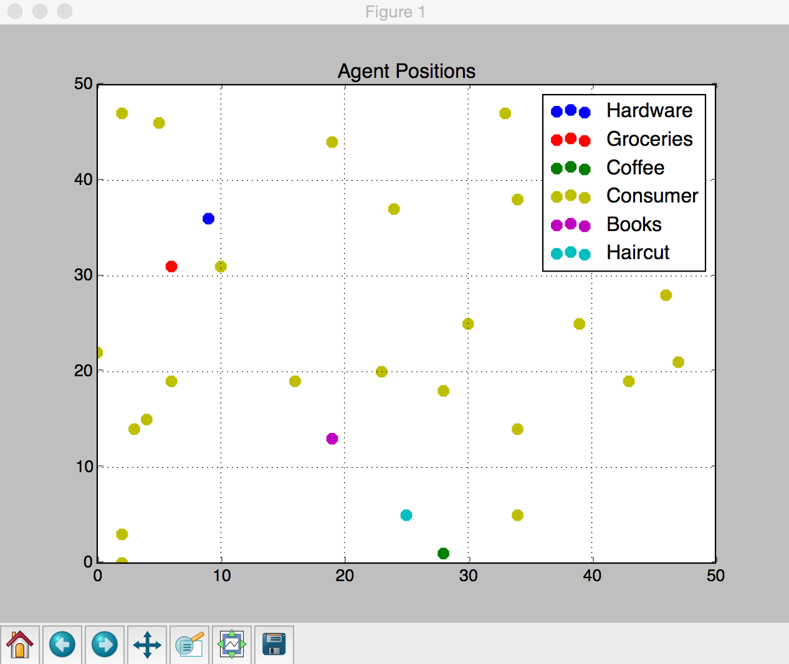

**Initial Situation**

## Design and Definition

In order to see if our notion is theoretically plausible, we create a model. The model has both the big box and the mom-and-pop stores, which (for ease of reading) we abbreviate as BBs and MPs.

Initially, there are only MPs, no BBs. And our city “EverytownUSA” begins with as many MPs as there are kinds of goods to sell. So if there are G different kinds of good, there will be G different stores.

Our city’s consumer population size is N. Endowed with and wholly spending M dollars, in each step of the model, every consumer purchases a good at one and only one store. His choice of what good to shop for is deterministic. He cycles through each of the G goods successively. Of the MPs and consumers, each supplies something the other needs: the consumers supply money to the mom-and-pop stores, and they supply goods to the consumers. This leaves MPs average income to be described as follows:

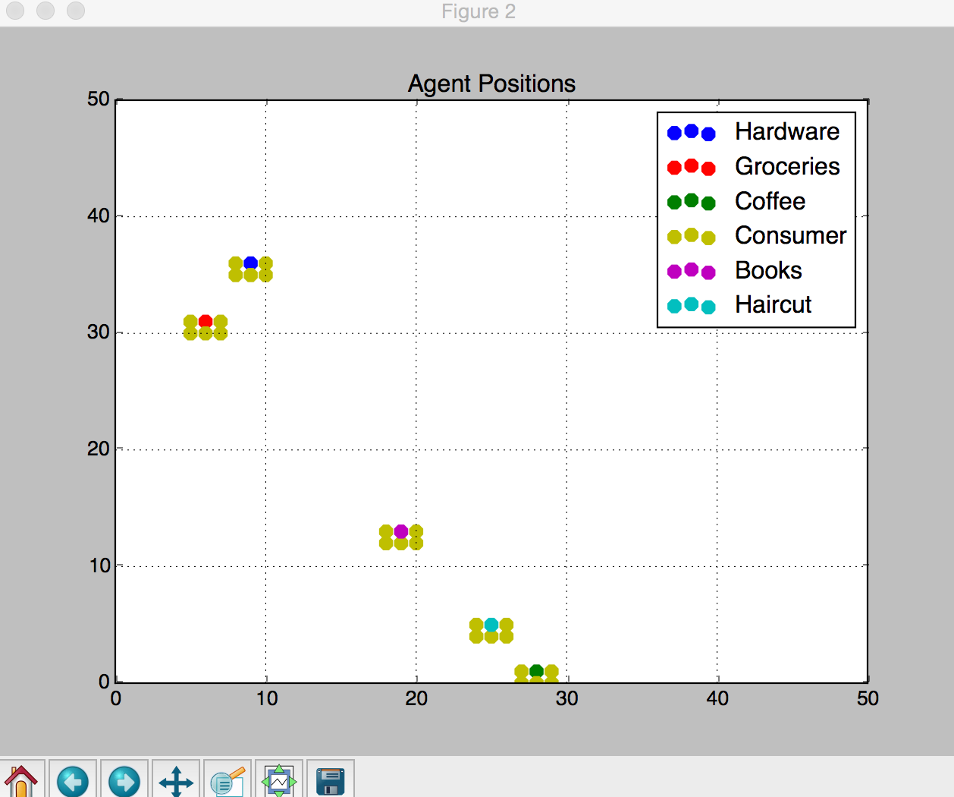

**Consumers shopping at the MPs**

And the MPs' financial security is sustained as long as its income is greater than its upkeep expense, R:

If he does not keep up this expense, he disappears. Without BB competitors, we discover an equilibrium can exist so that a certain number of MPs can remain in business.

At a certain point in the running of our model, the BBs appear. They have a much larger initial endowment of money then do the Ms. And while the MPs each supply a specific type of good, such as hardware or groceries, the BBs provide every sort of good. Here a new dynamic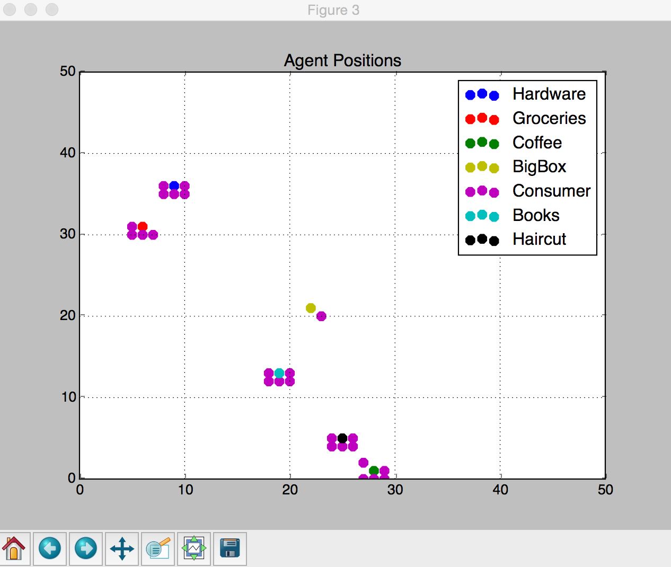 appears: consumer preference for MP and BB. Here the preference p is the probability customers will shop at the MP. And so, our above income equation becomes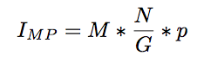

On the other hand, the consumer preference for the BB is (1-p), and so the BBs’ average income is

**The Big Box Appears**

For simplicity’s sake, we keep the cost of upkeep for the BB the same as that of the MP, that is, R. And again, if the BB runs out of funds, it disappears. (In order to illustrate the thesis of our paper, that consumer behavior may thwart consumer preferences, we have run our model with consumers preferring the mom-and-pops by as much as four-to-one, and have still gotten a result where the small shops disappear.)

The introduction of the new BB and the subsequent split in shopping habits may cause the funds of both types of store to dwindle. But as the BBs have a much greater initial endowment, they are able to survive this period of coexistence, while the MPs gradually disappear. We are left with an environment of only BBs and consumers, which the consumers did not want. Thus, given simple but not outrageous assumptions, our model shows our story above is plausible: it has what Weber would call "explanatory adequacy." Empirical work would be necessary to decide whether it has Weberian "causal adequacy." (See Callahan and Horwitz, 2010, for a brief description of the difference between the two concepts in Weber.)

## Formal Statement of the Problem

Now we may formally state our model.

1. Consumers want to shop at both MPs and BBs. [Formally: 0 < p < 1 and 0 < (1-p) < 1]
2. Consumers would rather shop only at BBs than MPs. [That is: p > 0.5]

But nevertheless it can occur that MPs cannot compete, or even survive, with the BBs. That is, on average:

leaving the consumers ultimately and exclusively shopping at the BB.

## The Program

Here we will dive into the specifics of the implementation of our model. What was described above in loose language is described in specific detail. (e.g. how consumers choose their preferred store and how they cycle through what kind of good they want.)

Our model is based on Indra, an agent based modeling (ABM) system built in Python. Since our model runs on it, it would be valuable to review its architecture. Indra includes the following capabilities:

* Looping over agents randomly, in order, in reverse order, or by type.
* Automatic generation of line graphs and scatter plots.
* The ability to enter model parameters interactively, from the command line, or from a file.
* The ability to save parameters sets.
* The ability to dump the state of the system to a JSON file.
* A built-in, extensible interactive menu.
* Automatic creation of network graphs showing the relationship among objects in the system.
* Extensible Markov-matrix capabilities for easily specified, probabilistic behavior on the part of agents.
* A flexible spacial environment model that allows the composition of agent views of the environment of any desired shape, easing the creation of models exploring limited, local agent knowledge.
* In-line debugging capabilities, allowing, e.g., the screen display of all of an agent's attributes at any point during the run of a model.
* The ability to step through a model to watch it develop in real time.

In addition to running on the base framework of agents and environments, our model includes Indra's Markov classes. These allow our Consumers to display pseudorandom shopping behavior according to the logic of Markov chains. These Consumers choose to either buy from a MomAndPop Retailer or a BigBox retailer; their preference is decided by use of a transition matrix. When an agent sees a collection of stores he could possibly go to, he needs some way to choose. Let's say we define his preferences so that when there are multiple places to go, he goes to a mom and pop about 70% of the time and to a big box 30% of the time. An option to simulate this is to generate random numbers: If a random number between 0.0 and 1.0 is less than 0.7, the agent goes to the mom and pop; otherwise he goes to the big box. We can do this by use of Indra's Markov classes, which provide the capability to work with a large array of phenomena that are, or, at least, look like, Markov processes.

The way we read the transition matrix is as follows. Our Consumer sees that there are both MomAndPop and BigBox retailers who sell his desired good. Further, he has a predilection for the MomAndPops such that he goes to them about 70% of the time; leaving the remaining 30% of shopping for the BigBox stores.

Let us look, first, at the behavior of consumers, and then, briefly, at the simpler behavior of retailers.

When a consumer acts, he surveys the world around him, evaluates his world on the basis of this survey, and he responds according to his evaluation. Naturally, therefore, we call these methods survey_env, eval_env, and respond_to_cond.

def act(self):

env_vars = self.survey_env()

eval_vars = self.eval_env(env_vars)

if eval_vars:

self.respond_to_cond(eval_vars)

The way the consumer surveys his environment goes like this: he finds all the stores he can view (a view which happens to be the whole environment this model) and he only remembers the stores which sell the good he wants.

def survey_env(self):

view = self.env.get_square_view(

center=self.pos,

distance=math.sqrt(

self.env.width**2 +

self.env.height**2))

n_census = []

n_census.extend(self.neighbor_iter(view=view,

filt_func=lambda x:

x.sells(self.goal)))

return n_census

Here is how a Consumer decides where to go shopping:

def eval_env(self, n_census):

self.state_pre = self.env.get_pre(self, n_census)

self.state_vec = markov.probvec_to_state(

self.state_pre.matrix)

self.state = markov.get_state(self.state_vec)

if(self.state == 0):

self.preference = MomAndPop

if(self.state == 1):

self.preference = BigBox

for store in n_census:

if type(store) is self.preference:

return store

Consumers look at their Environment to see what’s around. Based on what’s around, we build a 2x1 matrix. [Note: Matricies are used merely as a data structure in this program. Its affinity to the conceptual space of transition matrices chains (e.g. probability, rows or columns summing to unity), makes it just as good a candidate as any other.] The (1,1) entry represents the agent's chance of going to a mom_and_pop, and the (1,2) entry is that of the big_box. If a type is not in the agent’s neighborhood, we cannot go there. Since this means there may be a zero entry, we must normalize the vector. For the column must sum to 1, according to the idea of a transition matrix. This leads to the following method:

def get_pre(self, agent, n_census):

trans_str = ""

if(self.there_is(n_census, MomAndPop)):

trans_str += "0.7 "

else:

trans_str += "0.0 "

if(self.there_is(n_census, BigBox)):

trans_str += "0.3"

else:

trans_str += "0.0"

state_pre = markov.from_matrix(np.matrix(trans_str))

state_pre.matrix = vs.normalize(state_pre.matrix)

return state_pre

After choosing where to go, he goes there and buys his long sought after good.

def respond_to_cond(self, store):

self.move(store)

store.buy_from(self.allowance)

After this action, the consumer now decides his goal is to acquire a new good. This goal is to be acted out during the next cycle of interactions.

def postact(self):

"""

We cycle through the goods the agent might want

turn-by-turn.

"""

self.goal = (self.goal + 1) % NUM_GOODS

The retailer's action is much simpler. It merely pays its bills. If its funds go below zero, it goes bankrupt, and it disappears from the environment never to reappear.

def act(self):

self.pay_bills(self.rent)

if(self.funds <= 0):

self.declare_bankruptcy()

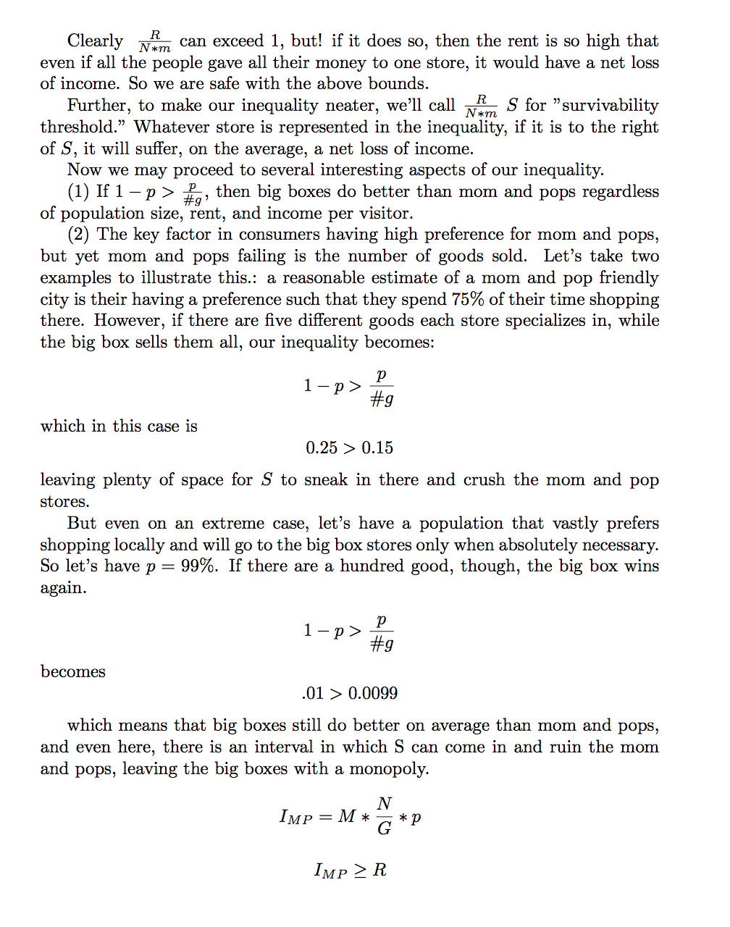

## Mathematical Analysis of the Model

## Conclusion

This behavior is due to consumers facing a collective action problem, as well as a knowledge problem: Consumers might, if they had perfect knowledge of the exit points of the local shops and the ability to finely coordinate their own shopping with that of others, be able to achieve their first preference (a mix of big box and mom-and-pop shopping available). But, in general, consumers have little knowledge of what percentage reduction in sales will cause a small shop to exit the industry, nor do they have very much ability to coordinate their shopping with other consumers. (The latter means that even if consumers forego a certain amount of shopping at the big box stores, which they would otherwise do, simply to keep the small stores solvent, they cannot ensure their neighbors will do the same. So their rational choice is to "defect" and shop at the big box store as often as they wish, regardless of the impact on the small shops.)

Therefore, since they cannot fine tune their shopping to achieve 1), they shop at the big box store whenever it suits them for a particular purchase, without regards to the "macro" effects of their choices. (See Schelling, 2006, for extensive analysis of the potential gap between micromotives and macrobeahvior.) They shift "too" much of their shopping to the big box, with the end result is that all of the mom-and-pops are driven out of business, despite no consumer wanting that result. Thus, it *might* make sense, faced with such knowledge and game theoretic difficulties, for consumers to bind themselves in advance to 2), by banning a, or some, or all, big box stores, or to trying to achieve 1) by, say, forcing big box retailers to locate well outside the center of town, making trips to them less convenient. (All legislation has unintended consequences, which is why we make the weak claim that these types of actions *might* make sense: such legislation might also, for instance, serve the interest of an inefficient local monopolist seeking to protect its privileged position in a market.)

## Bibliography

* Callahan, Gene and Steven Horwitz. "The Role of Ideal Types in Austrian Business Cycle Theory." In What Is so Austrian about Austrian Economics?, 14:205-24. Advances in Austrian Economics 14. Emerald Group Publishing Limited, 2010. http://www.emeraldinsight.com/doi/abs/10.1108/S1529-2134%282010%290000014013.
* DiLoernzo, Thomas. "The Myth of Predatory Pricing." Cato.org, 1992. https://www.cato.org/pubs/pas/pa-169.html.
* DiLoernzo, Thomas. "The Myth of Predatory Pricing." Cato.org, 1992. https://www.cato.org/pubs/pas/pa-169.html.
* Elster, Jon. Ulysses Unbound: Studies in Rationality, Precommitment, and Constraints. Cambridge: Cambridge University Press, 2000.
* Fernando Pérez, Brian E. Granger, IPython: A System for Interactive Scientific Computing, Computing in Science and Engineering, vol. 9, no. 3, pp. 21-29, May/June 2007, doi:10.1109/MCSE.2007.53. URL: http://ipython.org
* Schelling, Thomas C. Micromotives and Macrobehavior. New York: Norton, 2006.
* Slee, Tom. No One Makes You Shop At Walmart. Between the Lines, 2006.
* Main Street image by Larry D. Moore, CC BY-SA 3.0, <https://commons.wikimedia.org/w/index.php?curid=609290>