**Consumer Utility**

Our model assumes that consumers have some general amount of utility by which they favor mom-and-pop stores, although moment-to-moment changes in preferences might override this. To account for both this preference and variability, for the kth consumer, the utility gained from shopping at a mom-and-pop is a positive constant plus some random factor:

Uk = (pM + rkM[0,1))[1]

Consumers gain utility from shopping at the big-box store as well. Thus, the consumer’s overall utility gain is:

Uk = max{(pkM + rkM[0,1)), rkB[0,1)}

The overall utility in the market is expressed as the sum of these utilities over the population:

Σk Uk

To rephrase our assumptions: consumers gain the most utility when both mom-and-pops and big-boxes are around, they do second best when they have available only mom-and-pops, and worst when they have only big-boxes. But it turns out that even in cases of high preference for mom-and-pop store, the consumers’ least preferred outcome can arise.

**Big-box Statistics**

**Runs**

The following graphs represent the average run time of models where consumer “added” preference for mom-and-pops is 0.0, 0.2, 0.4, 0.6, and 0.8 respectively. All other variables beside preference are held constant.[2] For each preference level, we ran seventy-five runs of seventy-five periods each. Note that in all experiments the big-box store appears in period 20.

**[Graph 1.0] [Graph 1.2]**

**[Graph 1.4] [Graph 1.6]**

**[Graph 1.8]**

Clearly the trend is for environments whose consumers have a “low enough" preference to lose their mom-and-pop stores. In [Graphs 1.0, 1.2, 1.4. and 1.6], the consumer utility was raised by the presence of the big-box store; yet in the end, its presence drove out the mom-and-pops, leaving it in the cases where consumers preferred mom-and-pops to big-boxes where the end result was a net loss in utility.

**Mathematical Analysis**

We’ll denote the utility at step t by

( Σi Ui ) t

We give the expected utility in the three periods of our model.

1. When there are only mom-and-pops, E( ( Σi Ui ) t ) = E ( Σi (pM + riM[0,1))) = ( Σi  (E pM + E riM[0,1))) = ( Σi ( pM + 0.5) ) = N( pM + 0.5) by linearity.
2. When there are big-boxes as well as mom-and-pops, E( ( Σi Ui ) t ) = E ( Σi (max { pM + riM[0,1), riB[0,1) } )) = Σi E max { pM + riM[0,1), riB[0,1) } = N((2/3) + (1/2)pM+(1/2)pM^2-(1/6)pM^3).
3. When there are only big-boxes, E( ( Σi Ui ) t ) = E ( Σi riB[0,1)) = N(0.5)

We note that for preferences between 0 and 1, the expected value in 2. is greater than that of 1. which in turn is greater than that of 3.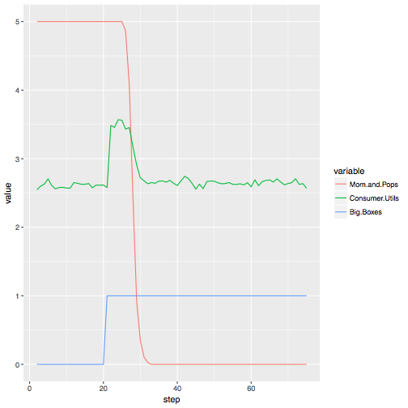

Pref. pM = 0.0

1. 2.6

2. 3.5

3. 2.6

Pref. pM = 0.2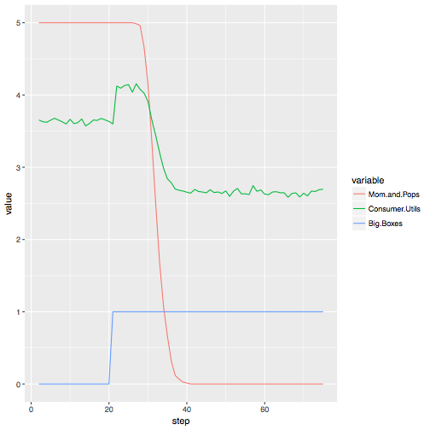

1. 3.6

2. 4.1

3. 2.6

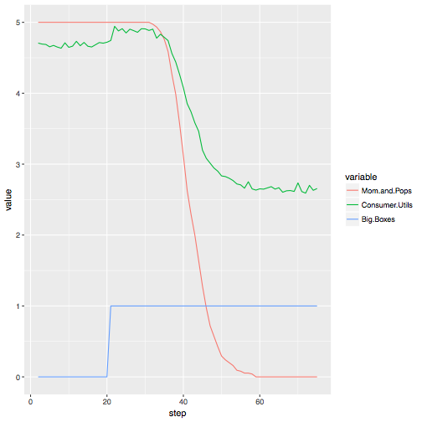

Pref. pM = 0.4

1. 4.6
2. 4.8
3. 2.6

Pref. pM = 0.6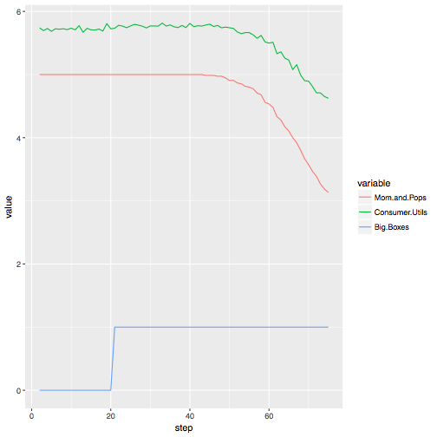

1. 5.7

2. 5.8

3. 2.6

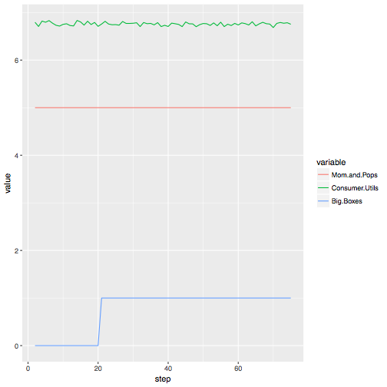

Pref. pM = 0.8

1. 6.8

2. 6.8

3. 2.6

1. The variables pM and rM(0,1] are between 0 and 1 inclusive. pM is consumer preference for mom-and-pops, and rX is a random number. We abbreviate “mom-and-pop” by *M* and “big-box” by *B.* The subscript indicates the variable belongs to the type of retailer.
2. There are 26 consumers, 5 mom-and-pop stores, each of which have an initial endowment of $30, gain $2 per purchase, and loose $10 per step. The big-box appears on period 20. It has an initial endowment 1000 times that of the big-box-store, and it pays five times the rent.