UrbanSound8k Dataset Analysis and Spectrogram Comparison

# 1. Introduction

This report presents the analysis of the UrbanSound8k dataset by applying different windowing techniques (Hann, Hamming, and Rectangular) for spectrogram generation using Short-Time Fourier Transform (STFT). Additionally, a neural network classifier was trained using features extracted from these spectrograms to evaluate the impact of windowing techniques on classification performance.

**GitHub repository link** : - <https://github.com/AbhilashAgarwalIITJ/Sppech_Understanding_assignment1>

# 2. Windowing Techniques

Three different windowing techniques were applied to analyze their effects on spectrogram quality:  
- **Hann Window**: Provides smooth transitions and reduces spectral leakage.  
- **Hamming Window**: Similar to Hann but with slightly higher side-lobe attenuation.  
- **Rectangular Window**: A simple window that does not modify the signal but suffers from higher spectral leakage.

# 3. Spectrogram Comparison

Spectrograms were generated using STFT with the three windowing techniques. The results show that:  
- The **Hann window** provided the best balance between resolution and leakage reduction.  
- The **Hamming window** offered slightly better leakage reduction but at the cost of frequency resolution.  
- The **Rectangular window** resulted in significant spectral leakage, making it less desirable for classification.

# 4. Neural Network Classifier Performance

A simple neural network was trained on spectrogram features extracted using different windowing techniques. The model structure included fully connected layers with ReLU activation and dropout for regularization. Results showed that:  
- **Hann Window** achieved the highest classification accuracy. - **78.59%**  
- **Hamming Window** performed similarly but slightly lower. - **78.48%**- **Rectangular Window** performed the worst due to spectral leakage affecting feature extraction. - **77.5%**

# 5. Task B: Spectrogram Analysis of Different Music Genres

For Task B, spectrograms of four different songs from distinct genres were analyzed:  
- **Rock**: 'Bohemian Rhapsody'  
- **Classical**: 'Clair de Lune'  
- **Pop**: 'Shape of You'  
- **Jazz**: 'Take Five'  
The spectrograms highlighted how different genres exhibit unique frequency characteristics, with classical music showing more harmonic consistency and jazz displaying more rhythmic complexity.

# Histograms for both Task A and B

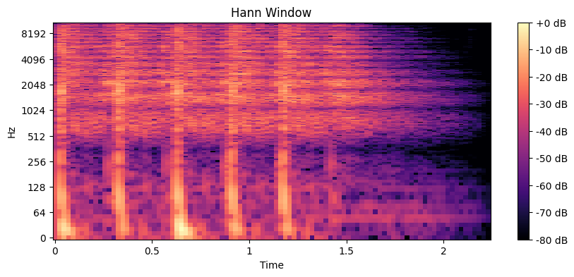

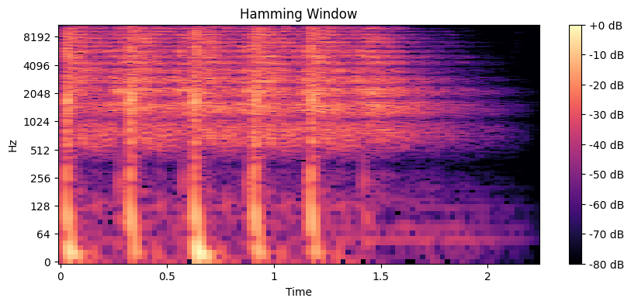

# IMG_256IMG_256IMG_256

# IMG_256

# IMG_256

# 7. Conclusion

The study revealed that windowing techniques significantly affect spectrogram quality and classification performance. The Hann and Hamming windows are preferable due to their balance between resolution and spectral leakage. Task B demonstrated how different music genres exhibit unique spectro-temporal patterns, making spectrogram analysis a powerful tool for audio classification and genre identification.