EX.NO: 4 DATE:

Reg no:220701004

MINIMAX ALGORITHM

A simple example can be used to explain how the minimax algorithm works. We've included an example of a game-tree below, which represents a two-player game. There are two players in this scenario, one named Maximizer and the other named Minimizer .Maximizer will strive for the highest possible score, while Minimizer will strive for the lowest possible score.Because this algorithm uses DFS, we must go all the way through the leaves to reach the terminal nodes in this game-tree.The terminal values are given at the terminal node, so we'll compare them and retrace the tree till we reach the original state.

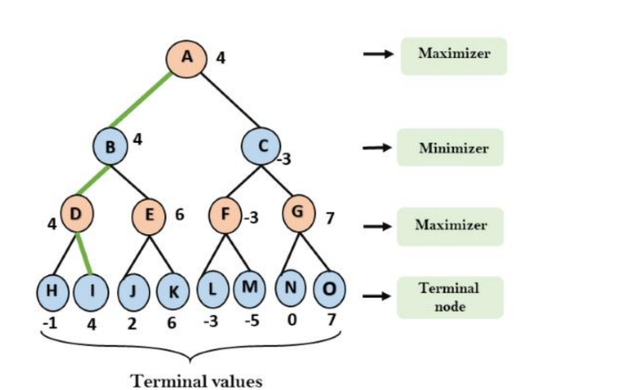

CODE:

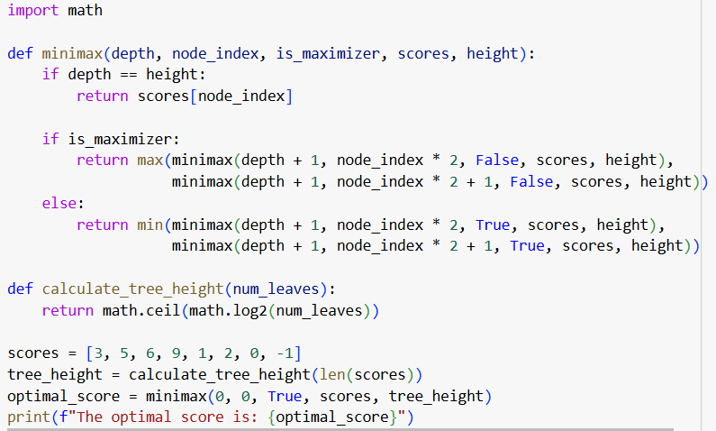

OUTPUT:



RESULT:

Thus the MINIMAX algorithm has been implemented successfully.