**Theoretical**

1. What are the valid places for the keyword break to appear?
2. How is a negative integer stored?
3. What is the meaning of base address?
4. S++ or S = S+1, which can be recommended to increment the value by 1 and why?
5. Can a program be compiled without main( ) function?
6. What is the difference between variable declaration and variable definition?
7. What is reminder for 5.0 % 2?
8. Explain the use of comma operator (,).
9. Define an array with example.
10. With an example define infinite loop.
11. What is the maximum length of an identifier?
12. What is header file in C language?
13. What is the difference between int, char, float, double?
14. With an example define Ternary Operator.
15. What is the difference between “=” and “= =” operators?
16. What will happen if break statement is not used in switch case in C?
17. How do you construct an increment statement or decrement statement in C?
18. In C programming, how do you insert quote character ‘ and “ into the output screen?
19. **How do you access the values within an array?**
20. **What is the advantage of an array over individual variables?**

**Practical**

**Question-1**

Today is Hari's birthday. His mom has surprised him with truly fruity gifts: **2 fruit baskets**. The first basket contains **N** apples, and the second one contains **M** oranges. Hari likes apples and oranges very much but he likes them equally, and therefore, wants to have the minimum possible difference between the number of apples and oranges he has. To do so, he can purchase **1** apple or **1** orange by paying exactly **1** gold coin (that's some expensive fruit, eh?). Hari can purchase fruits at most **K** times (as he has only **K** gold coins in his pocket) to make the difference the minimum possible.

Our little Hari is busy in celebrating his birthday to the fullest, and therefore, he has handed this job to his best friend — **you**. Can you help him by finding the minimum possible difference he can achieve between the number of apples and orange he owns?

### Input

The first line of input contains a single integer **T** denoting the number of test cases. The first and only line of each test case contains **3** space separated integers — **N**, **M** and **K** — denoting the number of apples, number of oranges, and number of gold coins our little Hari has.

### Output

For each test case, output the minimum possible difference between the number of apples and oranges that Hari can achieve.

**Example**

**Input**

3

3 4 1

5 2 1

3 4 3

**Output**

0

2

0

**Explanation**

**Test 1:** Chef will buy 1 apple by paying 1 gold coin and will have equal number of apples and oranges.

**Test 2:** Chef will buy 1 orange by paying 1 gold coin and will have 5 apples and 3 oranges.

**Question-2**

Professor Snape has lots of potions. Bottles containing all types of potions are stacked on shelves which cover the entire wall from floor to ceiling. Professor Snape has broken his bones several times while climbing the top shelf for retrieving a potion. He decided to get a ladder for him. But he has no time to visit Diagon Alley. So he instructed Ron Weasley to make a ladder for him. Professor Snape specifically wants a step ladder which looks like an inverted 'V' from side view.  
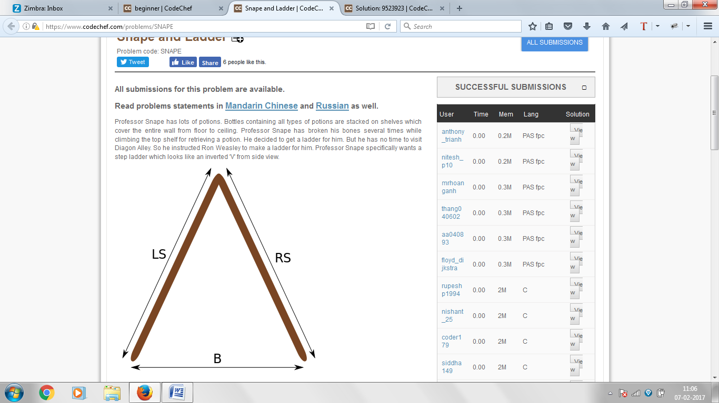

Professor just mentioned two things before vanishing-

* **B** - separation between left side (LS) and right side (RS) on the ground
* **LS** - the length of left side

What should be the length of **RS**? At one extreme **LS** can be vertical and at other **RS** can be vertical. Ron is angry and confused. Since Harry is busy battling Voldemort, its your duty to help him find the minimum and maximum length of **RS**.

**Input**

First line contains single integer **T**, the number of test cases. Then **T** lines follow each containing 2 integers - **B** and **LS**.

**Output**

Output **T** lines, each containing minimum value of **RS** and maximum value of **RS**, separated by space. The answer (**RS**) will be considered correct if it has relative and absolute error less than 10-2.

**Example**

**Input:**

3

4 5

10 12

10 20

**Output:**

3.0 6.40312

6.63325 15.6205

17.3205 22.3607