PROJECT AND TEAM INFORMATION

Project Title
Markdown to HTML and Typst converter

Student / Team Information
Team Name: | Compile Crafters
Team member 1 (Team Lead)  Abhilasha  2318150  23011426  abhilashabhatt77@gmail.com | 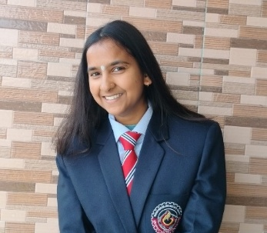
Team member 2  Deepshikha  2318706  230121796  DEEPSHIKHA.230121796@gehu.ac.in | 
Team member 3  Aayushi Sharma  2318130  230121926  sharmaaayushi953@gmail.com | 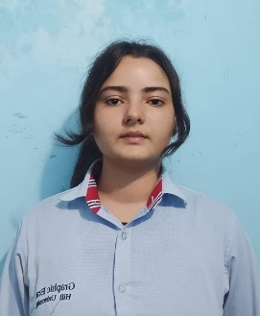
Team member 4  Tanuja  2319745  230124746  tanujachuphal7@gmail.com | 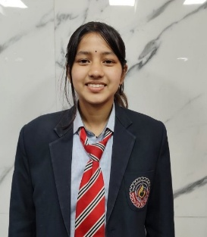

PROPOSAL DESCRIPTION (10 pts)

Motivation (1 pt)
Currently, users often rely on separate tools to convert Markdown to HTML and to other formats like PDF or LaTeX. Direct conversion from Markdown to Typst is not commonly supported. This creates inconvenience for users who want to write content once in Markdown and generate multiple structured outputs, especially high-quality typeset documents in Typst.
The problem this project aims to solve is to build a simple and structured conversion tool that takes Markdown as input and generates both HTML and Typst outputs. This reduces duplication of effort and allows users to maintain a single source document.
The project is important because:
- Markdown is widely adopted in academia and industry.
- Typst is growing as a modern alternative to LaTeX.
- A lightweight converter improves productivity.

State of the Art / Current solution (1 pt)
Currently, tools like:
- Pandoc – Converts Markdown into multiple formats including HTML, PDF, and LaTeX.
- Typst – Provides its own markup language for document preparation.
- GitHub – Renders Markdown directly into HTML for web viewing.
However:
- Direct Markdown → Typst conversion support is limited.
- Existing tools are often large and complex.
- Custom formatting rules may not be easily configurable.
Therefore, there is scope to build a simplified, focused converter that supports common Markdown syntax (headings, lists, bold, italics, links, code blocks) and generates equivalent Typst and HTML output.

Project Goals and Milestones (2 pts)

Goals
- Design a Markdown parser.
- Generate equivalent HTML output.
- Generate equivalent Typst output.
- Provide a simple CLI or web interface.
- Support core Markdown syntax.

Initial Milestones
- Study Markdown grammar and Typst syntax.
- Define supported Markdown subset (headings, paragraphs, lists, emphasis, links, code).
- Design tokenizer and parser.

Intermediate Milestones
- Implement HTML code generator.
- Implement Typst code generator.

Final Milestones
- Create user interface.
- Testing with sample documents.
- Documentation and demonstration.

Project Approach (3 pts)
The solution will follow a compiler-style pipeline:
- Lexical Analysis
  - Convert Markdown text into tokens (e.g., #, **, *, list markers).
  - Implemented using Python or JavaScript.
- Parsing
  - Use rule-based parsing to construct an Abstract Syntax Tree (AST).
  - Handle block-level elements first (headings, lists, paragraphs).
  - Then handle inline formatting (bold, italic, links).
- Intermediate Representation (AST)
  - Store document structure in tree format.
  - Each node represents a Markdown element.
- Code Generation
  - Traverse AST.
  - Generate:
    - HTML tags (<h1>, <p>, <ul>, etc.)
    - Typst syntax equivalents (= Heading, *bold*, etc.)

Platforms and Technologies
- Programming Language: Python
- Interface: CLI or simple HTML + CSS + JS web interface

System Architecture (High Level Diagram)(2 pts)
Main Components:
- Input Handler
- Lexer
- Parser
- AST
- HTML Generator
- Typst Generator
- Output Module

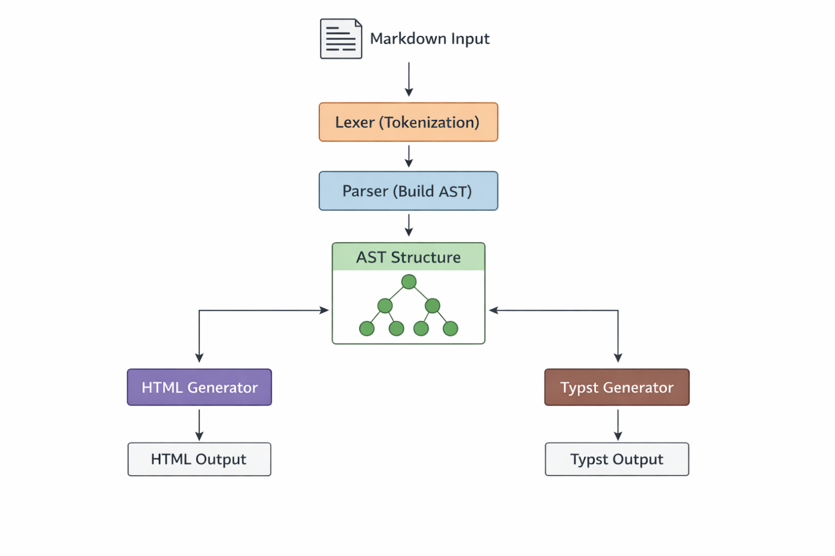

Project Outcome / Deliverables (1 pts)
The final outcomes of the project will include:
- A working Markdown to HTML converter.
- A working Markdown to Typst converter.
- Source code with modular structure.
- Sample test files.
- Documentation explaining design and usage.
- A simple user interface (CLI or web-based).
The system will support basic Markdown features and demonstrate document transformation using parsing techniques.

Assumptions
1.Only a subset of Markdown syntax will be supported.
2.Advanced features (tables, footnotes, math blocks) may not be fully implemented.
3.Input Markdown is reasonably well-formed.
4.Typst syntax used will follow standard formatting rules.
5.Performance optimization is not the primary goal.

References
- Pandoc – https://pandoc.org
- Typst – https://typst.app
- CommonMark – https://commonmark.org
- Markdown Guide – https://www.markdownguide.org
- Compiler Design concepts – Lexical Analysis, Parsing, AST

