PROJECT AND TEAM INFORMATION

Project Title
(Try to choose a catchy title. Max 20 words).
Write project title here

Student / Team Information
Team Name: | Stack Surge
Team member 1 (Team Lead)  Abhilasha  2318150  23011426  abhilashabhatt77@gmail.com | 
Team member 2  Deepshikha  2318706  230121796  DEEPSHIKHA.230121796@gehu.ac.in | 
Team member 3  Aayushi Sharma  2318130  230121926  sharmaaayushi953@gmail.com | 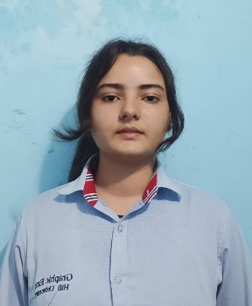
Team member 4  Tanuja  2319745  230124746  tanujachuphal7@gmail.com | 

PROPOSAL DESCRIPTION (10 pts)

Motivation (1 pt)
(Describe the problem you want to solve and why it is important. Max 300 words).
Many individuals want to improve their health but struggle to create personalized fitness and diet plans that fit their budget, time availability, and medical conditions.

The goal of this project is to design a full-stack web application that generates structured, personalized fitness and diet recommendations based on user-provided information such as age, weight, height, gender, health conditions, medication, budget, and available time.

The system aims to provide practical, easy-to-follow meal plans and exercise schedules tailored to individual needs. By using data-driven calculations such as BMI and BMR, and rule-based personalization logic, the platform can offer structured guidance without replacing professional medical advice.

State of the Art / Current solution (1 pt)
(Describe how the problem is solved today (if it is). Max 200 words).
Most free online BMI or calorie calculators only provide numeric results without generating structured diet schedules or time-based exercise plans. Additionally, many applications do not explicitly consider budget constraints or combine health conditions with exercise and meal scheduling in a unified system.
Therefore, while partial solutions exist (calorie tracking, workout apps, meal planning apps), an integrated system that combines health profile inputs, budget sensitivity, and timetable generation in a single academic-level platform remains limited.

Project Goals and Milestones (2 pts)

Goals:
- Develop a web-based fitness and diet recommendation system.
- Implement BMI and BMR calculations.
- Generate personalized diet plans based on user profile, budget, and time.
- Generate exercise schedules (yoga, gym, running, or home workouts).
- Provide progress tracking dashboard.

Initial Milestones:
- Requirement analysis and feature specification.
- Develop BMI and BMR calculation modules.

Intermediate Milestones:
- Implement diet recommendation logic.
- Implement exercise recommendation logic.
- Build frontend dashboard with charts.

Final Milestones:
- Integration testing.
- Deployment on cloud platform.
(Describe the project general goals. Include initial milestones as well any other milestones. Max 300 words).

Project Approach (3 pts)
(Describe how you plan to articulate and design a solution. Including platforms and technologies that you will use. Max 300 words).
The project will be developed as a client-side web application using HTML for structure, CSS for styling, and JavaScript for logic and interactivity.
HTML will be used to design structured forms to collect user input such as weight, height, age, gender, fitness goal, health conditions, medication details, budget level, and available time. CSS will ensure responsive and user-friendly interface design.
JavaScript will handle:
- BMI calculation
- BMR calculation
- Calorie requirement estimation
- Rule-based diet recommendation
- Exercise suggestion logic
- Timetable generation
Diet and exercise templates will be stored in JavaScript arrays/objects and filtered dynamically based on user input (budget, goal, health condition, time availability).
The responsibilities will be divided as follows:
- Member 1 – UI/UX & Frontend Structure (HTML + CSS)
- Member 2 – Health Calculations & Core Logic (JavaScript Logic)
- Member 3 – Diet & Exercise Recommendation Engine
- Member 4 – Progress Tracking & Data Storage

Stage 1:
- UI design + calculation logic

Stage 2:
- Recommendation engine + timetable

Stage 3:
- Storage + dashboard

Stage 4:
- Testing + integration + documentation

System Architecture (High Level Diagram)(2 pts)

Components:
- HTML Layer
- Input forms
- Result display
- Dashboard
- CSS Layer
- Responsive design
- Layout and styling
- JavaScript Layer
- Business logic
- Recommendation engine
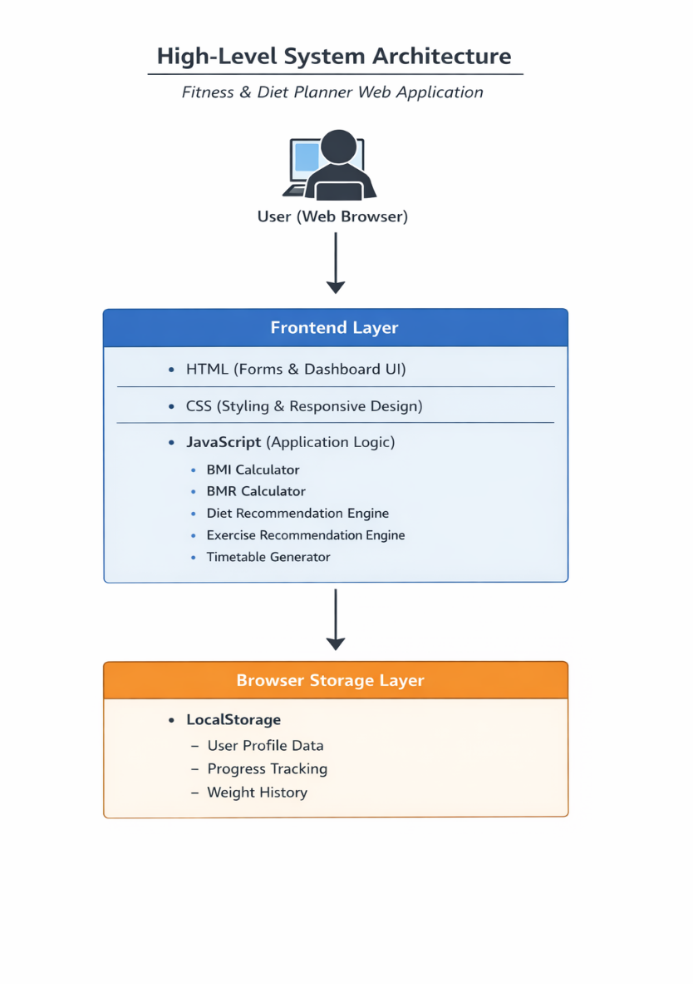
(Provide an overview of the system, identifying its main components and interfaces in the form of a diagram using a tool of your choice).

Project Outcome / Deliverables (1 pts)
(Describe what are the outcomes / deliverables of the project. Max 200 words).
The final deliverables will include:
- A working full-stack web application.
- User registration and login system.
- BMI and BMR calculator module.
- Personalized diet plan generator.
- Exercise recommendation and timetable generator.
- Dashboard with progress tracking.

Assumptions
( Describe the assumptions ( if any ) you are making to solve the problem. Max 100 words )
- Users provide accurate health and personal information.
- The system does not replace professional medical advice.
- Diet plans are template-based and not clinically validated.
- Internet access is available for users.
- Budget categories are predefined (low/medium/high).

References
(Provide a list of resources or references you utilised for the completion of this deliverable. You may provide links).
MDN Web Docs – HTML Documentation
https://developer.mozilla.org/en-US/docs/Web/HTML
MDN Web Docs – CSS Documentation
https://developer.mozilla.org/en-US/docs/Web/CSS
MDN Web Docs – JavaScript Documentation
https://developer.mozilla.org/en-US/docs/Web/JavaScript
Chart.js Documentation – For Data Visualization
https://www.chartjs.org/docs/latest/
W3Schools – Web Development Tutorials (HTML, CSS, JS basics)
https://www.w3schools.com

