Podman-Activity7 >> PODMAN COMPOSE

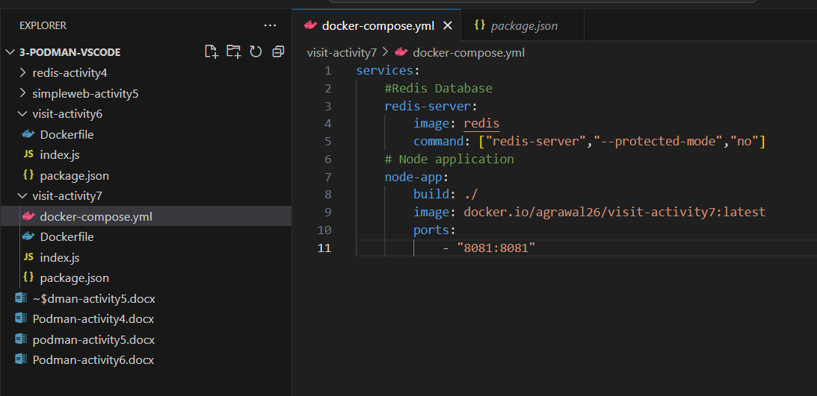

1st try to run from Terminal>> but it throws Admin authority required

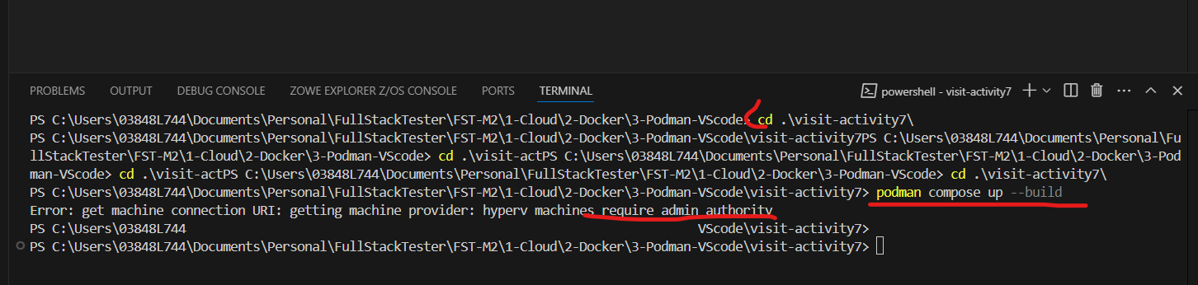

Open Windows powershell in Administrator mode:



