**KODNEST TRAINING (r)**

**9591349349 9389333338** www.training.kodnest.com

**INTRODUCTION TO SQL**

**DIFFERENCE BETWEEN DATA AND DATABASE**

**HISTORY OF ORACLE DBMS:**

**Larry Ellison co-founded Oracle Corporation in 1977 with Bob Miner and Ed Oates under the name Software Development Laboratories (SDL)**

**SDL developed the original version of the Oracle software**

**SDL changed its name to Relational Software, Inc (RSI) in 1979**

**RSI changed its name to Oracle Systems Corporation in 1982**

**In 1995, Oracle Systems Corporation changed its name to Oracle Corporation officially named Oracle, but sometimes referred to as Oracle Corporation.**

**Basic Queries**

**1.Write a query to display the employee_id and employee_name of all students present in database table Employees.**

**2.Write a query to display the employee_id and employee_age of all students present in database table students where employee_id is equal to 30**

**3.write a query to display all the details from the table employee**

**CASE SENSITIVITY IN SQL**

**1.KEYWORDS IN SQL IS NOT CASE SENSETIVE.**

**2.TABLE NAMES IN SQL ARE NOT CASE SENSETIVE.**

**3.COLUMN NAMES IN SQL ARE NOT CASE SENSETIVE.**

**4.DATA IN SQL IS CASE SENSETIVE.**

**DATATYPES**

**A data type specifies a particular type of data, such as integer, floating-point, Boolean etc.**

**A data type also specifies the possible values for that type, the operations that can be performed on that type and the way the values of that type are stored.**

**Each value which is manipulated by Oracle Database has a data type. The data type of a value associates a fixed set of properties with the value. Using these properties Oracle treats values of one data type differently from values of another. For example, you can add values of NUMBER data type, but not values of CHAR data type.**

**Oracle Built-in Data Types:**

|  |  |  |
| --- | --- | --- |
| **TYPE** | **DISCRIPTION** | **SIZE** |
| **VARCHAR2** | **Variable-length character string.** | **From 1 byte to 4KB.** |
| **NUMBER [ (p [, s]) ]** | **Number having precision p and scale s.**  **Range of p : From 1 to 38.**  **Ranges of s : From -84 to 127.**  **Both precision and scale are in decimal digits.** | **A NUMBER value requires from 1 to 22 bytes.** |
| **FLOAT [(p)]** | **A FLOAT value is represented internally as NUMBER.**  **Range of p : From 1 to 126 binary digits.** | **A FLOAT value requires from 1 to 22 bytes.** |
| **DATE** | **Valid date range : From January 1, 4712 BC, to December 31, 9999 AD.**  **The default format is determined explicitly by the NLS_DATE_FORMAT parameter or implicitly by the NLS_TERRITORY parameter.** | **The size is fixed at 7 bytes** |
| **CHAR [(size [BYTE | CHAR])]** | **Fixed-length character data of length size bytes or characters.** | **Maximum size is 2000 bytes or characters. Default and minimum size is 1 byte** |

**All further queries are solved using the following tables**

**Emp table**

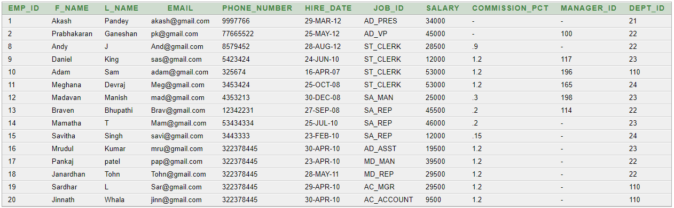

**Dept table**

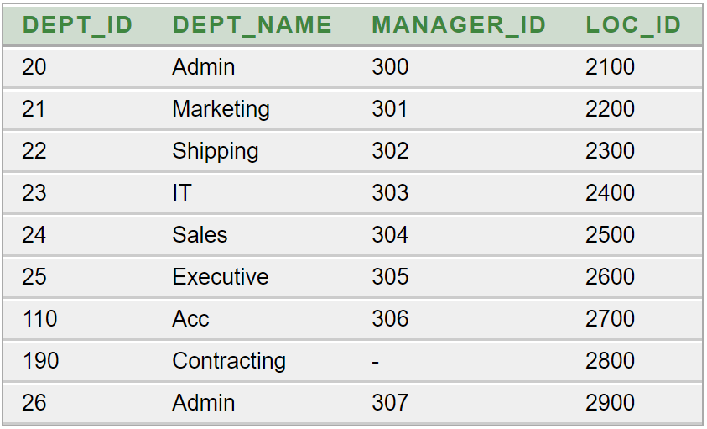

**J_Grade**

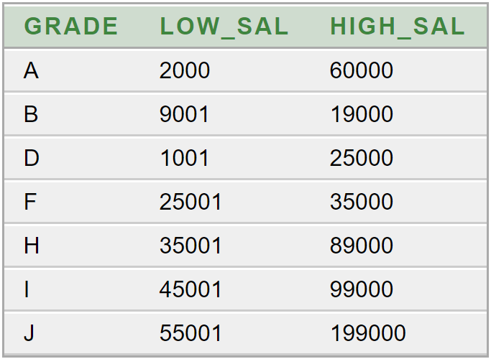

**4)Write a query to display the lastname,salary of all the employees whose details is present in the employees table**

**NOTE 1)Projection: Projection is a process of displaying the result using project queries.**

**Project queries are all those queries which is used to display(Project) particular columns to the user based on the requirement from the user.**

**NOTE 2)Selection: Selection is the process of displaying the result using select queries.**

**Select queries are those queries which displays particular rows to the user base on specific condition/s.**

**3)Join:Join process of displaying the data by comparing the data present in multiple table is called as join**

**OPERATORS IN SQL**

**1.Operators as symbols**

**1.1)Arithmetic operator**

**5.Write a query to display the emp_id ,employees f_name, employees hire_date ,from emp table where the job_id of the employees is sales representatives (SA-REP)**

**6.Write a query to display the last_name and the salary by incrementing the salary by 1000**

**7.Write a query to display the first_name and the salary by reducing the salary by 2000rs for every employee in the company**

**8.Write a query to display f_name and annual salary for all employees**

**9.Write a query to display commission_pct and halfyearly salary for all the employees.**

|  |  |  |
| --- | --- | --- |
| **OPERATOR** | **NAME** | **PRECEDANCE** |
| + | ADD | 3 |
| - | SUB | 4 |
| * | MUL | 1 |
| / | DIV | 2 |

**COLUMN ALIASES in SQL**

**Aliases are the other names given to columns in SQL.**

**Whenever aliases names have to be specified for columns then following syntax has to be used**

**columnname as aliasname**

**or**

**columnname “alias name”**

**note that The alias names will never be reflected in the actual tables present on the hard disk of the computer.**

**Example:**

**DISTINCT Keyword**

**10.Display the distinct salaries from employees**

**Note1:Distinct keyword is used to avoid displaying of repeated values**

**1.2)Concatenation operator in sql**

**Note1.The operator || is the concatenation operator in sql**

**Note2.Concatenation operator is used to combine multiple data or multiple columns .**

**11.Write a query to combine the columns f_name and l_name by using the concatenation operator.**

**12.Write a query in order to display the following output by accesing the data from employees table.**

|  |
| --- |
| **SALARY DETAILS** |
| **Akash works in department 21** |
| **Prabhakaran works in department 22** |
| **Andy works in department 22** |
| **...** |

**13.write a query to concatenate the data KODNEST with the Data TRAINING and display it to the user.**

**Getting Discription of table in oracle.**

**In order to get description of a table(,view , synonym,package etc.)in sql we have to use the command desc**

**Syntax: desc table.**

**Example: desc employees;**

**Output:**

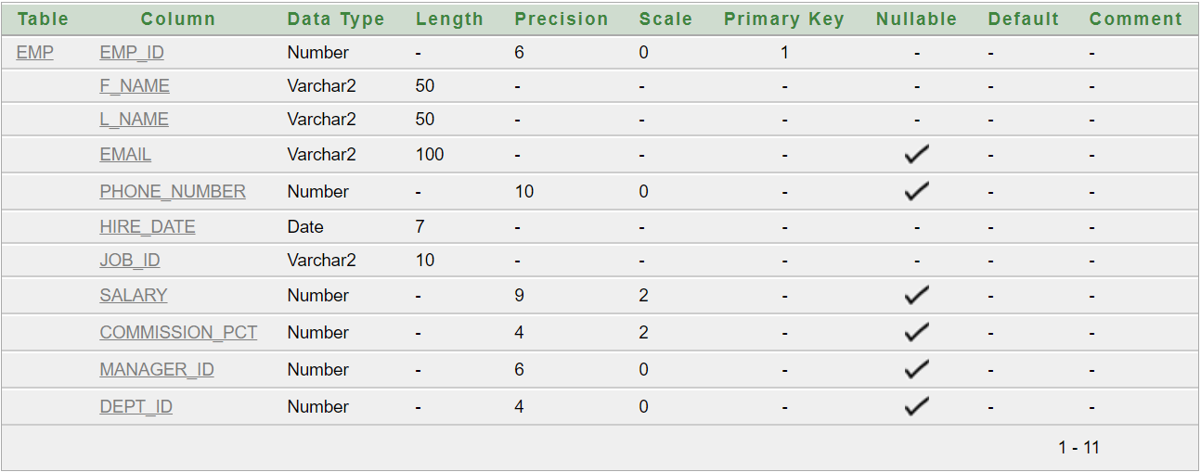

**DUAL TABLE**

***The DUAL table is a special one-row, one-column table present by default in Oracle and other database installations.***

***In Oracle, the table has a single VARCHAR2(1) column called DUMMY that has a value of 'X'.***

**Note1:*if the query* “desc dual” *is executed then following will be the output***

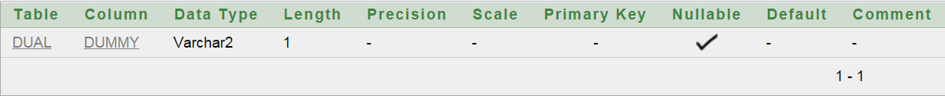

**Note2:if the query “select * from dual” *is executed then following will be the output***

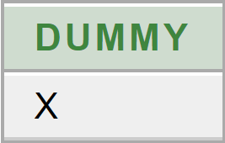

**Note3:*Selecting from the DUAL table is useful for computing a constant expression with the SELECT statement. Because DUAL has only one row, the constant is returned only once. Alternatively, you can select a constant, pseudo column, or expression from any table, but the value will be returned as many times as there are rows in the table.***

**14.write a query to concatenate the data KODNEST with the Data TRAINING and display it to the user.**

**Relational operators in sql.**

|  |  |
| --- | --- |
| **operator** | **precedence** |
| **=** | ***1*** |
| **>** | ***2*** |
| **<** | ***3*** |
| **>=** | ***4*** |
| **<=** | ***5*** |
| **!=** | ***6*** |
| **< >** | ***6*** |
| **^ =** | ***6*** |

**12.Write a query to display the rows from emp table for all the employees whose salary is greater than 20500**

**13.Write a query to display the rows from emp table for all the employees whose salary is greater than 20500**

**14.Write a query to display the l_name, hire_date, job_id, F_Name of all the employees whose salary is less than or equal to 25000**

**15. Write a query to display the dept_id, F_name , hire_date, job_id of all the employees whose salary is greater than or equal to 34000**

**16.Write a query to display the l_name, hire_date, job_id, F_Name of all the employees whose salary is less than or equal to 25000**

**17.Write a query to display last_name,salary from employees whose salary is in between 24000 ankd 18000**

**2)Operators as keywords**

**2.1)BETWEEN AND OPERATOR**

**When the condition has a range of values to be compared we should be using BETWEEN AND operator.**

**18.Write a query to display last_name,salary from employees whose salary is in between 21000 ankd 11000**

**19.Write a query to display the employee_id,commmission_pct,job_id for all employees whose salary is not in the range 45000 to 84000**

**20.Write a query to display the first_name,salary for all employees who are getting 18500,19500,24000 as the salary**

**2.2)In Operator**

**When ever comparison has to be done with respect to a set of values we have to use the operator IN**

**21.Write a query to display the first_name,salary for all employees who are not getting 18500,19500,24000 as the salary**

**22.Write a query to display the first_name,salary whose last names are ‘Pandey’ and ‘Ganeshan’**

**23.Write a query to retrieve the f_name, l_name and Salary whose last_name starts with ‘Ga’.**

**2.3)Like Keyword**

**The LIKE operator is used to search for a specified pattern in a column.**

**Note: pattern matching in SQL**

**There are two pattern matching symbols in sql**

1. **% (modolus) it matches 0 or more characters**
2. **_ (underscore) it matches exactly one character**

**24.Write a query to display the f_name, l_name and Salary whose l_name last two characters are ‘ey’**

**25.Write a query to display all the details of the employees whose l_name contains the substring ‘as’**

**26.** **Write a query Display the f_name and the l_name where the l_names third character is ‘n’**

**27.** **Write a query Display the f_name, l_name and commission_pct where the first names second and the last characters are ‘a’**

**28.** **Write a query Display the f_name and the l_name where the f_names ends with character is ‘sh’**

**29.** **Write a query Display the f_name and the l_name where the f_names dose not ends with character is ‘sh’**

**30.Write a query to display the commission_pct where the value of the commission_pct is null**

**2.4)IS NULL operator.**

**It is used to select only the records with NULL values in the column**

**31.Write a query to display the commission_pct where the value of the commission_pct is not null**

**2.5)LOGICAL OPERATORS**

**32.Write a Query to Display the f_name, l_name, salary and dept_id of all the employees whose salary is greater than 30000 and their f_name should not start with ‘A’**

**33.** **Write a Query to Display Display the emp_id, job_id,and the salary of employees whose emp_id is greater than 6 and job_id should have a substring ‘ash’**

**34.** **Write a Query to Display if an employee is president (AD_PRES) or if an employee is sales representative(SA_REP) or if he earns morn than 35000**

**35.** **Write a Query to Display the Details of all the employees who are president or sales representatives but they must earn more than 25000**

**36.display the l_name and salary whose salary should be between 20000 to 30000 and last name should have exactly four characters**

**THE ORDER BY CLAUSE**

***The output of the sql query can be preducted but the order in wich the rows get displayed cannot be preducted***

***If we have to print the output in a specific order we should be using order by clause***

**Syntax:order by column_name [asc/desc]**

**37.Write a query to display all the f_name of employees in the order of attendance**

**38.write a query to display the hire date from the oldest date to the newest date.**

**39.write a query to display salaries of employess in descending order**

**40.Write a query to display commission_pct in ascending order.**

**41.Write a query to display commission_pct in descending order.**

**FUNCTIONS IN SQL**

**In sql we have two types functions**

**1)single row functions**

**2)multiple row functions**

**Single row functions are such functions which will accept a single row as input (or) it accept multiple row as input but produces one result per row**

**Multiple row functions/group functions/aggrigate functions:are such functions which will accept a single row or multiple row as input but produces one result per group**

**Types of single row functions:**

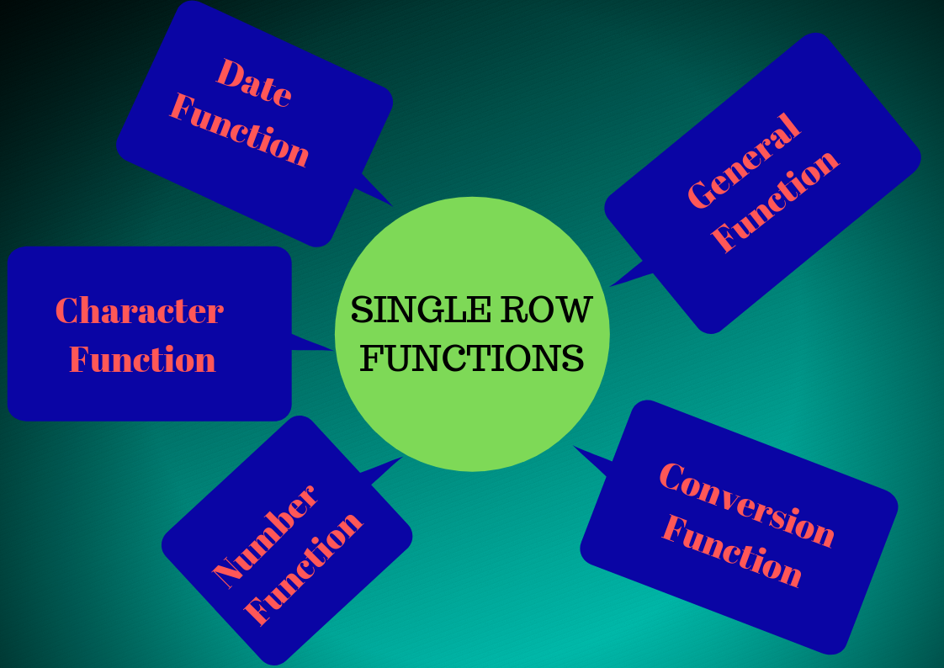

**42.Write a query to display uppercase of data 'Akash' .**

**43.** **Write a query to display lowercase of data 'Pandey'.**

**44.** **Write a query to display Initial letter capital of data 'kodnest'.**

**45.** **Write a query to display all the firstnames of the employees in uppercase.**

**46.** **Write a query to display all the FirstNames and lastnames of the employees in uppercase where lastname is 'Pandey'.**

**47.** **Write a query to display F_name , l_names and salaries whose F_name is 'Akash' in any case.**

**48.** **Write a query to concatenate data 'Akash' & 'Pandey'.**

**49.** **Write a query to concatenate data of f_name and l_name of all the employees from EMP table.**

**50.** **Write a query to combine the data ‘1111’ and ‘2222’.**

**51.** **Write a query to combine the data ‘1111’ and ‘Ramu’.**

**52.** **Write a query to combine the data ‘1111’ with null**

**53.** **Write a query to find the length of the string 'Prabhakaran'.**

**54.** **Write a query to find the length of all the f_names.**

**55.** **Write a query to find the length of 1111**

**56.** **Write a query to display the length of null**

**57.** **Write a query to display the substring of the string 'PRABHAKARAN' from 2nd position extract 5 charecters.**

**58.** **Write a query to display the substring 'oha' from the string 'RajaRamMohanRoy'.**

**59.** **Write a query to display the position of the charecter 'a' in the string 'Pandey'.**

**60.** **Write a query to display the position of the charecter 'a' in all the firstnames.**

**61.** **Write a query to display the substring 'bha' from the f_name where f_name is ‘Prabhakaran'(use both substring and instring)**

**62.** **Write a query to trim the leading 'm' in the string 'malayalam'**

**63.** **Write a query to trim the trailing 'm' in the string '** **malayalam '**

**64.** **Write a query to trim the both 'm' in the string '** **malayalam '**

**65.Write a query to display the data ‘Sharma ’ in the format ‘####Sharma’.**

**66.** **Write a query to display the data ‘Sharma ’ in the format ‘Sharma####’.**

**67.** **Write a query to display the data ‘Sharma ’ in the format ‘Sharma#!#!’.**

**68.What would be the output of the following query**

**Select round(45.326,2)**

**From dual;**

**69.** **What would be the output of the following query**

**Select round(1234.356,1)**

**From dual;**

**70.** **What would be the output of the following query**

**Select round(2678.345,-2)**

**From dual;**

**71.What would be the output of the following query.**

**Select round(123,-2)**

**From dual;**

**72.** **What would be the output of the following query**

**Select trunc(45.326,2)**

**From dual;**

**73.** **What would be the output of the following query**

**Select trunc(1234.356,1)**

**From dual;**

**74.** **What would be the output of the following query**

**Select trunc(2678.345,-2)**

**From dual;**

**75.** **What would be the output of the following query**

**Select trunc(123,-2)**

**From dual;**

**76.** **What would be the output of the following query**

**Select mod(120,2)**

**From dual;**

**77.** **Write a query to display the commission_pct. If commission_pct is null replace with 0.**

**78.** **Write a query to display the commission_pct. If commission_pct is null replace with 0 else replace with 5.**

**79.Write a query to display systems date.**

**80.Write a query to display the number of months between the dates 14-nov-2014 and 14-feb-2014**

**81.Write a query in order to add 9 months for the date 14-feb-2014**

**82. Write a query in order to add 9 months for the date 14-feb-2014 in reverse order**

**83.Write a query to find the date of the next Saturday after the date 08-dec-2012**

**Note:** **The Oracle NULLIF() function accepts two arguments. It returns a null value if the two arguments are equal. In case the arguments are not equal, the NULLIF() function returns the first argument.**

**Example1:** **SELECT NULLIF(100,100)**

**FROM dual;**

**Output: - (null)**

**Example2: SELECT NULLIF(100,200)**

**FROM dual;**

**Output:100**

**84.** **Write a query to display the f_name , l_name , length of f_name, length of l_name for all employees . if length of f_name is equal to length of l_name display null if length of f_name is not equal to length of l_name display length of f_name**

**85.write a query to display the l_name, hire_date where the hire_date should be displayed in the format dd/mm**

**86.Write a query to display the l_name and salary . the salary should be displayed in the format $99,999.99**

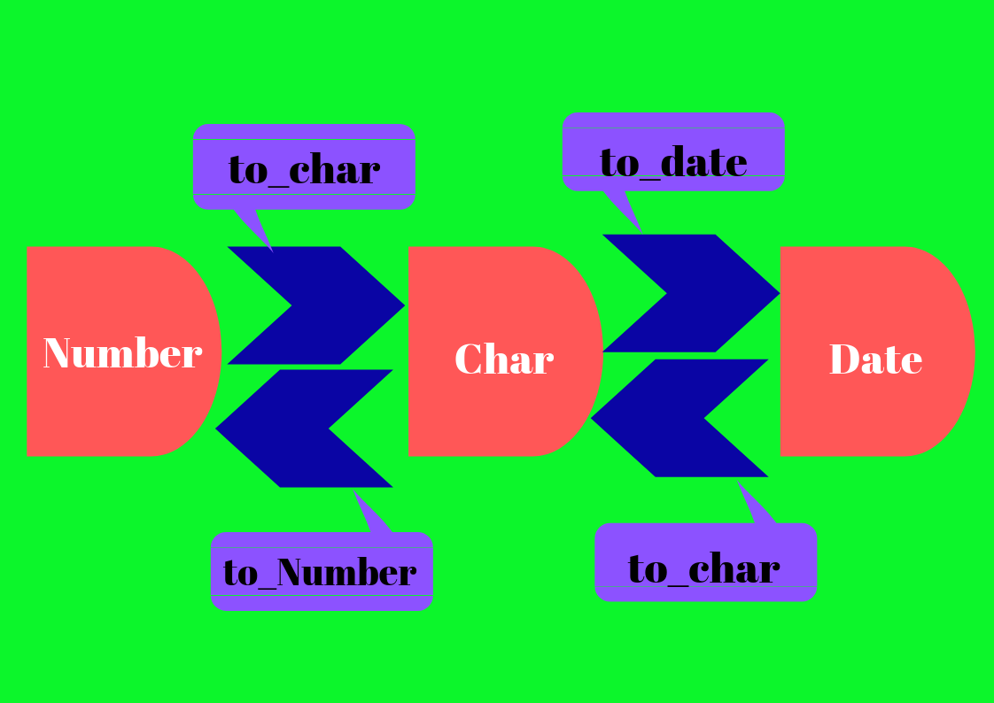

**MULTIPLE ROW FUNCTIONS**

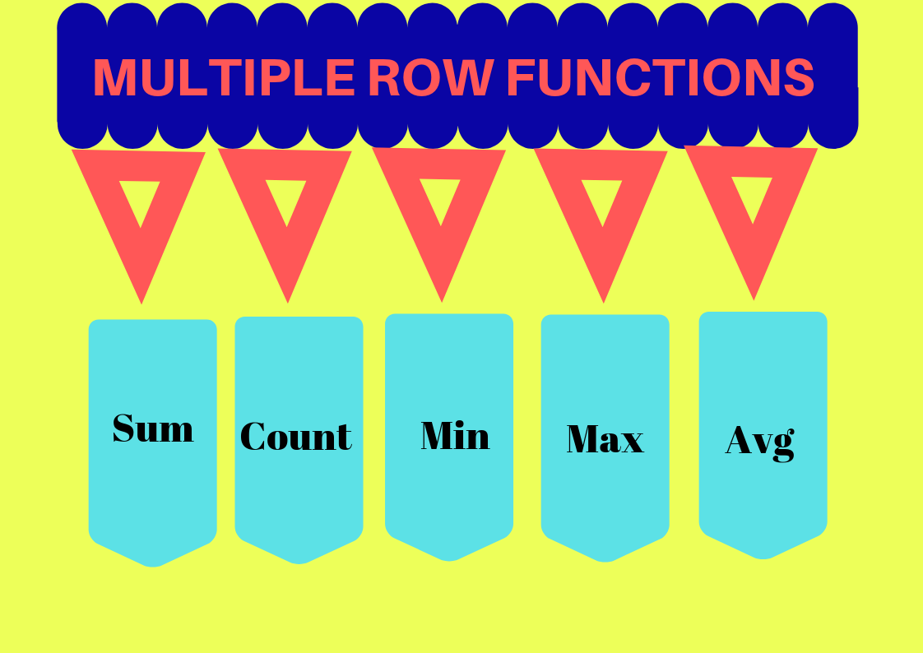

**85.write a query to display count of all the rows present in emp table**

**86.** **write a query to display the count of distinct salaries in exmp table.**

**87.** **write a query to display the minimum of all the salaries from emp table**

**88.** **write a query to display the minimum of all the salaries excluding duplicates**

**89.write a query to display the minimum of hiredate from emp table**

**90.**  **write a query to display the maximum of all the salaries from emp table**

**91. write a query to display the maximum of all the salaries excluding duplicates**

**92.write a query to display the maximum of hiredate from emp table**

**93.**  **write a query to display the sum of all the salaries from emp table**

**94. write a query to display the sum of all the salaries excluding duplicates**

**95.** **write a query to display the average of all the salaries from emp table**

**96. write a query to display the average of all the salaries excluding duplicates**

**97.** **write a query to display the hiredate of oldest employee in the emp table**

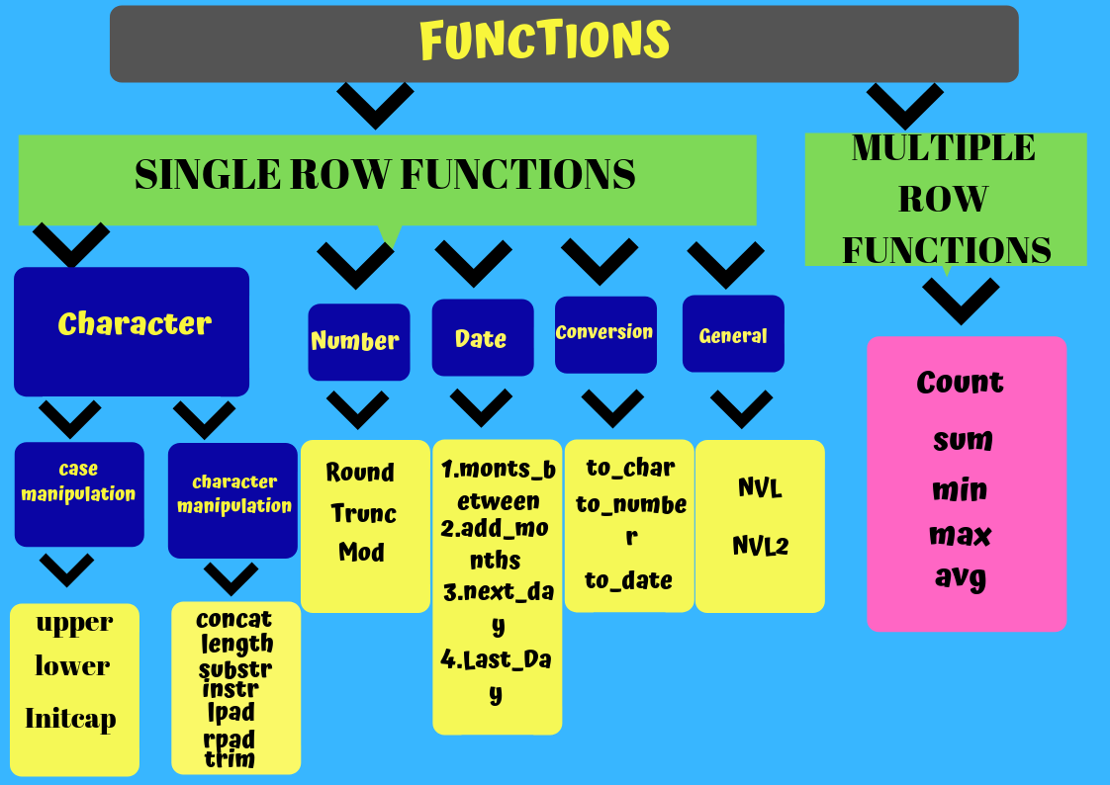

**98.Write a query to display the department_id and the sum of the salary for all the employees in each department**

**THE GROUP BY CLAUSE**

**The SQL GROUP BY clause is used in collaboration with the SELECT statement to arrange identical data into groups.**

**The GROUP BY clause follows the WHERE clause in a SELECT statement and precedes the ORDER BY clause.**

**.**

**99.Write a query to display the dept_id and the least salary of each department**

**100.Display the dept_id and heigest salary of each department for all departments whose department_id is >50**

**101.Write a query to display the dept_id, and count of the dept_id for all the employees whose department Id is equal to 90.**

**102.** **write a query to display the dept_id and the maximum salary of all the employees whose maximum salary is greater than 30000**

**THE HAVING CLAUSE**

**The HAVING clause was added to SQL because the WHERE keyword could not be used with aggregate functions**

**103.Write a query to display dept_id and maximum salary of all employees whose dept_id is greater than 10 and having maximum salary greater than 30000 for each department . while displaying display the data in descending order with respect to dept_id.**

**SUB QUERIES or Inner query or Nested query IN SQL**

**A Subquery is a query within another SQL query and embedded within the WHERE clause.**

**A subquery is used to return data that will be used in the main query as a condition to further restrict the data to be retrieved*.***

**Properties of subqueries**

**1.Subqueries must be enclosed within parentheses.**

**2.A subquery can have only one column in the SELECT clause, unless multiple columns are in the main query for the subquery to compare its selected columns.**

**3.An ORDER BY cannot be used in a subquery, although the main query can use an ORDER BY. The GROUP BY can be used to perform the same function as the ORDER BY in a subquery.**

**4.Subqueries that return more than one row can only be used with multiple value operators, such as the IN operator.**

**104. Write a query to display the l_name,f_name and salary of all employees who earn more than Pandey**

**105.Write a query to display the dept_id and the f_name for all employees who work in the same department in which ‘Prabhakaran’ works.**

**106.Write a query to display the dept_id, f_name and the job_id for all employees who work in administration department**

**107.Write a query to display the l_name and job_id whose job_id is similar to ‘King’ and whose salary is greater than sings salary**

**108.Write a query to display the emp_id of all the employees whose dept_id in employees table is equal to dept_id in dept table;**

**JOINS**

**Join (SQL) A SQL join clause combines records from two or more tables in a relational database. It creates a set that can be saved as a table or used as it is. A JOIN is a means for combining fields from two tables (or more) by using values common to each.**

* **INNER JOIN: Returns all rows when there is at least one match in BOTH tables**
* **LEFT JOIN: Return all rows from the left table, and the matched rows from the right table**
* **RIGHT JOIN: Return all rows from the right table, and the matched rows from the left table**
* **FULL JOIN: Return all rows when there is a match in ONE of the tables**
* **NATURAL JOIN: A NATURAL JOIN is a**[**JOIN operation**](http://docs.oracle.com/javadb/10.8.3.0/ref/rrefsqlj29840.html#rrefsqlj29840)**that creates an implicit join clause for you based on the common columns in the two tables being joined. Common columns are columns that have the same name in both tables.**
* **CROSS JOIN: The CARTESIAN JOIN or CROSS JOIN returns the Cartesian product of the sets of records from the two or more joined tables. Thus, it equates to an inner join where the join-condition always evaluates to True or where the join-condition is absent from the statement.**

**109.Write a query to display the emp_id ,emp_name, salary and the dept_name for all the employees whose dept_id in the emp table is equal to the dept_id in the dept table.**

**Refer the following tables for further queries**

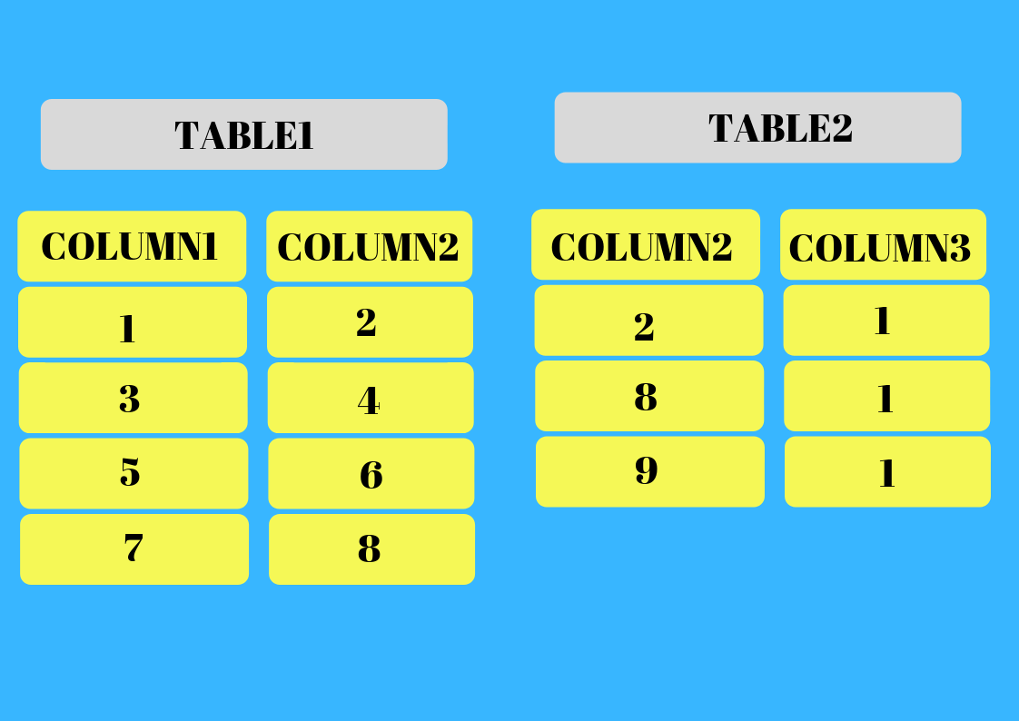

**110.Write a query to display all the details from table1 and table2 where the value of column2 in table1 is equal to the value of column2 in table2.**

**111.Write a query to display all the details from table1 and table2 where the value of column2 in table1 is equal to the value of column2 in table2 by using natural join keyword**

**112.** **display all the details from table1 and table2 by using leftouter join keyword**

**113.Write a Query to** **display all the details from table1 and table2 by using right outer join keyword.**

**114.** **Write a Query to** **display all the details from table1 and table2 by using full outer join keyword.**

**115.** **Write a Query to display all the details from table1 and table2 by using cross join keyword.**

**116.** **Write a query to display the emp_id ,emp_name, salary and the dept_name for all the employees whose dept_id in the emp table is equal to the dept_id in the dept table using inner join keyword.**

**117.Give an example to Perform natural join.**

**118.Perform emp table cross join with Dept table.**

**119.Perform emp table left outer join with Dept table.**

**120.Perform emp table right outer join with Dept table.**

**121.Perform emp table full outer join with Dept table.**

**CARTESIAN JOIN: A Cartesian join or Cartesian product is a**[**join**](http://www.orafaq.com/wiki/Join)**of every**[**row**](http://www.orafaq.com/wiki/Row)**of one**[**table**](http://www.orafaq.com/wiki/Table)**to every row of another table. This normally happens when no matching join**[**columns**](http://www.orafaq.com/wiki/Column)**are specified.**

**EXAMPLE:**

**122.Write a query to display all the rows from Employees and departments tables.**

**123.Write a note on DATA CONTROL LANGUAGE(DCL)**

**DCL is used to control access to data stored in a database (Authorization).**

**Examples of DCL commands include:**

**GRANT to allow specified users to Perform specified tasks.**

**REVOKE to cancel previously granted or denied permissions.**

**124.Write a query to create a user by name KODNEST_STUDENT and assign the user necessary privileges.**

**125.Write a query to take back the privileges from user by name KODNEST_STUDENT**

**126. Write a query to assign DBA privilege to the user KODNEST_STUDENT**

**127.Write a note on TRANSACTION CONTROL LANGUAGE (TCL)**

**TCL used to control transactional processing in a database.**

**A transaction is logical unit of work that comprises one or more SQL statements**

**There are 3 TCL language statements.**

* [**COMMIT**](https://en.wikipedia.org/wiki/Commit_(data_management))**to apply the transaction by saving the database changes.**
* **ROLLBACK to undo all changes of a transaction.**
* [**SAVEPOINT**](https://en.wikipedia.org/wiki/Savepoint)**to divide the transaction into smaller sections. It defines breakpoints for a transaction to allow partial rollback**

**Write a note on DataManipulationLanguage (DML)**

**There are 3 DML statements in SQL**

**1.Insert: it adds rows to a table**

**2.Delete: Removes Rows From Table**

**3.Update: Changes Column values in Table**

**Example.**

**128.Write a query to delete the rows from employees table where employees where employees dept_id is 110 and l_name of the employee is ‘Whala’.**

**129.Write a query to delete the rows where the emp_id is 8 or the last_name is ‘Devraj’**

**130.What happens when no condition is specified in delete statement?**

**131.Write a query to set department name to ‘KODNEST_DEPT’ where department id=110**

**132.Write a query to set the dept_name to ‘ Training_dept ’ and set location_id to 9999 where the dept_id is 23**

**Write a not on DATA DEFINITION LANGUAGE STATEMENTS**

**It is used to  define data structures in SQL**

**There are 4 DDL commands in sql**

**1.ALTER**

**2.DROP**

**3.TRUNCATE**

**4.DROP**

**133.Write a query to alter the table j_grade by adding the column location_id**

**134.Write a query to rename the column dept_name to Department_name**

**135.Write a query to drop the table1 table .**

**136.Write a query to delete the rows in the table2 table permanently.**

**137. Get f_Name from emp table after replacing 'p' with '&'**

**138.Select 35 % of salary from pandey , 10% of Salary for ganeshan and for other 15 % of salary from emp table**

**139. Select TOP 2 salary from emp table**

**140. Select 2nd Highest salary from emp table**

**141.If there are two tables employee1 and employee2, and both have common record. How can I fetch all the records but common records only once?**

**142.How to fetch only common records from two tables employee1 and employee2?**

**143.How can I retrieve all records of employee1 those should not present in employee2?**

**ASSIGNMENT QUERIES**

**Refer the below table for further queries.**

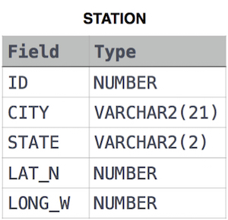

**144.** **Query a list of CITY and STATE from the STATION table.**

**.**

**145.** **Let  N be the number of CITY entries in STATION, and let N’  be the number of distinct CITY names in STATION; query the value of N-N’  from STATION. In other words, find the difference between the total number of CITYentries in the table and the number of distinct CITY entries in the table.**

**146.** **Query the list of CITY names starting with vowels (i.e., a, e, i, o, or u) from STATION.**

**147.** **Query the list of CITY names from STATION which have vowels (i.e., a, e, i, o, and u) as 2nd character**

**148.** **Query the list of CITY names from STATION that do not start with vowels**

**149.** **Write a query that prints a list of employee names (i.e.: the name attribute) for employees in Employee having a salary greater than 2000  per month who have been employees for less than 10 months. Sort your result by ascending employee_id.**

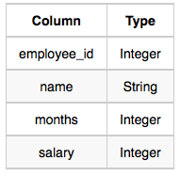

**150.** **Given the CITY and COUNTRY tables, query the sum of the populations of all cities where the CONTINENT is 'Asia'.**







