**WEB DEVELOPMENT INTERNSHIP**

**PROJECT 1**

# **Project Title: Personal Bucket List**

## **Objective:**

Create a visually engaging and responsive webpage that showcases a user’s personal bucket list. This project will help you practice core web development concepts while developing an eye for design and layout.

**Introduction:**

This project is a simple yet visually engaging **Personal Bucket List Webpage.** I am going to design this project using HTML, CSS, and JavaScript. The webpage allows users to view a list of tasks they wish to complete, mark them as completed, and interact with them dynamically. The project emphasizes styled lists, visual design, and responsive design.

**1. HTML Structure :**

**HTML (HyperText Markup Language)** is used to structure the content of the webpage. The key elements used in this project include:

* **<header>**: Contains the title of the page.
* **<main>**: Holds the main content, including the list of bucket list items.
* **<ul> (Unordered List)**: Displays the bucket list items.
* **<footer>**: Provides a copyright notice.
* **<script>**: Links the JavaScript file for interactivity.

**HTML Code :**

<!DOCTYPE html>

<html lang="en">

<head>

<meta charset="UTF-8">

<meta name="viewport" content="width=device-width, initial-scale=1.0">

<title>My Bucket List</title>

<link rel="stylesheet" href="styles.css">

<script src="https://kit.fontawesome.com/a076d05399.js" crossorigin="anonymous"></script>

</head>

<body>

<header>

<h1>My Personal Bucket List</h1>

</header>

<main>

<section class="container">

<h2>Things I Want to Do</h2>

<ul class="bucket-list">

<li> <i class="far fa-circle"></i> Skydiving</li>

<li> <i class="far fa-circle"></i> Visit Japan</li>

<li> <i class="far fa-circle"></i> Learn Guitar</li>

<li> <i class="far fa-circle"></i> Scuba Diving</li>

<li> <i class="far fa-circle"></i> See the Northern Lights</li>

</ul>

</section>

</main>

<footer>

<p>&copy; 2025 My Bucket List</p>

</footer>

<script src="script.js"></script>

</body>

</html>

* Here, First I create a new folder in desktop and named it as BucketListThings
* Now , I save above html file as index.html and place this file inside the BucketListThings folder

**2. CSS for Styling:**

**CSS (Cascading Style Sheets)** is used to enhance the visual appearance of the webpage. The key features include:

* **Background Colors & Typography**: Improves readability and aesthetics.
* **Hover Effects**: Provides visual feedback when interacting with the list.
* **Flexbox Layout**: Ensures proper alignment and spacing.
* **Media Queries**: Enables responsive design for different screen sizes.

**CSS Code :**

/* Reset Styles */

* {

margin: 0;

padding: 0;

box-sizing: border-box;

font-family: Arial, sans-serif;

}

/* Body Styling */

body {

background: #f4f4f4;

text-align: center;

}

/* Header */

header {

background: #3498db;

color: white;

padding: 20px;

font-size: 24px;

}

/* Container */

.container {

margin: 30px auto;

width: 60%;

background: white;

padding: 20px;

border-radius: 10px;

box-shadow: 0px 4px 10px rgba(0, 0, 0, 0.1);

}

/* Bucket List */

.bucket-list {

list-style: none;

padding: 0;

margin-top: 20px;

}

.bucket-list li {

font-size: 20px;

padding: 12px;

background: #ecf0f1;

margin: 10px 0;

border-radius: 5px;

display: flex;

align-items: center;

justify-content: center;

gap: 10px;

transition: 0.3s;

cursor: pointer;

}

.bucket-list li.completed {

color: green;

text-decoration: line-through;

}

.bucket-list li:hover {

transform: scale(1.05);

background: #ddd;

}

/* Footer */

footer {

background: #3498db;

color: white;

padding: 10px;

position: fixed;

bottom: 0;

width: 100%;

}

/* Responsive Design */

@media (max-width: 600px) {

.container {

width: 80%;

}

}

* Here, I save above css file as styles.css and place this file inside the BucketListThings folder

**3. JavaScript for Interactivity :**

JavaScript is used to make the webpage interactive. The key feature in this project is the ability to click on a task to mark it as completed or undo the completion.

**JavaScript Code :**

document.addEventListener("DOMContentLoaded", function () {

const listItems = document.querySelectorAll(".bucket-list li");

listItems.forEach(item => {

item.addEventListener("click", function () {

this.classList.toggle("completed");

let icon = this.querySelector("i");

if (this.classList.contains("completed")) {

icon.classList.remove("far", "fa-circle");

icon.classList.add("fas", "fa-check-circle");

} else {

icon.classList.remove("fas", "fa-check-circle");

icon.classList.add("far", "fa-circle");

}

});

});

});

* Here, I save above javascript file as script.js and place this file inside the BucketListThings folder
* Then, Open index.html in your browser.
* Click on items to mark them as done.

**Output :**

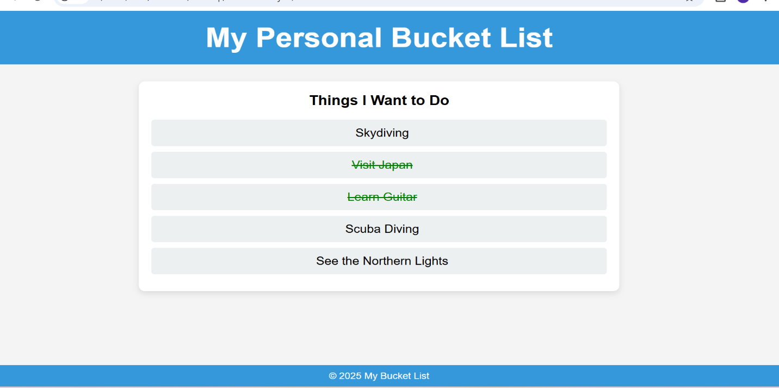

**Conclusion :**

The Personal Bucket List Webpage project successfully demonstrates core web development skills using HTML, CSS, and JavaScript. Through this project, we have:

* Structured content using HTML.
* Enhanced visual design with CSS, ensuring a clean, responsive layout.
* Added interactivity using JavaScript, allowing users to mark tasks as completed dynamically.
* Utilized Font Awesome icons to improve the UI and provide visual feedback.

This project serves as an excellent foundation for building more complex, interactive web applications. Future improvements could include saving progress using Local Storage, adding animations, or integrating a backend for user-specific lists.

By completing this project, you’ve gained hands-on experience in front-end development and applied best practices in design, responsiveness, and user experience. Keep experimenting and enhancing your skills—this is just the beginning