**WEB DEVELOPMENT INTERNSHIP**

**PROJECT 3**

# **Project Title: E-Commerce Product Page**

## **Objective:**

Create a functional and visually appealing e-commerce product page using HTML and CSS.

**Introduction:**

his project is a simple yet visually appealing e-commerce product page built using HTML and CSS. The page displays a sunscreen product with essential details such as an image, name, description, price, and an "Add to Cart" button. Additionally, a navigation bar is included for better usability, and a background image enhances the visual experience.

**Technologies Used:**

* **HTML**: Used to structure the webpage.
* **CSS**: Used to style the page and make it visually appealing.
* **Images**: sunscreen.jpg for the product and background.jpg for the background.

**Features:**

1. **Product Details:**
   * Displays the product name: **Sunscreen SPF 50**
   * Shows product price: **$19.99**
   * Contains a brief product description
   * Includes an "Add to Cart" button
2. **Navigation Bar:**
   * Links to Home, Shop, Contact, and Cart sections.
3. **Styling and Layout:**
   * Clean and modern design.
   * Fully responsive layout.
   * Background image for better aesthetics.
   * Hover effect on the "Add to Cart" button.
4. **Interactivity Enhancements:** (Optional future improvements)
   * Customer reviews section.
   * Product image carousel.
   * Interactive quick-view popup.

**HTML Code :**

<!DOCTYPE html>

<html lang="en">

<head>

<meta charset="UTF-8">

<meta name="viewport" content="width=device-width, initial-scale=1.0">

<title>Product Page</title>

<link rel="stylesheet" href="styles.css">

<style>

body {

background-image: url('background.jpg');

background-size: cover;

background-position: center;

background-attachment: fixed;

}

</style>

</head>

<body>

<nav class="navbar">

<a href="#">Home</a>

<a href="#">Shop</a>

<a href="#">Contact</a>

<a href="#">Cart</a>

</nav>

<div class="product-container">

<div class="product-image">

<img src="sunscreen.jpg" alt="Sunscreen Image">

</div>

<div class="product-details">

<h1>Sunscreen SPF 50</h1>

<p class="price">$19.99</p>

<p class="description">Protect your skin from harmful UV rays with our high-quality SPF 50 sunscreen. Lightweight, non-greasy, and water-resistant for up to 80 minutes.</p>

<button class="add-to-cart">Add to Cart</button>

</div>

</div>

</body>

</html>

* Here, First I create a new folder in desktop and named it as E-Commerce Product Page.
* Now, I save above html file as index.html and place this file inside the E-Commerce Product Page folder

**CSS Code:**

body {

font-family: Arial, sans-serif;

margin: 0;

padding: 0;

background-color: #f8f8f8;

}

.navbar {

background-color: #333;

padding: 15px;

text-align: center;

}

.navbar a {

color: white;

text-decoration: none;

margin: 0 15px;

font-size: 18px;

}

.product-container {

display: flex;

justify-content: center;

align-items: center;

flex-wrap: wrap;

padding: 50px;

}

.product-image img {

max-width: 100%;

border-radius: 10px;

}

.product-details {

max-width: 400px;

margin-left: 30px;

}

.product-details h1 {

font-size: 28px;

margin-bottom: 10px;

}

.price {

font-size: 24px;

color: #e67e22;

margin-bottom: 10px;

}

.description {

font-size: 16px;

color: #555;

margin-bottom: 20px;

}

.add-to-cart {

background-color: #e67e22;

color: white;

border: none;

padding: 10px 20px;

font-size: 18px;

cursor: pointer;

border-radius: 5px;

transition: background-color 0.3s;

}

.add-to-cart:hover {

background-color: #d35400;

}

* Here, I save above css file as styles.css and place this file inside the E-Commerce Product Page folder.
* And we need to save sunscreen.jpg and background.jpg images inside the E-Commerce Product page folder.

**Output :**

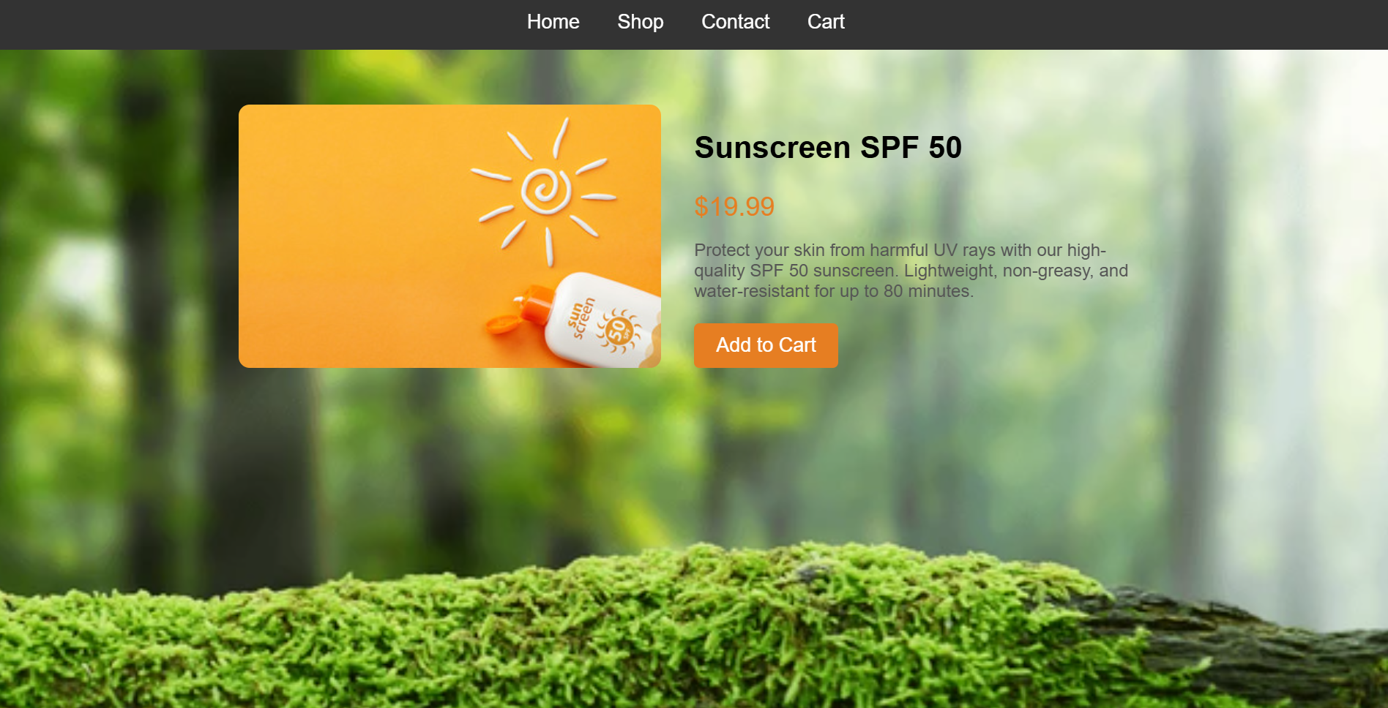

**Conclusion :**

The Personal Bucket List Webpage project successfully demonstrates core web development skills using HTML, CSS, and JavaScript. Through this project, we have:

* Structured content using HTML.
* Enhanced visual design with CSS, ensuring a clean, responsive layout.
* Added interactivity using JavaScript, allowing users to mark tasks as completed dynamically.
* Utilized Font Awesome icons to improve the UI and provide visual feedback.

This project serves as an excellent foundation for building more complex, interactive web applications. Future improvements could include saving progress using Local Storage, adding animations, or integrating a backend for user-specific lists.

By completing this project, you’ve gained hands-on experience in front-end development and applied best practices in design, responsiveness, and user experience. Keep experimenting and enhancing your skills—this is just the beginning