**WEB DEVELOPMENT INTERNSHIP**

**PROJECT 1**

# **Project Title: Dynamic image slider**

## **Objective:**

The objective of this project is to create a dynamic image slider using HTML, CSS, and JavaScript. This slider will showcase different images with smooth transitions, providing an engaging and interactive user experience.

**Introduction:**

The **Dynamic Image Slider** is a web component built using HTML, CSS, and JavaScript. It allows users to navigate through multiple images with smooth transitions, either manually using navigation buttons or automatically at a set interval.

**Project Overview:**

The project consists of an image slider that rotates through images with smooth transitions. The user can manually switch between images using **previous** and **next** buttons. The slider is also responsive, ensuring it works well on different screen sizes.

**Features:**

* **Automatic Image Sliding**: Images change at a set interval without user interaction.
* **Navigation Controls**: Users can move between images using previous and next buttons.
* **Smooth Transitions**: The slider includes smooth animations for seamless image changes.
* **Responsiveness**: The slider adapts to various screen sizes for an optimal viewing experience.
* **Optional Enhancements**: Thumbnails, captions, swipe support, and fade effects can be added.

**Technologies Used:**

* **HTML**: Provides the structure for the image slider.
* **CSS**: Handles the styling, layout, and animations.
* **JavaScript**: Implements the functionality for navigation, auto-sliding, and user interaction.

**Optional Enhancements :**

1. **Thumbnail Navigation**: Display small images below the slider for quick selection.
2. **Captions and Descriptions**: Add a text overlay for each image.
3. **Swipe Support**: Enable touch gestures for mobile users.
4. **Fade Transitions**: Use fading effects instead of sliding.

**Code:**

<!DOCTYPE html>

<html lang="en">

<head>

<meta charset="UTF-8">

<meta name="viewport" content="width=device-width, initial-scale=1.0">

<title>Flower Image Slider</title>

<style>

body {

margin: 0;

font-family: Arial, sans-serif;

background: url('https://source.unsplash.com/1600x900/?rose') no-repeat center center/cover;

height: 100vh;

display: flex;

align-items: center;

justify-content: center;

}

.slider-container {

position: relative;

width: 80%;

max-width: 800px;

height: 400px;

overflow: hidden;

border-radius: 15px;

box-shadow: 0px 5px 15px rgba(0, 0, 0, 0.3);

background: rgba(255, 255, 255, 0.2);

}

.slider {

display: flex;

width: 300%;

transition: transform 0.5s ease-in-out;

height: 100%;

}

.slide {

min-width: 100%;

box-sizing: border-box;

position: relative;

}

.slide img {

width: 100%;

height: 100%;

object-fit: cover;

border-radius: 15px;

}

.caption {

position: absolute;

bottom: 20px;

left: 50%;

transform: translateX(-50%);

background: rgba(0, 0, 0, 0.5);

color: white;

padding: 10px 15px;

border-radius: 5px;

text-align: center;

font-size: 18px;

}

.prev, .next {

position: absolute;

top: 50%;

transform: translateY(-50%);

background: rgba(0, 0, 0, 0.5);

color: white;

border: none;

padding: 10px 15px;

cursor: pointer;

font-size: 20px;

border-radius: 50%;

}

.prev { left: 10px; }

.next { right: 10px; }

.prev:hover, .next:hover {

background: rgba(0, 0, 0, 0.8);

}

@media (max-width: 768px) {

.slider-container {

width: 90%;

height: 300px;

}

.caption {

font-size: 14px;

}

}

</style>

</head>

<body>

<div class="slider-container">

<div class="slider">

<div class="slide">

<img src= rose.jpg alt="Rose">

<div class="caption">Beautiful Rose</div>

</div>

<div class="slide">

<img src=tulip.jpg alt="Tulip">

<div class="caption">Vibrant Tulips</div>

</div>

<div class="slide">

<img src=sunflower.jpg alt="Sunflower">

<div class="caption">Bright Sunflower</div>

</div>

</div>

<button class="prev" onclick="moveSlide(-1)">❮</button>

<button class="next" onclick="moveSlide(1)">❯</button>

</div>

<script>

let currentIndex = 0;

const slides = document.querySelectorAll(".slide");

const totalSlides = slides.length;

function moveSlide(direction) {

currentIndex += direction;

if (currentIndex < 0) {

currentIndex = totalSlides - 1;

} else if (currentIndex >= totalSlides) {

currentIndex = 0;

}

updateSlider();

}

function updateSlider() {

const slider = document.querySelector(".slider");

slider.style.transform = `translateX(-${currentIndex * 100}%)`;

}

setInterval(() => {

moveSlide(1);

}, 3000);

</script>

</body>

</html>

**Output :**

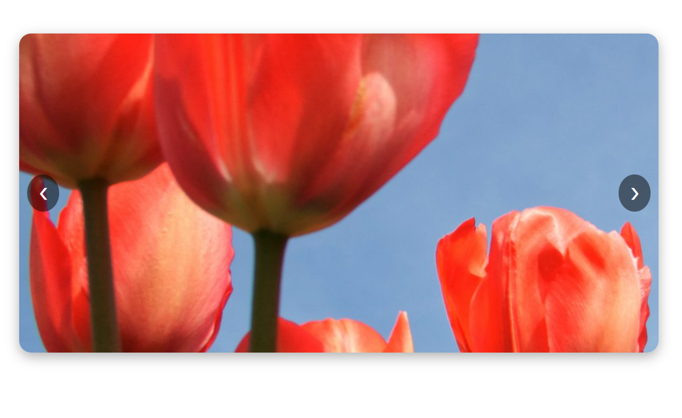



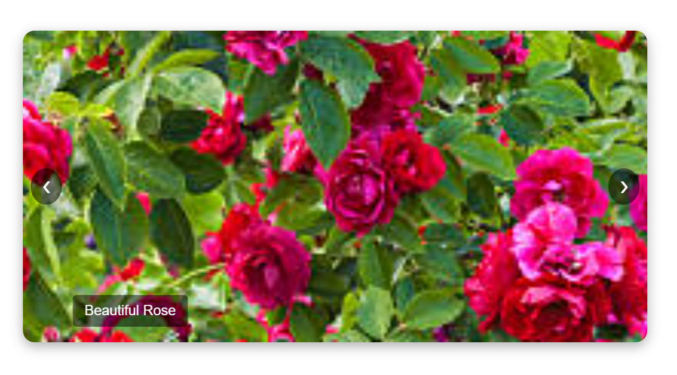

**Conclusion :**

This Dynamic Image Slider enhances user experience by providing smooth and interactive image transitions. Further improvements can be made by incorporating additional features like thumbnails, swipe gestures, and text overlays.