### Creation of a Redshift Cluster

**Screenshots of the configuration of the Redshift cluster that you have created:**

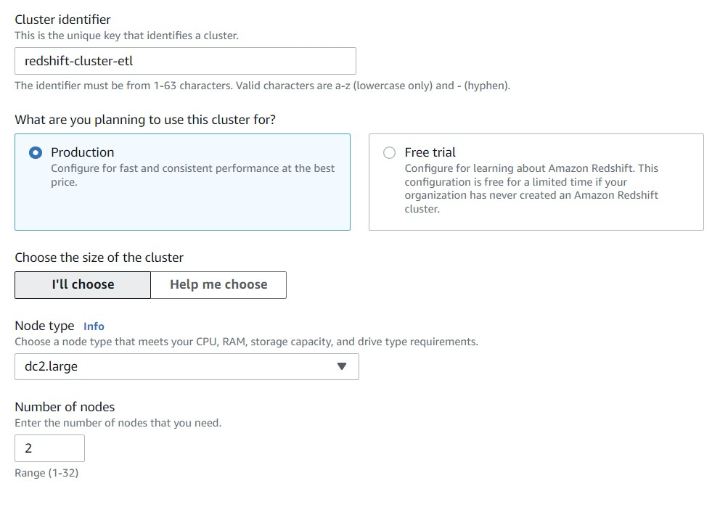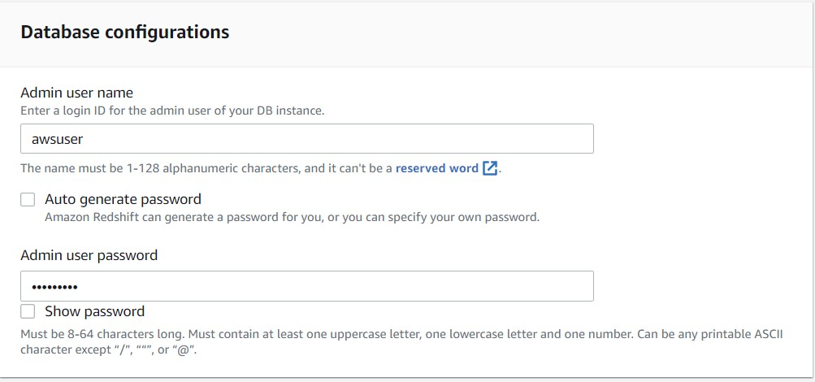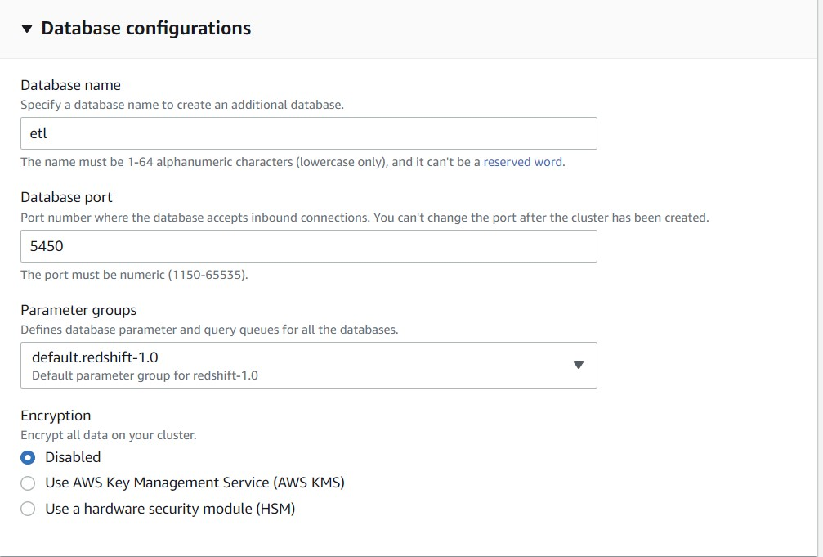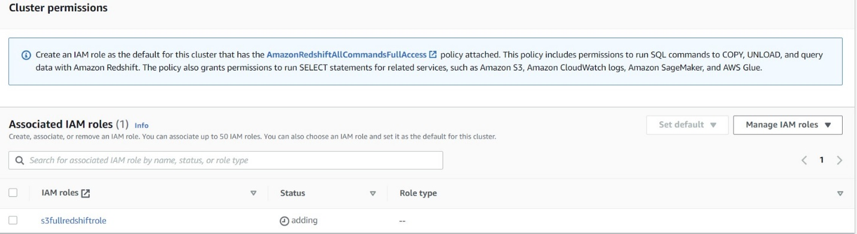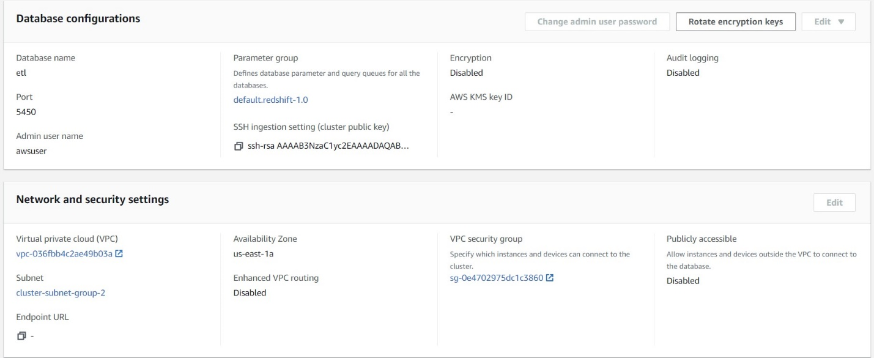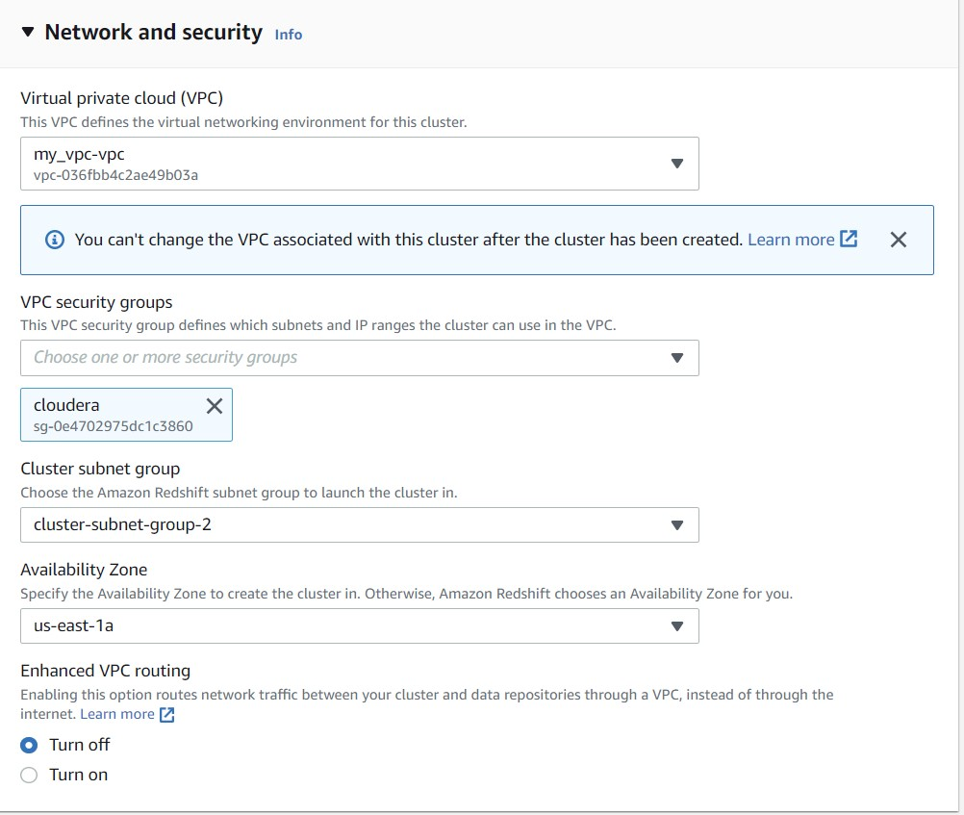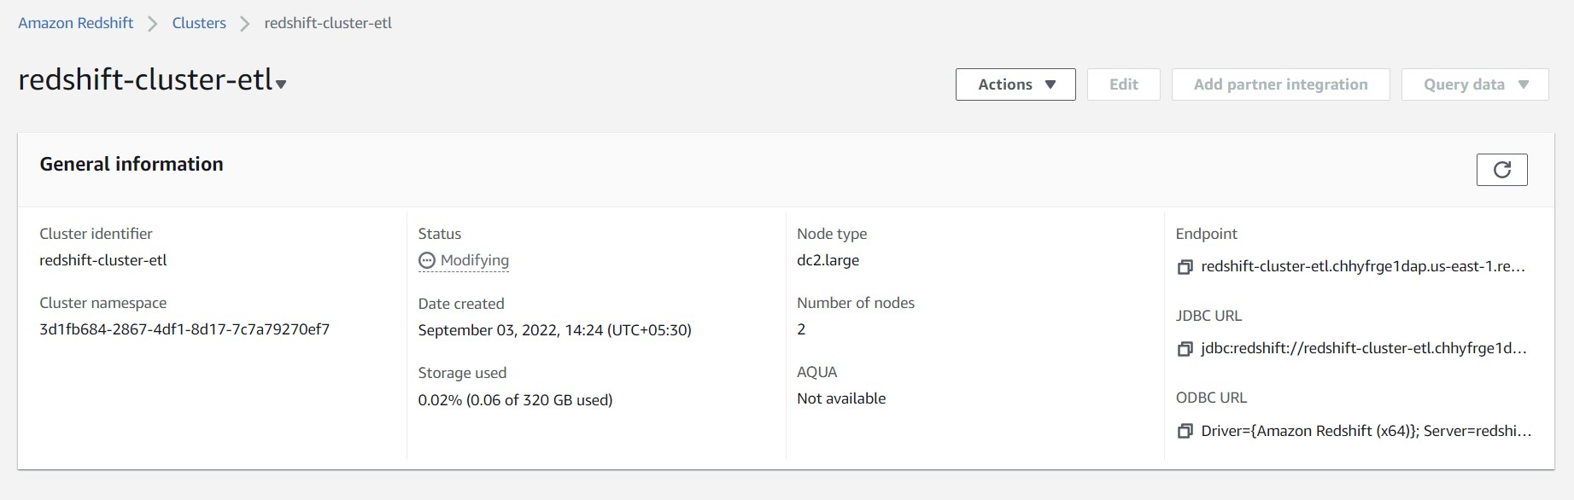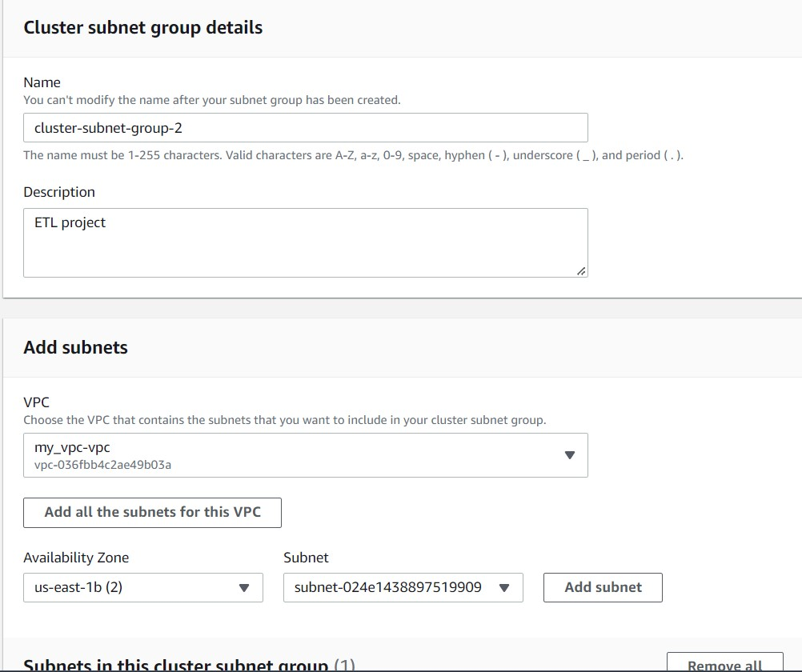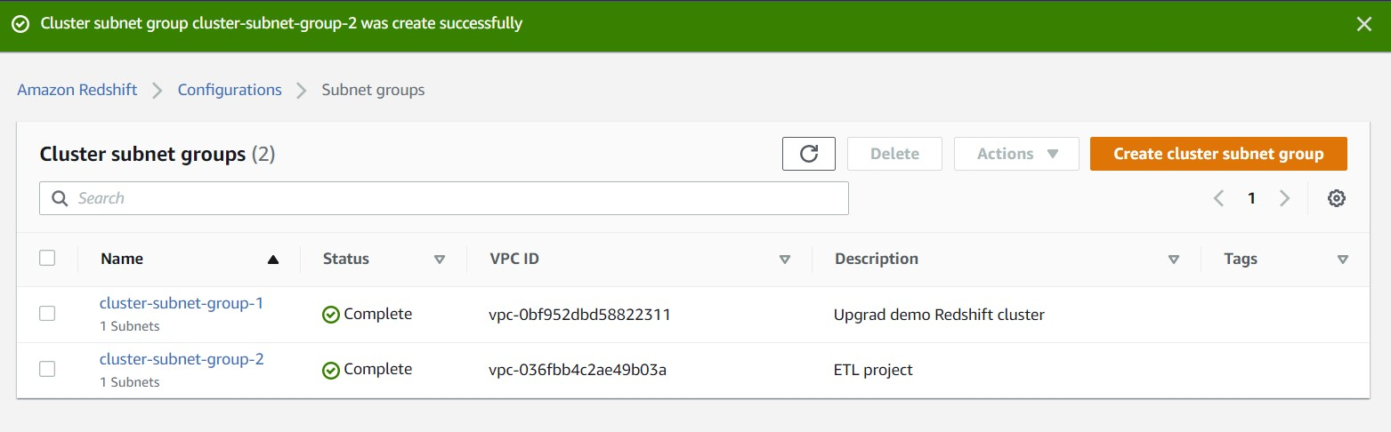

### 

### Setting up a database in the Redshift cluster and running queries to create the dimension and fact tables

**Queries to create the various dimension and fact tables with appropriate primary and foreign keys:**

Schema Creation : SPAR_NORD_ATM_TRANS

|  |
| --- |
| ***create schema spar_nord_atm_trans;*** |

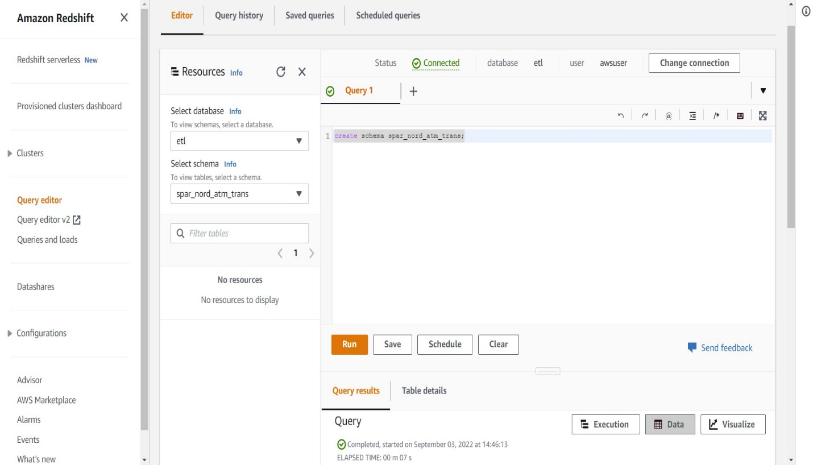

DIMENSION TABLE 1: DIM_ATM

|  |
| --- |
| ***create table spar_nord_atm_trans.DIM_ATM***  ***(atm_id integer not null primary key,***  ***atm_number varchar(20),***  ***atm_manufacturer varchar(50),***  ***atm_location_id integer not null,***  ***foreign key(atm_location_id) references spar_nord_atm_trans.DIM_LOCATION(location_id));*** |

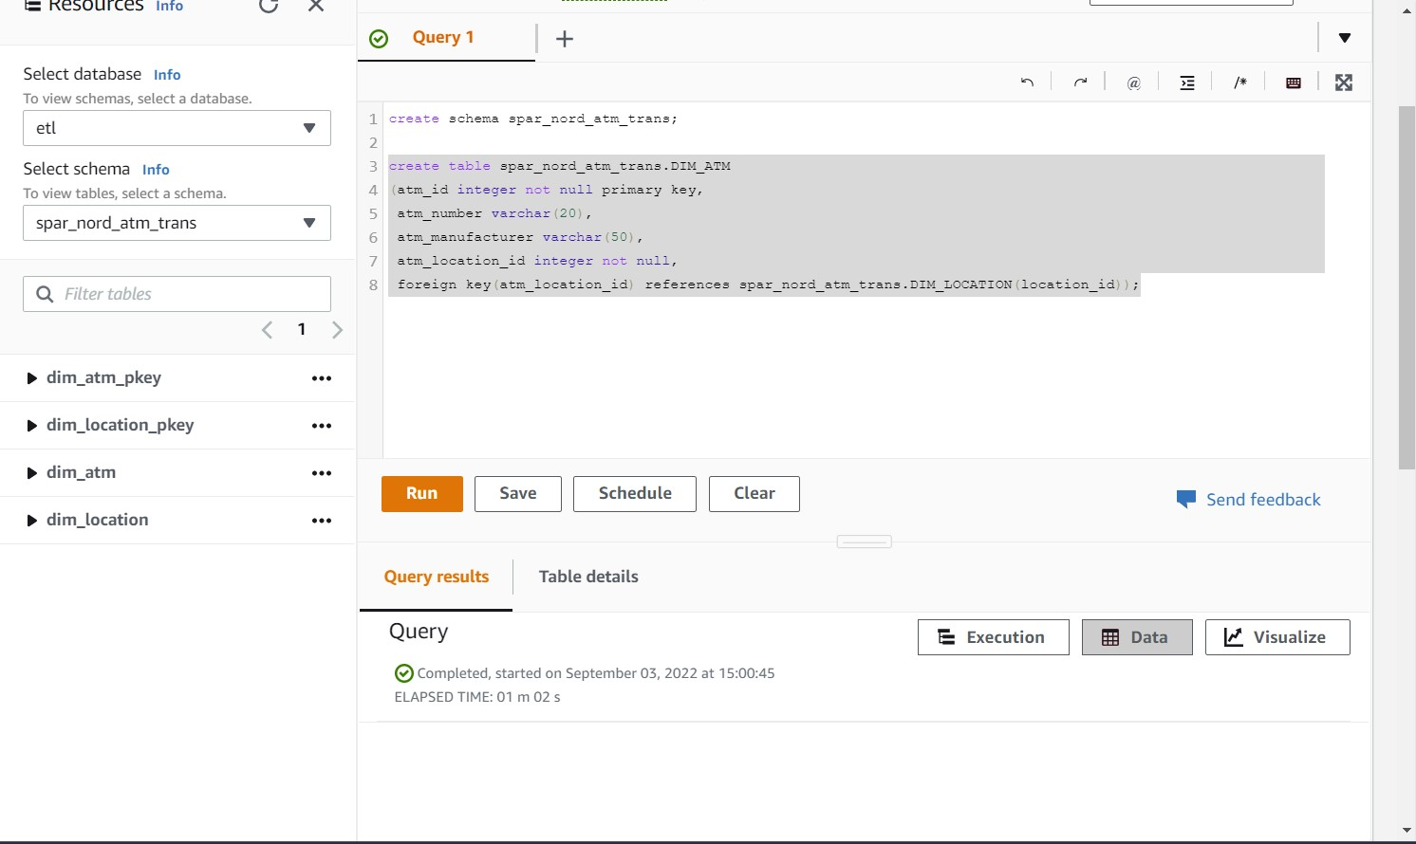

DIMENSION TABLE 2: DIM_CARD_TYPE

|  |
| --- |
| ***create table spar_nord_atm_trans.DIM_CARD_TYPE***  ***(card_type_id integer not null primary key,***  ***card_type varchar(23));*** |

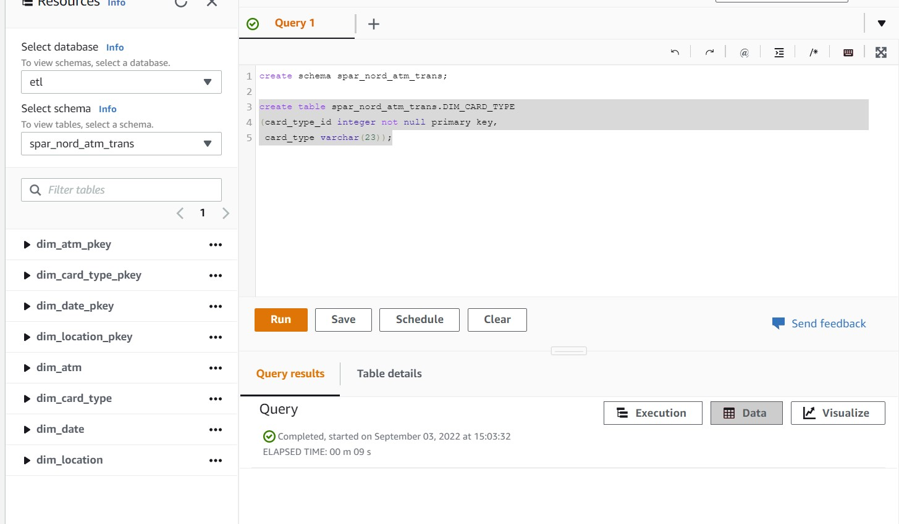

DIMENSION TABLE 3: DIM_DATE

|  |
| --- |
| ***create table spar_nord_atm_trans.DIM_DATE***  ***(date_id integer not null primary key,***  ***full_date_time timestamp,***  ***year integer,***  ***month varchar(20),***  ***day integer,***  ***hour integer,***  ***weekday varchar(20));*** |

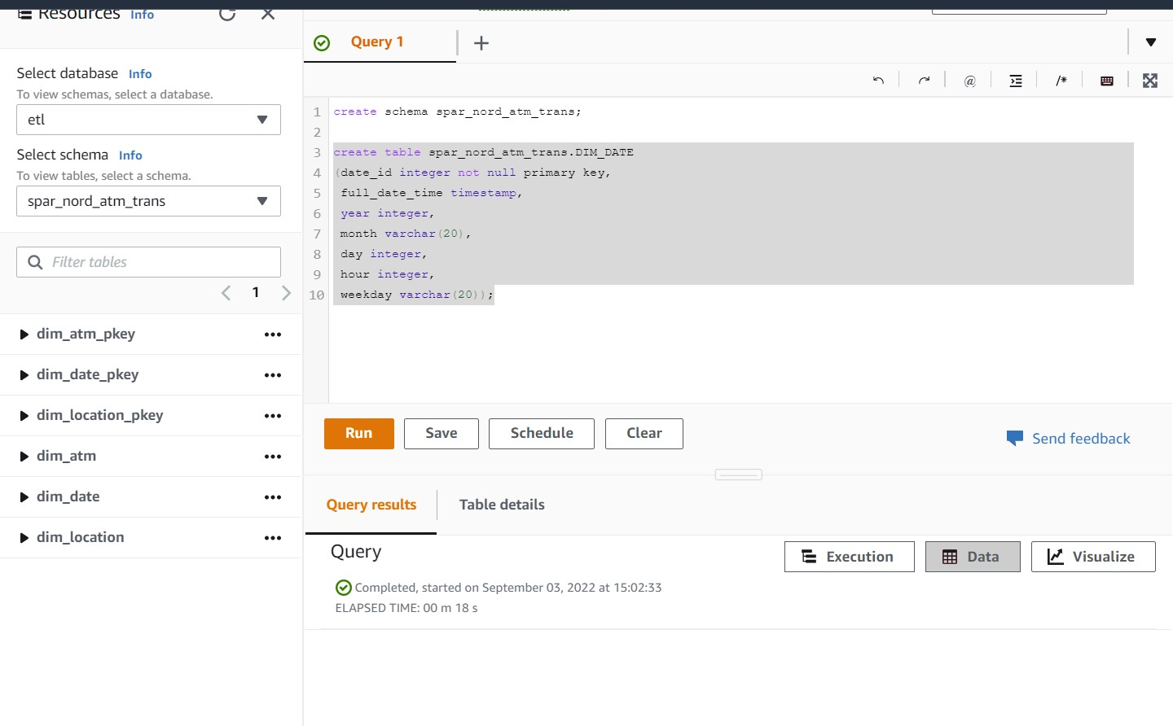

DIMENSION TABLE 4: DIM_LOCATION

|  |
| --- |
| ***create table spar_nord_atm_trans.DIM_LOCATION***  ***(location_id integer not null primary key,***  ***location varchar(50),***  ***streetname varchar(255),***  ***street_number integer,***  ***zipcode integer,***  ***lat decimal(10,3),***  ***lon decimal(10,3));*** |

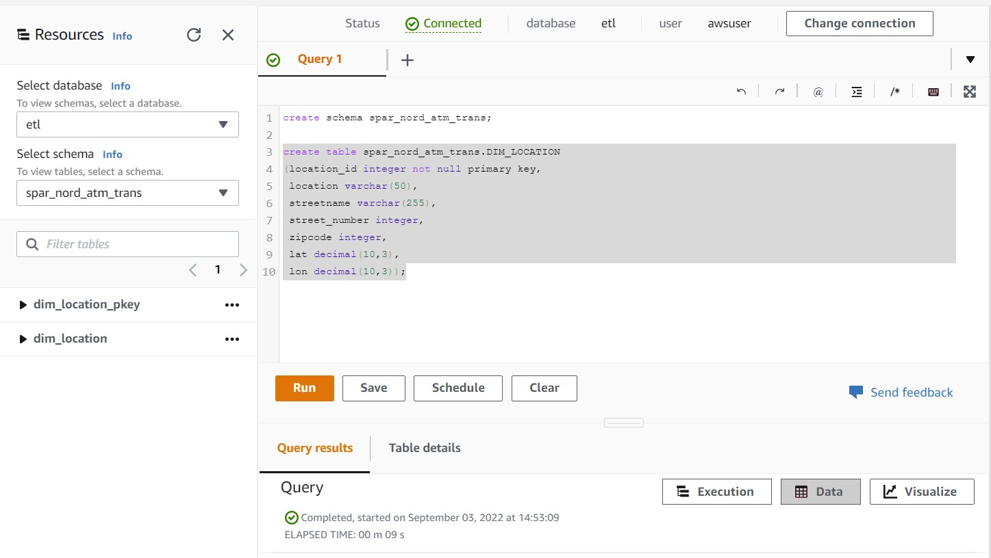

FACT TABLE : FACT_ATM_TRANS

|  |
| --- |
| ***create table spar_nord_atm_trans.FACT_ATM_TRANS***  ***(trans_id bigint not null DISTKEY SORTKEY,***  ***atm_id int,***  ***weather_loc_id int,***  ***date_id int,***  ***card_type_id int,***  ***atm_status varchar(20),***  ***currency varchar(10),***  ***service varchar(20),***  ***transaction_amount int,***  ***message_code varchar(225),***  ***message_text varchar(225),***  ***rain_3h decimal(10,3),***  ***clouds_all int,***  ***weather_id int,***  ***weather_main varchar(50),***  ***weather_description varchar(255),***  ***PRIMARY KEY(trans_id),***  ***FOREIGN KEY(weather_loc_id) references spar_nord_atm_trans.DIM_LOCATION(location_id),***  ***FOREIGN KEY(atm_id) references spar_nord_atm_trans.DIM_ATM(atm_id),***  ***FOREIGN KEY(date_id) references spar_nord_atm_trans.DIM_DATE(date_id),***  ***FOREIGN KEY(card_type_id) references spar_nord_atm_trans.DIM_CARD_TYPE(card_type_id));*** |

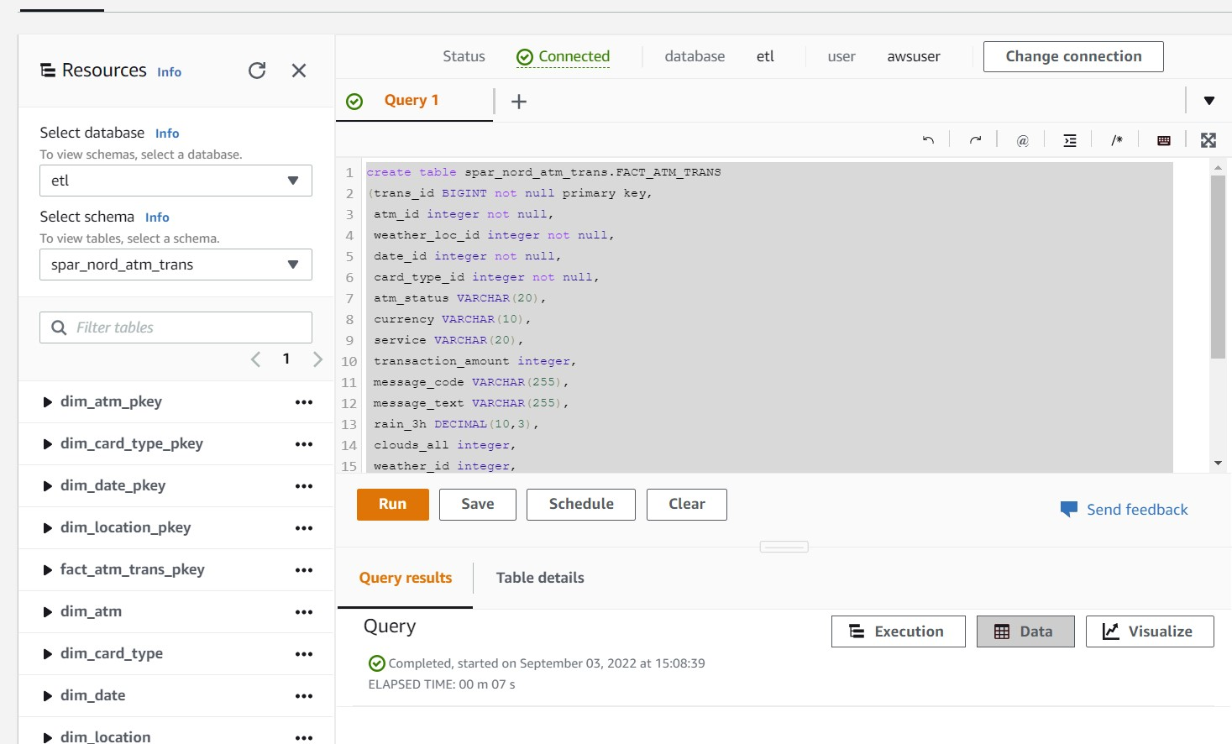

### 

### Loading data into a Redshift cluster from Amazon S3 bucket

**Queries to copy the data from S3 buckets to the Redshift cluster in the appropriate tables**

**S3 to Redshift DIM_ATM**

|  |
| --- |
| ***copy spar_nord_atm_trans.DIM_ATM from 's3://s3etlbucket/dim_atm/part-00000-f38f2738-f84e-4581-af21-6eaebeedef11-c000.csv' iam_role 'arn:aws:iam::536330618235:role/s3fullredshiftrole' delimiter ',' region 'us-east-1';*** |

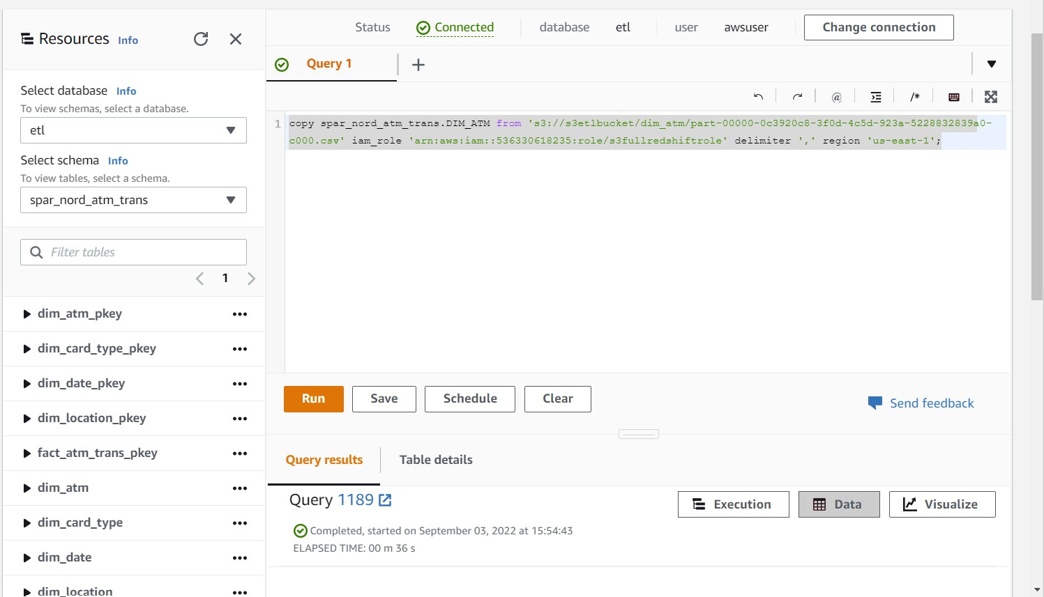

**S3 to Redshift DIM_CARD_TYPE**

|  |
| --- |
| ***copy spar_nord_atm_trans.DIM_CARD_TYPE from 's3://s3etlbucket/dim_card_type/part-00000-e7170186-2eb6-4b2d-a1f0-f23527062a3b-c000.csv' iam_role 'arn:aws:iam::536330618235:role/s3fullredshiftrole' delimiter ',' region 'us-east-1';*** |

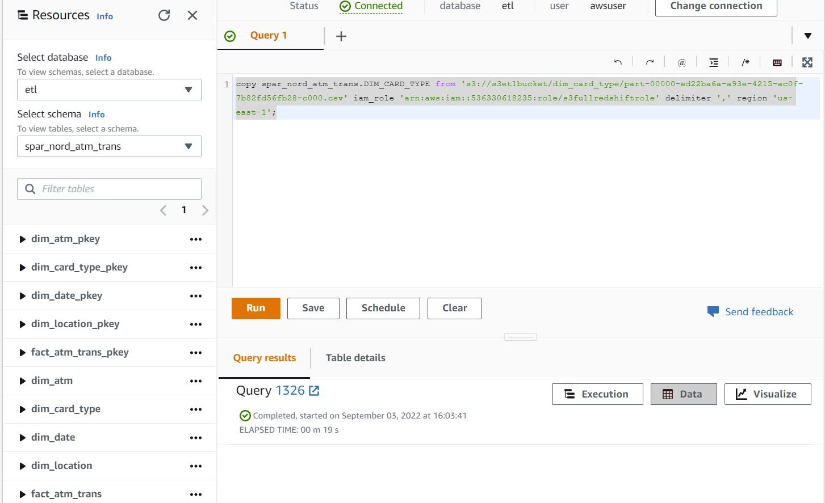

**S3 to Redshift DIM_DATE**

|  |
| --- |
| ***copy spar_nord_atm_trans.DIM_DATE from 's3://s3etlbucket/dim_date/part-00000-ace51bd0-f726-40e3-9a8f-3c9bfe6066de-c000.csv' iam_role 'arn:aws:iam::536330618235:role/s3fullredshiftrole' delimiter ',' region 'us-east-1' TIMEFORMAT 'auto';*** |

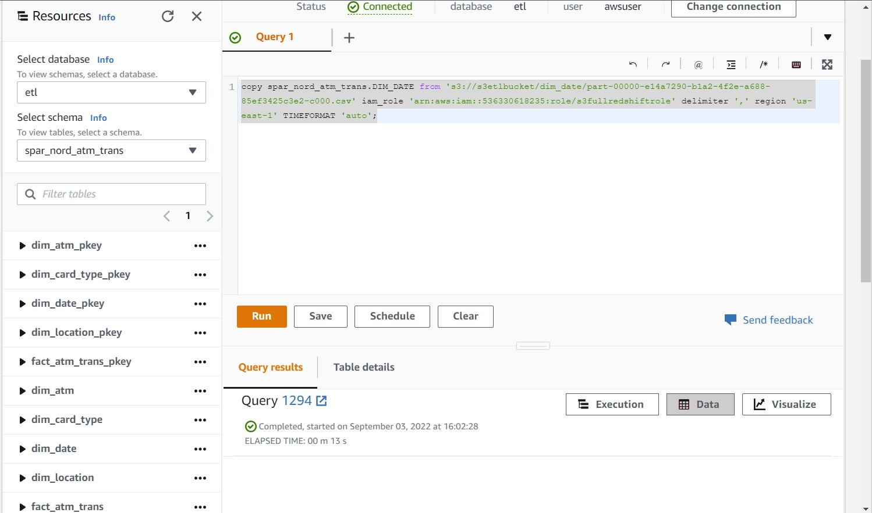

**S3 to Redshift DIM_LOCATION**

|  |
| --- |
| ***copy spar_nord_atm_trans.DIM_LOCATION from 's3://s3etlbucket/dim_location/part-00000-4083086e-aae6-44e1-833d-88b52c5f5f0d-c000.csv' iam_role 'arn:aws:iam::536330618235:role/s3fullredshiftrole' delimiter ',' region 'us-east-1';*** |

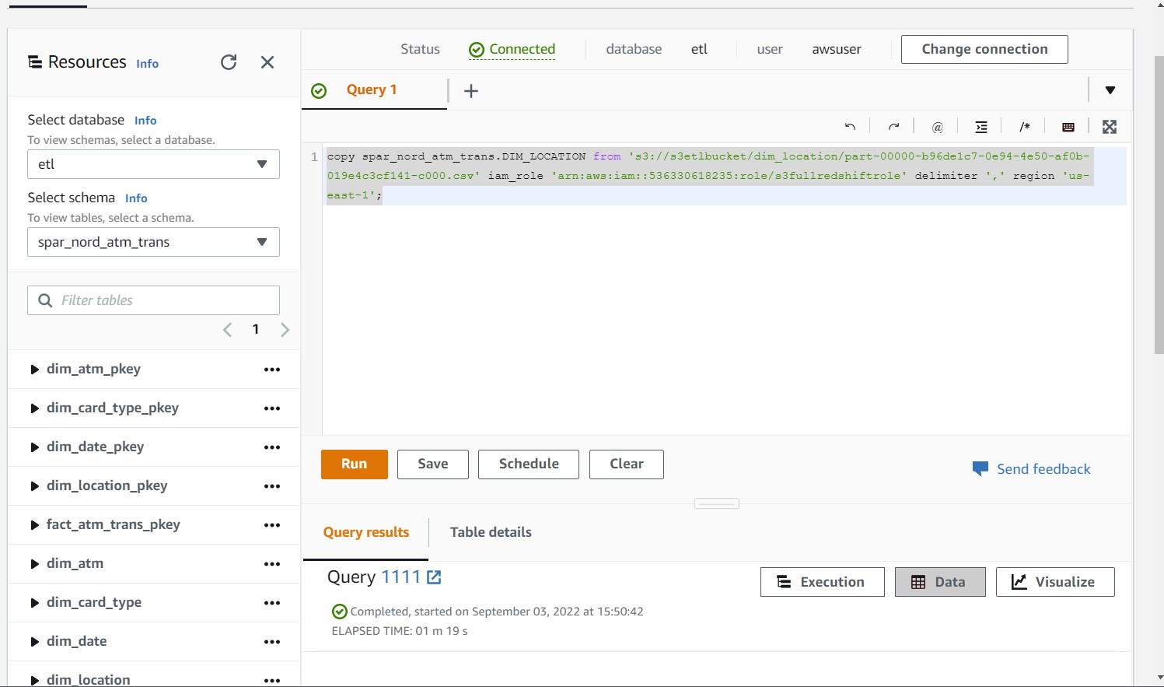

**S3 to Redshift FACT_ATM_TRANS**

|  |
| --- |
| ***copy spar_nord_atm_trans.FACT_ATM_TRANS from 's3://s3etlbucket/fact_atm_trans/part-00000-6d0fcdcf-adb2-4e08-bfd6-e24254fc7d11-c000.csv' iam_role 'arn:aws:iam::536330618235:role/s3fullredshiftrole' delimiter ',' region 'us-east-1' CSV;*** |

