### Data Ingestion from the RDS to HDFS using Sqoop

**Sqoop Import command used for importing table from RDS to HDFS:**

|  |
| --- |
| sqoop import \  --connect jdbc:mysql://upgraddetest.cyaielc9bmnf.us-east-1.rds.amazonaws.com/testdatabase \  --table SRC_ATM_TRANS \  --username student --password STUDENT123 \  --target-dir /user/root/SRC_ATM_TRANS \  -m 1 |

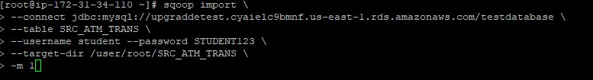

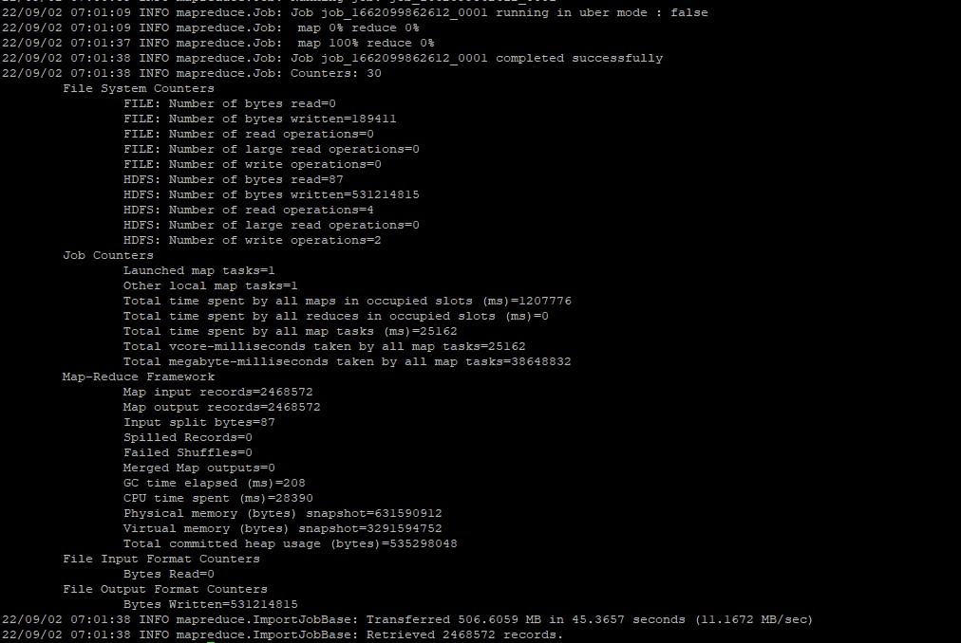

**Command used to see the list of imported data in HDFS:**

|  |
| --- |
| hadoop fs -ls /user/root/SRC_ATM_TRANS |

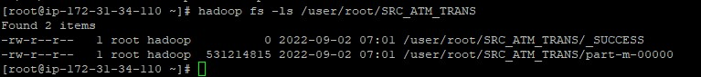

**Screenshot of the imported data:**

