**Assignment 1 Of Session 2**

**Task 1 :**

Check whether /user/acadgild directory exists or not in the HDFS. If it doesn't exist, then create this. Create a directory /user/acadgild/hadoop.

Step 1 :

Check if /user/acadgild directory is present in hdfs

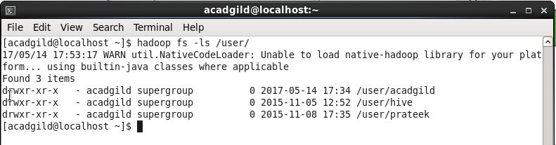

Directory /user/acadgild is present in hdfs

Yes, directory /user/acadgild is already present

Step 2 :

Check if /user/acadgild/hadoop directory is present in hdfs

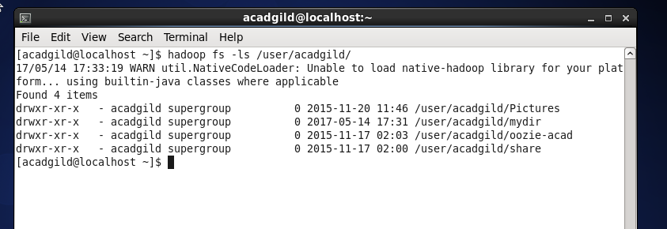

/user/acadgild/hadoop directory is not present in hdfs

Step 3 :

Create directory /user/acadgild/Hadoop in hdfs

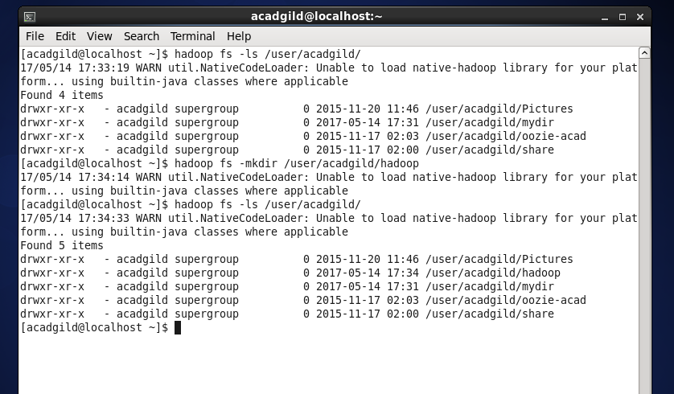

Directory created

Command executed to create directory

**Task 2 :**

Create a file in HDFS under directory /user/acadgild/hadoop, with name word-count.txt. Whatever we type on screen should get appended to the file. Try to type (on screen) few lines from any online article or textbook.

Step 1 :

Check if the file word-count.txt is already present in directory /user/acadgild/Hadoop

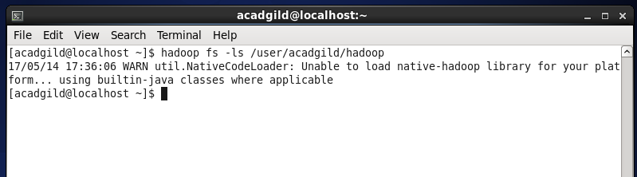

No, word-count.txt is not already present in directory /user/acadgild/Hadoop. This directory is empty.

Step 2 :

Create the file word-count.txt and put the contents typed on terminal into the file

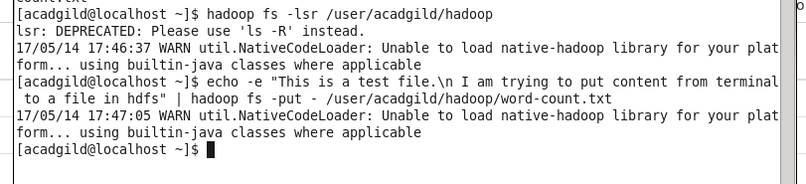

Create file word-count.txt and put contents in it

The command ‘put’ is creating the file word-count.txt in directory /user/acadgild/Hadoop, as well as appending the contents to it.

Step 3 :

Verify the contents of the file

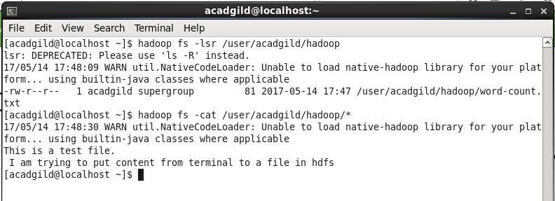

Content appended to the file

File created

Step 4 :

Verify the existence of file from browser

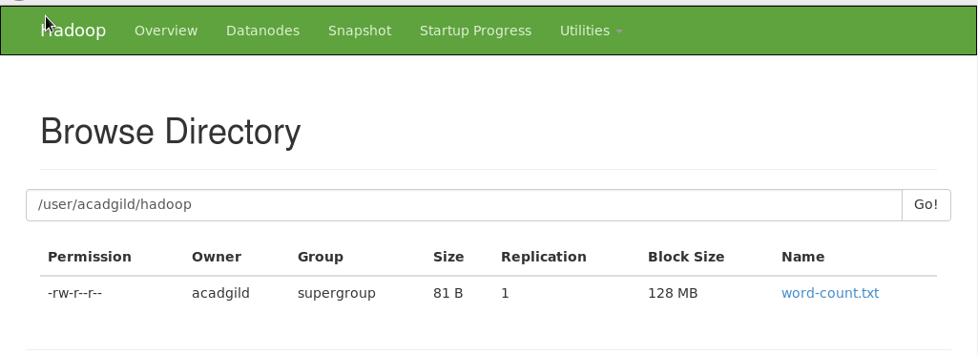

Alternatively, we could also use the command ‘appendToFile’

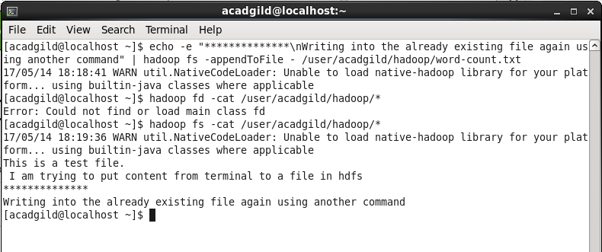

Using an alternate command to write to file word-count.txt

Content appended to file word-count.txt