**Assignment 2 of Session 2**

**Task1:**

Create a file max-temp.txt in local FS. Put 10-15 records of date and temperature [dd-mm-yyyy,tempperature]. Move this file at /user/acadgild/Hadoop.

Step 1 : Create file max-temp.txt in local FS

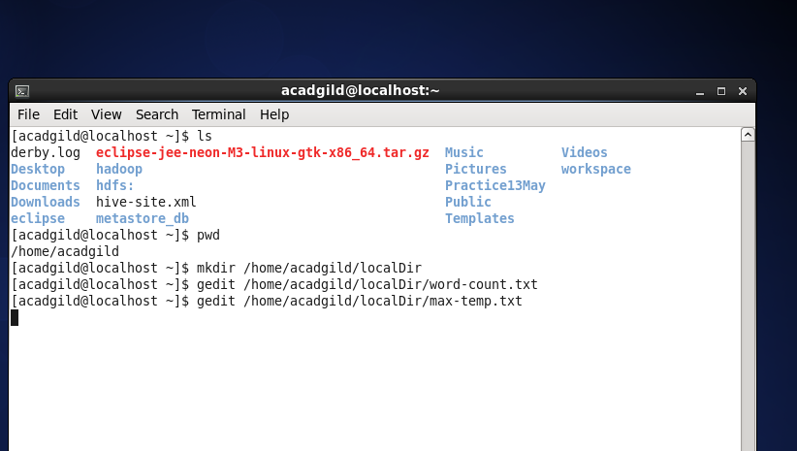

Max-temp.txt was not already present

Create file max-temp.txt

Step 2 : Inserting records in the file created

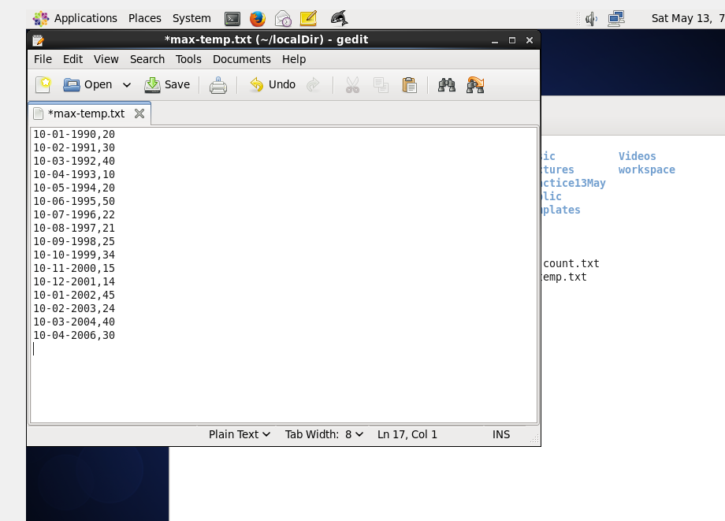

Step 3 : Check if file already existed in Hadoop FS

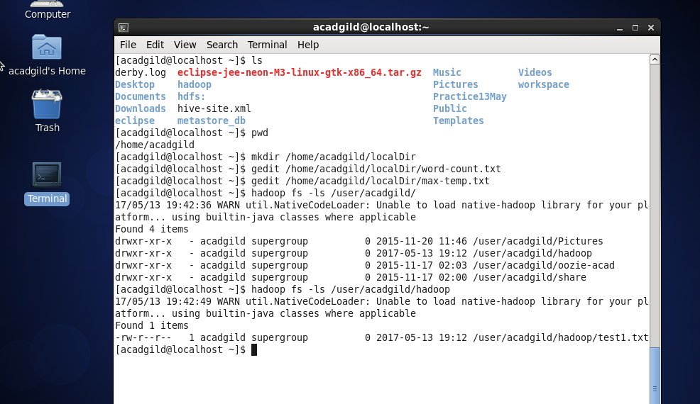

List all files in /user/acadgild/Hadoop

Max-temp.txt was not already existing in required directory

Step 4 : Send the file in local FS to HDFS at .user/acadgild/hadoop

Command to send the file to hdfs from local fs

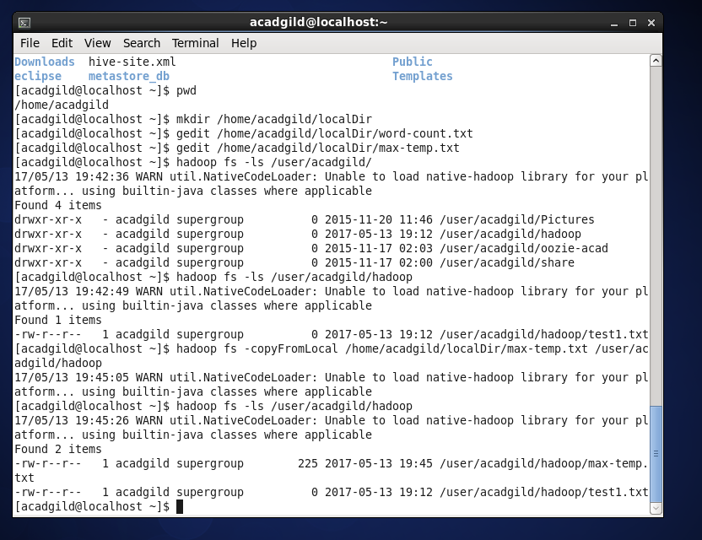

File created in required destination

Step 5 : Cross-check file in hadoop FS from the browser

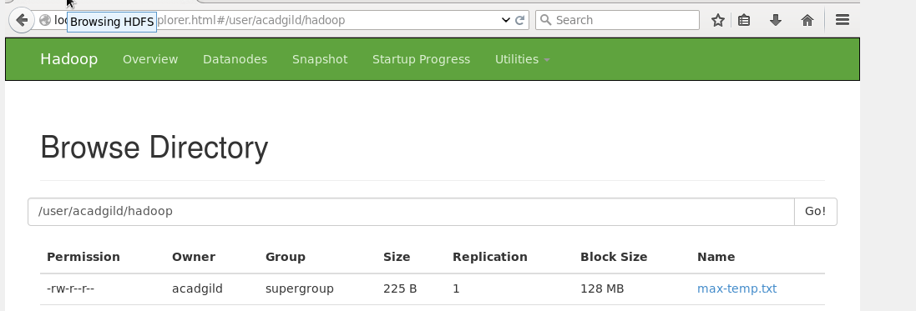

**Task 2 :**

Change the permission of the file /user/acadgild/hadoop/max-temp.txt, such that only the owner and the group members have full control over the file. Others do not have any control over it.

Step 1 : As seen in previous screen-shot, file /user/acadgild/hadoop/max-temp.txt has -rw-r--r--permissions.

Step 2 : Change permission of this file to rwxrwx---

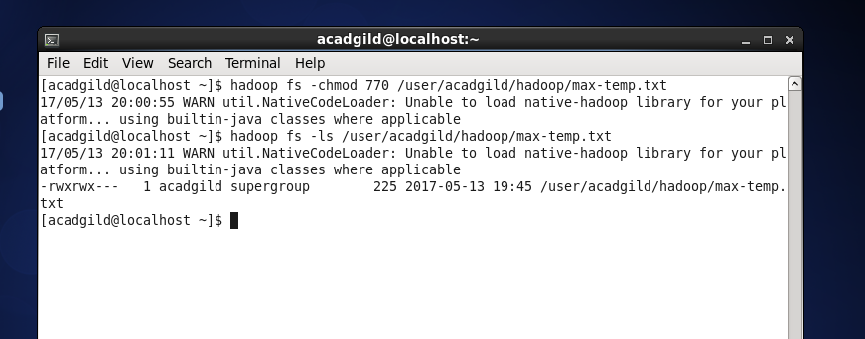

Permissions modified

Command to change permission executed

Step 3 : Verifying permissions changed from browser

