**BigData And Hadoop**

**Task 7 of Assignment 2 of Session 5**

**Problem Statement :**

Write a Map Reduce program to view the total sales for each product for every Company corresponding to each size.Make sure that all records for a single company goes to a single reducer and inside every reducer, keys must be sorted in descending order of the size.You may write a custom WritableComparable for this purpose.

**Solution**

**Code files are as follows :**

Mapper class : SalesMapper.java

Reducer class : SalesReducer.java

Partitioner class : SalesPartitioner.java

Driver class : Sales.java

**Snapshots of the output are as follows :**

1. Input file present in ‘/home/acadgild/Abhilasha’. Its name is television.txt

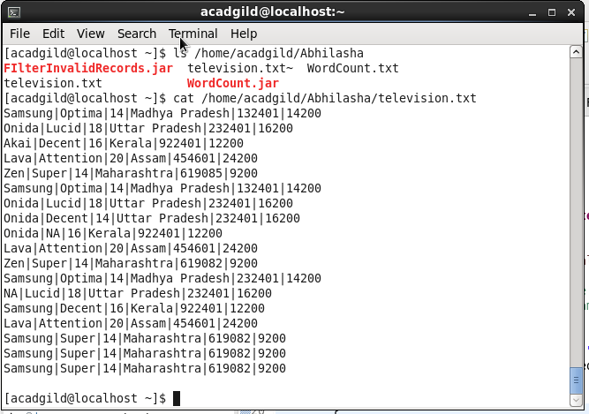

Command used to see the content of the input file

Path where input file is saved locally

1. Input file opened in gedit locally

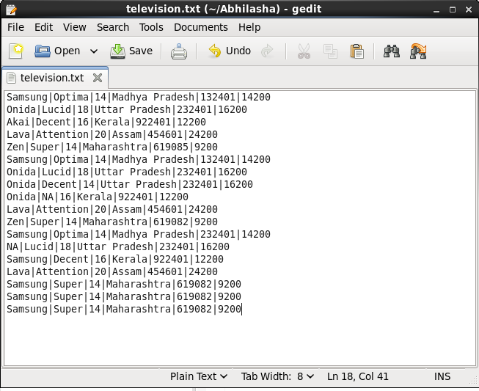

1. Command executed to put television.txt to hdfs system

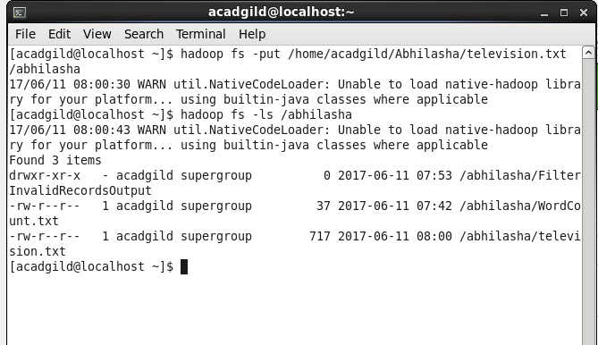

television.txt stored on hdfs

1. Jar is placed locally at /home/acadgild/Abhilasha. Its name is TVSales.jar

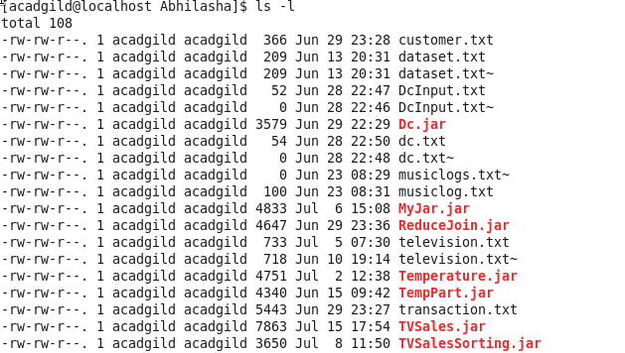

1. Executing the map-reduce program on Hadoop.

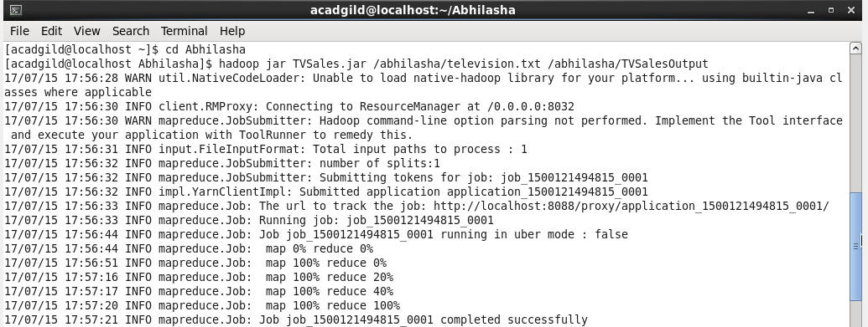

1. Job history server mentioning the success of the job

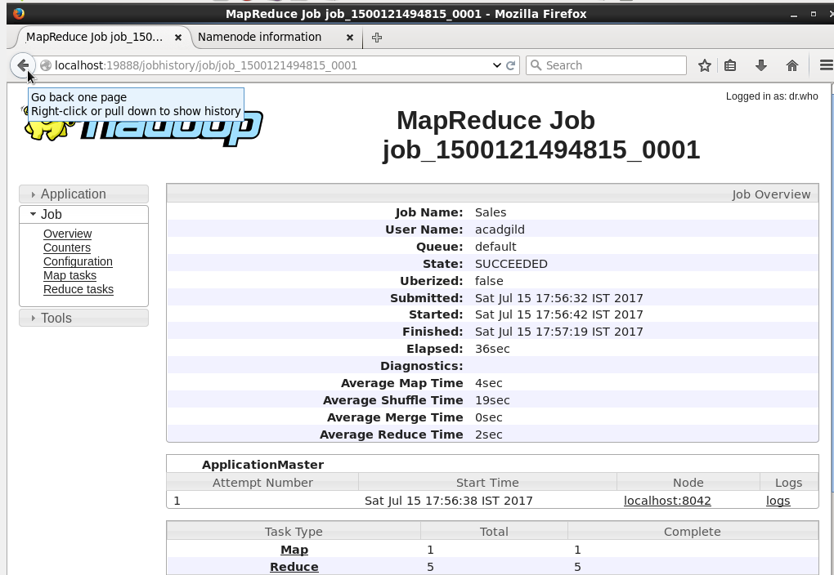

1. Output folder created on hdfs :

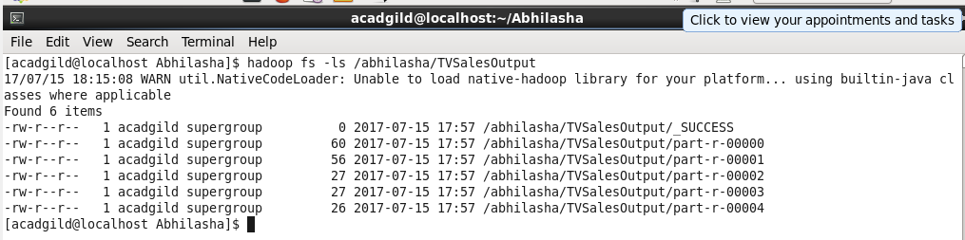

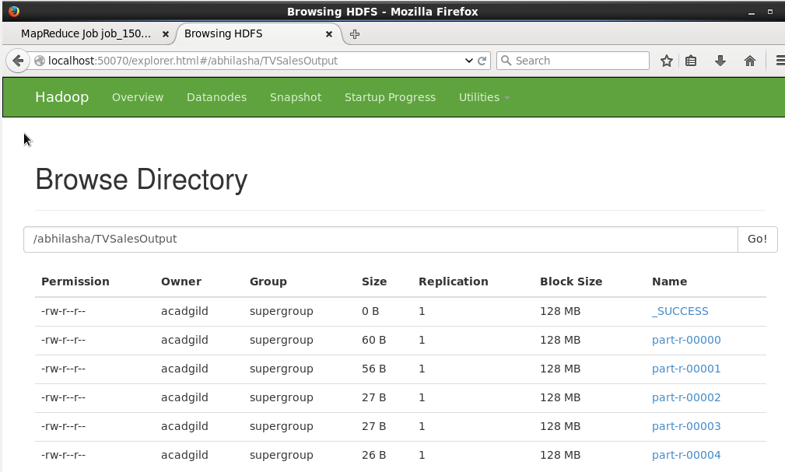

1. Content of output files : **We have excluded the invalid records here**

