**BigData And Hadoop**

**Assignment 1 of Session 6**

**Problem Statement :**

Write a Map Reduce program that takes the output of Task 5 (refer session 5, assignment 1) as input, and produce output which is sorted on the total units sold. You may use a single reducer for the sorting. Use Sequence File formats as output for Task 5 and as input for this task.

**Solution**

**Stage1 : Generating sequence file**

Code files to find number of units for every company, with output as a sequence file is as follows :

Mapper class : TelevisionSalesMapperC.java

Reducer class : TelevisionSalesReducerC.java

Driver class : TelevisionSalesC.java

**Snapshots of the output are as follows :**

1. Input file present in ‘/home/acadgild/Abhilasha’. Its name is television.txt

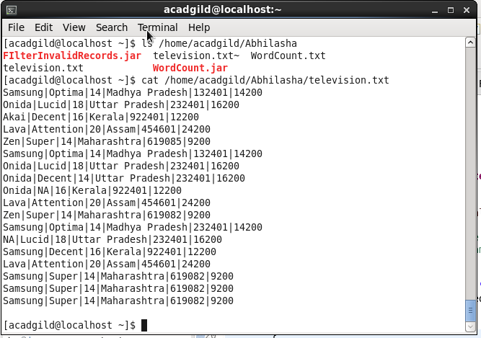

Command used to see the content of the input file

Path where input file is saved locally

1. Command executed to put television.txt to hdfs system

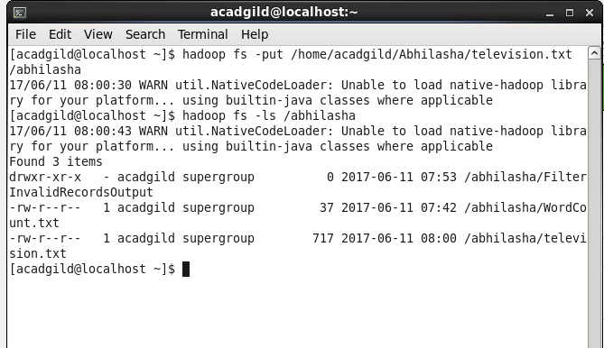

television.txt stored on hdfs

1. Executing the map-reduce program on Hadoop.

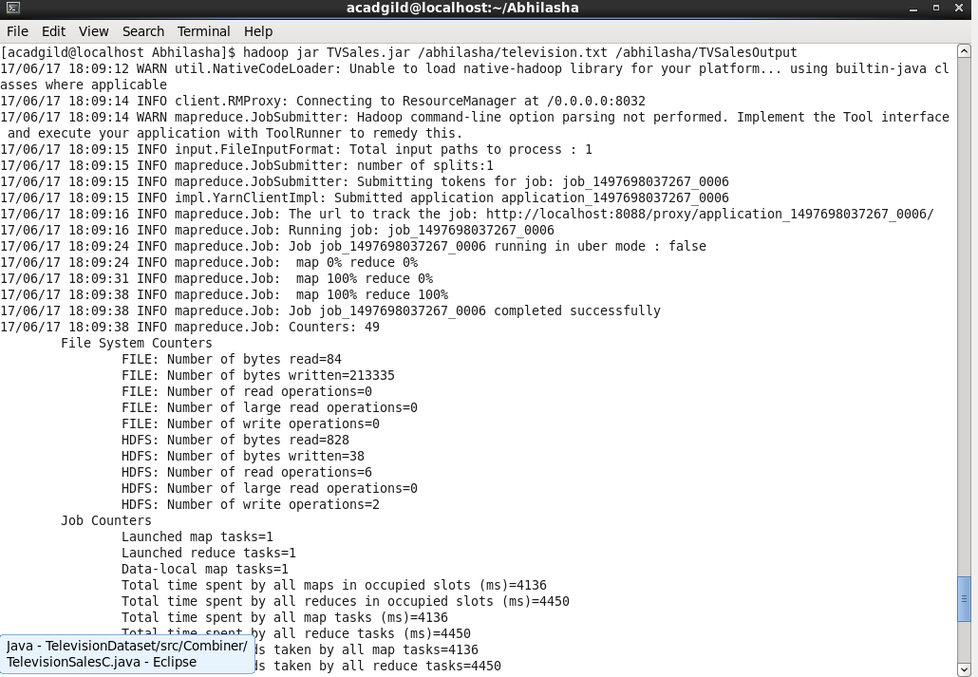

1. Output folder created on hdfs. The folder contains output in the form of sequence file, which on printing on console using ‘cat’ command was displayed as follows.

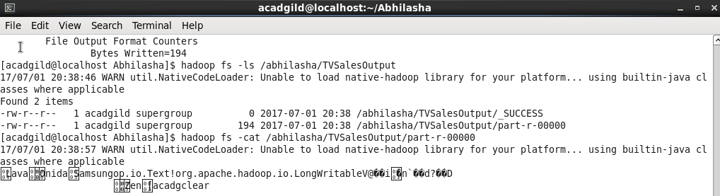

**Stage2 : Verifying the contents of sequence file through a java code**

Class Name : SequenceFileReader.java

It is a simple java code and not a map-reduce program.

Code is as follows :

package Assignment1;

import java.io.IOException;

import org.apache.hadoop.conf.Configuration;

import org.apache.hadoop.fs.Path;

import org.apache.hadoop.io.LongWritable;

import org.apache.hadoop.io.SequenceFile;

import org.apache.hadoop.io.Text;

public class SequenceFileReader

{

public static void main(String[] args) throws IOException

{

Path inputPath = new Path("/abhilasha/TVSalesOutput/part-r-00000");

SequenceFile.Reader reader = new SequenceFile.Reader(new Configuration(), SequenceFile.Reader.file(inputPath));

System.out.println("Is file compressed : "+reader.isCompressed());

Text key = new Text();

LongWritable value = new LongWritable();

while(reader.next(key, value))

{

System.out.println("key : "+key+"\t\tValue : "+value);

}

reader.close();

}

}

Output on executing this code is as follows :

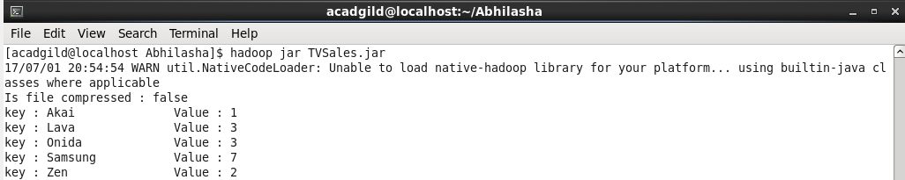

**Stage3 : Sorting the data based on units sold**

Code files to find number of units for every company, with output as a sequence file is as follows :

Mapper class : TvMapper.java

Reducer class : Default reducer used

Driver class : TvDriver.java

1. Input to this program is output of previous program and stored in /abhilasha/TVSalesOutput/part-r-00000. It is already present in hdfs.



1. Jar TVSalesSorting.jar located at /home/acadgild/Abhilasha

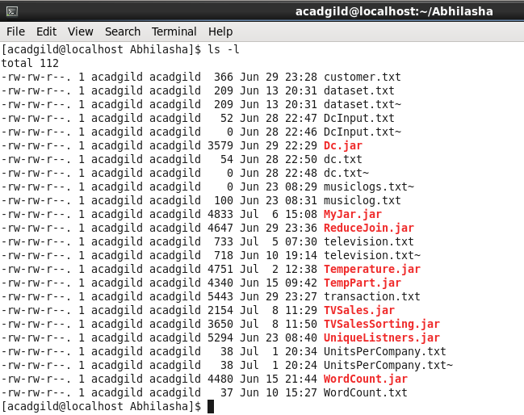

1. Executing the map-reduce program :

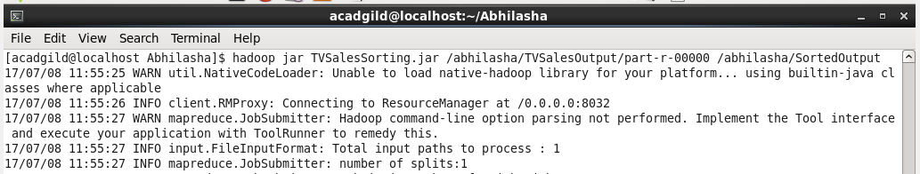

1. Job completed successfully :

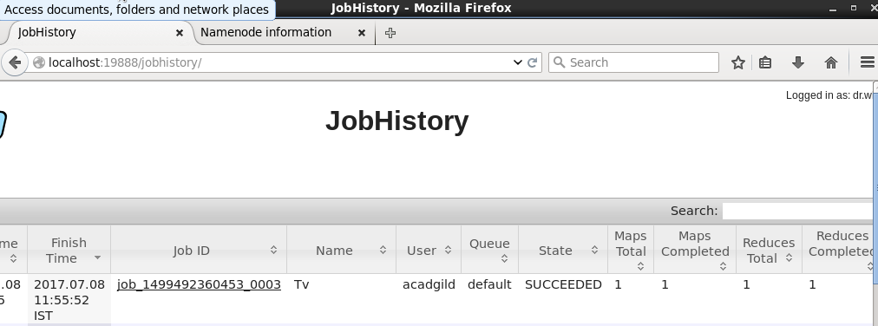

1. Output files generated as follows:

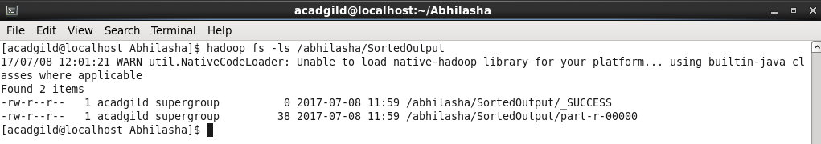

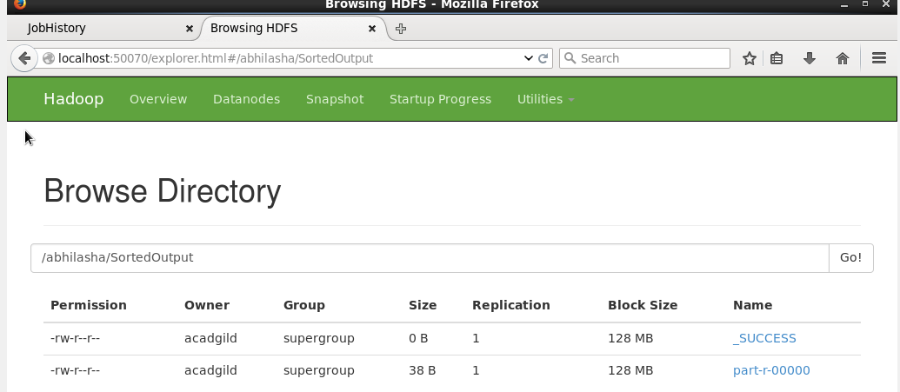

1. Sorted output content is as follows :

