**BigData And Hadoop**

**Assignment 3 of Session 6**

**Problem Statement :**

Enhance the task 8(refer session 6, assignment 1) to calculate the top 3 state-wise sales for each company. You may use multiple reducers for this activity.

**Solution**

**Stage1 : Finding number of units for every state of every company**

Code files to find number of units for every state of every company, with output as a sequence file is as follows :

Mapper class : TelevisionSalesMapperC.java

Reducer class : TelevisionSalesReducerC.java

Driver class : TelevisionSalesC.java

**Snapshots of the output are as follows :**

1. Input file present in ‘/home/acadgild/Abhilasha’. Its name is television.txt

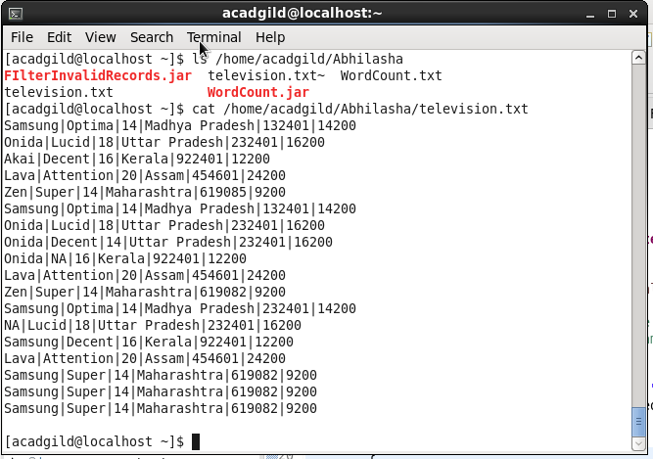

Command used to see the content of the input file

Path where input file is saved locally

1. Command executed to put television.txt to hdfs system

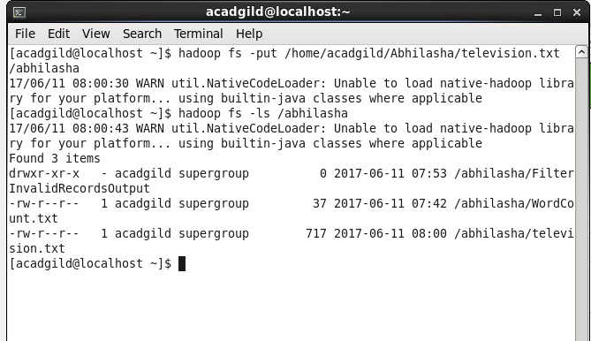

television.txt stored on hdfs

1. Executing the map-reduce program on Hadoop and completed successfully.

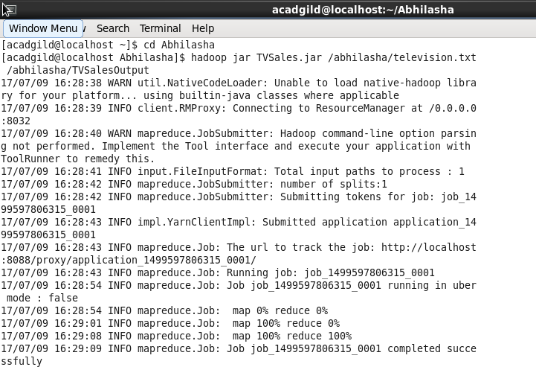

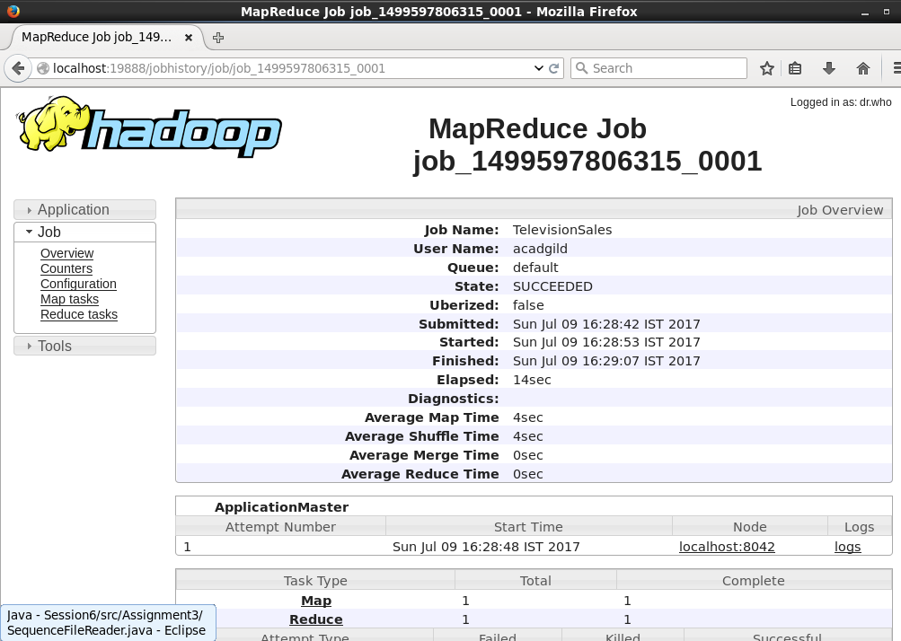

1. Output folder created on hdfs. The folder contains output in the form of sequence file, which on printing on console using ‘cat’ command was displayed as follows.

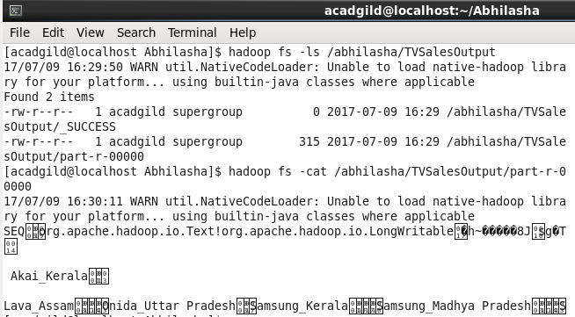

**Stage2 : Verifying the contents of sequence file through a java code**

Class Name : SequenceFileReader.java

It is a simple java code and not a map-reduce program.

Code is as follows :

package Assignment1;

import java.io.IOException;

import org.apache.hadoop.conf.Configuration;

import org.apache.hadoop.fs.Path;

import org.apache.hadoop.io.LongWritable;

import org.apache.hadoop.io.SequenceFile;

import org.apache.hadoop.io.Text;

public class SequenceFileReader

{

public static void main(String[] args) throws IOException

{

//Check if input parameters provided appropriately

if(args==null || args.length!=1)

{

System.err.println("Incorrect input parameter provided");

System.exit(-1);

}

Path inputPath = new Path(args[0]);

SequenceFile.Reader reader = new SequenceFile.Reader(new Configuration(), SequenceFile.Reader.file(inputPath));

System.out.println("Is file compressed : "+reader.isCompressed());

Text key = new Text();

LongWritable value = new LongWritable();

while(reader.next(key, value))

{

System.out.println("key : "+key+"\t\tValue : "+value);

}

reader.close();

}

}

Output on executing this code is as follows :

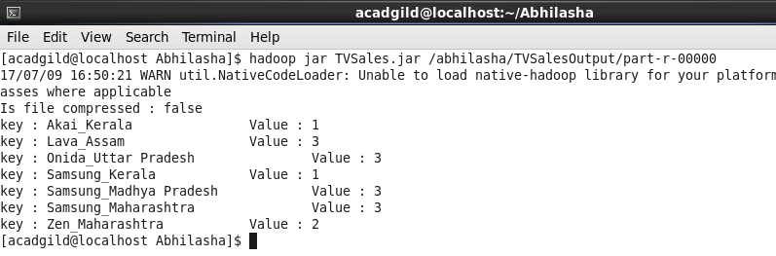

**Stage3 : Getting state-wise top 3 sales for every company**

Code are as follows :

Bean class : Television.java

Driver class : TelevisionDriver.java

Mapper class : TelevisionMapper.java

Reducer class : TelevisionReducer.java

Partitioner class : TelevisionPartitioner.java

GroupingComparator class : TelevisionGroupingComparator.java

1. Input to this program is output of previous program and stored in /abhilasha/TVSalesOutput/part-r-00000. It is already present in hdfs.

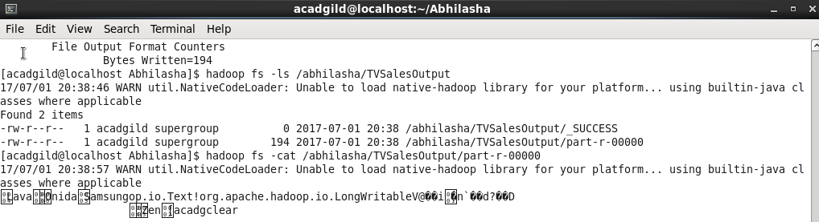

1. Jar TVSales2.jar located at /home/acadgild/Abhilasha 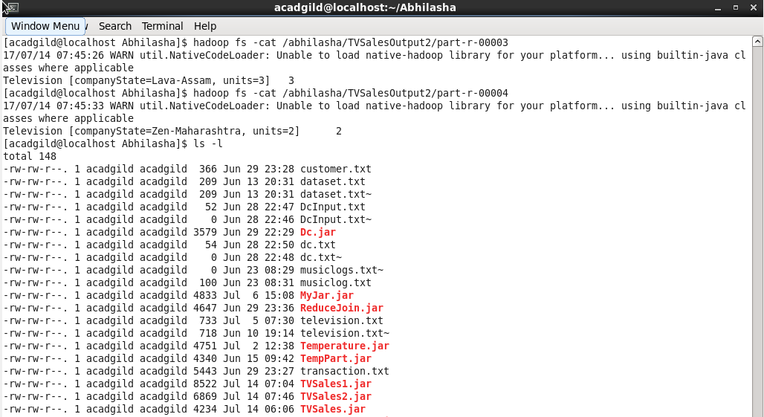
2. Executing the map-reduce program :

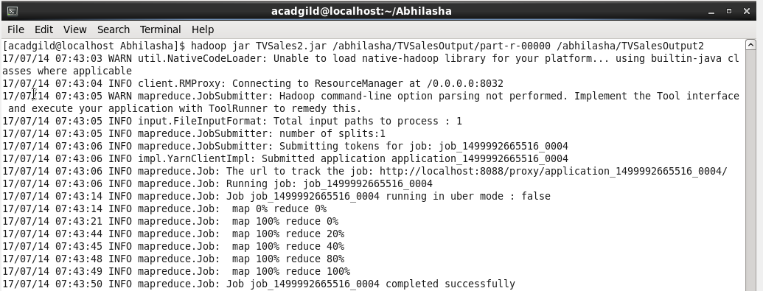

1. Job completed successfully with 5 reducers :

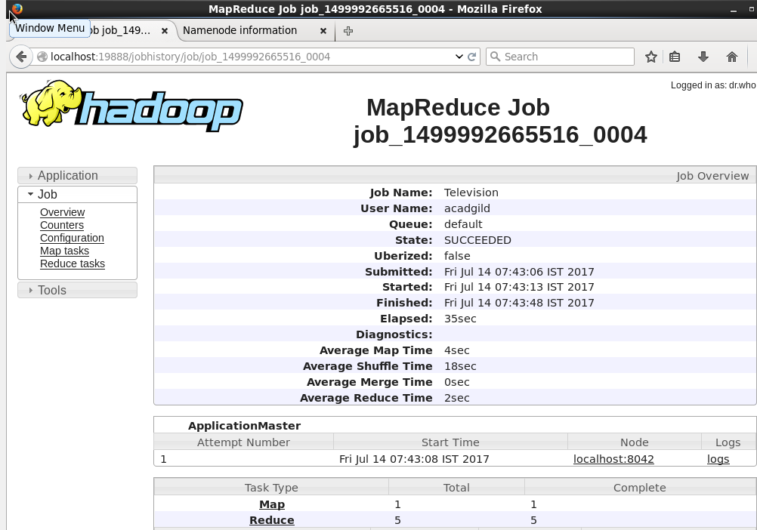

1. Output files generated as follows:

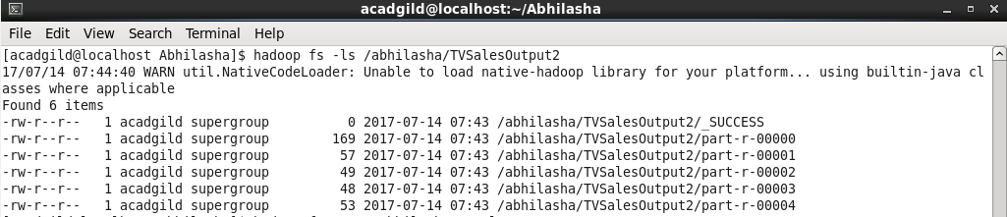

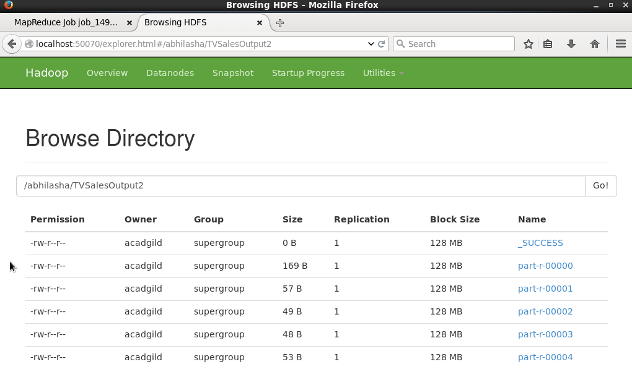

1. Sorted output content is as follows :

