**E-Commerce Sales Analysis Using SQL**

**Introduction**

In this project, I performed a comprehensive analysis of e-commerce sales data using SQL. The goal was to extract meaningful insights into customer spending habits, product performance, and payment preferences, which can help improve business strategies.

The analysis involves querying a simulated e-commerce database that includes the following tables: **order_table**, **Payment_t**, **Product**, **customer_sales**, and **order_detail**.

**Database Structure Overview**

To better understand the data, here’s an overview of the key tables:

* **order_table**: Contains records of each customer’s orders, including the order ID, customer ID, date, and total order value.
* **Payment_t**: Stores details related to payments, such as payment methods, payment amounts, and dates.
* **Product**: Holds product details, such as name, category, price, and available stock.
* **customer_sales**: Includes customer-specific information, including their total expenditure across all orders.
* **order_detail**: This table tracks which products were bought in each order, along with the quantities and prices.

**SQL Queries for Analysis**

The following SQL queries were run on the database to generate insights that are valuable to a business looking to optimize its operations.

**Query 1: Top-Selling Products by Quantity Sold**

This query identifies the best-selling products based on the quantity sold. The result helps determine which products are in high demand.

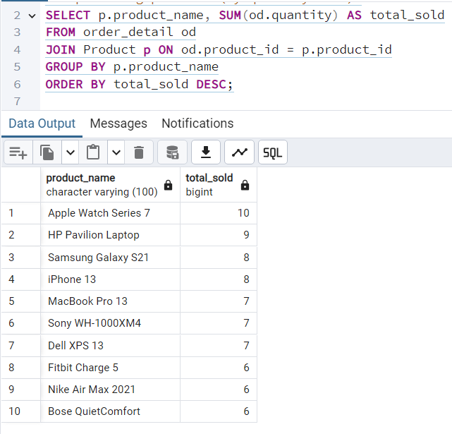

**Insight**: The query provides a list of products sorted by the total quantity sold. This data is essential for inventory management and marketing focus.

**Result**:

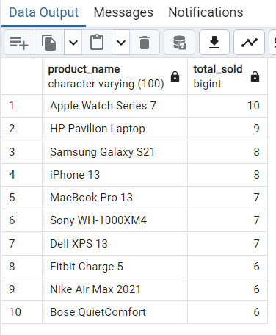

**Query 2: High-Spending Customers**

This query finds customers who have spent the most money. By analyzing spending habits, businesses can identify potential high-value customers for targeted marketing or loyalty programs.

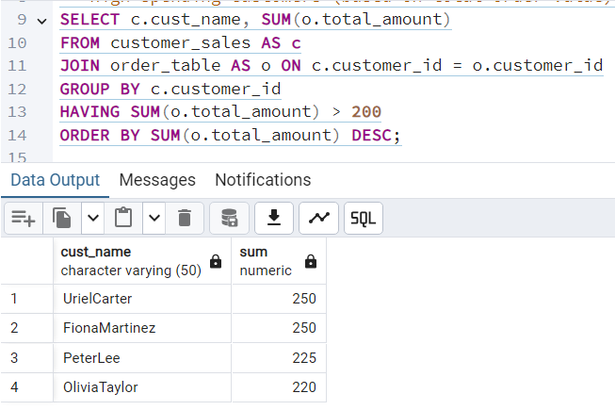

**Insight**: The result identifies high-spending customers, which helps businesses target promotions and rewards for these valuable customers.

**Result**:



**Query 3: Monthly Revenue Trends**

This query tracks the revenue generated each month, which can be used to identify sales trends over time.

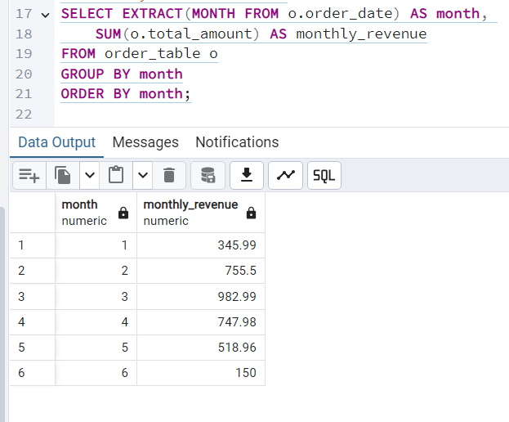

**Insight**: Monthly revenue trends help identify peak sales periods and plan marketing campaigns accordingly.

**Result**:



**Query 4: Payment Methods Usage**

Understanding which payment methods are most commonly used is crucial for optimizing payment gateways and customer experience

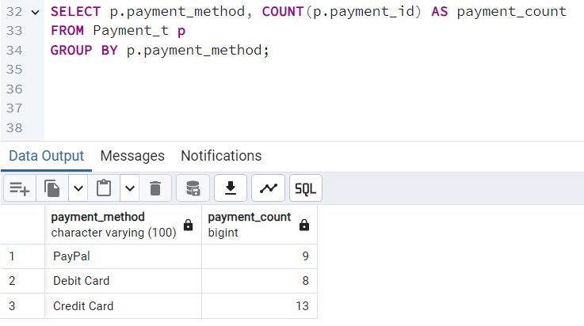

**Insight**: This query gives insight into payment preferences, which can guide businesses in selecting the right payment solutions for their customers.

**Result**:



**Query 5: Detailed Product Purchases by Customer**

This query provides a detailed view of what each customer has purchased, including product names, quantities, and prices. It is valuable for personalizing customer outreach and improving product recommendations.

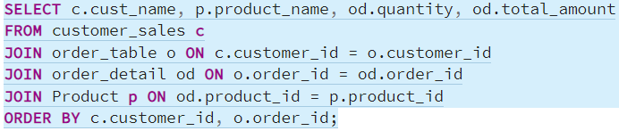**Insight**: This data is helpful for businesses aiming to personalize marketing efforts based on individual customer purchase history.

**Result:**

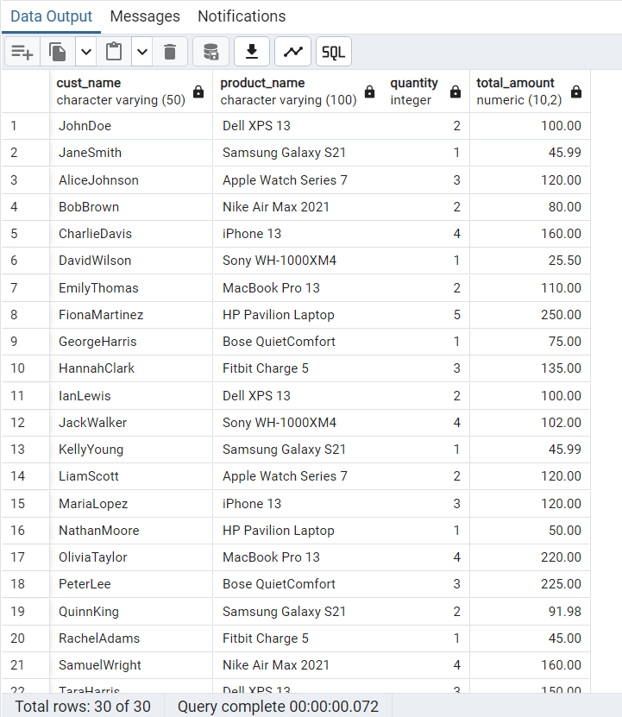

**Key Insights and Recommendations**

* **Top-Selling Products**: The list of top-selling products will help inform decisions about stock replenishment and promotional efforts.
* **High-Spending Customers**: Targeting high-value customers can lead to increased retention and higher lifetime value.
* **Revenue Trends**: Monthly revenue insights enable businesses to anticipate busy periods and optimize inventory management.
* **Payment Method Preferences**: Understanding customer preferences for payment methods can improve the checkout experience and reduce cart abandonment.
* **Customer Purchase Behavior**: Analyzing customer-specific purchases allows for personalized marketing strategies, improving engagement and sales.

**Conclusion**

* By analyzing this e-commerce sales data with SQL, we can uncover valuable insights that help businesses optimize their operations. From identifying high-spending customers to understanding product performance and customer behavior, these insights can be used to improve marketing strategies, customer experience, and overall business growth.