Game Design Document

Fill up the Following document

1. Write the title of your project.

goCovidgo

1. What is the goal of the game?

The girl has to dodge the corona virus and people as that would lead her to be in the hospital

1. Write a brief story of your game?

This game is a pictorial representation of corona times wherein a girl is moving and she comes across objects like sanitizer, mask and virus and people. She needs to collect ones which are good objects an dodge the ones which are bad for her health unless she will end up in a hospital

1. Which are the playing characters of this game?

* Playing characters are the ones which respond to the user based on the input from the user
* Cars, monkeys, dinos, wizards etc, are the playing characters in the game.

|  |  |  |
| --- | --- | --- |
| Number | Character Name | What can this character do? |
| 1 | man | She is the main character |
| 2 |  |  |
| 3 |  |  |
| 4 |  |  |
| 5 |  |  |
| 6 |  |  |
| 7 |  |  |
| 8 |  |  |

1. Which are the Non Playing Characters of this game?

* Non Playing characters are the ones which don't have an action or a behaviour when the user interacts with the game.
* Hurdles, stones, bananas, coins, etc are non playing characters in the game.

|  |  |  |
| --- | --- | --- |
| Number | Character Name | What can this character do? |
| 1 | sanitizer | Collect for Extra points |
| 2 | mask | Collect for Extra points |
| 3 | people | Enemy  Deduce points |
| 4 | coronavirus | Enemy  You will end up at hospital if you touch one |
| 5 |  |  |
| 6 |  |  |
| 7 |  |  |
| 8 |  |  |

Draw your imagination of this game. What does this game look like?

* Draw the game either on your computer or on paper,
* Add images of scenes of the game to show each of the playing and non-playing characters at least once.

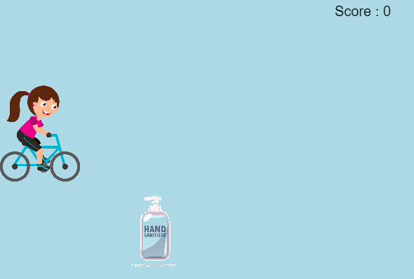

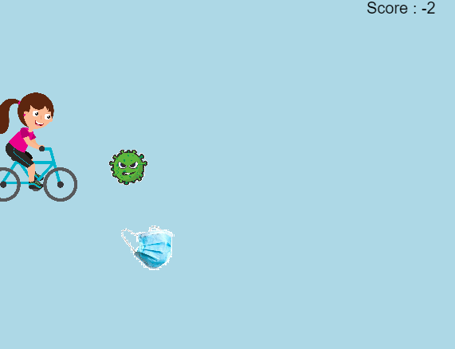

How do you plan to make your game engaging?

Since it is a real story of all the people around the world in 2020, when the pandemic hit this game is not only fun but informational as well.