PREDICTIVE ANALYSIS PSET 4
Abhilasha Das
2026-02-18
library(ISLR)
library(MASS)
library(car)
library(stargazer)

PROBLEM 1: Multicollinearity in Credit Data

Question:
Consider the Credit data in the ISLR library. Choose balance as the response and Age, Limit and Rating as the predictors.

(a) Scatter Plots

Question:
Make a scatter plot of (i) Age versus Limit and (ii) Rating Versus Limit. Comment on the scatter plot.
data("Credit")
par(mfrow=c(1,2))
plot(Credit$Limit, Credit$Age, main="Age vs Limit", xlab="Limit", ylab="Age", col="blue")
plot(Credit$Limit, Credit$Rating, main="Rating vs Limit", xlab="Limit", ylab="Rating", col="red")
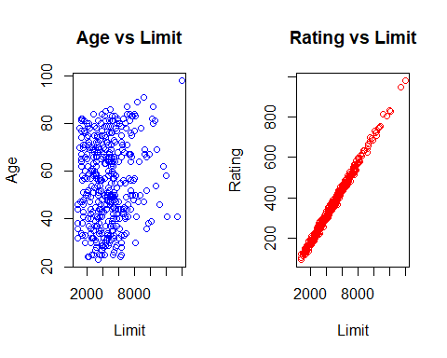

Interpretation:
The scatter plot of Age versus Limit shows a random distribution with no clear linear relationship, suggesting low correlation between these two predictors. However, the plot of Rating versus Limit shows a nearly perfect linear relationship. This indicates extremely high correlation, which is a classic sign of structural multicollinearity between these two variables.

(b) Regression Comparison

Question:
Run three separate regressions: (i) Balance on Age and Limit (ii) Balance on Age, Rating and Limit (iii) Balance on Rating and Limit. Present all output using stargazer. What is the marked difference that you can observe from the output?
model1 = lm(Balance ~ Age + Limit, data = Credit)
model2 = lm(Balance ~ Age + Rating + Limit, data = Credit)
model3 = lm(Balance ~ Rating + Limit, data = Credit)
stargazer(model1, model2, model3, type = "html",
column.labels = c("Model 1", "Model 2", "Model 3"),
title = "Regression Comparison for Multicollinearity",out="table2.html")

Regression Comparison for Multicollinearity
 | Dependent variable:
 | Balance
 | Model 1 | Model 2 | Model 3
 | (1) | (2) | (3)
Age | -2.291*** | -2.346***
 | (0.672) | (0.669)
Rating |  | 2.310** | 2.202**
 |  | (0.940) | (0.952)
Limit | 0.173*** | 0.019 | 0.025
 | (0.005) | (0.063) | (0.064)
Constant | -173.411*** | -259.518*** | -377.537***
 | (43.828) | (55.882) | (45.254)
Observations | 400 | 400 | 400
R² | 0.750 | 0.754 | 0.746
Adjusted R² | 0.749 | 0.752 | 0.745
Residual Std. Error | 230.532 (df = 397) | 229.080 (df = 396) | 232.320 (df = 397)
F Statistic | 594.988*** (df = 2; 397) | 403.718*** (df = 3; 396) | 582.820*** (df = 2; 397)
Note: | *p<0.1; **p<0.05; ***p<0.01

Interpretation
In Model 1, the variable Limit is a highly significant predictor of Balance ($p<0.01$). However, in Model 2, as soon as we introduce Rating with Age, Limit becomes statistically insignificant ($p>0.1$). Same goes for Model 3 where regressing Balance only with Rating and Limit also makes Limit insignificant.
Here we can also notice that Model 1 yields $R^{2}$=0.750 but when we add Rating as seen in Model 2 the$R^{2}$ jumps to 0.754. If two variables are highly collinear, the second variable adds almost no new information. The Adjusted $R^{2}$ (0.752) confirms this, as it penalizes the model for adding predictors that do not contribute enough explanatory power to justify the loss of degrees of freedom. So, we choose either Limit or Rating in the model but not both.

(c) Variance Inflation Factor (VIF)

Question:
Calculate the variance inflation factor (VIF) and comment on multicollinearity.
vif2 = vif(model2)
print(vif2)
## Age Rating Limit
## 1.011385 160.668301 160.592880

Interpretation
In predictive modeling, a VIF > 10 is generally considered a sign of severe multicollinearity. Here, the values for Rating and Limit are extremely high. While Age has a low VIF (near 1), indicating it is independent, the high VIF-s for the other two predictors suggest that one of them (either Limit or Rating) should be dropped to ensure the model’s reliability.

PROBLEM 2: Detection of Outliers, Leverage, and Influential Points

Question:
Attach “Boston” data from MASS library in R. Select median value of owner-occupied homes as the response and per capita crime rate, nitrogen oxides concentration, proportion of blacks, and percentage of lower status of the population as predictors. The objective is to fit a multiple linear regression model of the response on the predictors. With reference to this problem, detect outliers, leverage points and influential points if any.

Solution
data("Boston")
boston = lm(medv ~ crim + nox + black + lstat, data = Boston)
summary(boston)
##
## Call:
## lm(formula = medv ~ crim + nox + black + lstat, data = Boston)
##
## Residuals:
## Min 1Q Median 3Q Max
## -15.564 -4.004 -1.504 2.178 24.608
##
## Coefficients:
## Estimate Std. Error t value Pr(>|t|)
## (Intercept) 30.053584 2.170839 13.844 <2e-16 ***
## crim -0.059424 0.037755 -1.574 0.116
## nox 3.415809 3.056602 1.118 0.264
## black 0.006785 0.003408 1.991 0.047 *
## lstat -0.918431 0.050167 -18.307 <2e-16 ***
## ---
## Signif. codes: 0 '***' 0.001 '**' 0.01 '*' 0.05 '.' 0.1 ' ' 1
##
## Residual standard error: 6.183 on 501 degrees of freedom
## Multiple R-squared: 0.5517, Adjusted R-squared: 0.5481
## F-statistic: 154.1 on 4 and 501 DF, p-value: < 2.2e-16
n = nrow(Boston)
p = 4 # Number of predictors
res = residuals(boston) # Raw Residuals (e_i)
rse = summary(boston)$sigma # Residual Standard Error (sigma-hat)
h = hatvalues(boston) # Hat values (Leverage)
cooks = cooks.distance(boston) # Cook's Distance (Influence)
# Outliers: Residuals greater than 3 times the RSE
outliers = which(abs(res) > 3 * rse)
# Leverage points: Hat values greater than twice the average leverage (p+1)/n
lev_limit = 2 * (p + 1) / n;lev_limit
## [1] 0.01976285
leverage_pts = which(h > lev_limit)
# Influence points: Cook's Distance greater than 4/n
influential_pts=which(cooks>1)
# Instead of printing 'outliers', print the count
cat("Total Outliers detected (Residual > 3*RSE):", length(outliers), "\n")
## Total Outliers detected (Residual > 3*RSE): 11
cat("Total High-Leverage points (> 2*mean):", length(leverage_pts), "\n")
## Total High-Leverage points (> 2*mean): 64
cat("Total Influential points (Cook's distance > 1):", length(influential_pts), "\n")
## Total Influential points (Cook's distance > 1): 0
par(mfrow = c(2, 2))
plot(boston)
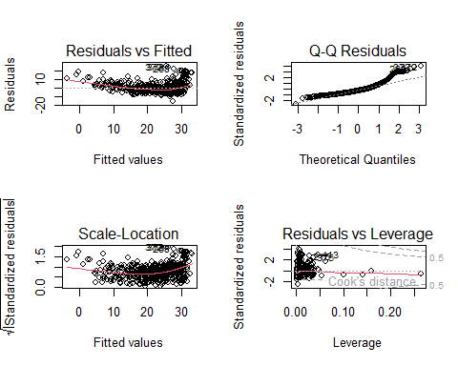
par(mfrow = c(1, 3))
boxplot(Boston$crim, main="Crime Rate", col="gold", border="brown")
boxplot(Boston$lstat, main="Lower Status %", col="tomato", border="darkred")
boxplot(Boston$nox, main="Nitrogen Oxides", col="skyblue", border="blue")
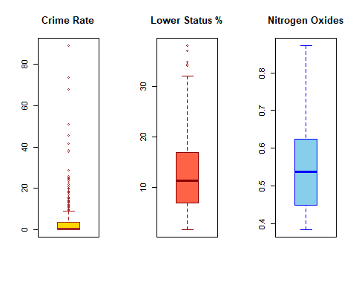
par(mfrow=c(1,2))
boxplot(Boston$black, main="Black Proportion", col="lightgreen", border="darkgreen")
boxplot(res, main="Model Residuals", col="plum", border="purple")
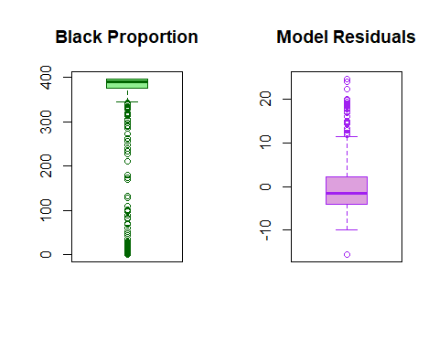

Interpretation
Out of the entire dataset, only 11 homes were flagged as outliers.These are cases where the actual house price doesn’t match the trend at all. The Residual Boxplot makes this clear that while most of our errors are clustered around zero, these 11 points are found far outside the whiskers. We found 64 high-leverage points. Looking at the Boxplots for Crime or Lower Status , we see many dots above the top whisker. These are neighborhoods with extreme socio-economic conditions. They are important because they are away from the average Boston suburb. Here we see that there exists no influential point is found which indicates that the model is robust as no outlier is ruling the others.

