ROUND 2 SUBMISSION DOCUMENT

PS-07: ICS Anomaly Detection in Thermal Power Plant
Team ID: EV18
Problem Statement: Industrial Control System (ICS/SCADA) Anomaly Detection
Industry Focus: Thermal Power Plant
Round: Data Preprocessing & Solution Planning

1. Introduction & Problem Context
Industrial Control Systems (ICS) in thermal power plants operate critical infrastructure that must maintain near-zero downtime while ensuring operational safety. These systems consist of tightly coupled subsystems such as water/feedwater circulation, boiler operations, and power generation units. Due to complex physical dependencies and rare failure events, traditional cybersecurity solutions are often unsuitable.
The objective of this work is to design a passive, physics-aware anomaly detection framework capable of identifying abnormal system behavior without disrupting ongoing operations. This round focuses on data preprocessing, visualization, and solution planning to prepare a robust foundation for anomaly detection.

2. Dataset Overview (From Round 1)
The dataset represents a thermal power plant ICS environment, integrating multiple subsystems using real, open industrial data sources.

2.1 Subsystems Covered
The dataset represents a thermal power plant ICS consisting of three interconnected subsystems:
- Water / Feedwater System: flow rate, pressure, temperature
- Boiler System: steam pressure, boiler temperature
- Power Generation System: turbine-related indicators and power output
Data was collected from open government portals and peer-reviewed industrial datasets, merged using a common timestamp to preserve physical causality across subsystems.

2.2 Data Sources
- Government open data portals (catalog.data.gov)
- Peer-reviewed industrial boiler dataset (Springer Nature Figshare)
- Public power generation datasets
All datasets were merged using a common timestamp, resulting in a unified ICS-style time-series dataset.

3. Data Preprocessing Pipeline
The following preprocessing steps were applied:
- Timestamp alignment: all data resampled to a common time resolution
- Missing values: small gaps filled using interpolation/forward fill; large gaps flagged
- Noise handling: rolling smoothing applied without masking real anomalies
- Scaling: feature normalization for anomaly detection models

Physics-Aware Feature Engineering
Derived features were created to reflect real system behavior:
- Rate of change of key sensors
- Pressure and temperature differentials
- Flow-to-steam ratios
- Cross-subsystem correlations
These features encode physical laws, not just statistical patterns.

4. Visualization
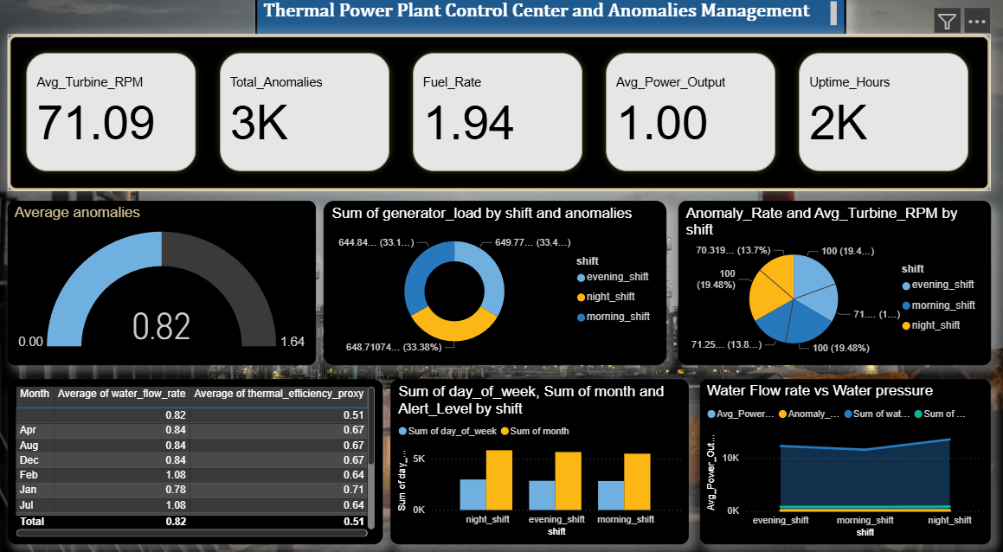

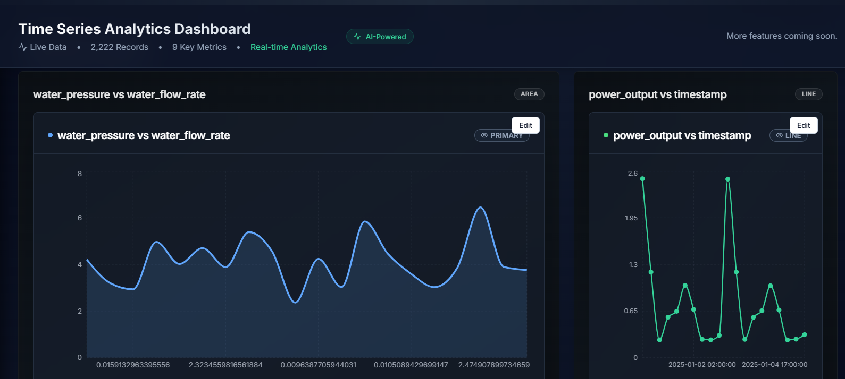

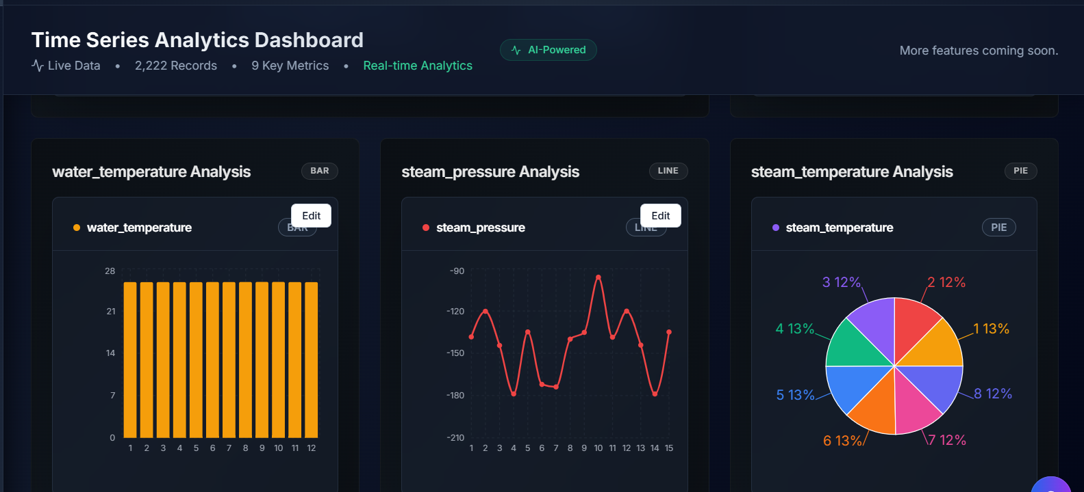
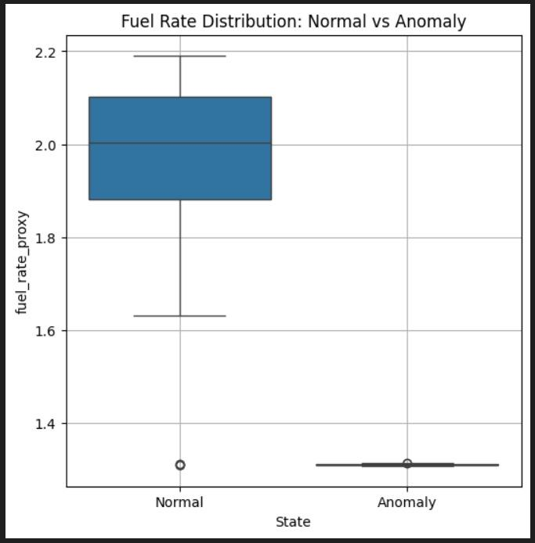

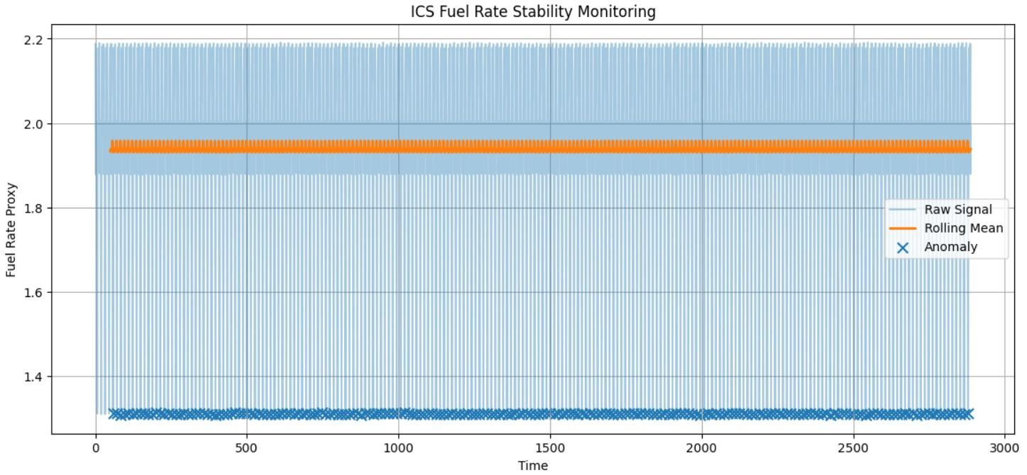

Dashboard Overview
The KPI panel provides a high-level summary of plant performance, including:
- Average Turbine RPM
- Total Anomalies
- Fuel Rate
- Average Power Output
- System Uptime
These indicators allow operators to quickly assess whether the plant is operating under normal conditions or experiencing abnormal behavior.

Anomaly Detection & Shift Analysis
The dashboard clearly differentiates normal and anomalous operating patterns using:
- Anomaly rate and average anomaly severity indicators
- Shift-wise analysis (morning, evening, night) of generator load and anomaly distribution
This helps identify time-dependent operational risks and periods with higher anomaly concentration.

Subsystem & Physics-Aware Monitoring
Subsystem-level visuals capture key physical relationships:
- Water flow rate vs water pressure
- Thermal efficiency trends over time
- Boiler and power output behavior
Outliers in these plots indicate physics-based inconsistencies, supporting explainable anomaly detection rather than black-box alerts.

Decision Support & Safety
The dashboard is designed for passive monitoring only:
- No automated control actions are taken
- All anomalies are presented with contextual operational indicators
- Supports human-in-the-loop decision-making, ensuring ICS safety compliance

5. Solution Plan (High-Level)
The proposed solution follows a hybrid, physics-aware anomaly detection approach suitable for industrial control systems.
At the subsystem level, unsupervised anomaly detection models such as Isolation Forest, One-Class SVM, and Autoencoders will be used to learn normal operational behavior of individual subsystems (water, boiler, and power generation) and detect deviations.
In parallel, physics consistency checks will be applied to validate system behavior using domain knowledge, such as mass and energy balance relationships between water flow, boiler pressure, temperature, and power output.
Final anomaly decisions will be made using an ensemble scoring mechanism, which combines model-based anomaly scores with physics rule violations to improve reliability and reduce false alarms.
All detected anomalies will trigger explainable alerts designed for operator review only, ensuring a human-in-the-loop monitoring framework.

6. Safety & Explainability
The system is designed to operate strictly in passive monitoring mode, without performing any automated control or actuation actions. Each alert is accompanied by a clear, physically interpretable explanation, enabling operators to understand the root cause of the anomaly.
Ex: Boiler pressure increased while feedwater flow decreased, violating mass balance constraints.
This approach ensures operator trust, system safety, and compliance with ICS/SCADA operational requirements.

7. Conclusion
Round 2 establishes a clean, synchronized, and physically meaningful dataset, supported by clear visualizations and a well-defined, safety-compliant solution plan. This structured preparation provides a strong foundation for implementing and evaluating anomaly detection models in subsequent rounds.

