1. What is the source of your dataset?

- Power generation: https://catalog.data.gov/dataset/teamer-vertical-axies-hydrokinetic-turbine-data-emrgy-inc-2022-post-access-submission-fc1ca#:~:text=Hydrokinetic%20Turbine,stress%20and%20strain%20at%20varied

- Boiler research paper: https://springernature.figshare.com/articles/dataset/A_long-tailed_distribution_time-series_dataset_in_boiler_equipment/28868849

- data flow: https://catalog.data.gov/dataset/demo-ftes-test-1-water-flow-pressure-temperature-and-electrical-conductivity-data#:~:text=This%20dataset%20contains%201,and%20points%20along%20several%20boreholes

2. Why did you choose this dataset for your problem statement?

We chose this dataset because it closely represents the operational flow of a thermal power plant Industrial Control System (ICS), which is the core focus of our problem statement.

The dataset integrates three critical subsystems that operate in a real thermal power plant:

Water system (flow rate, pressure, temperature)
Boiler system (steam pressure, steam temperature, fuel rate proxy)
Power generation system (turbine RPM, power output, generator temperature proxy)

These subsystems are physically interdependent:

Water conditions directly affect boiler performance,
Boiler steam characteristics influence turbine behavior,
Turbine operation determines power output.

Since anomaly detection in ICS environments must be physics-aware and safety-compliant, this dataset allows us to:

Capture normal operational behavior across interconnected systems,
Detect cross-system anomalies rather than isolated sensor faults,
Model realistic failure or attack scenarios without disrupting production.

Additionally, the dataset:

Contains time-series sensor data, which is essential for anomaly detection,
Uses continuous timestamps, matching real SCADA monitoring,
Is derived from real industrial and experimental sources, not synthetic toy data.

Therefore, this dataset is highly relevant, domain-aligned, and suitable for passive monitoring-based anomaly detection, exactly matching the problem statement requirements.

3. How was the data collected?
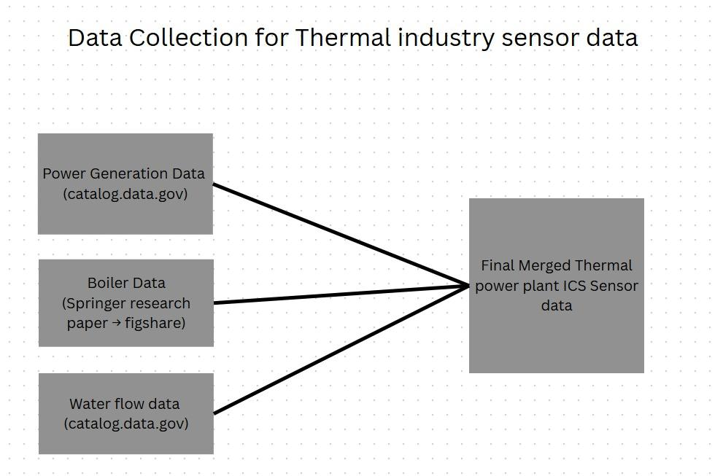

The data was collected using openly available industrial and research datasets that are publicly accessible to everyone. No web scraping or private APIs were used. All data files were downloaded directly in CSV or XLSX format from official open data portals and research publications.

The datasets represent passively recorded sensor measurements from water circulation systems, boiler operation logs, and power generation performance studies. This method aligns with industrial control system safety requirements, as the data was collected without actively interacting with or disturbing any live industrial processes.

After downloading, the data from different sources was standardized by timestamp, resampled to a common time interval, and combined into a single dataset containing only the relevant parameters required for anomaly detection.

