**ROUND I**

**CURRENT AFFAIRS**

1. Poly Umrigar award belongs to which sports?
2. Cricket
3. Hockey
4. Football
5. Baseball

**Cricket**

1. Who is the present chief of the Naval Staff of Indian Navy?
2. Admiral B.S. Soman
3. Admiral Karambir Singh
4. Admiral S.M Nanda
5. Admiral Suni Lanba

**Admiral Karambir Singh**

1. Which of the following National Parks was in news due to massive forest fire outbreak that raged for many days?
2. Nagarahole National Park, Karnataka
3. Kanha National Park, Madhya Pradesh
4. Anshi National Park, Karnataka
5. Bhitarkanika National Park, Odisha

**Nagarahole National Park, Karnataka**

1. Which of the following is not correctly matched?
2. Cyrus Mistry : Tata Group
3. Sheryl Sandberg : Facebook
4. Larry Page : Google
5. Deepak Parekh : HFCL

**Deepak Parekh : HFCL**

1. **“TRYSEM” a programme made for :**
2. Employment to Rural youths
3. Employment to Urban youths
4. Development of nutrition intake in the food of poor of the country.
5. Providing road connectivity to the villages.

**Employment to Rural youths**

1. Who was the first Indian women to scale the Mount Everest?

**Bachendri Pal**

1. Which city houses the headquarters of International Cricket Counci(ICC)?

**Dubai**

1. Which is the capital of Union Territory of Ladak?

**Leh, Kargil**

1. Which states government has recently appointed two Disha Special Officers?

**Andhra Pradesh**

1. Kadri Gopalanath who died recently is famous for playing which instruments?

**Saxophone**

**ROUND II**

**INDIAN HISTORY**

1. The Vijayanagara ruler ,KishnadevaRaya’s work Amuktamalyada, was in…….
2. Telugu
3. Sanskrit
4. Kannada
5. Tamil

**Telugu**

1. Who spoke: “At the stroke of midnight, when the world sleeps, India awakes to life and freedom”?
2. Subhas Chandra Bose
3. Mahatma Ghandi
4. Jawaharlal Nehru
5. Rajgopalchari

**Jawaharlal Nehru**

1. At which place national flag hoisted for the first time?
2. Maharashtra
3. West Bengal
4. Kolkata
5. Manipur

**KOLKATA**

1. Who had founded the first women University in India?
2. Rani Ahilya Devi
3. Ishwar Chandra Vidyasagar
4. Rani of Thomi
5. Dhondo Keshav Karve

**Dhondo Keshav Karve**

1. In which state the Nalanda University is located?
2. Bengal
3. Bihar
4. Oddissa
5. Uttarpradesh

**Bihar**

1. ‘Man- The Maker of His Own Destiny’ book was written by ……..

**Swami Vivekananda**

1. Who was the first president of the Indian Trade Union Congress?

**Lala Lajapat Rai**

1. What is the full name of V. D. Sarvarkar?

**Vinayak Damodar Sarvarkar**

1. Name the Mughal Emperor who prohibited the use of Tobbaco.

**Jahangir**

1. Who named Prayag Nagar as Alahabhad?

**Akbar**

**ROUND III**

**INDIAN ECONOMY**

1. Which bank allows banks and other financial institutions to use video- Based Customer Identification Process (V-CIP), amended the KYC norms?
2. RBI
3. RRB
4. HSBC
5. Doha

**RBI**

1. Who take the responsibility of conducting decennial Census in India?
2. Minister of Statistical Commission
3. India Census Genealogy
4. Registrar General and Census Commission
5. State Census Commission

**Registrar General and Census Commission**

1. The best indicator of economic development of any country is?
2. Its agriculture
3. Its transport
4. Its gross production
5. Its per capita income

**Its per capita income**

1. The data of estimation of India’s National Income is issued by?
2. Planning Commission
3. National Data Center
4. Central Statistical Organization
5. None of the above

**Central Statistical Organization**

1. Name the commercial bank that launched funds transfer through Missed Call System?
2. ICICI
3. SBI
4. HDFC
5. Axis Bank

**Axis Bank**

1. Who was the first administrator-statesman to attempt planning as a means for economic development?

**M. Viswesvaryya**

1. What is green gold?

**Tea**

1. What is the animal on the insignia of the RBI?

**Panther**

1. In India which source of irrigation is widely used?

**Canals**

1. As per the National Statistical Office(NSO) projects India’s GDP growth rate for 2019-2020 is……

**5%**

**ROUND IV**

**INDIAN ART AND CULTURE**

1. In which place the famous chariot festival of **Suchindram Thanumalam Temple** situated?
2. Kerala
3. Tamilnadu
4. Gujarat
5. Karnataka

**Tamilnadu**

1. As per Indian Mythology, Dhumravarna is an incarnation or avatara of ………
2. Vishnu
3. Shiva
4. **Ganesha**
5. Hanuman

**Ganesha**

1. Who is the voice behind the audio book “**Wings of Fire**” written by former president APJ Abdul Kalam ?
2. Om Puri
3. Amitabh Bacchan
4. Girish Karnad
5. Harish Bhhimani

**Girish Karnad**

1. **’Golden Threshold’ is a collection of poems written by:**
2. Annie Besant
3. Vijyalakshmi Pandit
4. Aruna Asaf Ali
5. Sarojini Naidu

**Sarojini Naidu**

1. Who wrote Kavyavalokana in Kannada?
2. Nagachandra
3. Chamarasa
4. Nagavarma
5. Keshiraja

**Nagavarma**

1. What is the number of letters in Sanskrit alphabhet?

**54**

1. Who is the father of Indian Art?

**Raja Ravi Verma**

1. Ten thaats or scales, belongs to which system is music?

**Hindustani Music**

1. In which city, Panchamahal is located?

**Fathepur Sikri**

1. Which is the official language of Lakshadweep?

**Malayalam**

**ROUND V**

**INDIAN CONSTITUTION AND POLITICS**

1. Protection and improvement of environment and safeguarding of forests and wildlife of the country are the important directives that come under…..
2. Fundamental Rights
3. Fundamental Duties
4. Directive Principles of State Policy
5. None of these

**Directive Principles of State Policy**

1. Who among the following Chief Election Commissioners of India was a Cabinet Secretary to the Government of India?
2. Sukumar Sen
3. T. N. Seshan
4. J. M. Lyogdoh
5. Navin Chawla

**T. N. Seshan**

1. Which of the following Schedules of the constitution of India has to be amended to provide for the formation of a new State?
2. Second schedule
3. Ninth Schedule
4. First Schedule
5. Eight Schedule

**First Schedule**

1. Under which among the following acts, Lokapal and Lokayukta act started in India?
2. 2011
3. 2010
4. 2013
5. 2014

**2013**

1. Who is the first women judge of Supreme Court of India?
2. Fathima Bheevi.M.
3. R. Bhanumati
4. Indu Malhotra
5. Indira Banarjee

**Fathima Bheevi.M.**

1. Karnataka was formed on the basis of the report of….
2. JVP commission
3. Wanchoo commission
4. Fazal Ali commission
5. Pattabi Ramayya Commission

**Fazal Ali commission**

1. The 8th schedule of constitution of India, originally had how many languages?

**14**

1. Which article is referred as jewel of the constitution?

**Article 32**

1. Which Congress president conducted negotiations with Cripps in 1942 and Wavell at the Simla Conference?

**Jawaharlal Nehru**

1. Who has the right to transfer a judge from one high court to another high court?

**President**

**ROUND VI**

**SCIENCE AND TECHNOLOGY**

1. Which among the following which is the India’s 1st indigenous aircraft carrier to be commissioned by 2021?
2. Vikrant
3. Ranger
4. Enterprise
5. Independence

**Vikrant**

1. Which metal is protected b layer of its own oxide?
2. Iron
3. Silver
4. Aluminum
5. Sodium

**Silver**

1. Which of the following is used as a lubricant?
2. Graphite
3. Silica
4. Iron Oxide
5. Diamond

**Graphite**

1. Which of the following is a video compression technology?
2. MPEG
3. NPEG
4. LPEG
5. OPEG

**MPEG**

1. Which one of the body parts/ organs of the human body does not have smooth muscles?
2. Urethras
3. Iris of eye
4. Bronchi of lungs
5. Biceps

**Iris of eye**

1. Junk email is also called as………….

**Spam**

1. What land mammal holds the record for the greatest age?

**Human**

1. What is the better known name for the deadly poison prussic acid?

**Cyanide or Hydrogen Cyanide**

1. India’s multitask supersonic fighter plane was named “Tejas” by which famous Prime Minister?

**Atal Bihari Vajapaye**

1. The largest organ of human body is……

**Skin**

**ROUND VII**

**VISUAL ROUND**

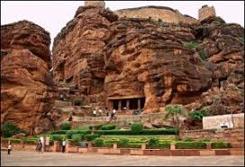

**Badami Temple**

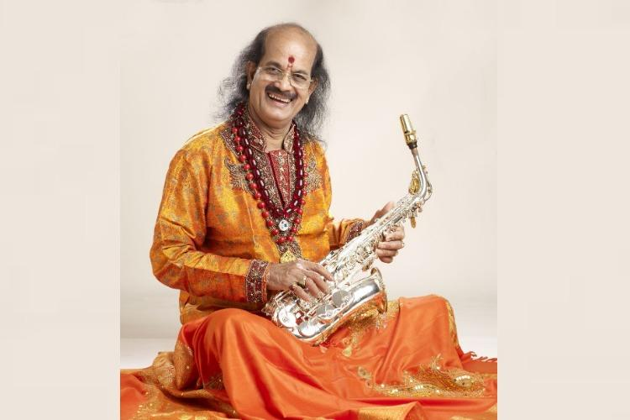

**Kadri Gopalanath**

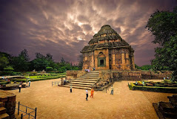

**Kornak Temple**

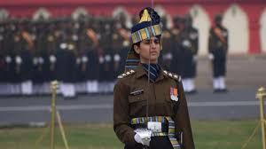

**Taniya Shergil**

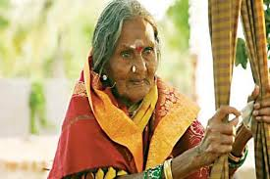

**Sulagitti Narasamma**

**ROUND VIII**

**RAPID ROUND**

**TEAM A**

1. Capital of Manipur….
2. Currency of Qatar…..
3. Who is the first law minister of India?
4. The highest mountain in the world is
5. The World Environment day is observed on…..
6. Capital of Manipur….**Imphal**
7. Currency of Qatar…..**Qatari Riyal**
8. Who is the first law minister of India?..... **Dr. B R Ambedkar**
9. The highest mountain in the world is ……..**Mount Everest**
10. The World Environment day is observed on…..5th **June**

**TEAM B**

1. Capital of Bihar….
2. Currency of Egpt…..
3. The country called the land of Rising Sun is …..
4. The Army Day is on…….
5. Who designed the Indian Flag?........
6. Capital of Bihar….**Patna**
7. Currency of Egpt…..**Egyptian Pound**
8. The country called the land of Rising Sun is ….. **Japan**
9. The Army Day is on……..**15th January**
10. Who designed the Indian Flag?....**Pingali Venkayya**

**TEAM C**

1. Capital of Haryana….
2. Currency of Nepal…
3. The Independence day of South Korea is celebrated on…..
4. The longest river in India is…..
5. Who is the current Indian team coach?
6. Capital of Haryana….**Chandigarh**
7. Currency of Nepal… **Rupee**
8. The Independence day of South Korea is celebrated on…..**15th August**
9. The longest river in India is….. **Ganga**
10. Who is the current Indian team coach?

**Anil Kumble**

**TEAM D**

1. Capital of Odisha….
2. Currency of France….
3. Which is the Jewel of incredible India?......
4. World Literacy day is celebrated on……
5. India’s flag bearer during parade at 2016 Rio Olympics opening ceremony was?

1. Capital of Odisha…. Bhubaneswar

1. Currency of France…. Euro
2. Which is the Jewel of incredible India?......Manipur
3. World Literacy day is celebrated on……8th September
4. India’s flag bearer during parade at 2016 Rio Olympics opening ceremony was

.Abhinav Bindra

**TEAM E**

1. Capital of Jharkhand is….
2. Currency of China is ….
3. India’s first e-Port is…..
4. National Youth Day is on…..
5. Which India’s state is known as ‘One State, Many Worlds’ ?
6. Capital of Jharkand is…..**Ranchi**
7. Currency of China….**Chinese** **Yuan**
8. India’s first e-Port…..**Kochi**
9. National Youth Day is on…..**12th January**
10. Which India’s state is known as ‘One State, Many Worlds’?

**Karnataka**

**THANK YOU**