

**Tribhuvan University**

**Faculty of Humanities and Social Science**

**.Store**

**A PROJECT REPORT**

**Submitted to**

**Department of Computer Application**

**Danfe College**

***“In partial fulfillment of the requirements for the Bachelors in Computer Application”***

**Submitted by**

Abhimanu Raut Tharu (6-2-920-1-2020)

March, 2024

**Under the Supervision of**

**Mr. Sarad Pokhrel**



**Tribhuvan University**

**Faculty of Humanities and Social Science**

**Danfe College**

**Supervisor’s Recommendation**

I hereby recommend that this project prepared under my supervision by **Abhimanu Raut Tharu** entitled “**.Store”** in partial fulfillment of the requirements for the degree of Bachelor of Computer Application is recommended for the final evaluation.

_______________

Mr. Sarad Pokhrel

BCA Department

Sinamangal, Kathmandu



**Tribhuvan University**

**Faculty of Humanities and Social Science**

**Danfe College**

**LETTER OF APPROVAL**

This is to certify that this project prepared by **Abhimanu Raut Tharu** entitled **“.Store”** in partial fulfillment of the requirements for the degree of Bachelor in Computer Application has been evaluated. In our opinion it is satisfactory in the scope and quality as a project for the required degree.

|  |  |
| --- | --- |
| **Supervisor**  **___________________________**  Mr. Sarad Pokhrel  Danfe College  Sinamangal, Kathmandu | **HOD/ Coordinator**  **___________________________**  Mr. Tul Bdr Rai  Danfe College  Sinamangal, Kathmandu |
| **___________________________**  **Internal Examiner** | **___________________________**  **External Examiner** |

# **ABSTRACT**

**.Store** is an innovative e-commerce platform designed to cater to the diverse fashion needs of individuals from all walks of life. Our website offers a comprehensive collection of fashionable clothing that has been thoughtfully chosen to suit a wide range of preferences, interests, and styles. Store offers a wide selection of clothes for men, women, and kids, Wtach, ranging from sporty outfits to elegant formal dress and all in between. Customers can browse a wide range of fashion options and select the ideal ensemble to express their individuality thanks to an easy-to-use interface and smooth purchasing experience. When it comes to fashion fans looking for high-quality clothing that is easily accessible, is the go-to source, offering both classic pieces and the newest trends.

# **ACKNOWLEDGEMENT**

Apart from our efforts, the success of any project depends largely on the encouragement and guidelines of many others. We take this opportunity to express our gratitude to the people who have been instrumental in the successful completion of this project. We would like to show our greatest appreciation to Tul Bdr Rai and **Mr. Sharad Pokhrel**. We can't say thank them enough for his tremendous support and help. We feel motivated and encouraged every time we attend his meeting. Without their encouragement and guidance, this project would not have materialized. We are grateful for their constant support and help throughout this project.

*Keywords: User friendly interface, CMS, E-Commerce, B2C, Online Shopping.*

**Table of Contents**

ABSTRACT iii

ACKNOWLEDGEMENT iv

LIST OF ABBREVIATIONS vi

CHAPTER 1: INTRODUCTION 1

1.1 Introduction to Ecommerce 1

1.2 Classification of Ecommerce 2

1.3 Objectives 3

CHAPTER 2: PROCESS OF BUILDING A WEBSITE 4

2.1 Steps for Building a website 4

2.3 Steps of Online Shopping 7

2.3.1 Add to cart 7

2.3.2 Cart page 7

2.3.3 Checkout page 8

2.3.4 Checkout Detail 8

2.4 Tracking Order of Products 9

2.4.1 Viewing list of Orders 9

2.4.2 Detail Updating Order 9

CHAPTER 3: CONCLUSION 11

3.1 Lesson Learnt 11

3.2 Conclusion 11

References 12

Appendices 13

# **LIST OF ABBREVIATIONS**

CMS – Content Management System

B2C – Businesses to Consumers.

B2B – Businesses to Businesses.

C2B – Consumers to Businesses.

C2C – Consumers to Consumers

B2G – Businesses to Governments.

C2G – Consumers to Governments.

G2B – Governments to Business.

G2C - Governments to Customers.

**LIST OF FIGURES**

Figure 1. 1 Ecommerce 1

Figure 2. 3 Adding Payment Methods 6

Figure 2. 4 Product Page 7

Figure 2. 5 Cart Page 7

Figure 2. 6 Billing and Checkout 8

Figure 2. 7 Checkout Detail 8

Figure 2. 8 Order List 9

Figure 2. 9 Updating Orders 9

# **CHAPTER 1: INTRODUCTION**

## **1.1 Introduction to Ecommerce**

"Ecommerce" or "electronic commerce" is the trading of goods and services on the internet. It is your bustling city center or brick-and-mortar shop translated into zeroes and ones on the internet superhighway. An estimated 2.14 billion people worldwide buy goods and services online. Ecommerce is one way people buy and sell things in retail. Some companies sell products online only, while other sellers use ecommerce as a part of a broader strategy that includes physical stores and other distribution channels. Either way, ecommerce allows startups, small businesses, and large companies to sell products at scale and reach customers across the world.

An ecommerce website is your digital storefront on the internet. It facilitates the transaction between a buyer and seller. It is the virtual space where you showcase products, and online customers make selections. Your website acts as the product shelves, sales staff, and cash register of your online business channel. [1]

Unlike a physical store that limits a business to its geographical area, an e-commerce website allows you to reach customers anywhere. Once customers can place orders online and you can ship a product to their location or provide a service, there’s no limit to your reach. E-commerce websites provide flexibility for their owners and customers. You can offer a wide selection of products while customers make round-the-clock purchases, regardless of their time zone or location. And as a business owner, you can earn even while sleeping. [2]

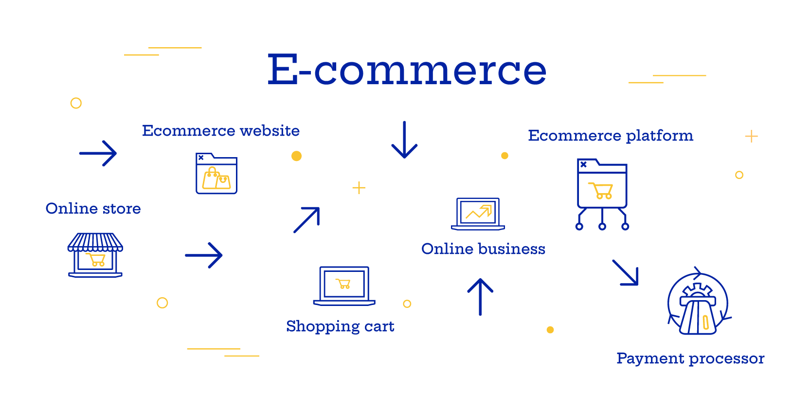

Figure 1. 1 Ecommerce

## **1.2 Classification of Ecommerce**

Ecommerce takes as many different forms as there are various ways to shop online channels. A few common business models that shape the world of ecommerce are:

1. B2C – Businesses sell to individual consumers (end-users).
2. B2B – Businesses sell to other businesses.
3. C2B – Consumers sell to businesses.
4. C2C – Consumers sell to other consumers
5. B2G – Businesses sell to governments or government agencies.
6. C2G – Consumers sell to governments or government agencies.
7. G2B – Governments or government agencies sell to businesses.
8. G2C - Governments or government agencies sell to consumers.

**a) B2C (Business to Consumer):**

This model involves businesses selling products or services directly to individual consumers, who are the end-users. Examples include retail stores, online marketplaces, and service providers like streaming platforms or gyms.

**b) B2B (Business to Business):**

In this model, businesses sell products or services to other businesses. This could involve selling raw materials, software solutions, consultancy services, or any other goods or services required by businesses to operate.

**c) C2B (Consumer to Business):**

This model involves consumers selling products or services to businesses. Examples include freelance services where individuals offer their skills or expertise to businesses, or platforms where consumers can sell their used goods to businesses for resale.

**d) C2C (Consumer to Consumer):**

Here, consumers sell products or services directly to other consumers. This often occurs through online marketplaces or classified ads platforms where individuals can buy and sell items with each other, such as eBay or Craigslist.

**e) B2G (Business to Government):**

In this model, businesses sell products or services to governments or government agencies. This could include supplying equipment, providing consulting services, or offering specialized services tailored to the needs of government entities.

**f) C2G (Consumer to Government):**

This involves consumers selling products or services directly to governments or government agencies. An example might be an individual offering consulting services to a government department or selling artwork to a government institution.

**g) G2B (Government to Business):**

In this model, governments or government agencies sell products or services to businesses. This could include selling surplus equipment, offering licenses or permits, or providing access to government-owned resources or facilities.

**h) G2C (Government to Consumer):**

Here, governments or government agencies sell products or services directly to consumers. Examples include issuing passports, providing public transportation services, or selling recreational permits for parks or other government-managed facilities.

## **1.3 Objectives**

Some objectives of our system:

* To boost sales with effective marketing and brand engagement.
* To grow customer base through improved brand visibility.
* To enhance website usability for better shopping experiences.
* To cultivate customer loyalty via exceptional service and loyalty programs.

# **CHAPTER 2: PROCESS OF BUILDING A WEBSITE**

## **2.1 Steps for Building a website**

The process to build a successfully ecommerce website is as follows. They are followed in the completion of this project.

**2.1.1 Select a Web host:** Selecting a web hosting provider is one of the initial decisions an online business must make. Options range from being included in virtual shopping malls like 3d-berlin.com, the-virtualmall.com, or pointshop.com/mall, to joining marketplaces such as Yahoo! Small Business (smallbusiness.yahoo.com), Amazon.com, Etsy, or eBay. Alternatively, medium to large-sized businesses often opt for independent hosting services or self-hosting arrangements to maintain control over their websites' infrastructure and customization.

***Apache Server and MySQL is used***

**2.1.2 Choose a Domain Name:** In a virtual mall or web store hosted by another platform, the business name might be an extension of the host's name. However, for a standalone website, a unique domain name is necessary. Decisions about the top-level domain and whether it should include the business name or branding elements need to be made. Registering a domain name is a critical step in establishing an online presence.

- Current: http://localhost/stylesassy

- Future: https://www.stylesassy.com.np

**2.1.3 Develop and Maintain Content:** A website requires various forms of content, including text, catalogs, images, audio, and video, to provide visitors with the information they need. Content can originate from different sources, but ensuring it is relevant, easily accessible to viewers, effectively delivered, and consistently updated is crucial for success. Utilizing Next.js, an excellent Content Management System (CMS), facilitates content creation, organization, and maintenance.

**2.1.4 Website Design:** Designing the website is crucial. While some platforms offer limited options, I used the free Ecommerce Landing Page . With theme customization and the Classic Widgets plugin, I transformed a starter site into My Computer Shop, tailoring it to my needs.

I designed the website using the free Ecommerce Landing Page , customizing it with theme options and the Classic Widgets plugin to create My Computer Shop.

**2.1.5 Build and Test Website:** Decide whether to design internally or outsource to a web design firm. After completion, transfer the website to the host. Conduct final testing to ensure functionality. Opted for Cash on Delivery payment option for cost-effectiveness. Explored integration of payment platforms like Esewa, requiring merchant private and public keys. Tested product insertion for items like computers and laptops.

I chose Cash on Delivery for payments and explored adding Esewa integration, testing product insertion for items such as computers and laptops.

**2.1.6 Market and Promote Website:** Businesses promote the website's location through online and offline channels. Various advertising strategies can be employed, both online and offline. Promotion is the final step in launching after successful website testing.

## **2.3 Steps of Online Shopping**

The steps involve in this process is as follows:

### **2.3. Add to Cart**

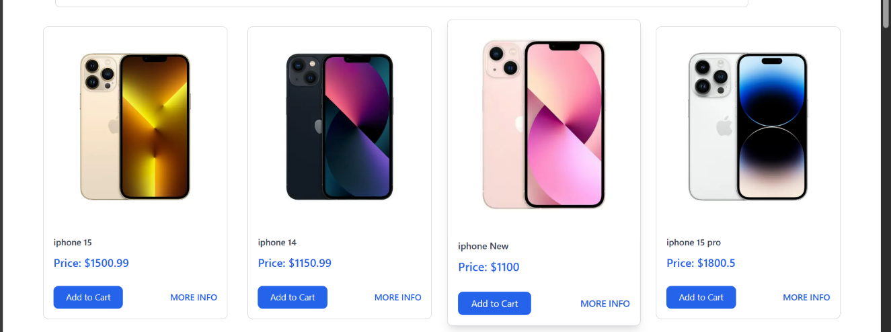

Figure 2. 4 Product Page

### **2.3.2 Cart page**

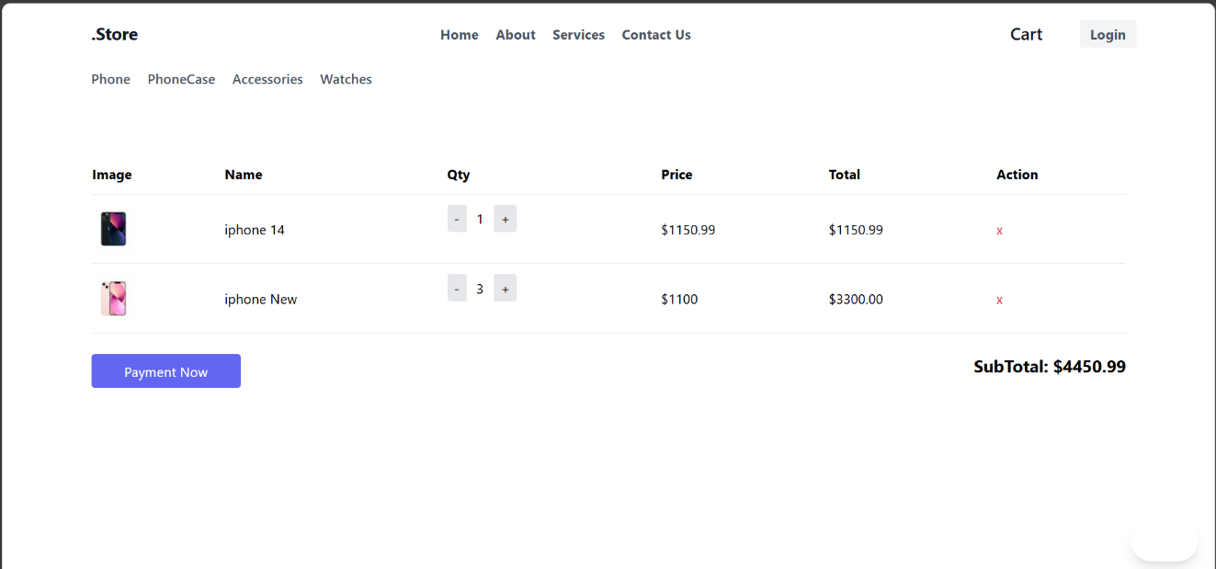

Figure 2. 5 Cart Page

### **2.3.3 Checkout page**

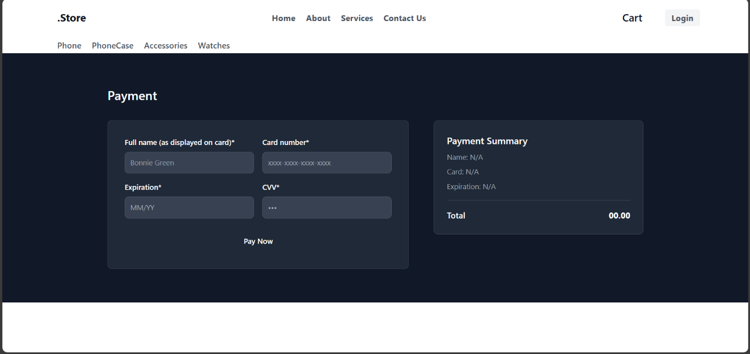

Figure 2. 6 Billing and Checkout

### **2.3.4 Checkout Detail**

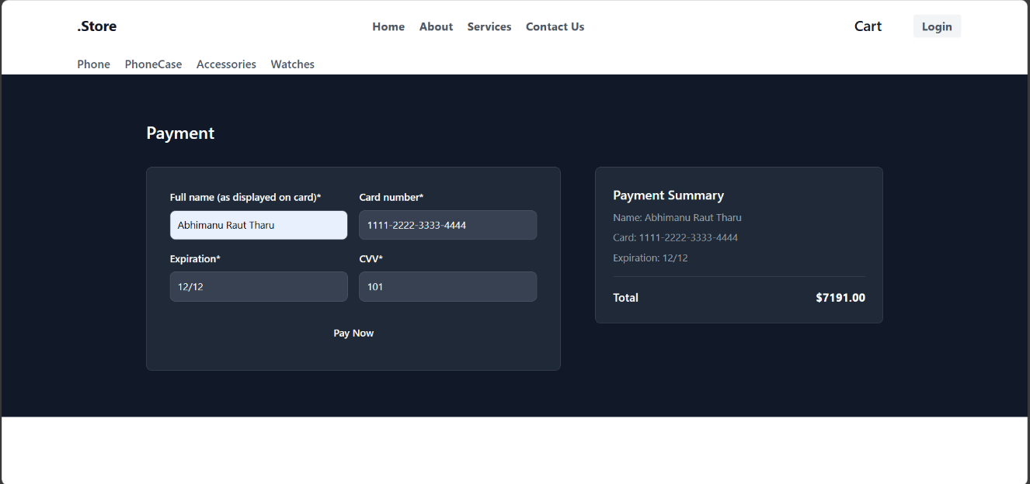

Figure 2. 7 Checkout Detail

## **2.4 Tracking Order of Products**

### **2.4.1 Viewing list of Orders**

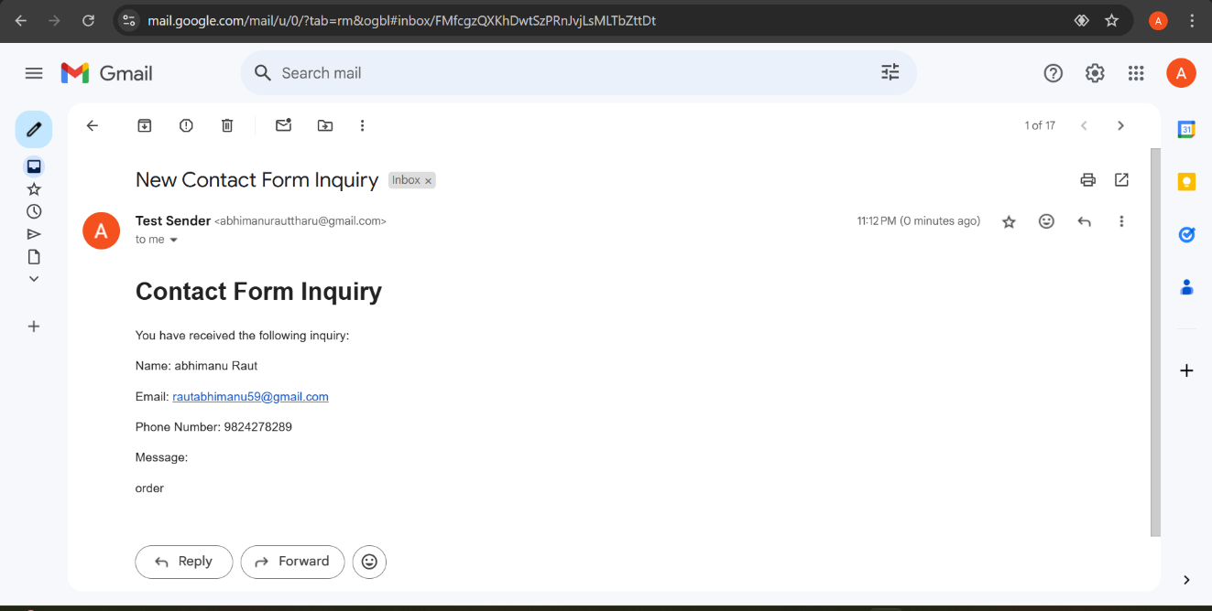

Figure 2. 8 Order List

# **CHAPTER 3: CONCLUSION**

## **3.1 Lesson Learnt**

Completing a website project as a student has taught me invaluable lessons. First and foremost, effective project management and planning are the cornerstones of a successful endeavor. Clear objectives, well-defined timelines, and consistent progress tracking proved essential. Moreover, the importance of collaboration and communication within a team became evident. Open dialogue allowed us to resolve conflicts, share innovative ideas, and collectively tackle complex problems. Additionally, adaptability and flexibility were key, given the evolving nature of technology. Incorporating user feedback for a user-friendly design and rigorous testing for quality assurance further underscored the need for attention to detail. These lessons will undoubtedly benefit me in future projects and academic pursuits.

## **3.2 Conclusion**

In conclusion, this project aimed to create an ecommerce platform offering a seamless shopping experience with various payment options. Through user-friendly interface design and robust backend operations, we ensure efficient product management and secure transactions, enhancing customer satisfaction and facilitating business growth.

# References

|  |  |
| --- | --- |
| [1] | Amazon, "What is ecommerce? Launch and grow an online sales channel," [Online]. Available: https://sell.amazon.com/learn/what-is-ecommerce. |
| [2] | Forbes, "What Is E-Commerce? Definition, Types & Getting Started," [Online]. Available: https://www.forbes.com/advisor/business/what-is-ecommerce/. [Accessed 19 2 2024]. |
| [3] | K. P. Acharya, S. Panday and P. Sunil, MIS and E-Business, Kathmandu: KEC Publication, 2078. |

# **Appendices**

Home page And Product Page

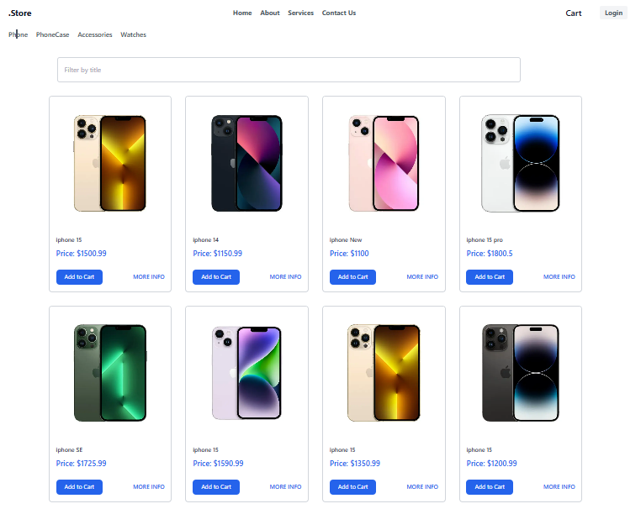

Login Page

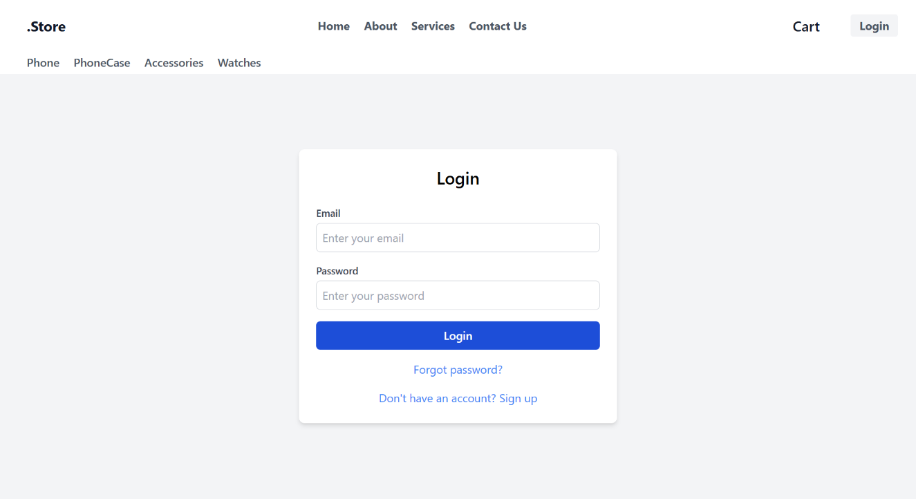

Cart Page



Checkout Page

